Chemistry, Life, the Universe *&* Everything

Melanie M. Cooper & Michael W. Klymkows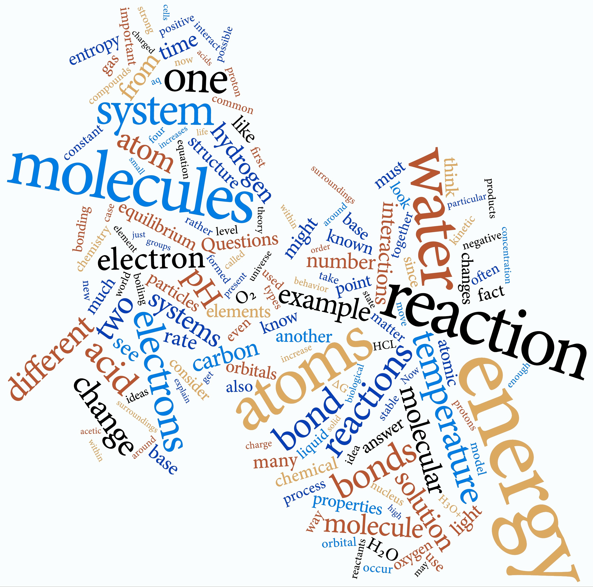ky

14 September 2016 edition – CLUE trademark and copyright reserved  


Preface for the reader: 6

To the Student: 8

Introduction to the course (as opposed to the book) 10

Chapter 1: Atoms 12

1.1 What Do You Think You Know About Atoms? 13

1.2 Atomic Realities and Scientific Theories 14

1.3 Some History of Atomic Theory 16

1.4 Identifying and Isolating Elements 19

1.5 Evidence for Atoms 20

Probing the Substructure of Atoms 22

1.7 Interactions Between Atoms and Molecules 26

Interactions Between Atoms: A Range of Effects 27

Forces and Energy: an overview. 29

Interacting Atoms: Forces, Energy Conservation and Conversion 33

1.8 Interactions Between Helium Atoms and Hydrogen Molecules 36

Chapter 2: Electrons and Orbitals 39

2.1 Light and Getting Quantum Mechanical 39

2.2 Taking Quanta Seriously 41

2.3 Exploring Atomic Organization Using Spectroscopy 43

Making sense of spectra: 44

2.4 Beyond Bohr 45

Certainty and Uncertainty 46

2.5 Organizing Elements: Introduction to the Periodic Table 48

2.6 Orbitals, Electron Clouds, Probabilities, and Energies 50

Examining Atomic Structure Using Light: On the Road to Quantum Numbers 51

2.7 Quantum Numbers 53

Chapter 3: Elements, Bonding, and Physical Properties 58

3.1 Elements and Bonding 58

Where Do Atoms Come From? 59

Thinking About Atomic Origins 60

Looking at Stars 63

3.2 Elements and Their Interactions 65

Thinking about the nature of the chemical bond 66

Discrete Versus Continuous Molecules 69

The Hybrid Orbital Model 72

The Molecular Orbital Model 73

Graphite 73

3.4 Metals 75

Why Are Metals Shiny? 77

Chapter 4: Heterogeneous Compounds 79

3D and 2D Representations 79

Carbon: Always Tetravalent and Often Tetrahedral 79

Building Increasingly Complex Molecules 83

4.2 Single Bonds and Molecular Shape 85

Collapsing Real Structures Down to 2-Dimensional Representations 86

4.3 Double and Triple Bonds 87

Shapes of Molecules with Double (and Triple) Bonds 88

4.4 Bonding in Nitrogen, Oxygen, and Fluorine 89

Bonding of Oxygen and Fluorine 90

Molar mass 91

(g/mole) 91

Atomic radius 91

(pm) 91

Polarized Bonds and Electronegativity 92

4.5 Molecular Shapes, Polarity, and Molecular Interactions 94

The Famous Hydrogen “Bond” 95

Other Polar Bonds 97

Intermolecular Forces 98

The Importance of Shape 98

4.6 Ionic Bonding 99

Back to Sodium Chloride 101

How Ionic Bonding Explains the Properties of Ionic Compounds 102

Chapter 5: Systems Thinking 104

5.1 Temperature 105

Kinetic Energy and Temperature 105

5.2 Thinking About Populations of Molecules 106

Temperature, Kinetic Energy and Gases 108

5.3 Vibrating, Bending, and Rotating Molecules 109

Heat Capacity and Molecular Structure 110

Removing Thermal Energy from a Gas 112

Liquids to Solids and Back Again 113

5.4 Open Versus Closed Systems 114

5.5 Thermodynamics and Systems 116

The Second Law of Thermodynamics 118

Probability and Entropy 118

5.6 Back to Phase Changes 121

5.7 Gibbs (Free) Energy to the Rescue 122

What Is “Free” About Gibbs Free Energy? 123

Free Energy and Temperature 124

Chapter 6: Solutions 127

6.1 What Is a Solution? 127

Molecular Formation of Solutions 128

6.2 Solubility: why do some things form solutions and others not? 129

Entropy and Solubility: Why Don’t Oil and Water Mix? 132

Solubility of Ionic Compounds: Salts 133

6.4 Gibbs Energy and Solubility 135

6.5 Polarity 136

Questions to Answer 138

Solutions, Colloids & Emulsions 138

Solutions of Solids in Solids: Alloys 140

Is the Formation of a Solution a Reaction? 140

Chapter 7: A Field Guide to Chemical Reactions 142

7.1 Collisions and Chemical Reactions 142

7.2 Acid–Base Reactions: A Guide for Beginners 146

Arrhenius Acids and Bases 147

How to Spot an Acid 151

Strong, Weak, Concentrated, and Dilute Acids and Bases 152

Factors That Affect Acid Strength 153

How to Spot a Base 154

7.3 Lewis Acid–Base Reactions 155

7.4 Nucleophiles and Electrophiles 157

Considering Acid–Base Reactions: pH 158

Making Sense of Vinegar and Other Acids 162

7.5 Oxidation–Reduction Reactions 164

Oxidation States and Numbers 165

7.6 Energy Changes and Chemical Reactions 166

Chapter 8: How Far? How Fast? 170

8.1 What Factors Control Reactions? 170

8.2 Reaction Rates 172

Reaction Rates and Probabilities 173

8.3 Kinetics and the Mechanisms of Reactions 175

Concentrations and Reaction Rates 175

Temperature and Reaction Rates 179

8.4 Catalysis 182

8.5 Equilibrium 183

Free Energies and Equilibrium Constants 185

Equilibrium and Non-Equilibrium States 187

Le Chatelier's Principle 189

Temperature, Equilibrium, and Reaction Rates 189

Equilibrium and Steady State 191

8.6 Back to Reaction Mechanisms 193

Chapter 9: Reaction Systems 196

9.1 Systems Composed of One Reaction 196

9.2 Buffered Systems 199

9.4 Coupled, Non-Equilibrium Reaction Systems 205

9.5 Energetics and Coupling 208

Appendix I: Spectroscopy 212

# Preface for the reader:

You might well ask, does the world really need another introductory chemistry textbook? The answer is, of course not—not if that book is just a variation on those currently available. Chemistry, and particularly introductory general chemistry, is simply not changing that much and people learn pretty much the same way they always did, at least if we restrict ourselves to the last fe thousand years.[1] On the other hand, there is compelling evidence that the way chemistry is commonly presented, both to the public and in college, is both off-putting and ineffective–a potent combination that leads to the widespread public misunderstanding of chemical principles. How many times do we hear about “natural remedies, without drugs or chemicals,” despite the fact that everything is composed of chemicals and the most toxic chemicals known are natural products.[2]



A growing body of research results on student understanding of chemistry indicates, pretty emphatically, that we need better ways to teach and assess students’ understanding of the fundamental ideas upon which chemistry is based. These are important ideas that students need to learn, and learn in a robust way that enables them to transfer their understanding to new situations rather than just remember what they were told. It would be even better if we could cultivate an appreciation for how science works and, in our most ambitious moments, light a spark of enthusiasm for the beauty, unity, and bizarre processes that make up the natural world. Our problem is how to approach the Socratic ideal in a practical and economically feasible manner.

In this light, we should ‘fess up to where we stand on a number of important issues—we unambiguously accept the liberal ideals of the Enlightenment, namely that intellectual honesty and rigor, rational and logical discourse, and free and dispassionate analyses, together with compassion and empathy, something all too often forgotten by revolutionaries, are critical, both in the context of the scientific enterprise and more generally in making the world a better place for all of its inhabitants. Unfortunately, the ideals of the Enlightenment appear to have fallen somewhat out of favor, at least in some circles. While there is an apparent excess of passion, few appear to be willing to examine objectively or even consider both the positive and negative implications of their positions. Passionate advocacy devoid of rational analysis and the recognition that our understanding of the world is tentative and incomplete, and likely to remain that way for some time into the future, seems to encourage various forms of irrational, and often cruel and violent beliefs, many of which should be dismissed out of hand.

So, back to the project at hand—how do we build a better chemistry book and course? We freely admit our inspirations. Books like Bill Bryson's “*A Short History of Nearly Everything*” and Einstein and Infeld's “*The Evolution of Physics*” present science in a logical and engaging manner; they are both interesting and stimulating to read. Unfortunately, this is quite different from the style found in most textbooks. So what is missing from the Bryson and Einstein and Infeld books that make them inappropriate for use as a college textbook? Most obviously, they do not concern themselves with determining whether their readers really–that is, accurately–understand and can apply the ideas presented. Therein lies the logic and impetus behind our book and its associated web-based and in-class materials. Our goal is to merge the inherently engaging aspects of chemistry with the active experiences and metacognitive reflections needed to rewire the student’s (that is, your) brain to really understand and accurately use chemical knowledge.

While there have been many educational experiments over the last 100 years, we take our inspiration from Socrates (470–399 bce). Basically, our goal is to present concepts and skills in various ways, ask students to talk about and work with their understanding, and then ask questions about what students actually mean when they use specific words and ideas. Critical to the success of this approach is time: the time required to understand what students think before, during, and after reading the text and working with the applets and activities; the time required for students to recognize and talk about their assumptions; the time required to listen to them, to ask them what, exactly, they mean, and for them to explain, analyze, and where appropriate reconsider, their ideas. Because of the critical link between time and learning, we will not consider some of the topics often presented in standard textbooks and instead will concentrate on more foundational ideas. Does this mean that using this book and its associated materials will leave students unprepared in critical areas of chemistry? No, and we can demonstrate that is not the case. Rather, it leaves students able to work through many of these topics on their own and we will provide web resources to make this possible.

We developed much of the material in this new curriculum using research on how people learn and our own work on how to improve understanding and problem solving in college-level science classes. In previous studies we have found that our methods, which include dramatic reorganization and reduction of materials covered, increase student interactions and activity and lead to equal or better performance on standardized exams, greater conceptual understanding, and improved problem-solving skills. By focusing the time and effort on the foundational ideas we expect that you will achieve a more robust and confident understanding of chemical principles, an understanding that should serve you well in subsequent chemistry and other science courses, not to mention “real life”!

# 

# To the Student:

We designed this book to help you attain a confident, competent, and coherent understanding of basic chemistry, in particular of the chemistry associated with organisms and their origins. That said, this is not a chemistry for biologists or non-scientists book but rather an approach to the difficult and often counterintuitive ideas at the heart of chemistry, for an intelligent and engaged student who, often quite reasonably, finds these ideas unbelievable, arbitrary, or incoherent. Our goal is to assist you in developing an understanding of the foundations of chemistry, so that you can apply these ideas to a range of new situations. We are aware that many of you are not excited by the prospect of learning chemistry and we share your concerns—many of the ideas presented are difficult and often counterintuitive and past experiences with chemistry not have been optimal. At the same time, it is possible to approach chemistry from a more reasoned and rational direction, recognizing difficult ideas, why we are forced to accept them, and how we can apply them.

**Why is basic chemistry often perceived as boring?** One reason maybe the way it is all too commonly presented: a laundry list of facts to remember and exercises to perform, often with little effort made to connect abstract and frankly weird concepts to your lifetime of day-to-day and quite real experiences. For example, it is certainly not obvious that matter is made of a small set of essentially indestructible objects–atoms–connected to one another in various ways; or how such combinations of atoms–molecules–can lead to complex processes like life and dreams. Where did this strange idea come from? How is it that we come to appreciate and accept the reality of things as abstract as atoms and molecules, or that a tree is composed primarily of gas, carbon dioxide, and water molecules, rearranged? Is it even possible for the average person to really accept, understand and learn to work with, such bizarre abstractions? We think we are reasonably average people not withstanding our excessive amounts of formal education and our obsessive efforts to understand what may seem to be insignificant, weird, and occasionally trivial problems. We think that while scientific understanding is not easy, it can be made more engaging by recognizing explicitly which ideas are odd and what types of observations and logic led or forced scientists to accept them.

Throughout our journey we will consider what makes sense from our day-to-day experiences, how that differs from the current models of chemical systems, and what types of observations resolve the apparent contradictions between the two. We encourage you to take your own ideas seriously and consider when they do and do not make scientific sense. This is not an easy task, but it is the only way to understand scientific ideas, rather than simply memorizing words and formulae.

**Why think about chemistry from a biological perspective?** The answer is simple really. Biological systems, whether cells, organisms, or ecosystems, are the most complicated examples of chemical systems. They rely on chemical reactions and the chemical properties of atoms and molecules to produce truly amazing behaviors. They are the end products of evolutionary processes that have been going on form more that 3.5 billion years; processes based on random variations that are captured and turned into information through natural selection. Molecular analyses strongly support the rather amazing conclusion—namely that all organisms currently living on earth are related and descended from a common ancestor through unbroken lineages.

The underlying unity of life, and its chemical basis, is only one of many amazing, bizarre, and counterintuitive ideas we will encounter. To help you grapple with these ideas we will use various interactive materials that will help you test and strengthen your understanding. Where you feel lost, try to articulate what, exactly, you find confusing and why. You can start a socratic dialog with yourself, and then bring it to your instructor and fellow students. That is the best way to learn, or so claims Socrates.

**A note on footnotes**: The authors have an inordinate fondness for footnotes. We do not expect you, the student, to read them or the follow the links within them, but they enable us to indulge our interests in various topics. Please be careful to avoid getting lost in them–that may well be a mistake.

# Introduction to the course (as opposed to the book)

This text is intended to provide an in-depth introduction to the key ideas in chemistry. We have designed the book to show how these ideas are developed from simple to complex systems and how they relate to each other. We consider three ideas central to an understanding of chemistry: the structure of matter, the properties of matter, and the energy changes involved in the reorganization of matter; all are connected by the interactions or forces that cause matter to interact. We aim to provide compelling reasons why you will find yourself wanting to learn chemistry and to illustrate what you will be able to do with this knowledge once you have learned it.

We hope that you will find the book both readable and engaging, but keep in mind, it is not intended to contain everything that will be learned in this course. It is purposely not cluttered with boxes, asides, and long descriptions about how to solve problems or learn other skills such as learning how to construct a scientific explanation, or developing a model. This is not because these aspects of chemistry are unimportant – quite the contrary – but rather that there is little evidence that reading a book will lead to effective mastery of such skills. Instead, you will work with activities within the class. We have designed these to be interactive and to support and expand on the text. In some cases these ancillary materials introduce ideas that are not, perhaps, as engaging to read about even though they are important to master. These ancillary CLUE materials include:

1. A set of class presentations and activity materials;

2. A set of YouTube videos showing how to do various skills and solve different types of problems; and

3. A set of online activities using the beSocratic system that can be done in class, in recitation, or for homework.

Much like the “questions to answer, questions to ponder, and questions for later” sections of the book, these ancillary activities require you to actively construct answers rather than choose from a list of responses. This is a deliberate focus of the CLUE curriculum because we have compelling evidence that drawing, writing, and constructing answers help students learn more deeply. These materials are also available as worksheets that can be done off-line.

Materials integral to the CLUE curriculum but that are not covered exhaustively in the text are:

1. Common chemistry calculations, illustrated by YouTube videos, including:

* Stoichiometry;
* Energy, frequency, and wavelength conversions;
* Mass energy conversions;
* Thermochemistry, including specific heat, bond energy and entropy, enthalpy, and Gibbs energy;
* Equilibrium calculations, pH and Ka;
* Reaction rates and rate law determinations; and
* Buffers and linked chemical reaction energy changes.

2. Common skills, including:

* Electron configurations, particularly to determine the number of valence electrons;
* Drawing Lewis structures;
* VESPR;
* Assigning oxidation numbers; and
* Using curved arrows to predict the outcome of simple reactions.

# Chapter 1: Atoms

*If, in some cataclysm, all of scientific knowledge were to be destroyed, and only one sentence passed on to the next generation of creatures, what statement would contain the most information in the fewest words? I believe it is the atomic hypothesis (or the atomic fact, or whatever you wish to call it) that all things are made of atoms—little particles that move around in perpetual motion, attracting each other when they are a little distance apart, but repelling on being squeezed into one another. In that one sentence, you will see, there is an enormous amount of information about the world, if just a little imagination and thinking are applied. Nobel Laureate Richard Feynman, 1963*

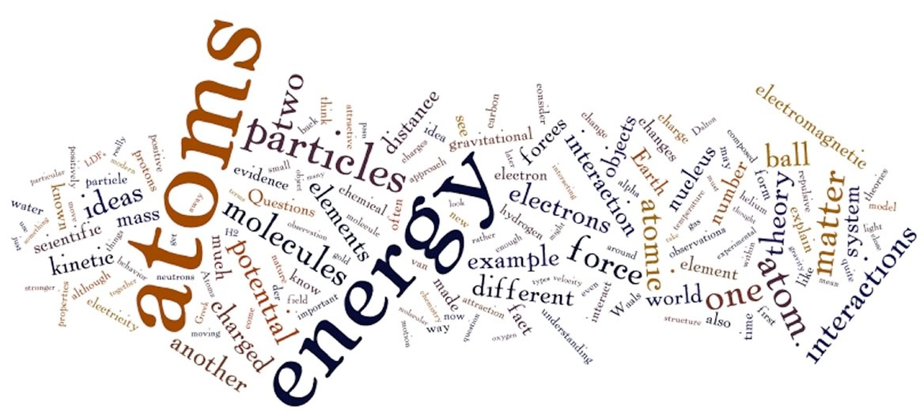

Most of us are quite familiar with the core principle of atomic theory—the idea that matter is composed of atoms—because we have been told that this is so since childhood. But how many of us really, and we mean *really* believe it, use it in our day-to-day life, understand its implications, or know the reasons why it is assumed to be true? It seems so completely and totally impossible and improbable because we do not experience atoms directly and it is easy to go through life quite successfully, at least for the vast majority of us, without having to take atoms seriously. The average person's brain is simply not wired to believe in the reality of things like atoms in a concrete and day-to-day way. Yet most scientists, and certainly most chemists, would agree that Feynman’s deceptively simple statement contains the essence of chemistry.

Atomic theory is also critical for understanding a significant number of the underlying concepts of biology and physics, not to mention geology, astronomy, ecology, and engineering. How can one sentence contain so much information? Can we really explain such a vast and diverse set of scientific observations with so little to go on? In the next two chapters we will expand on Feynman’s sentence to see just what you can do with a little imagination and thinking. At the same time, it is worth remembering that the fact that atoms are so unreal from the perspective of our day-to-day experience means that the atomic theory poses a serious barrier to understanding modern chemistry. This is a barrier that can only be dealt with if you recognize it explicitly and try to address and adjust to it. You will be rewiring your brain in order to take atoms, and their implications, seriously. We are aware that this is not an easy task. It takes effort, and much of this effort will involve self-reflection, problem-solving, and question-answering. In an important sense, you do not have to believe in atoms, but you do have to understand them.

## 1.1 What Do You Think You Know About Atoms?

You almost certainly have heard about atoms and it is very likely you have been taught about them. If asked you might profess to believe in their reality. You might accept that matter, in all its forms, is made up of atoms — particles that are the smallest entities that retain the identity of an element (we will discuss elements in much greater detail in the next few chapters.) It is very likely that you have been taught that atoms are made up of even smaller particles: positively charged protons, uncharged neutrons, and negatively charged electrons. You may even have heard, and perhaps even believe, that protons and neutrons can be further subdivided into quarks and gluons, while electrons are indivisible. Equally difficult to appreciate is that all atoms are organized in a very similar way, with a very tiny, but relatively heavy, positively charged nucleus surrounded by the much lighter, negatively charged electrons.

Part of the difficulty in really understanding atoms is the fact that the forces holding the atomic nucleus together, the so-called strong and weak forces, operate at such infinitesimal distances that we do not experience them directly. This is in contrast to electromagnetism and gravity, which we experience directly because they act over longer, macroscopic or visible distances. A second problem is associated with the fact that to experience the world we need to use energy; at the atomic scale the energy used to observe the system also perturbs it. This is the basis of the Heisenberg uncertainty principle, which you may have encountered or at least heard of before, and to which we will return. Finally, objects at the atomic and subatomic scales behave differently from the macroscopic objects with which we typically interact. A particle of light, a photon, an electron, a proton, or a neutron each behaves as both a particle and a wave. In terms of physics, these are neither particles nor waves; they are quantum mechanical particles. Luckily, the weirder behaviors of atomic and subatomic entities can often, but not always, be ignored in chemical and biological systems. We will touch on these topics as necessary.

Current theory holds that each atom contains a very, very small, but very dense nucleus, which contains protons and neutrons and is surrounded by electrons. These electrons are very light, relatively, but the space occupied by moving electrons accounts for the vast majority of the volume of an atom. Because the number of positively charged protons and negatively charged electrons are equal and the size of the charges are the same but opposite, atoms are electrically neutral when taken as a whole; that is, each positively-charged proton is counterbalanced by a negatively-charged electron.

Often the definition of an atom contains some language about how atoms are the smallest particle identifiable as that element. What do we mean by that? For example, can an atom have chemical properties? And how can ensembles of the same particles, that is protons, electrons, and neutrons, have different properties? This is the mystery of the atom and understanding it is the foundation of chemistry. In this first chapter, we hope to lead you to a basic understanding of atomic structure and inter-atomic interactions. Subsequent chapters will extend and deepen this understanding.

**Questions to Ponder**

* If you had to explain to a non-scientist why it is that scientists accept the idea that all material things are composed of atoms what evidence would you use?
* Does the ability of science to explain so much about the world influence your view about the reality of supernatural forces?

## 1.2 Atomic Realities and Scientific Theories

We assume that you have lots of ideas about atoms but did you ever stop to think how we came to accept this information as reasonable or what the reality of atoms implies about how the world we perceive behaves? Atoms are incredibly and unimaginably small. A gold atom with its full complement of electrons is less than a nanometer (1 x 10–9 meters) in diameter and its nucleus, which contains 79 protons and generally around 116 neutrons, has a radius of   
~1.5 x 10–14 meters. While these sizes are actually unimaginable, there are a number of web-based activities that can help you come to terms with the scales of atoms.[3] There is no way you could see an atom with your eye or with a light microscope, although there are now techniques that allow us to view computer representations of individual atoms using various types of electron and force-probe microscopes. The smallest particle of matter that you can see with your naked eye contains more atoms than there are people in the world. Every cell in your body contains a huge number of atoms. Obviously, whatever we know about atoms is based on indirect evidence; we do not directly experience atoms.

The full story of how we know what we know about the existence and structure of atoms is fascinating, complex, and perhaps fortunately for you, too long to go into in detail. What we do want to do is to consider a number of key points that illustrate how our ideas of atoms arose and have changed over time. We will present the evidence that has made accepting the atomic theory unavoidable if you want to explain and manipulate chemical reactions and the behavior of matter.

Atomic theory is an example of a scientific theory that began as speculation and, through the constraints provided by careful observation, experimentation, and logical consistency, evolved over time into a detailed set of ideas that make accurate predictions and are able to explain an increasing number of diverse, and often previously unknown, phenomena. As scientists made new observations, atomic theory was adapted to accommodate and organize these observations.

A key feature of scientific ideas, as opposed to other types of ideas, is not whether they are right or wrong but whether they are logically coherent and make unambiguous, observable, and generally quantitative predictions. They tell us what to look for and predict what we will find if we look at or measure it. When we look, we may find the world acts as predicted or that something different occurs. If the world is different from what our scientific ideas suggest then we assume we are missing something important: either our ideas need altering or perhaps we are not looking at the world in the right way. As we will see, the types of observations and experimental evidence about matter have become increasingly accurate, complex, and often abstract, that is, not part of our immediate experience. Some of these observations can be quite difficult to understand, because matter behaves quite differently on the atomic and sub-atomic scale than it does in the normal, macroscopic world. It is the macroscopic world that evolutionary processes have adapted us to understand, or at least cope with, and with which we are familiar. Yet, if we are to be scientific, we have to go where the data lead us. If we obtain results that are not consistent with our intuitions and current theories, we have to revise those theories rather than ignore the data.

However, scientists tend to be conservative when it comes to revising well-established theories because new data can sometimes be misleading. This is one reason there is so much emphasis placed on reproducibility. A single report, no matter how careful it appears, can be wrong or misinterpreted and the ability of other scientists to reproduce the observation or experiment is key to its acceptance. This is why there are no miracles in science. Even so, the meaning of an observation is not always obvious or unambiguous; more often than not an observation that at first appears to be revolutionary turns out to have a simple and even boring explanation. Truly revolutionary observations are few and far between. This is one reason that the Carl Sagan (1934-1996) quote, ”*Extraordinary claims require extraordinary evidence*" is so often quoted by scientists. In most cases where revolutionary data is reported, subsequent studies reveal that the results were due to poor experimental design, sloppiness, or some irrelevant factor. The fact that we do not all have cold fusion energy plants driving perpetual motion refrigerators in our homes is evidence that adopting a skeptical approach that waits for experimental confirmation is wise.

A common misconception about scientific theories is that they are simply ideas that someone came up with on the spur of the moment. In everyday use, the word theory may well mean an idea or even a guess, a hypothesis, or a working assumption, but in science the word theory is reserved for explanations that encompass and explain a broad range of observations. More than just an explanation, a theory must be well tested and make clear predictions relating to new observations or experiments. For example, the theory of evolution predicted that the fossil record would show evidence for animals that share many of the features of modern humans. This was a prediction made before any such fossils were found; many fossils of human-like organisms have since been and continue to be discovered. Based on these discoveries, and on comparative analyses of the structure of organisms, it is possible to propose plausible family trees, known as phylogenies, connecting different types of organisms. Modern molecular genetics methods, particularly genome (DNA) sequencing, have confirmed these predictions and produced strong experimental support for the current view that all organisms now living on Earth are part of the same family–that is, they share a common ancestor that lived billions of years ago. The theory of evolution also predicts that the older the rocks, the more different the fossilized organisms found will be from modern organisms. In rocks dated to ~410 million years ago, we find fossils of various types of fish but not the fish that exist today. We do not find evidence of humans from that period; there are, in fact, no mammals, no reptiles, no insects, and no birds.

A scientific theory is also said to be falsifiable, which doesn’t mean that it is false but rather that it may be proven false by experimentation or observation. For example, it would be difficult to reconcile the current theory of evolution with the discovery of fossil rabbits from rocks older than 300 million years. Similarly, the atomic theory would require some serious revision if someone discovered an element that did not fit into the periodic table; the laws of thermodynamics would have to be reconsidered if someone developed a successful perpetual motion machine. A theory that can be too easily adapted to any new evidence has no real scientific value.

A second foundational premise of science is that all theories are restricted to natural phenomena; that is, phenomena that can be observed and measured, either directly or indirectly. Explanations that invoke the supernatural or the totally subjective are by definition not scientific, because there is no imaginable experiment that could be done that might provide evidence one way or another for their validity. In an important sense, it does not matter whether these supernatural explanations are true or not; they remain unscientific. Imagine an instrument that could detect the presence of angels. If such an instrument could be built, angels could be studied scientifically; their numbers and movements could be tracked and their structure and behaviors analyzed; it might even be possible to predict or control their behavior. Thus, they would cease to be supernatural and would become just another part of the natural world. Given these admitted arbitrary limitations on science as a discipline and an enterprise, it is rather surprising how well science works in explaining (and enabling us to manipulate) the world around us. At the same time, science has essentially nothing to say about the meaning of the world around us, although it is often difficult not to speculate on meaning based on current scientific ideas. Given that all theories are tentative, and may be revised or abandoned, perhaps it is wise not to use scientific ideas to decide what is good or bad, in any moral sense.

As we will see, the history of atomic theory is rife with examples of one theory being found to be inadequate, at which point it must be revised, extended, and occasionally totally replaced by a newer theory that provides testable explanations for both old and new experimental evidence. This does not mean that the original theory was necessarily completely false but rather that it was unable to fully capture the observable universe or to accurately predict newer observations. Older theories are generally subsumed as newer ones emerge; in fact, the newer theory must explain everything explained by the older one and more.

**Questions to Answer: Scientific Questions and Theories:**

* How would you decide whether a particular question was answerable scientifically?
* How would you decide whether an answer to a question was scientific?
* What is the difference between a scientific and a non-scientific question? Provide an example of each.

**Questions to Ponder**

* What things have atoms in them? Air, gold, cells, heat, light?
* How do you know atoms exist?

## 1.3 Some History of Atomic Theory

Modern atomic theories have their roots in the thinking of ancient peoples, in particular ancient Greek philosophers who lived over 2500 years ago. At that time the cultural, economic, and intellectual climate in Ancient Greece permitted a huge surge of philosophical and scientific development, the so-called Greek miracle. While most people of that time believed that the world was ruled by a cohort of semi-rational gods a series of philosophers, beginning with Thales of Miletus (died 546 bce),[4] were intent on developing rational and non-supernatural explanations for observable phenomena such as what we are made of and where we came from. As we know now, they could not possibly have understood the underlying nature of matter because they lacked the tools to observe and experiment at the atomic scale. However, this does not mean that their ideas were simple idle speculation. The ideas they produced, although not scientific as we understand the term today, contained remarkable insights - some of which appear to be true.

This era gave birth to a new way to approach and explore natural phenomena in order to gain understanding of their complexity and diversity in terms of natural explanations. It is worth considering that such a rational approach did not necessarily have to be productive; it could be that the world is really a totally irrational, erratic, and non-mechanistic place, constantly manipulated by supernatural forces; but given that science can not address these kinds of ideas, let us just leave them to fantasy authors. The assumption that the world is ruled solely by natural forces has been remarkably productive; that is, consistent with the way the world appears to behave when we look at it dispassionately.

The ancient Greeks developed complex ideas about the nature of the universe and the matter from which it was composed, some of which were accepted for a long time. However, in response to more careful observation and experimental analysis, these ideas were eventually superseded by more evidence-based theories. In large part this involved a process by which people took old ideas seriously, and tried to explain and manipulate the world based on them. When their observations and manipulations failed to produce the expected or desired outcomes, such as turning base metals into gold, curing diseases, or evading death altogether, they were more or less forced to revise their ideas, often abandoning older ideas for newer ideas that seemed to work.

The development of atomic theories is intertwined with ideas about the fundamental nature of matter, not to mention the origin of the universe and its evolution. Most Greek philosophers thought that matter was composed of some set of basic elements, for example, the familiar earth, air, fire, and water. Some philosophers proposed the presence of a fifth element, known as quintessence or aether.[5] These clearly inadequate ideas persist today as part of astrology and the signs of the Zodiac—a poor tribute to some very serious thinkers.

The original elements, that is, earth, air, fire, and water, were thought to be composed of tiny indestructible particles, called atoms by Leucippus and Democritus (who lived around 460 bce).[6] The atoms of different elements were assumed to be of different sizes and shapes, and their shapes directly gave rise to the properties of the particular element. For example, the atoms of earth were thought to be cubic; their close packing made earth solid and difficult to move. The idea that the structure of atoms determines the observable properties of the material is one that we will return to, in a somewhat different form, time and again. Although the particulars were not correct, the basic idea turns out to be sound.

In addition to their shapes, atoms were also thought to be in constant motion, based on watching the movement of dust motes in sunlight, with nothing, or a void, between them.[7] Many centuries later Einstein's analysis of this type of motion, known as Brownian motion, provided strong experimental support for the physical reality of molecules, larger structures composed of atoms, and the relationship between molecular movement, temperature, and energy, which we will consider later on in this chapter.

All in all the combined notions of the Greek philosophers provided a self-consistent and satisfactory basis for an explanation of the behavior of matter, as far as they could tell. The trap here is one that is very easy to fall into, namely that a satisfying explanation for a phenomenon is not necessarily true. Even if it seems to be self-consistent, useful, or comforting, an explanation is not scientific unless it makes testable, quantitative predictions. For example, it was thought that different materials were made up of different proportions of the four ancient elements. Bones were made of water, earth, and fire in the proportions 1:1:2, whereas flesh was composed of these elements in a ratio of 2:1:1.[8] While these ideas are now considered strange, they contain a foreshadowing of the “law of multiple proportions”, which would come some 2300 years later and which we will deal with later in this chapter. Some philosophers even thought that the soul was composed of atoms or that atoms themselves had a form of consciousness, two ideas that seem quite foreign to (most of) us today.

Such ideas about atoms and elements provided logical and rational, that is, non-supernatural explanations for many of the properties of matter. But the Greeks were not the only ancient people to come up with explanations for the nature of matter and its behavior. In fact, it is thought that the root of the words alchemy and chemistry is the ancient Greek word Khem, the Greek name for Egypt, where alchemy and chemistry are thought to have originated.[9] Similar theories were being developed in India at about the same time, although it is the Greek ideas about atoms that were preserved and used by the people who eventually developed our modern atomic theories. With the passage of time ancient ideas about atoms and matter were kept alive by historians and chroniclers, in particular scholars in the Arab world. During the European Dark Ages and into medieval times, there were a few scattered revivals of ideas about atoms, but it was not until the Renaissance that the cultural and intellectual climate once again allowed the relatively free flowering of ideas. This included speculation on the nature of matter, atoms, and life. Experimental studies based on these ideas led to their revision and the eventual appearance of science, as we now know it. It is also worth remembering that this relative explosion of new ideas was occasionally and sometimes vigorously opposed by religious institutions, leading to torture, confinement, and executions.[10]

**Questions to Answer**

* What properties ascribed by the Greeks to atoms do we still consider to be valid?

**Questions to Ponder**

* If earth had atoms that were cubic, what shape would you ascribe to the elements air, water, and fire?

**Questions for Later**

* If atoms are in constant motion, what do you think keeps them moving?

## 1.4 Identifying and Isolating Elements

The Greek notion of atoms and elements survived for many centuries and it was eventually fleshed out with the addition of a few more elements, mostly through the efforts of the alchemists. Some elements such as gold were discovered much earlier - mainly because they exist as elements rather than compounds. By the late eighteenth century, the idea of an element as a substance that cannot be broken down into more fundamental substances had begun to be accepted. In 1789 Antoine Lavoisier (1743–1794) produced a list of 33 elements. His list did not include earth, air, fire, and water, but it did contain light and heat, along with a number of modern elements including cobalt, mercury, zinc, and copper. It had already been established that oxygen and hydrogen were elements, while water was not. The stage was set for a rapid growth in our knowledge about the underlying structure of matter. We now know of 91 naturally occurring elements, and quite a number of unnatural, that is, human-made ones which are not found in nature because they unstable. These human-made elements are heavier in atomic terms than the naturally occurring elements and are typically generated by smashing atoms of natural elements into one another; they break down, or decay, rapidly into atoms of other elements. As examples of how science can remove some of the mystery from the universe: our understanding of atoms and elements means that no new natural, light elements are theoretically possible. We know of all the light elements that can possibly exist anywhere in the universe, a pretty amazing fact. Similarly, our current understanding of the theory of general relativity and the laws of thermodynamics make faster-than-light travel and perpetual motion machines impossible, although it does not stop people from speculating about them.

The first modern chemical isolation of an element is attributed to the alchemist Hennig Brand (c. 1630–c. 1710).[11] He isolated phosphorus from urine while in pursuit of the philosopher’s stone.[12] While this may seem like an odd thing to do, people have done much stranger things in pursuit of gold or cures for diseases like syphilis. Imagine his surprise when, after boiling off all the water from the urine, the residue burst into flames and gave off a gas that, when condensed, produced a solid that glowed green in the dark. It was for this reason that he named it phosphorus, from the Greek for light-bearer. Similarly, mercury was originally isolated by roasting the mineral cinnabar. Despite being quite toxic, mercury was used as a treatment for syphilis prior to the discovery of effective antibiotics.

**Questions to Answer**

* Given what you know, how would you explain the difference between an atom and an element?
* What differentiates one element from another?
* What is the difference between an atom and a molecule?
* What is the difference between an element and a compound?

**Questions to Ponder**

* What types of evidence might be used to prove you had isolated a new element?
* When can unproven/unsubstantiated assumptions be scientific?
* Under what conditions are such assumptions useful?
* Why do you think gold was recognized as an element earlier than many others?

## 1.5 Evidence for Atoms

It is important to note that from the time that the first ideas of atoms arose, and for thousands of years thereafter, there was not one shred of evidence for the particulate nature of matter or the physical existence of atoms. The idea of atoms was purely a product of imagination, and while there was vigorous debate about the nature of matter, this debate could not be settled scientifically until there was objective empirical evidence one way or another.

So the question arises, how did scientists in the nineteenth century eventually produce clear evidence for the existence of atoms? We have already said atoms are much too small to be seen by any direct method. So what would lead scientists to the unavoidable conclusion that matter is composed of discrete atoms? It is often the case that a huge intuitive leap must be made to explain the results of scientific observations. For example, the story about Isaac Newton (1643–1727) and the falling apple captures this truism, namely the remarkable assumption that the movement of Earth around the Sun, the trajectory of a cannon ball, and the falling of an apple to Earth are all due to a common underlying factor, the force of gravity, which acts at a distance and obeys an inverse square relationship, 1/r2 where r is the distance between two objects. This seems like a pretty weird and rather over-blown speculation; how does this “action at a distance” between two objects work? Yet, followed scientifically, it appeared to be very powerful and remarkably accurate. The point is that Newton was able to make sense of the data, something that is in no way trivial. It requires a capacity for deep, original, and complex thought. That said, it was not until Albert Einstein (1874-1955) proposed his general theory of relativity in 1915 that there was a coherent, mechanistic explanation for gravitational forces.

The first scientific theory of atomic structure was proposed by John Dalton (1766–1844), a self-taught Quaker[13] living in Manchester, England.[14] In 1805 Dalton published his atomic theory to explain the observed law of multiple, or definite, proportions, which stated briefly is “when elements combine, they do so in the ratio of small whole numbers”, we will return to this idea later on, in much greater detail[15]. Rather surprisingly, Dalton never really explained what led him to propose his atomic theory, although he certainly used it to explain existing rules about how different elements combine. Among these rules was the observation that the total matter present in a system does not change during a chemical reaction, although a reaction might lead to a change from a solid to a gas or vice versa. Dalton’s atomic theory (1805) had a number of important components:

* Elements are composed of small indivisible, indestructible particles called atoms.
* All atoms of an element are identical and have the same mass and properties.
* Atoms of a given element are different from atoms of other elements.
* Compounds are formed by combinations of atoms of two or more elements.
* Chemical reactions are due to the rearrangements of atoms, and atoms (matter) are   
   neither created nor destroyed during a reaction.

Based on these tenets he was able to explain many of the observations that had been made, by himself and others, about how matter behaves and reacts. More modern atomic theories have made some modifications, for example to include the existence of atomic isotopes, that is, atoms with different numbers of neutrons, but the same number of protons and electrons, and the conversion of energy into matter and vice versa, but Dalton’s core ideas remain valid.

**Questions to Answer**

* In what ways is Dalton’s atomic theory different from the ideas of the Greek philosophers?
* Which tenets of Dalton’s theory still hold up today?
* Design an experiment to investigate whether there is a change in mass when water changes phase. What data would you collect? How would you analyze it?

**Questions to Ponder**

* How did Dalton conclude that there were no half-atoms?
* Which parts of Dalton's theory were unfounded speculation and which parts were based on direct observation?

**1.6 The Divisible Atom**

*The opposite of a correct statement is a false statement. But the opposite of a profound truth may well be another profound truth.* Neils Bohr (1865–1962)

Dalton’s theory of atoms as indivisible, indestructible, objects of different sizes, weights, and perhaps shapes, depending on the element, held up for almost 100 years, although there was considerable dissent about whether atoms really existed, particularly among philosophers. By 1900 the atomic theory was almost universally accepted by chemists. More evidence began to accumulate, more elements were discovered, and it even became possible to calculate the number of atoms in a particular sample. The first step, along this direction, was made by Amedeo Avogadro (1776–1856). In 1811 he proposed that, under conditions of equal temperature and pressure, equal volumes of gases contained equal numbers of particles (molecules) and that the densities of the gases, that is their weight divided by their volume, were proportional to the weight of the individual molecules. This was expanded on by the Austrian high school teacher Josef Loschmidt (1821–1895) who, in 1865, combined Avogadro's conclusion with the assumption that atoms and molecules move very much as elastic objects, think billiard balls. This enabled him to calculate the force a molecule would exert when traveling at a particular speed, something difficult to measure, and relate that to the pressure, something easily measured. In fact, this assumption enabled physicists to deduce that the temperature of a gas is related to the average kinetic energy of the molecules within it, a concept we will return to shortly.

### Probing the Substructure of Atoms

The initial Greek assumption was that atoms were indivisible, essentially unchangeable from their initial creation. However, gradually evidence began to accumulate that atoms were neither indivisible nor indestructible. Evidence for the existence of particles smaller than atoms had been building up for some time, although it was not recognized as such. For example, the well-recognized phenomenon of static electricity had been known since the ancient Greeks. The name electricity comes from the Latin electricus, meaning amber-like. Rubbing amber with fur generates static electricity—the same type of spark that jumps from your finger to a doorknob or another person under dry conditions. In the late 1700s Luigi Galvani (1737–1798) discovered that animals can produce and respond to electricity, perhaps the most dramatic example being the electric eels and rays that stun their prey through electrical shocks. The discovery of bioelectricity was exploited in many novels and movies, beginning with Mary Shelly's (1797–1851) novel Frankenstein and continuing through Mel Brook's (b. 1926) comedy film, Young Frankenstein. Galvani discovered that a dead frog’s leg would twitch in response to exposure to static electricity; it appeared to come back to life, just like Frankenstein’s monster. He assumed, correctly it turns out, that electrical activity was involved in the normal movement of animals. He thought that a specific form of electricity, bioelectricity, was carried in the fluid within the muscles and was a unique product of biological systems, a type of life-specific force. We now recognize that a number of biological phenomena, such as muscle contraction and brain activity, are initiated by changes in electric fields (across membranes) and that the underlying physicochemical principles are similar to those taking place in non-biological systems.

The excitement about electricity and its possible uses prompted Alessandro Volta (1745–1827) to develop the first modern battery, now known as a voltaic pile. He alternated sheets of two different metals, such as zinc and copper, with discs soaked in salt water (brine). It produced the first steady electrical current that, when applied to frog muscles, caused them to contract. Such observations indicated that biological systems can both generate and respond to electrical currents, suggesting that bioelectricity was no different than any other form of electricity. What neither Volta nor Galvani knew was the nature of electricity. What was it, exactly, and how did it flow from place to place? What was in the spark that jumped from finger to metal doorknob, or from Benjamin Franklin's (1705–1790) kite string to his finger? What was this “electrical fluid” made of?

Progress in the understanding of the nature and behavior of electricity continued throughout the 19th century and the power of electricity was harnessed to produce dramatic changes in the way people lived and worked, powering factories, lighting houses and streets, and so on. Yet there was no deep of understanding as to the physical nature of electricity. It was known that electric charge came in two forms, positive and negative, and that these charges were conserved; that is, they could not be created or destroyed, ideas first proposed by Franklin. The electrical (charged) nature of matter was well established, but not where those charges came from or what they were.

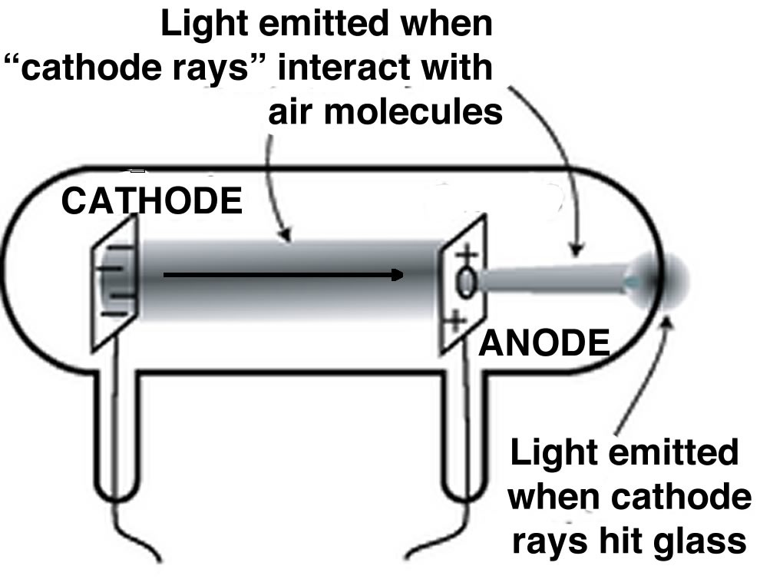

A key step to understanding electricity involved unraveling the idea of the indivisible atom and involved a series of experiments by J. J. Thompson (1856–1940), another Mancunian[16] Although the idea of electricity was now well appreciated, Thompson and other scientists wanted to study it in a more controlled manner. They used what were, and are now, known as cathode ray tubes (CRTs). Once common in televisions, these have now been replaced by various flat screen devices. CRTs are glass tubes with wires embedded in them; these wires are connected to metal discs. The inside of the tube is coated with a chemical that glows (fluoresces) in response to electricity. They generally have ports in the walls that can be connected to a vacuum pump, so that most of the air within the tube can be removed, typically the ports are then sealed. When connected to a source of electricity, such as a voltaic pile, the fluorescent material at one end of the tube glows. In a series of experiments (1897) Thompson was able to show that:

* Rays emerged from one disc (the cathode) and moved to the other (the anode).
* “Cathode” rays were deflected by electrical fields in a direction that indicated that they were negatively charged.
* The rays could also be deflected by magnetic fields.[17]
* The rays carried the electrical charge; that is, if the ray was bent, for example by a magnetic field, the charge went with it.
* The metal that the cathode was made of did not affect the behavior of the ray; so whatever the composition of the ray, it appeared to be independent of the element that it came from.

In all of these experiments, it needs to be stressed that "positive" and "negative" are meant to indicate opposite and are assigned by convention. That means that we could decide tomorrow that positive was negative, and negative positive, and nothing would change, as long as we were consistent. From these experiments, Thompson concluded that “cathode” rays were carried by discrete charged particles, he called them corpuscles, and he assigned these particles a negative charge. But the truly stunning conclusion he reached was that *these particles must come from within the atoms of the metal cathode*. Because the type of metal did not affect the nature or behavior of the cathode rays, he assumed that these particles were not newly created but must pre-exist within the atoms of the cathode. Moreover, he hypothesized that identical particles must be present in all atoms, not just in the atoms of one particular metal. Do you see how he jumps from experimental results using a few metals to all elements and all atoms? Of course, we now know these particles as electrons but it is difficult to imagine what a huge impact this new theory had on scientists at the time.

*Since electrons can be produced by all chemical elements, we must conclude that they enter the constitution of all atoms. We have thus taken our first step in understanding the structure of the atom.* —J. J. Thompson, The Atomic Theory, 1914[18]

The discovery of the electron made the old idea of an atom as a little indestructible billiard ball-like objects obsolete, and necessitated a new model. It is an example of a paradigm shift[19]—a fundamental change in scientific thinking driven by new evidence. Thompson’s first version of this new model became known as the plum pudding model.[20] His basic idea was that the atom is a ball of positively charged, but apparently amorphous, matter with electrons studded here and there, like the raisins in a pudding. Because it contained equal numbers of positive and negative charges, the overall structure was electrically neutral. Subsequent work by Thompson and Robert A. Millikan (1868–1953) established that all electrons are identical, each with the same, very small mass and negative charge. The mass of an electron is less than 1/1000th of the mass of a hydrogen atom.

Thompson's proposed plum pudding model of the atom spurred much experimental and theoretical work and led to a remarkable number of subsequent discoveries. For example, it was soon recognized that the β particles emitted by some radioactive minerals and elements, were, in fact, electrons. Other studies found that the number of electrons present in the atoms of a particular element was roughly proportional to half the element's atomic weight, although why this should be the case was unclear.

However, as more and more data began to accumulate, the plum pudding model had to be abandoned because it just could not explain what was being observed. The key experiment that led to a new model of the atom was carried out in 1908 by Ernest Rutherford (1871–1937). As you may have already guessed, he was working at the University of Manchester. In this experiment, he examined how alpha (α) particles, which he knew to be positively charged particles made of the element helium without it’s electrons, behaved when they were fired at a very thin sheet of metal, such as gold or platinum. In the experiment a narrow parallel beam of α particles was directed at a thin sheet of gold foil and the angles at which the deflected particles scattered were detected. The observed result was completely unexpected. Instead of passing straight through the thin sheet of foil, he found that a few particles were deflected, some of them at large angles. Rutherford wrote, “It is as if I had fired a cannon ball at a piece of tissue paper, and it bounced right back.” Here again, we see a particular aspect of the scientific enterprise, namely that even though only a few alpha particles bounced back, we still need to explain how this could possibly occur. We could not just say, "Only a few particles were bounced so it doesn't matter"; we have to provide a plausible scenario to explain the observation. Often it is paying attention to, and taking seriously, the unexpected result that leads to the most profound discoveries.

Based on these experimental results Rutherford reasoned that the positively charged α particles were being repelled by positive parts of the atom. Because only a very small percentage of alpha particles were deflected, only a very small region of each atom could be positively charged. That is, the positive charge in an atom could not be spread out more or less uniformly, as the plum pudding model assumed; instead it must be concentrated in a very small region. This implied that most of the atom is empty (remember the void of the ancient Greeks?) or occupied by something that poses little or no resistance to the passage of the α particles. What it left unexplained was why positively charged particles (which we now know as protons) concentrated in such a small volume, did not repel one another – the answer to which had to wait to discovery of the strong nuclear force (see below). Again we see a scientist making a huge intuitive leap from the experimental observation to a hypothesis that was consistent with that evidence and that makes specific predictions that can be confirmed or falsified by further experiment and observation. Rutherford's model, which became known as the planetary model, postulated a very, very small nucleus where all of the positive charge and nearly all of the mass of the atom was located; this nucleus was encircled by electrons. In 1920 Rutherford went on to identify the unit of positive charge and called it the proton. In 1932 James Chadwick (1891–1974)(who co-incidentally studied at the University of Manchester) identified a second component of the nucleus, the neutron. Neutrons are heavy, like protons. In fact they are slightly heavier than protons, but have no charge. The identity of the element depends on the number of protons, however the number of neutrons may be different in different atoms of the same element. For example an atom of carbon always has six protons, but it can have different numbers of neutrons. Most carbon atoms have six neutrons (C-12), but some have seven (C-13) and some have eight (C-14).   
  
**Questions for Later**

* If atoms are mostly empty space, why can’t we walk through walls?
* What is radiation?

How does an atom change when it emits an alpha particle? Or a beta particle/electron?

**Questions to Ponder**

* If the original discoverers of electricity had decided that electrons have a positive charge, would that have made a difference in our understanding of electricity?
* Why do you think electrons were the first sub-atomic particles to be discovered?
* How exactly did Rutherford detect alpha particles?
* Can you think of an alternative model of the atom based on Rutherford's observations?

How would the experiment change if he had used electrons or neutrons?

## 1.7 Interactions Between Atoms and Molecules

At this point we have arrived at a relatively simple model of the atom. Do not to worry, we will move to more complex and realistic models in the next chapter. In this simple model the atom has a very small but heavy nucleus that contains both protons and neutrons. As we talk about biology now and again, take care not to confuse the nucleus of an atom with the nucleus of a cell; they are completely different - besides the fact that they are of very different sizes. For example, there is no barrier round the nucleus of an atom—an atomic nucleus is a clump of protons and neutrons. Surrounding the atomic nucleus are electrons, in the same number as there are protons. The atom has no net electrical charge since the number of electrons is equal to the number of protons.

Where the electrons actually are in an atom, however, is a trickier question to answer, because of quantum mechanical considerations, specifically the Heisenberg uncertainty principle, which we will return to in the next chapter. For now we are going to assume the electrons are outside the nucleus and moving. We can think of them as if they were a cloud of electron density rather than particles whizzing around (don’t worry we will provide evidence for this model soon). This simple model captures important features and enables us to begin to consider how atoms interact with one another to form molecules and how those molecules can be rearranged—real chemistry!

There are four fundamental forces that we know about at the moment: gravity, the electromagnetic force, the strong nuclear force, and the weak nuclear force. For now we can largely ignore the strong nuclear force that is involved in holding the nucleus together: .it is an attractive force between neutrons and protons and is the strongest of all known forces in the universe, ~137 times stronger than the electromagnetic force. The strong nuclear force, acts at very short ranges, ~10-15 m, or about the diameter of the nucleus. The other force involved in nuclear behavior, the weak force, plays a role in nuclear stability, specifically the stability of neutrons, but it has an even shorter range of action (10-18 m). Because the nucleus is much smaller than the atom itself we can (and will) ignore the weak and strong nuclear forces when we consider chemical interactions. The force we are probably most familiar with is gravity, which is the weakest force, more than 10-37 times weaker than the electromagnetic force, and we can ignore it from the perspective of chemistry, although it does have relevance for the biology of dinosaurs, elephants, whales, and astronauts. The electromagnetic force is responsible for almost all the phenomena that we encounter in our everyday lives. While we remain grounded on the Earth because of the gravitational interaction between our body and the Earth, the fact that we don't fall through to the center of the earth is entirely due to electromagnetic interactions. One obvious feature of the world that we experience is that it is full of solid things—things that get in each other's way. If atoms and molecules did not interact with one another, one might expect to be able to walk through walls, given that atoms are mostly empty space, but clearly this is not the case. Similarly, your own body would not hold together if your atoms, and the molecules they form, failed to interact. As we will see, all atoms and molecules attract one another—a fact that follows directly from what we know about the structure of atoms and molecules.

**Questions to Ponder**

* What would a modern diagram of an atom look like and what could it be used to explain?
* Why don’t the protons within a nucleus repel one another?
* Why don’t the electrons and protons attract each other and end up in the nucleus?
* How the electrons within an atom interact?

**Questions for Later**

* Can an atom have chemical and/or physical properties; if so, what are they?
* What are chemical and physical properties? Can you give some examples?
* What distinguishes one element from another?

### Interactions Between Atoms: A Range of Effects

The attractions and repulsions between charged particles and magnets are both manifestations of the electromagnetic force. Our model of the interactions between atoms will involve only electric forces; that is, interactions between electrically charged particles, electrons and protons. In order to understand this we need to recall from physics that when charged particles come close to each other they interact. You probably recall that “like charges repel and unlike charges attract”, and that this interaction, which is known as a Coulombic interaction, depends on the sizes and signs of the charges, and is inversely proportional to the square of the distance between them (this interaction can be modeled by the equation:

F α (q1 x q2 ) / r2 (Coulomb’s Law),

where q1 and q2 are the charges on the particles and r is the distance between them. That is: there is a force of attraction (or repulsion if the two charges are of the same sign) that operates between any two charged particles. This mathematical description of the electromagnetic interaction is similar to the interaction due to gravity. That is, for a gravitational interaction there must be at least two particles (e.g. you and the Earth) and the force of the attraction depends on both masses, and is inversely proportional to the square of the distance between them:

F α (m1 x m2 ) / r2.

The difference between the two forces are: a) gravitational interactions are much weaker than electromagnetic interactions and b) gravity is solely an attractive interaction while electromagnetic interactions can be either attractive or repulsive.

Now, let us consider how atoms interact with one another. Taken as a whole, atoms are electrically neutral, but they are composed of discrete electrically charged particles. Moreover, their electrons behave as moving objects.[21] When averaged over time the probability of finding an electron is spread uniformly around an atom, the atom is neutral. At any one instant, however, there is a non-zero probability that the electrons are more on one side of the atom than the other. This results in momentary fluctuations in the charge density around the atom and leads to a momentary charge build up; for a instant one side of the atom is slightly positive (δ+) and the other side is slightly negative (δ–). This produces what is known as an instantaneous and transient electrical dipole - that is a charge separation. As one distorted atom nears another atom it affects the second atom’s electron density distribution and leads to what is known as an “induced dipole”. So, for example, if the slightly positive end of the atom is located next to another atom, it will attract the electron(s) in the other atom. This results in an overall attraction between the atoms that varies as 1/r6 –where r is the distance between the atoms. Note that this is different than the attraction between fully charged species, the Coulombic attraction, which varies as 1/r2. What does that mean in practical terms? Well, most importantly it means that the effects of the interaction will be felt only when the two atoms are quite close to one another.

As two atoms approach, they will be increasingly attracted to one another. But this attraction has its limit - when the atoms get close enough, the interactions between the negatively charged electrons (and positively charged nuclei) of each atom increase very rapidly, which leads to an overall repulsion,which will stop the two atoms approaching so closely.

A similar effect was in also seen in Rutherford's experiment. Recall that he accelerated positively charged alpha particles toward a sheet of gold atoms. As an alpha particle approaches a gold atom's nucleus, the positively (+2) charged alpha particle and the gold atom’s positively (+79) nucleus begin to repel each other. If no other factors were involved, the repulsive force would approach infinity as the distance between the nuclei (r) approached 0. (You should be able to explain why.) But infinite forces are not something that happens in the macroscopic, atomic, or subatomic worlds, if only because the total energy in the universe is not infinite. As the distance between the alpha particle and gold nucleus approaches zero, the repulsive interaction grows strong enough to slow the incoming alpha particle and then push it away from the target particle. If the target particle is heavy compared to the incoming particle, as it was in Rutherford's experiments, the target, composed of gold atoms that weigh about 50 times as much as the alpha particle, will not move much while the incoming alpha particle will be reflected away. But, if the target and incoming particle are of similar mass, then both will be affected by the interaction and both will move. Interestingly, if the incoming particle had enough initial energy to get close enough (within ~10-15 m) to the target nucleus, then the strong nuclear force of attraction would come into play and start to stabilize the system. The result would be the fusion of the two nuclei and the creation of a different element, a process that occurs only in very high-energy systems such as the center of stars or during a stellar explosion, a supernova. We return to this idea in Chapter 3.  
  
**Questions to Answer**

* How does the discovery that atoms have parts alter Dalton's atomic theory?
* What would the distribution of alpha particles, relative to the incident beam, look like if the positive nucleus took up the whole atom (sort of like the plum pudding)? What if it took up 50% of the atom?
* What does the distribution of alpha particles actually look like (recall that 1 in every 8000 particles were deflected)?

### Forces and Energy: an overview.

We would like to take some time to help you think about the interactions (forces) between atoms and molecules, and how these interactions lead to energy changes. These energy changes are responsible for the formation of molecules, their reorganization through chemical reactions, and the macroscopic properties of chemical substances (i.e. everything). While you may have learned about forces and energy in your physics classes, most likely these concepts were not explicitly related to how things behave at the atomic-molecular level. We are going to begin with a discussion of the interactions and energy changes that result from the force of gravity, because these ideas are almost certainly something you are familiar with, certainly more familiar with than electromagnetic interactions – but the purpose of this section is to help you make the connections between what you already know (at the macroscopic level), and how these ideas are transferred to the molecular level, including similarities and differences. For example, Newton’s Laws of Motion describe how objects behave when they come into contact, say when a baseball comes in contact with a bat. But often objects interact with one another at a distance. After the ball is hit, its movements are determined primarily by its gravitational interactions with all other objects in the Universe, although because of the nature of the gravitational interaction, by far the most important interaction is between the ball and the Earth (see below).

A force is an interaction between objects that causes a pull (attraction) or a push (repulsion) between those objects. When such an interaction occurs, there is a change in energy of the objects. As noted above, there are four fundamental forces: gravitational, electromagnetic, the strong and the weak nuclear forces. We will have more to say about the electromagnetic force that is relevant for understanding chemical interactions, that is how atoms and molecules behave. Many of the phenomena you are familiar with are based on electromagnetic forces. For example, electromagnetic forces stop the ball from going through the bat – or you from falling down to the center of the Earth.

Now let us consider what happens when you throw a ball straight up into the air. You apply a force to the ball (through the action of your muscles), and once it leaves your hand the only force acting on the ball is gravity (we are, of course, ignoring friction due to interactions with the molecules in the air). The ball, initially at rest, starts moving upward. Over time, you observe the velocity of the ball changes, as the ball slows, stops and falls back to earth. So what forces cause these changes? The answer is the force of gravity, which is a function of the masses of the ball and the Earth, which do not change over time, and the distance (r) between the Earth and the ball, which does. This gravitational force F, can be modeled by an equation that shows it is proportional to the product of the masses of the ball (M1) and the Earth (M2) divided by the square of the distance between the objects (r).[22]

In gravitational interactions, the force decreases as the distance between the objects increases (the decrease is proportional to 1/r2), which means the further away you get from the Earth the smaller is the attractive force between you and the Earth. If you get far enough away, and you are moving away from the Earth, the interaction will not be enough to keep you attracted to the Earth and you will continue to move away forever.

Of course, **why** objects with mass attract each other is a subject for physics – beyond the scope of this course.[23] What we can say is that the force is mediated by a gravitational field. Any object with mass will interact with other objects with mass through this field. The field can also be said to transfer energy through space between two (or more) objects. That is, the interaction leads to an energy change in the system of interacting objects. In chemistry we are concerned with both the forces that cause interactions and the energy changes that result.

**How do forces influence energy?** If we take our macroscopic example of your throwing a ball upwards, we know that you transfer some energy to the ball. Of course this begs the question “what do we mean by energy?” and unfortunately we do not have an easy answer, in fact Richard Feynman once famously said “in physics we have no idea of what energy is”. Physicists might say energy is the capacity to do work, and then define work as force times distance, which does not really get us anywhere, especially in chemistry where the notion of work is often not helpful. What we can say is that any changes are accompanied by energy changes, and that we can calculate or measure these energy changes.[24]

You may be familiar with what are often referred to as “forms of energy”, such as mechanical, or elastic, or chemical, but at the most basic level all forms of energy we will be concerned with can be described either as kinetic energy, potential energy, or electromagnetic energy (e.g. light). Kinetic energy is often called the energy of motion (KE = 1/2 mv2, where m is the mass and v the velocity of the object), and potential energy the energy of position, or stored energy (it is calculated in various ways as we will see). Changes between kinetic and potential forms of energy involve forces. The ball that you throw straight up and then comes down has changing amounts of kinetic energy (it changes as the velocity of the ball changes) and potential energy (which changes as the distance between the Earth and the ball changes.) As the ball rises, you can observe that the velocity of the ball decreases, and therefore the KE decreases. At the same time the PE increases since the distance between the Earth and ball is increasing. On the way down the opposite is true, the ball starts moving faster – the KE increases and the PE decreases. Recall the principle of the conservation of energy; after the ball leaves your hand, no energy is added or taken away as the ball is traveling, if one form of energy increases, the other must decrease.

Another important point about energy is that it is a property of a system, rather than of an object. Although it may be tempting to consider that a ball in motion has a certain amount of kinetic energy it is important to remember the frame of reference from which you are considering the ball. Certainly the ball’s velocity is related to the KE, but that velocity depends upon where you are viewing the ball from. Usually (almost always) we consider the velocity from the point of view of an observer who is stationary, but if we changed the system we were considering, and viewed the ball while we were also moving, then the velocity of the ball would be different. This may seem quite an abstract point, but it is an important one.

Similarly it is quite tempting to say that the ball has potential energy, but in fact this is also not entirely accurate. It is more accurate – and more useful – to say that the **system of the ball and the Earth** has potential energy – again we are taking a systems perspective here. Unlike kinetic energy, the potential energy in a system also depends on the force that is acting on it, and that force is a function of the position of the objects that are interacting within the gravitational field. For example, a “frictionless” object traveling through a space free of fields (gravitational or otherwise) at a constant velocity has a constant kinetic energy, but no potential energy.

Potential energy (often called stored energy) or the energy of position, raises the question – where is the energy “stored”? A useful way to think about this is that for the example of the ball and the Earth, this energy is stored in the gravitational field. In this way we can accommodate the idea that the PE depends on the distance between the two interacting objects. It will also allow us to generate a more overarching concept of potential energy that will be useful in chemistry, as we extend these ideas to interactions of atoms and molecules. You might ask why then is it OK to say an object has kinetic energy (as long as you specify the frame of reference), and the difference here is that any object in motion can have energy associated with it (for example, you, an atom or a car), but potential energy must be associated with objects that are interacting via a field, be it gravitational or electromagnetic. That said, fields are everywhere – there is no place in the universe where there are no fields (although they can be balanced, leaving the net force zero). What is important here is that i) you understand that objects interact, ii) that these interactions cause a change in energy of the system, and iii) that the interacting forces depend on the distance between the interacting objects (as well as other factors, such as mass, which are constant).

**The electromagnetic force:** While gravitational interactions are, for all intents and purposes, irrelevant in chemistry (except to hold the beaker down on the lab bench!) they do provide a familiar example of the relationship between the kinetic and potential energies of a system that we can use to explore the electromagnetic interactions that are responsible for the behavior of atoms and molecules. There are some important similarities between gravitational and electromagnetic interactions; both act at a distance, both are mediated by fields, and both display the same relationship between force and distance. There are also important differences. In the context of chemistry, electromagnetic interactions are much stronger and while gravity is always attractive, electromagnetic interactions can be either attractive or repulsive[25].

All electrically charged objects interact via electromagnetic forces. As we have already seen (and will to return to again) atoms and molecules are made up of charged particles (electrons and protons) and these produceunequal charge distributions that lead to the same kinds of interactions. The strength of these interactions between charged particles can be modeled using an equation, Coulomb’s Law. You will note that its form is similar to Newton’s Law of Gravitation. Instead of the masses of the two interacting objects, however, the electromagnetic force depends on the charges on the two particles (q1 and q2). The electromagnetic force typically acts over much shorter distances than gravitation, but is much stronger. It is the force that affects interactions of atoms and molecules.

As with the gravitational force as the charged particles get closer together, the interaction (whether attractive or repulsive) gets stronger. Just like gravity, the interaction between charged particles is mediated by a field, which transfers energy between interacting objects. We can identify (and calculate) the types of energy changes that are occurring as the particles interact. For example two oppositely charged particles are attracted to each other. As they approach one another, the force of attraction becomes stronger, the particles will move faster – and their kinetic energies increase. Given the fact that energy is conserved, the potential energy of the system of particles must decrease to a similar extent.[26] If, on the other hand the two charges are of the same sign, then the force between them is repulsive. So if two particles of the same charge are moving toward each other, this repulsive force will decrease their velocity (and kinetic energy), and increase their potential energy. As the distance between the particles decreases, the repulsion will eventually lead to the two particles moving away from one another.

Of course you may have noticed that there is a little problem with the equations that describe both gravitation and electromagnetic forces. If the forces change as r decreases, what happens as the distance between the interacting objects approaches zero? If we were to rely on the equations we have used so far, as r approaches 0, the force (whether repulsive or attractive) would approach infinity. Clearly something is wrong here since infinite forces are not possible (do you know why?). The ball is stopped by the surface of the Earth - it does not plummet to the center of the Earth, and charged particles do not merge into each other (or fly away at infinite speed). What is it that we are missing? Well, the problem lies in the idea that these equations are really dealing with idealized situations such as point charges or masses, rather than taking into account the fact that matter is made up of atoms, molecules and ions. When two atoms, or two molecules (or two particles made up of atoms or molecules) approach each other, they will eventually get close enough that the repulsions between like charges will become stronger than the attractive forces between unlike charges. As we will see, when two macroscopic objects appear to touch, they do not really – what stops them is the electron-electron repulsions of the atoms on the surface of the objects <http://www.youtube.com/watch?v=BksyMWSygnc>. We will revisit all these ideas as we discuss how atoms and molecules interact at the atomic-molecular level, and how electrons behave (quantum mechanically).

### Interacting Atoms: Forces, Energy Conservation and Conversion

Let us step back, collect our thoughts, and reflect on the physics of the situation. First, remember that the total matter and energy of an isolated system are conserved; that is the first law of thermodynamics. As we mentioned above, while energy and matter can, under special circumstances, be interconverted, typically they remain distinct. That means in most systems the total amount of matter is conserved and the total amount of energy is conserved, and that these are separate.

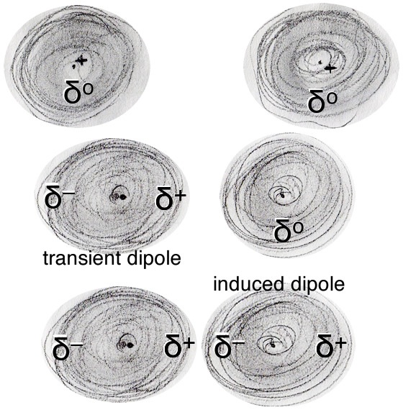

So let us consider the situation of atoms or molecules in a gas. These atoms and molecules are moving randomly in a container, colliding with one another and the container’s walls. We can think of the atoms/molecules as a population. Population thinking is useful for a number of phenomena, ranging from radioactive decay to biological evolution. For the population of atoms/molecules as a whole, there is an average speed and this average speed is a function of the temperature of the system.[27] If we were to look closely at the population of molecules, however, we would find that some molecules are moving very fast and some are moving very slowly; there is a distribution of speeds and velocities (speed + direction).

As two atoms/molecules approach each other they will feel the force of attraction caused by the electron density distortions, these are known as London dispersion forces, which we will abbreviate as LDFs. The effects of these LDFs depend on the strength of the interaction (that is the magnitude of the charges and the distance between them) and on the kinetic energies of the atoms and molecules. LDF are one of a number of intermolecular forces (IMFs), which we will consider later. LDFs are the basis of van der Waals interactions in biological systems.

To simplify things we are going to imagine a very simple system: assume for the moment that there are just two isolated atoms, atom1 and atom2. The atoms are at rest with respect to one another, but close enough that the LDF-based attractive interactions between them are significant. For this to occur they have to be quite close, since such attractive interactions decreases rapidly, as 1/r6 where r is the distance between the two atoms. At this point, the system, which we will define as the two atoms, has a certain amount of energy. The exact amount does not matter, but as long as these two atoms remain isolated, and do not interact with anything else, the energy will remain constant.

So what does all this have to do with atoms approaching one another? We can use the same kinds of reasoning to understand the changes in energy that occur as the atoms approach each other. Initially, the system will have a certain amount of energy (kinetic + potential). If the atoms are close enough to feel the effects of the attractive LDFs, they begin to move toward each other, think of a ball falling towards the Earth, and some of the potential energy associated with the atoms’ initial state is converted into kinetic energy (EK = ½mv2).

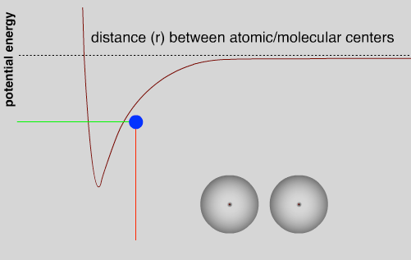

As they approach each other the LDFs grow stronger, the atoms are more strongly attracted to each other; the system’s potential energy decreases and is converted into kinetic energy, the atoms move faster.[28] The total energy remains the same as long as there are no other atoms around. This continues until the atoms get close enough that repulsive interactions between the electrons become stronger and as they approach even more closely the repulsive interactions between the positively charged nuclei also come into play, causing the potential energy in the system to rise. As the atoms begin to slow down their kinetic energy is converted back into potential energy. They will eventually stop and then be repelled from one another. At this point potential energy will be converted back into kinetic energy. As they move away, however, repulsion will be replaced by attraction and they will slow; their kinetic energy will be converted back into potential energy.[29] With no other factors acting within the system, the two atoms will oscillate forever. In the graph showing potential energy versus the distance between the atoms, we see that the potential energy of the system reaches a minimum at some distance. Closer than that and the repulsive electromagnetic forces come into play, further away and the attractive electromagnetic forces (LDF’s) are dominant. The distance between the two atoms is a function of the relative strengths of the attractive and repulsive interactions. However, even at the minimum, there is some potential energy in the system, stored in the electromagnetic field between the two atoms. At temperatures above absolute zero (0 K), the pair of atoms will also have kinetic energy – as they oscillate back and forth.

Here we have a core principle that we will return to time and again: a stabilizing interaction always lowers the potential energy of the system, and conversely a destabilizing interaction always raises the potential energy of the system. In an isolated system with only two atoms, this oscillation would continue forever because there is no way to change the energy of the system. This situation doesn’t occur in real life because two-atom systems do not occur. For example, even in a gas, where the atoms are far apart, there are typically large numbers of atoms that have a range of speeds and kinetic energies present in the system. These atoms frequently collide and transfer energy between one another. Therefore, when two atoms collide and start to oscillate, some energy may be transferred to other particles by collisions. If this happens, a stable interaction can form between the two particles; they will “stick” together. If more particles approach, they can also become attracted, and if their extra energy is transferred by collisions, the particles can form a bigger and bigger clump.

As we discussed earlier, LDFs arise due to the fluctuations of electron density around nuclei and are a feature common to all atoms; all atoms/molecules attract one another in this manner. The distance between atoms/molecules where this attraction is greatest is known as the van der Waals radius of the atom/molecule. If atoms/molecules move closer to one another than their van der Waals radii they repel one another. The van der Waals radius of an atom is characteristic for each type of atom/element. As mentioned earlier, it is only under conditions of extreme temperature and pressure that the nuclei of two atoms can fuse together to form a new type of atom; such a nuclear/atomic fusion event results in the interconversion of matter into energy.[30]

**Questions to Answer**

* What is potential energy? Can you provide an example?
* What is kinetic energy? Can you provide an example?
* At the atomic level, what do you think potential energy is?
* At the atomic level, what do you think kinetic energy is?
* Why does raising the temperature affect the speed of a gas molecule?

**Questions to Ponder**

* What is energy (have your ideas changed from before)?

**Questions for Later:**

* When we talk about potential energy of a system, what does system mean?
* Helium liquefies at around 4K. What makes the helium atoms stick together? (Why don’t they turn into a gas?)
* Consider two atoms separated by 1 spatial unit versus 4 spatial units. How much weaker is the interaction between the more distant atoms? How does that compared to the behavior of simple charges (rather than atoms)?

## 1.8 Interactions Between Helium Atoms and Hydrogen Molecules

Now let’s take a look at a couple of real systems. We begin by considering interactions between the simplest atoms, hydrogen (H) and helium (He), and the simplest molecule, molecular hydrogen (H2). A typical hydrogen atom consist of one proton and one electron, although some contain one or two neutrons and form “isotopes” known as deuterium and tritium, respectively. A hydrogen molecule is a completely different chemical entity: it contains two hydrogen atoms, but its properties and behavior are quite different. Helium atoms have 2 protons and 2 neutrons in their nuclei, and 2 electrons in their electron clouds. We will consider more complicated atoms and molecules after we discuss atomic structure in greater detail in the next chapter. One advantage of focusing on molecular hydrogen and helium is that it also allows us to introduce, compare, and briefly consider both van der Waals interactions (due to IMFs) and covalent bonds; we will do much more considering later on.

When two atoms of helium approach each other LDFs come into play and a attractive interaction develops. In the case of He the drop in potential energy due to the interaction is quite small, that is, the stabilization due to the interaction, and it does not take much energy to knock the two atoms apart. This energy is delivered by collisions with other He atoms. In fact at atmospheric pressures, Helium is never a solid and liquid He boils at ~4 K (−268.93ºC), only a few degrees above absolute zero or 0 K (−273.15 ºC).[31] This means that at all temperatures above ~4 K there is enough kinetic energy in the atoms of the system to disrupt the interactions between He atoms. The weakness of these interactions means that at higher temperatures, above 4 K, helium atoms do not “stick together”. Helium is a gas at temperatures above 4 K.

Now let us contrast the behavior of helium with that of hydrogen (H). As two hydrogen atoms approach one another they form a much more stable interaction, about 1000 times stronger than the He–He London dispersion forces. In an H–H interaction the atoms are held together by the attraction of each nucleus for both electrons. The attractive force is much stronger and as the atoms get closer this leads to a larger drop in potential energy and a minimum for the two interacting hydrogen atoms that is much deeper than that for He–He. Because of its radically different stability the H–H system gets a new name; it is known as molecular hydrogen or H2 and the interaction between the H atoms is known as a covalent bond. In order to separate a hydrogen molecule back into two hydrogen atoms, that is, to break the covalent bond, we have to supply energy.[32] This energy can take several forms: for example, energy delivered by molecular collisions with surrounding molecules or by the absorption of light both lead to the breaking of the bond.

Each H can form only a single covalent bond, leading to the formation of H–H molecules, which are often also written as H2 molecules. These H–H molecules are themselves attracted to one another through LDFs. We can compare energy associated with the H–H covalent bond and the H2 - H2 IMF. To break a H–H covalent bond one needs to heat the system to approximately 5000 K. On the other hand to break the intermolecular forces between separate H2 molecules, the system temperature only needs to rise to ~20 K; above this temperature H2 is a gas. At this temperature the IMFs between individual H2 molecules are not strong enough to resist the kinetic energy of colliding molecules. Now you may ask yourself, why does H2 boil at a higher temperature than He? Good question! It turns out that the strengths of LDFs depend on several factors including shape of the molecule, surface area, and number of electrons. For example the greater the surface areas shared between interacting atoms or molecules the greater the LDFs experienced and the stronger the resulting interaction. Another factor is the ability of the electron cloud to become charged, a property known as polarizability. You can think of polarizability as the floppiness of the electron cloud. As a rough guide, the further away from the nucleus the electrons are, the more polarizable (floppy) the electron cloud becomes. We will return to this and related topics later on. As we will see, larger molecules with more complex geometries, such as biological macromolecules (proteins and nucleic acids), can interact through more surface area and polarizable regions, leading to correspondingly stronger interactions.

At this point, you are probably (or should be) asking yourself some serious questions, such as, why don’t helium atoms form covalent bonds with one another? Why does a hydrogen atom form only one covalent bond? What happens when other kinds of atoms interact? To understand the answers to these questions, we need to consider how the structure of atoms differs between the different elements, which is the subject of the next chapter.

**Questions to Answer**

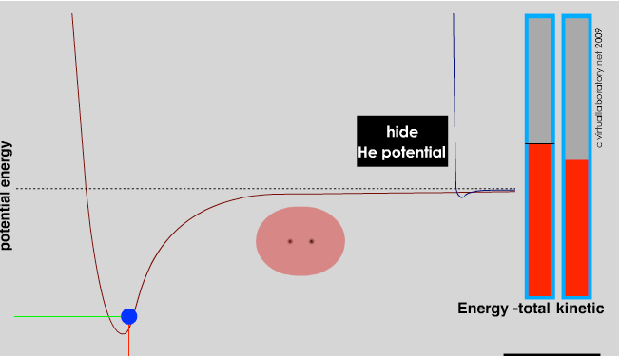

* Can you draw a picture (with about 20 helium atoms, represented as circles) of what solid helium would look like if you could see it?
* How would that differ from representations of liquid helium or gaseous helium?
* Now make a similar drawing of H2. Does this help explain the higher melting point of H2?

**Question to Ponder**

* How do the properties of solids, liquids, and gases differ?

# Chapter 2: Electrons and Orbitals

Even as he articulated his planetary model of the atom, Rutherford was aware that there were serious problems with it. For example because like charges repel and unlike charges attract, it was not at all clear why the multiple protons in the nuclei of elements heavier than hydrogen did not repel each other and cause the nuclei to fragment. What enables them to stay so close to each other? On the other hand, if electrons are orbiting the nucleus like planets around the Sun, why don't they repel each other, leading to quite complex and presumably unstable orbits? Why aren’t they ejected spontaneously and why doesn’t the electrostatic attraction between the positively-charged nucleus and the negatively-charged electrons result in the negatively-charged electrons falling into the positively charged nucleus? Assuming that the electrons are moving around the nucleus, they are constantly accelerating (changing direction). If you know your physics, you will recognize that (as established by J.C. Maxwell – see below) a charged object emits radiation when accelerating. [33] As the electron orbits the nucleus this loss of energy will lead it to spiral into the nucleus – such an atom would not be stable. But, as we know, most atoms are generally quite stable.

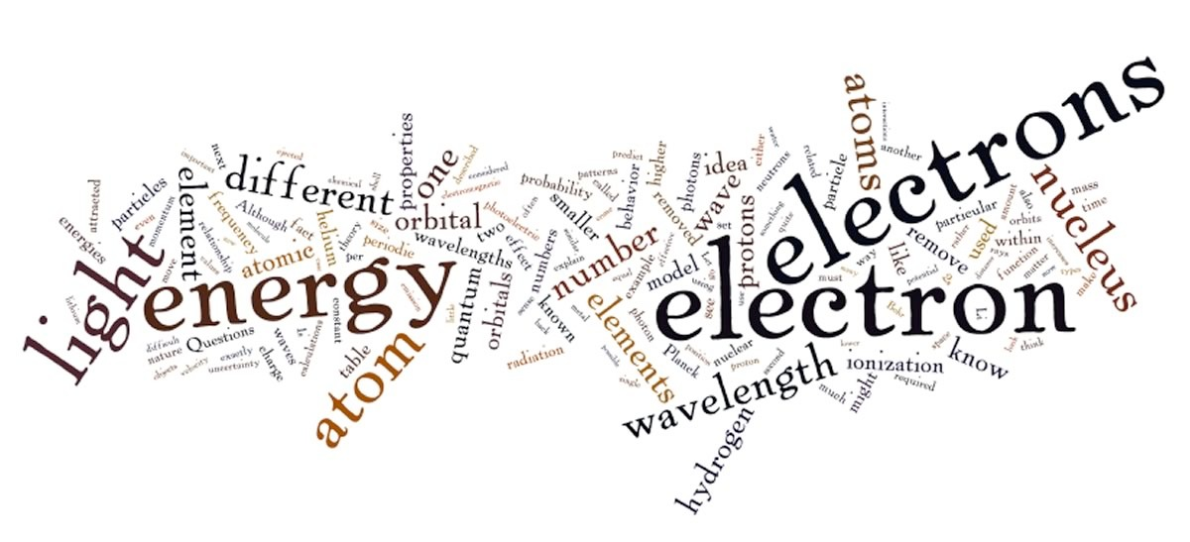

So many questions and so few answers! Clearly Rutherford's model was missing something important and assumed something that cannot be true with regard to forces within the nucleus, the orbital properties of electrons, and the attractions between electrons and protons. To complete this picture leads us into the weird world of quantum mechanics.

## 2.1 Light and Getting Quantum Mechanical

While Rutherford and his colleagues worked on the nature of atoms, other scientists were making significant progress in understanding the nature of electromagnetic radiation, that is, light. Historically, there had been a long controversy about the nature of light, with one side arguing that light is a type of wave, like sound or water waves, traveling through a medium like air or the surface of water and the other side taking the position that light is composed of particles. Isaac Newton called them corpuscles. There was compelling evidence to support both points of view, which seemed to be mutually exclusive, and the attempt to reconcile these observations into a single model proved difficult.

By the end of the 1800s, most scientists had come to accept a wave model for light because it better explained behaviors such as interference[34] and diffraction,[35] the phenomena that gives rise to patterns when waves pass through or around objects that are of similar size to the wave itself. James Clerk Maxwell (1831–1879) developed the electromagnetic theory of light, in which visible light and other forms of radiation, such as microwaves, radio waves, X-rays, and gamma rays, were viewed in terms of perpendicular electric and magnetic fields. A light wave can be described by defining its frequency (ν) and its wavelength (λ). For all waves, the frequency times its wavelength equals the velocity of the wave. In the case of electromagnetic waves, λν = c, where c is the velocity of light.

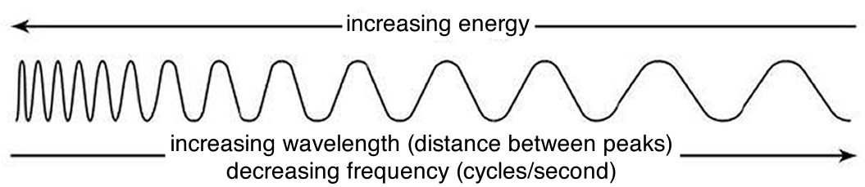

Although the wave theory explained many of the properties of light, it did not explain them all. Two types of experiments in particular gave results that did not appear to be compatible with the wave theory. The first arose during investigations by the German physicist Max Planck (1858–1947) of what is known as black body radiation. In these studies, an object heated to a particular temperature emits radiation. Consider your own body, which typically has a temperature of approximately 98.6 ºF or 36 ºC. Your body emits infrared radiation that can be detected by some cameras.[36] Some animals, like snakes, have infrared detectors that enable them to locate their prey—typically small, warm-blooded, infrared-light-emitting mammals.[37] Because mammals tend to be warmer than their surroundings, infrared vision can be used to find them in the dark or when they are camouflaged.

Planck had been commissioned by an electric power company to produce a light bulb that emitted the maximum amount of light using the minimum amount of energy. In the course of this project he studied how the color of the light emitted (a function of its wavelength) changed as a function of an object's (such as a light bulb filament) temperature. We can write this relationship as λ (wavelength) = f(t) where t = temperature and f indicates "function of.” To fit his data Planck had to invoke a rather strange and non-intuitive idea, namely that matter absorbs and emits energy only in discrete chunks, which he called quanta. These quanta occurred in multiples of E (energy) = hν, where h is a constant, now known as Planck's constant, and ν is the frequency of light. Planck’s constant is considered one of the fundamental numbers that describes our universe.[38] The physics that uses the idea of quanta is known as quantum mechanics.

One problem with Planck’s model, however, is that it disagreed with predictions of classical physics; in fact as the frequency of the light increased, his measurements diverged more and more from the predictions of the then current, wave-based theory.[39] This divergence between classical theory and observation became known, perhaps over-dramatically, as the ultraviolet catastrophe. It was a catastrophe for the conventional theory because there was no obvious way to modify classical theories to explain Planck’s observations; this was important because Planck’s observations were reproducible and accurate. Once again, we see an example of the rules of science: a reproducible discrepancy, even if it seems minor, must be addressed or the theory must be considered either incomplete or just plain wrong.

The idea that atoms emit and absorb energy only in discrete packets is one of the most profound and revolutionary discoveries in all of science, and set the stage for a radical rethinking of the behavior of energy and matter on the atomic and subatomic scales. Planck himself proposed the idea with great reluctance and spent a great deal of time trying to reconcile it with classical theories of light. In the next section we will see how this property can be used to identify specific types of atoms, both in the laboratory and in outer space.

**Questions to Answer**

* What is a constant? What is a function?
* What happens to the energy of a photon of light as the frequency increases? What about as the wavelength increases? (remember: λν = c)
* Why is it difficult to detect cold-blooded animals using infrared detectors?

**Questions to Ponder**

* How can the phenomena of diffraction and interference be used as evidence that light behaves like it a wave?
* How can light be both a wave and a particle?
* Is light energy?

## 2.2 Taking Quanta Seriously

In 1905, Albert Einstein used the idea of quanta to explain the photoelectric effect, which was described by Philipp Lenard (1862-1947). The photoelectric effect occurs when light shines on a metal plate and electrons are ejected, creating a current.[40] Scientists had established that there is a relationship between the wavelength of the light used, the type of metal the plate is made of, and whether or not electrons are ejected. It turns out that there is a threshold wavelength (energy) of light that is characteristic for the metal used, beyond which no electrons are ejected. The only way to explain this is to invoke the idea that light comes in the form of particles, known as photons, that also have a wavelength and frequency (we know: this doesn’t make sense, but bear with us for now). The intensity of the light is related to the number of photons that pass by us per second, whereas the energy per photon is dependent upon its frequency or wavelength, because wavelength and frequency of light are related by the formula λν = c where c is the speed of light in a vacuum, is a constant and equal to ~3.0 x 108 m/s. The higher the frequency ν (cycles per second, or Hertz), the shorter the wavelength λ (length per cycle) and the greater the energy per photon. Because wavelength and frequency are inversely related–that is, as one goes up the other goes down– energy is directly related to frequency by the relationship E = hν or inversely related to the wavelength E= hc/λ, where h is Planck’s constant. So radiation with a very short wavelength, such as x rays (λ= ~10–10 m) and ultraviolet light (between 10-7 to 10-8 m), have much more energy per particle than long wavelength radiation like radio and microwaves (λ= ~103 m). This is why we (or at least most of us) do not mind being surrounded by radio waves essentially all the time yet we closely guard our exposure to gamma rays, X-rays, and UV light; their much higher energies cause all kinds of problems with our chemistry, as we will see later.

Because of the relationship between energy and wavelength (λν = c), when you shine long-wavelength, low energy, such as infrared, but high intensity (many photons per second) light on a metal plate, no electrons are ejected. But when you shine short-wavelength, high energy (such as ultraviolet or x rays) but low intensity (few photons per second) light on the plate, electrons **are** ejected. Once the wavelength is short enough (or the energy is high enough) to eject electrons, increasing the intensity of the light now increases the number of electrons emitted. An analogy is with a vending machine that can only accept quarters; you could put nickels or dimes into the machine all day and nothing will come out. The surprising result is that the same **total** amount of energy can produce very different effects. Einstein explained this observation (the photoelectric effect) by assuming that only photons with “enough energy” could eject an electron from an atom. If photons with lower energy hit the atom no electrons are ejected - no matter how many photons there are,.[41] You might ask: Enough energy for what? The answer is enough energy to overcome the attraction between an electron and the nucleus. In the photoelectric effect, each photon ejects an electron from an atom on the surface of the metal. These electrons exist somewhere within the atoms that make up the metal (we have not yet specified where) but it takes energy to remove them and the energy is used to overcome the force of attraction between the negative electron and the positive nucleus.

Now you should be really confused, and that is a normal reaction! On one hand we were fairly convinced that light acted as a wave but now we see some of its behaviors can be best explained in terms of particles. This dual nature of light is conceptually difficult for most normal people because it is completely counterintuitive. In our macroscopic world things are either particles, such as bullets, balls, coconuts, or waves (in water); they are not—no, not ever—both. As we will see, electromagnetic radiation is not the only example of something that has the properties of both a wave and a particle; this mix of properties is known as wave–particle duality. Electrons, protons, and neutrons also display wavelike properties. In fact, all matter has a wavelength, defined by Louis de Broglie (1892–1987), by the equation λ = h/mν where mv is the object’s momentum (mass x velocity) and h is Planck’s constant. For heavy objects, moving at slow speeds, the wavelength is very, very small, but it becomes a significant factor for light objects moving fast, such as electrons. Although light and electrons can act as both waves and as particles, it is perhaps better to refer to them as quantum mechanical particles, a term that captures all features of their behavior and reminds us that they are weird! Their behavior will be determined by the context in which we study (and think of) them.

## 2.3 Exploring Atomic Organization Using Spectroscopy[42]

As we will often see, there are times when an old observation suddenly fits into and helps clarify a new way of thinking about a problem or process. In order to understand the behavior of electrons within atoms scientists brought together a number of such observations. The first observation has its roots in understanding the cause of rainbows. The scientific explanation of the rainbow is based on the fact that light of different wavelengths is bent through different angles (refracted) when it passes through an air–water interface. When sunlight passes through approximately spherical water droplets, it is refracted at the air–water interface, partially reflected (note the difference) from the backside of the water droplet, and then refracted again as it leaves the droplet. The underlying fact that makes rainbows possible is that sunlight is composed of photons with an essentially continuous distribution of visible wavelengths. Isaac Newton illustrated this nicely by using a pair of prisms to show that white light could be separated into light of many different colors by passing it through a prism and then recombined back into white light by passing it through a second prism. On the other hand, light of a single color remained that color, even after it passed through a second prism.

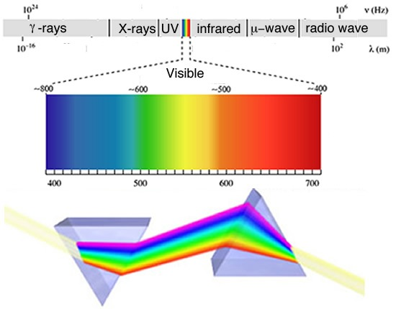

When a dense body, like the Sun or the filament of an incandescent light bulb, is heated, it emits light of many wavelengths (colors)—essentially all wavelengths in the visible range. However, when a sample of an element or mixture of elements is heated, for example in a flame 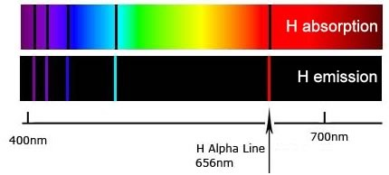provided by a Bunsen burner, it emits light of only very particular wavelengths. The different wavelengths present in the emitted light can be separated from one another using a prism to produce what is known as an emission spectra. When projected on a screen these appear as distinct, bright-colored lines, known emission lines. In a complementary manner, if white light, which consists of a continuous distribution of wavelengths of light, is passed through a cold gaseous element the same wavelengths that were previously emitted by the heated element will be absorbed, while all other wavelengths will pass through unaltered. By passing the light through a prism we can see which wavelengths of light have been absorbed by the gas. We call these dark areas “absorption” lines within the otherwise continuous spectrum. The emission and absorption wavelengths for each element the same and unique for each element. Emission and absorption phenomenon provide a method (spectroscopy) by which the absorbance or emission of specific wavelengths of light by can be is used to study the composition and properties of matter. Scientists used spectroscopic methods to identify helium, from the Greek “sun”, in the Sun before it was isolated on Earth.

In the 1800s, it became increasingly clear that each element, even the simplest, hydrogen, has a distinctive and often quite complex emission/absorption spectra. In 1855 Johann Balmer (1825-1898) calculated the position of the lines in the visible region. In 1888 Johannes Rydberg (1854-1919) extended those calculations to the entire spectrum. These calculations, however, were based on an empirical formula and it was unclear why this formula worked or what features of the atom it was based on—this made the calculations rather unsatisfying. Although useful, they provided no insight into the workings of atoms.

### Making sense of spectra:

How do we make sense of these observations? Perhaps the most important clue is again the photoelectric effect; that is, the observation that illuminating materials with light can in some circumstances lead to the ejection of electrons. This suggests that it is the interactions between light and the electrons in atoms that are important. Using this idea and the evidence from the hydrogen spectra Niels Bohr (1885-1962) proposed a new model for the atom His first hypothesis was that the electrons within an atom can only travel along certain orbits at a fixed distance from the nucleus, each orbit corresponding to a specific energy. The second idea was that electrons can jump from one orbit to another, but this jump requires either the capture (absorption) or release (emission) of energy, in the form of a photon. An electron can move between orbits only if a photon of exactly the right amount of energy is absorbed (lower to higher) or emitted (higher to lower). Lower (more stable) orbits are often visualized as being closer to the nucleus whereas higher, less stable and more energetic orbits are further away. Only when enough energy is added in a single packet is the electron removed completely from the atom, leaving a positively-charged ion (an ion is an atom or molecule that has a different number of protons and electrons) and a free electron. Because the difference in energy between orbits is different in different types of atoms, moving electrons between different orbits requires photons carrying different amounts of energy (different wavelengths).

Bohr’s model worked well for hydrogen atoms; in fact, he could account for and accurately calculate the wavelengths for all of hydrogen’s observed emission/absorption lines. These calculations involved an integer quantum number that corresponded to the different energy levels of the orbits.[43] Unfortunately, this model was not able to predict the emission/absorption spectrum for any other element, including helium and certainly not for any molecule. Apparently Bohr was on the right track—because every element does have a unique spectrum and therefore electrons must be transitioning from one energy level to another—but his model was missing something important. It was not at all clear what restricted electrons to specific energy levels. What happens in atoms with more than one electron? Where are those electrons situated and what governs their behavior and interactions? It is worth remembering that even though the Bohr model of electrons orbiting the nucleus is often used as a visual representation of an atom, **it is not correct.** **Electrons do not circle the nucleus in defined orbits.** Bohr’s model only serves as an approximate visual model for appearance of an atom–it is not how electrons actually behave!

**Questions to Answer**

* If the intensity of a beam of light is related to the number of photons passing per second, how would you explain intensity using the model of light as a wave? What would change and what would stay the same?
* Why do we not worry about being constantly bombarded by radio waves (we are), but yet we guard our exposure to x rays?
* Draw a picture of what you imagine is happening during the photoelectric effect.
* Is the energy required to eject an electron the same for every metal?

**Questions to Ponder**

* Can you think of other scientific ideas that you find nonsensical? Be honest.
* How does the idea of an electron as a wave fit with your mental image of an atom?
* Where is the electron if it is a wave?

**Questions for Later**

* What trends might you expect in the energies required to eject an electron?
* Why do you think this phenomenon (the photoelectric effect) is most often seen with metals? What property of metals is being exploited here?
* What other kinds of materials might produce a similar effect?

## 2.4 Beyond Bohr

Eventually, as they considered the problems with the Bohr model, scientists came back to the idea of the wave–particle duality as exemplified by the photon. If light (electromagnetic radiation), which was classically considered to be a wave, could have the properties of a particle, then perhaps matter, classically considered as composed of particles, could have the properties of waves, at least under conditions such as those that exist within an atom. Louis De Broglie (1892–1987) considered this totally counterintuitive idea in his Ph.D. thesis. De Broglie used Planck’s relationship between energy and frequency (E = h), the relationship between frequency and wavelength (c = λ), and Einstein’s relationship between energy and mass (E = mc2) to derive a relationship between the mass and wavelength for any particle (including photons).[44] You can do this yourself by substituting into these equations, to come up with λ = h/mv, where mv is the momentum of a particle with mass m and velocity v. In the case of photons, v = c, the velocity of light.

Although the math involved in deriving the relationship between momentum (mv) of a particle and its wavelength λ is simple, the ideas behind it are most certainly not. It is even more difficult to conceptualize the idea that matter, such as ourselves, can behave like waves, and yet this is consistent with a broad range of observations. We never notice the wavelike properties of matter because on the macroscopic scale, the wavelength associated with a particular object is so small that it is negligible. For example, the wavelength of a baseball moving at 100 m/s is much smaller than the baseball itself. It is worth thinking about what you would need to know to calculate it. At the atomic scale, however, the wavelengths associated with particles are similar to their size, meaning that the wave nature of particles such as electrons cannot be ignored; their behavior cannot be described accurately by models and equations that treat them as simple particles. The fact that a beam of electrons can undergo diffraction, a wave-like behavior provides evidence of this idea.

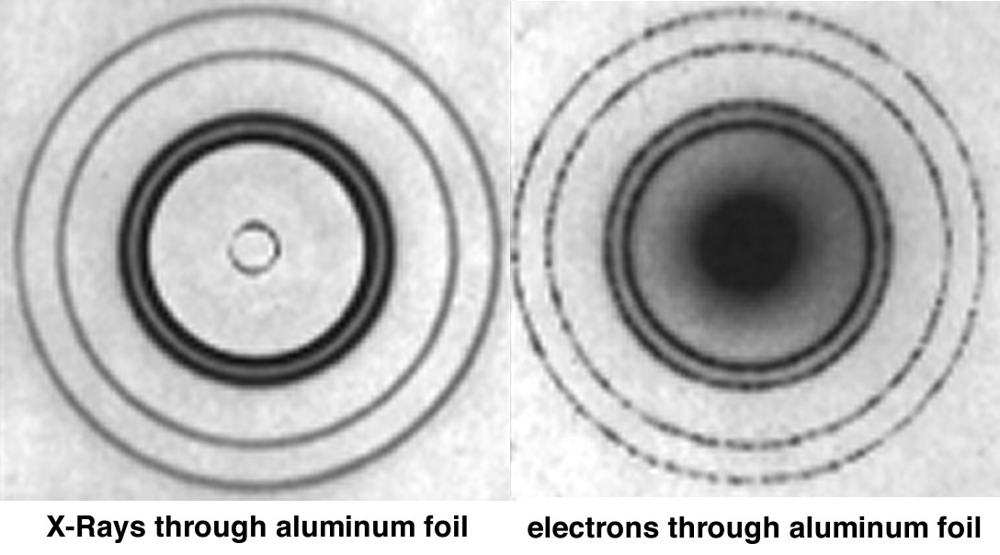

### Certainty and Uncertainty

Where is a wave located? The answer is not completely obvious. You might think it would be easier to determine where a particle is, but things get complicated as they get smaller and smaller. Imagine that we wanted to view an electron within an atom using some type of microscope, in this case, an imaginary one with unlimited resolution. To see something, photons have to bounce or reflect off it and then enter our eye, be absorbed by a molecule in a retinal cell, and start a signal to our brain where that signal is processed and interpreted. When we look at macroscopic objects, their interactions with light have little effect on them. For example, objects in a dark room do not begin to move just because you turn the lights on! Obviously the same cannot be said for atomic-scale objects; we already know that a photon of light can knock an electron completely out of an atom (the photoelectric effect). Now we come to another factor: the shorter the wavelength of light we use, the more accurately we can locate an object.[45] Remember, however, that wavelength and energy are related: the shorter the wavelength the greater its energy. To look at something as small as an atom or an electron we have to use electromagnetic radiation of a wavelength similar to the size of the electron. We already know that an atom is about 10-10 m in diameter, so electrons are presumably much smaller. Let us say that we use gamma rays, a form of electromagnetic radiation, whose wavelength is ~10–12 m. But radiation of such short wavelength carries lots of energy, so these are high-energy photons. When such a high-energy photon interacts with an electron, it dramatically perturbs the electron's position and motion. That is, if we try to measure where an electron is, we perturb it by the very act of measurement. The act of measurement introduces uncertainty and this uncertainty increases the closer we get to the atomic molecular scale.

This idea was first put forward explicitly by Werner Heisenberg (1901-1976) and is known as the Heisenberg Uncertainty Principle. According to the uncertainty principle, we can estimate the uncertainty in a measurement using the formula Δmv × Δx > h/2π, where Δ mv is the uncertainty in the momentum of the particle (mass times velocity or where it is going and how fast), Δx is the uncertainty in its position in space (where it is at a particular moment), and h is Planck’s constant now divided by 2π. If we know exactly where the particle is (Δx = 0) then we have absolutely no information about its velocity, which means we do not know how fast or in what direction it is going. Alternatively, if we know its momentum exactly (Δmv = 0), that is, we know exactly how fast and in which direction it is going, we have no idea whatsoever where it is! The end result is that we cannot know exactly where an electron is without losing information on its momentum, and vice versa. This has lots of strange implications. For example, if we know the electron is within the nucleus (Δx ~1.5 x 10–14 m), then we have very little idea of its momentum (how fast and where it is going). These inherent uncertainties in the properties of atomic-level systems are one of their key features. For example, we can estimate some properties very accurately but we cannot know everything about an atomic/molecular-level system at one point in time. This is a very different perspective from the one it replaced, which was famously summed up by Pierre-Simon Laplace (1749–1827), who stated that if the positions and velocities of every object in the universe were known, the future would be set:

*We may regard the present state of the universe as the effect of its past and the cause of its future. An intellect which at a certain moment would know all forces that set nature in motion, and all positions of all items of which nature is composed, if this intellect were also vast enough to submit these data to analysis, it would embrace in a single formula the movements of the greatest bodies of the universe and those of the tiniest atom; for such an intellect nothing would be uncertain and the future just like the past would be present before its eyes. -- Pierre-Simon Laplace (1745-1827)*

It turns out that a major flaw in Bohr’s model of the atom was that he attempted to define both the position of an electron (a defined orbit) and its energy, or at least the energy difference between orbits, at the same time. Although such a goal seems quite reasonable and would be possible at the macroscopic level, it simply is not possible at the atomic level. The wave nature of the electron makes it impossible to predict exactly where that electron is if we also know its energy level. In fact, we do know the energies of electrons very accurately because of the evidence from spectroscopy. We will consider this point again later in this chapter.

**Questions to Answer**

* How does the wavelength of a particle change as the mass increases?
* Planck’s constant is h = 6.626 x 10–34 J·s. What are the implications for particles of macroscopic size? (1 J = the kinetic energy of a two-kilogram mass moving at the speed of 1 m/s.)
* What would be the wavelength of the world-record holder for the 100-m sprint? What assumptions do you have to make to answer this question?
* What is the wavelength of a protein of 60,000 daltons? (That is, if the protein has a molar mass of 60,000 g/M, what is the mass of one molecule of the protein?)

**Questions to Ponder**

* What is the uncertainty in your momentum, if the error in your position is 0.01 m (remembering   
   that Planck’s constant h = 6.626068 × 10-34 J·s)?
* How is it that we experience objects as having very definite velocities and positions?
* Does it take energy to determine your position?
* How is the emission and absorption behavior of atoms related to electron energies?

## 2.5 Organizing Elements: Introduction to the Periodic Table

Up to this point we have made a number of unjustified assumptions. We have talked about elements but we have not explicitly specified how they are different, so let us do that now. If we start with hydrogen we characterized it by the presence of one proton in the nucleus and one electron surrounding it. Atoms are always neutral, which means that the number of positively-charged particles is equal to the number of negatively-charged particles, and charges come in discrete, equal, and opposite units. The presence of one proton and one electron defines a hydrogen atom but the world is a little more complex than that. A hydrogen atom may also contain one or two neutrons in its nucleus. A neutron can be considered, with the forgiveness of physicists, a proton, an electron, and an uncharged neutrino, and so it is electrically neutral. Neutrons are involved in the strong nuclear force and become increasingly important as the element increases in atomic number. In hydrogen, the neutrons (if they are present) have rather little to do, but in heavier elements the strong nuclear force is critical in holding the nucleus together, because at short distances this force is ~100 times stronger than the electrostatic repulsion between positively charged protons, which is why nuclei do not simply disintegrate. At the same time, the strong force acts over a very limited range, so when particles are separated by more than about 2 x 10-15 m (2 femtometers or fm), we can ignore it.

As we add one proton after another to an atom, which we can do in our minds, and which occurs within stars and supernova, in a rather more complex manner, we generate the various elements. The number of protons determines the elemental identity of an atom, whereas the number of neutrons can vary. Atoms of the same element with different numbers of neutrons are known as isotopes of that element. Each element is characterized by a distinct, whole number (1, 2, 3, …) of protons and the same whole number of electrons. An interesting question emerges here: is the number of possible elements infinite? And if not, why not? Theoretically, it might seem possible to keep adding protons (and neutrons and electrons) to produce a huge number of different types of atoms. However, as Rutherford established, the nucleus is quite small compared to the atom as a whole, typically between one and ten femtometers in diameter. As we add more and more protons (and neutrons) the size of the nucleus exceeds the effective range of the strong nuclear force (< 2 fm), and the nucleus becomes unstable. As you might expect, unstable nuclei break apart (nuclear fission), producing different elements with smaller numbers of protons, a process that also releases tremendous amounts of energy. Some isotopes are more stable than others, which is why the rate of their decay, together with a knowledge of the elements that they decay into can be used to calculate the age of rocks and other types of artifacts.[46]

Each element is defined by the number of protons in the nucleus, and as such is different from every other element. In fact, careful analysis of different elements reveals that there are periodicities (repeating patterns) in the properties of elements. Although John Dalton produced a table of elements with their atomic weights in 1805, it was only when Dimitri Mendeleev (1834–1907) tried to organize the elements in terms of their chemical and physical properties that some semblance of order began to emerge. Mendeleev, a Russian chemistry professor, was frustrated by the lack of organization of chemical information, so he decided to write his own textbook (not unlike your current authors). At the time, scientists had identified about 60 elements and established their masses relative to hydrogen. Scientists had already noticed that the elements display repeating patterns of behavior: and that some elements have very similar properties. It was Mendeleev’s insight that these patterns could be used as a guide for arranging the elements in a systematic way. In his periodic table, published in 1869, he placed elements in order of increasing atomic weight in repeating rows from left to right; elements with similar chemical properties were placed in vertical columns (known as groups).

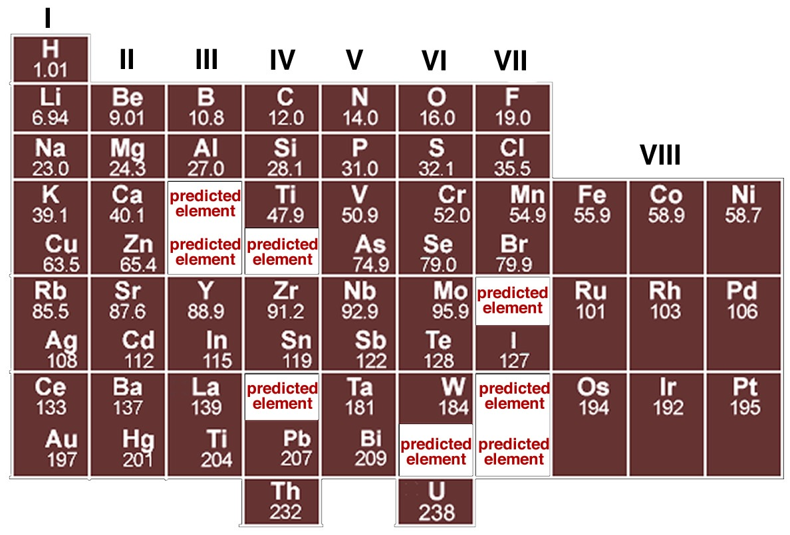

Although several other scientists were working on schemes to show patterns in elemental behavior, it was Mendeleev's arrangement that emerged as the basis for the modern periodic table, not only because of the way he arranged the elements but also for what he left out and what he changed. For example he was so sure about the underlying logic of his table that where certain elements seemed out of place, based, for example, on their reported atomic weights, such as tellurium and iodine, he reversed them and he turned out to be correct. Where Mendeleev predicted elements should be, he left gaps in his table to accommodate them. Subsequently, scientists discovered these missing elements (for example germanium, gallium, and scandium). In fact, we now know that it is not atomic weight (that is the number of protons and neutrons) but rather atomic number, Z, (the number of protons and electrons) that increases periodically. This explains why tellurium (atomic mass 127.6, Z = 52) must come before iodine (atomic mass 126.9, Z = 53). The important point to note is that although the modern periodic table is arranged in order of increasing number of protons and electrons, the repetition and patterns that emerge are the property of the electrons, their arrangements, and energies. This is our next subject.

**Question to Answer**

* Science fiction authors like weird elements. Provide a short answer for why no new elements with atomic numbers below 92 are possible.
* Isotopes of the same element are very similar chemically. What does that imply about what determines chemical behavior?

**Questions to Ponder**

* Why do you think there were no noble gases in Mendeleev’s periodic table?
* Why aren’t the atomic weights in Mendeleev’s periodic table whole numbers?
* Why would you expect different isotopes of the same element to differ in stability?
* You discover a new element. How would you know where would it should go in the periodic table?

## 2.6 Orbitals, Electron Clouds, Probabilities, and Energies

Our current working model of the atom is based on quantum mechanics that incorporate the ideas of quantized energy levels, the wave properties of electrons, and the uncertainties associated with electron location and momentum. If we know their energies, which we do, then the best we can do is to calculate a probability distribution that describes the likelihood of where a specific electron might be found, if we were to look for it. If we were to find it, we would know next to nothing about its energy, which implies we would not know where it would be in the next moment. We refer to these probability distributions by the anachronistic, misleading, and Bohrian term orbitals. Why misleading? Because to a normal person, the term orbital implies that the electron actually has a defined and observable orbit, something that is simply impossible to know (can you explain why?)

Another common and often useful way to describe where the electron is in an atom is to talk about the electron probability density or electron density for short. In this terminology, electron density represents the probability of an electron being within a particular volume of space; the higher the probability the more likely it is to be in a particular region at a particular moment. Of course you can't really tell if the electron is in that region at any particular moment because if you did you would have no idea of where the electron would be in the next moment.

Erwin Schrödinger (1887–1961) developed, and Max Born (1882–1970) extended, a mathematical description of the behavior of electrons in atoms. Schrödinger used the idea of electrons as waves and described each atom in an element by a mathematical wave function using the famous Schrödinger equation (HΨ = EΨ). We assume that you have absolutely no idea what either HΨ or EΨ are but don’t worry—you don’t really need to. The solutions to the Schrödinger equation are a set of equations (wave functions) that describe the energies and probabilities of finding electrons in a region of space. They can be described in terms of a set of quantum numbers; recall that Bohr’s model also invoked the idea of quantum numbers. One way to think about this is that almost every aspect of an electron within an atom or a molecule is quantized, which means that only defined values are allowed for its energy, probability distribution, orientation, and spin. It is far beyond the scope of this book to present the mathematical and physical basis for these calculations, so we won’t pretend to try. However, we can use the results of these calculations to provide a model for the arrangements of electrons in an atom using orbitals, which are mathematical descriptions of the probability of finding electrons in space and determining their energies. Another way of thinking about the electron energy levels is that they are the energies needed to remove that electron from the atom or to move an electron to a “higher” orbital. Conversely, this is the same amount of energy released when an electron moves from a higher energy to a lower energy orbital. Thinking back to spectroscopy, these energies are also related to the wavelengths of light that an atom will absorb or release. Let us take a look at some orbitals, their quantum numbers, energies, shapes, and how we can used them to explain atomic behavior.

### Examining Atomic Structure Using Light: On the Road to Quantum Numbers

J.J. Thompson’s studies (remember them?) suggested that all atoms contained electrons. We can use the same basic strategy in a more sophisticated way to begin to explore the organization of electrons in particular atoms. This approach involves measuring the amount of energy it takes to remove electrons from atoms. This is known as the element’s ionization energy which in turn relates directly back to the photoelectric effect.

All atoms are by definition electrically neutral, which means they contain equal numbers of positively- and negatively-charged particles (protons and electrons). We cannot remove a proton from an atom without changing the identity of the element because the number of protons is how we define elements, but it is possible to add or remove an electron, leaving the atom’s nucleus unchanged. When an electron is removed or added to an atom the result is that the atom has a net charge. Atoms (or molecules) with a net charge are known as ions, and this process (atom/molecule to ion) is called ionization. A positively charged ion (called a cation) results when we remove an electron; a negatively charged ion (called an anion) results when we add an electron. Remember that this added or removed electron becomes part of, or is removed from, the atom’s electron system.

Now consider the amount of energy required to remove an electron. Clearly energy is required to move the electron away from the nucleus that attracts it. We are perturbing a stable system that exists at a potential energy minimum – that is the attractive and repulsive forces are equal at this point. We might naively predict that the energy required to move an electron away from an atom will be the same for each element. We can test this assumption experimentally by measuring what is called the ionization potential. In such an experiment, we would determine the amount of energy (in kilojoules per mole of molecules) required to remove an electron from an atom. Let us consider the situation for hydrogen (H). We can write the ionization reaction as:

H (gas) + energy → H+ (gas) + e–.[47]

What we discover is that it takes 1312 kJ to remove a mole of electrons from a mole of hydrogen atoms. As we move to the next element, helium (He) with two electrons, we find that the energy required to remove an electron from helium is 2373 kJ/mol, which is almost twice that required to remove an electron from hydrogen!

Let us return to our model of the atom. Each electron in an atom is attracted to all the protons, which are located in essentially the same place, the nucleus, and at the same time the electrons repel each other. The potential energy of the system is modeled by an equation where the potential energy is proportional to the product of the charges divided by the distance between them. Therefore the energy to remove an electron from an atom should depend on the net positive charge on the nucleus that is attracting the electron and the electron’s average distance from the nucleus. Because it is more difficult to remove an electron from a helium atom than from a hydrogen atom, our tentative conclusion is that the electrons in helium must be attracted more strongly to the nucleus. In fact this makes sense: the helium nucleus contains two protons, and each electron is attracted by both protons, making them more difficult to remove. They are not attracted exactly twice as strongly because there are also some repulsive forces between the two electrons.

The size of an atom depends on the size of its electron cloud, which depends on the balance between the attractions between the protons and electrons, making it smaller, and the repulsions between electrons, which makes the electron cloud larger.[48] The system is most stable when the repulsions balance the attractions, giving the lowest potential energy. If the electrons in helium are attracted more strongly to the nucleus, we might predict that the size of the helium atom would be smaller than that of hydrogen. There are several different ways to measure the size of an atom and they do indeed indicate that helium is smaller than hydrogen. Here we have yet another counterintuitive idea: apparently, as atoms get heavier (more protons and neutrons), their volume gets smaller!

Given that i) helium has a higher ionization energy than hydrogen and ii) that helium atoms are smaller than hydrogen atoms, we infer that the electrons in helium are attracted more strongly to the nucleus than the single electron in hydrogen. Let us see if this trend continues as we move to the next heaviest element, lithium (Li). Its ionization energy is 520 Kj/mol. Oh, no! This is much lower than either hydrogen (1312 kJ/mol) or helium (2373 kJ/mol). So what do we conclude? First, it is much easier (that is, requires less energy) to remove an electron from Li than from either H or He. This means that the most easily removed electron in Li is somehow different than are the most easily removed electrons of either H or He. Following our previous logic we deduce that the “most easily removable” electron in Li must be further away (most of the time) from the nucleus, which means we would predict that a Li atom has a larger radius than either H or He atoms. So what do we predict for the next element, beryllium (Be)? We might guess that it is smaller than lithium and has a larger ionization energy because the electrons are attracted more strongly by the four positive charges in the nucleus. Again, this is the case. The ionization energy of Be is 899 kJ/mol, larger than Li, but much smaller than that of either H or He. Following this trend the atomic radius of Be is smaller than Li but larger than H or He. We could continue this way, empirically measuring ionization energies for each element (see figure), but how do we make sense of the pattern observed, with its irregular repeating character that implies complications to a simple model of atomic structure?

**Questions to Answer**

* Why are helium atoms smaller than hydrogen atoms?
* What factors govern the size of an atom? List all that you can. Which factors are the most important?

**Questions to Ponder**

* What would a graph of the potential energy of a hydrogen atom look like as a function of distance of the electron from the proton?
* What would a graph of the kinetic energy of an electrion in a hydrogen atom look like as a function of distance of the electron from the nucleus?
* What would a graph of the total energy of a hydrogen atom look like as a function of distance of the electron from the proton?

## 2.7 Quantum Numbers[49]

Quantum numbers (whose derivation we will not consider here) provide the answer to our dilemma. Basically we can describe the wave function for each individual electron in an atom by a distinct set of three quantum numbers, known as n, l, and ml. The principal quantum number, n, is a non-zero positive integer (n = 1, 2, 3, 4, etc.). These are often referred to as electron shells or orbitals, even though they are not very shell- or orbital-like. The higher the value of n, the higher the overall energy level of the electron shell. For each value of n there are only certain allowable values of l, and for each value of l, only certain allowable values of ml. Table 2.1 (next page) shows the allowable values of l and ml for each value of n are shown. There are a few generalizations we can make. Three quantum numbers, n, l, and ml, describe each orbital in an atom and each orbital can contain a maximum of two electrons. As they are typically drawn, each orbital defines the space in which the probability of finding an electron is 90%. Because each electron is described by a unique set of quantum numbers, the two electrons within a particular orbital must be different in some way.[50] But because they are in the same orbital they must have the same energy and the same probability distribution. So what property is different? This property is called spin. The spin quantum number, ms, can have values of either + ½ or – ½. Spin is responsible for a number of properties of matter including magnetism.

Hydrogen has one electron in a 1s orbital and we write its electron configuration as 1s1. Helium has both of its electrons in the 1s orbital (1s2). In lithium, the electron configuration is 1s2 2s1, which tells us that during ionization, an electron is being removed from a 2s orbital. Quantum mechanical calculations tell us that in 2s orbital there is a higher probability of finding electrons farther out from the nucleus than the 1s orbital, so we might well predict that it takes less energy to remove an electron from a 2s orbital (found in Li) than from a 1s orbital (found in H). Moreover, the two 1s electrons act as a sort of shield between the nucleus and the 2s electrons. The 2s electrons feel what is called the effective nuclear charge, which is smaller than the real charge because of shielding by the 1s electrons. In essence, two of the three protons in the lithium nucleus are counterbalanced by the two 1s electrons. The effective nuclear charge in lithium is +1. The theoretical calculations are borne out by the experimental evidence—always a good test of a theory.

**Table 2.1 Elemental electron shell organization**

At this point, you might start getting cocky; you may even be ready to predict that ionization energies across the periodic table from lithium to neon (Ne) will increase, with a concomitant decrease in atomic radius. In the case of atomic radius, this is exactly what we see in the figure – as you go across any row in the periodic table the atomic radius decreases. Again, the reason for both these trends is that same: that is, each electron is attracted by an increasing number of protons as you go from Li to Ne, which is to say that the effective nuclear charge is increasing. Electrons that are in the same electron shell do not interact much and each electron is attracted by all the unshielded charge on the nucleus. By the time we get to fluorine (F), which has an effective nuclear charge of 9 – 2 = +7, and neon (10 – 2 = +8), each of the electrons are very strongly attracted to the nucleus, and very difficult to dislodge. Meaning that the size of the atom gets smaller, and the ionization energy gets larger.

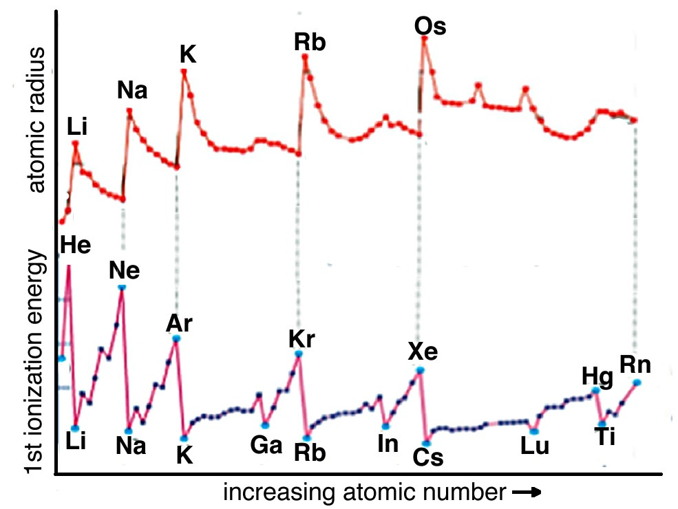

As you have undoubtedly noted from considering the graph, the increase in ionization energy from lithium to neon is not uniform: there is a drop in ionization energy from beryllium to boron and from nitrogen to oxygen. This arises from the fact that as the number of electrons in an atom increases the situation becomes increasingly complicated. Electrons in the various orbitals influence one another and some of these effects are quite complex and chemically significant. We will return to this in a little more detail in Chapter 3 and at various points through the rest of the book.

If we use the ideas of orbital organization of electrons, we can make some sense of patterns observed in ionization energies. Let us go back to the electron configuration. Beryllium (Be) is 1s2 2s2 whereas Boron (B) is 1s2 2s2 2p1. When electrons are removed from Be and B they are removed from the same quantum shell (n = 2) but, in the case of Be, one is removed from the 2s orbital whereas in B, the electron is removed from a 2p orbital. s orbitals are spherically symmetric, p orbitals have a dumbbell shape and a distinct orientation. Electrons in a 2p orbital have lower ionization energies because they are on average a little further from the nucleus and so a little more easily removed compared to 2s electrons. That said, the overall average atomic radius of boron is smaller than beryllium, because on average all its electrons spend more time closer to the nucleus.

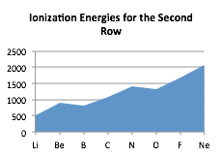

The slight drop in ionization potential between nitrogen and oxygen has a different explanation. The electron configuration of nitrogen is typically written as 1s2 2s2 2p3, but this is misleading: it might be better written as 1s2 2s2 2px1 2py1 2pz1, with each 2p electron located in a separate p orbital. These p orbitals have the same energy but are oriented at right angles (orthogonally) to one another. This captures another general principle: electrons do not pair up into an orbital until they have to do so.[51] Because the p orbitals are all of equal energy, each of them can hold one electron before pairing is necessary. When electrons occupy the same orbital there is a slight repulsive and destabilizing interaction; when multiple orbitals of the same energy are available, the lowest energy state is the one with a single electron in an orbital. Nitrogen has all three 2p orbitals singly occupied and therefore the next electron, which corresponds to oxygen, has to pair up in one of the p orbitals. Thus it is slightly easier to remove a single electron from oxygen than it is to remove a single electron from nitrogen, as measured by the ionization energy.

To pull together a set of seriously obscure ideas, the trends in ionization energies and atomic radii indicate that electrons are not uniformly distributed around an atom’s nucleus but rather have distinct distributions described by the rules of quantum mechanics. Although we derive the details of these rules from rather complex calculations and the wave behavior of electrons, we can cope with them through the use of quantum numbers and electron probability distributions. Typically electrons in unfilled shells are more easily removed or reorganized than those in filled shells because atoms with unfilled shells have higher effective nuclear charges. Once the shell is filled, the set of orbitals acts like a shield and cancels out an equal amount of nuclear charge. The next electron goes into a new quantum shell and the cycle begins again. This has profound implications for how these atoms react with one another to form new materials because, as we will see, chemical reactions involve those electrons that are energetically accessible: the valence electrons.

We could spend the rest of this book (and probably one or two more) discussing how electrons are arranged in atoms but in fact your average chemist is not much concerned with atoms as entities in themselves. As we have said before, naked atoms are not at all common. What is common is combinations of atoms linked together to form molecules. From a chemist’s perspective, we need to understand how, when, and where atoms interact. The electrons within inner and filled quantum shells are “relatively inert” which can be translated into English to mean that it takes quite a lot of energy (from the outside world) to move them around. Chemists often refer to these electrons as core electrons, which generally play no part in chemical reactions; we really do not need to think about them much more except to remember that they form a shield between the nucleus and the outer electrons. The results of their shielding does, however, have effects on the strong interactions, commonly known as bonds, between atoms of different types, which we will discuss in Chapters 4 and 5. Reflecting back on Chapter 1, we can think about the distinction between the London Dispersion Forces acting between He atoms and between H2 molecules versus the bonds between the two H atoms in a H2 molecule.

Bonds between atoms involve the valence electrons found in outer, and usually partially filled, orbitals. Because of the repeating nature of electron orbitals, it turns out that there are patterns in the nature of interactions atoms make—a fact that underlies the organization of elements in the periodic table. We will come back to the periodic table once we have considered how atomic electronic structure influences the chemical properties of the different elements.

**Questions to Answer**

* Try to explain the changes in ionization potential as a function of atomic number by drawing your impression of what each atom looks like as you go across a row of the periodic table, and down a group.

**Questions to Ponder**

* How does the number of valence electrons change as you go down a group in the periodic table? How does is change as you go across a row?
* How do you think the changes in effective nuclear charge affect the properties of elements as you go across a row in the periodic table?

# Chapter 3: Elements, Bonding, and Physical Properties

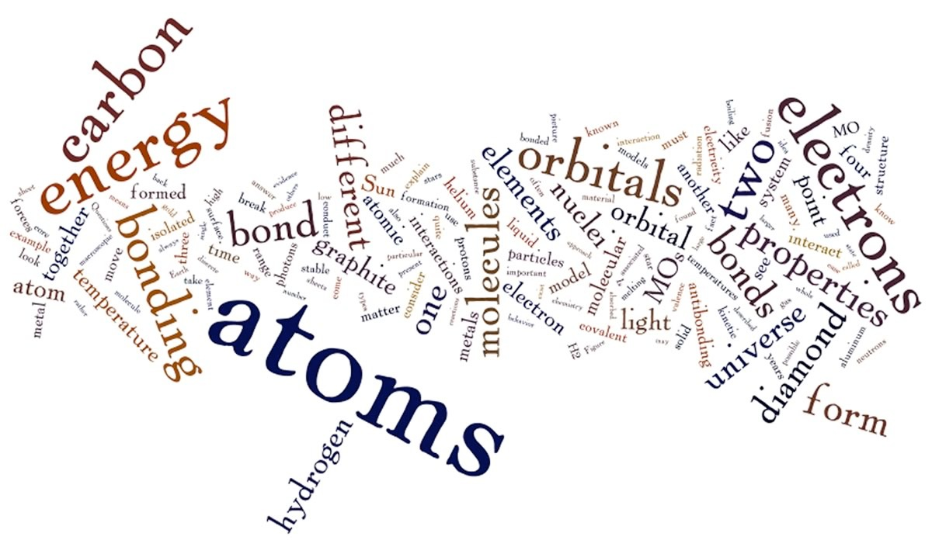

Up to now we have been concerned mainly with isolated atoms, an extremely abstract topic. We now move on to consider the macroscopic behavior of atoms, that is, the behaviors of very, very large numbers of atoms that form the materials that we touch, feel, smell, and observe with our own eyes. Before we do that, it is important to understand and be explicit about what properties atoms, molecules, and their aggregates can and cannot exhibit.

## 3.1 Elements and Bonding

When atoms interact with one another to form molecules or larger structures, the molecules have different properties than their component atoms; they display what are often referred to as emergent properties, where the whole is more than, or different from the sum of its parts. In a similar way groups of atoms or molecules have different properties from isolated atoms/molecules. For example while groups of atoms/molecules exist in solid, liquid, or gaseous states, and often have distinct colors and other properties, isolated atoms/molecules do not; there are no solid or liquid isolated atoms and they do not have a color or a boiling point. So the obvious question is, how many atoms or molecules need to aggregate before they display these emergent properties, before they have a color, before they have a melting point, boiling point, heat capacity, and other properties that isolated atoms do not? The answer is not completely simple, as you are probably slowly coming to expect. As we add more and more atoms or molecules together their properties change but not all at once. You have probably heard about nanoscience and nanotechnologies, which have been the focus of a great deal of research and economic interest in the past decade or so. Nanoparticles are generally classified as being between 1 and 100 nm in diameter (a nanometer is one billionth of a meter or 1 x 10–9 m). Such particles often have properties that are different from those of bulk (macroscopic) materials. Nanomaterials can be thought of as a bridge between the atomic-molecular and macroscopic scales.

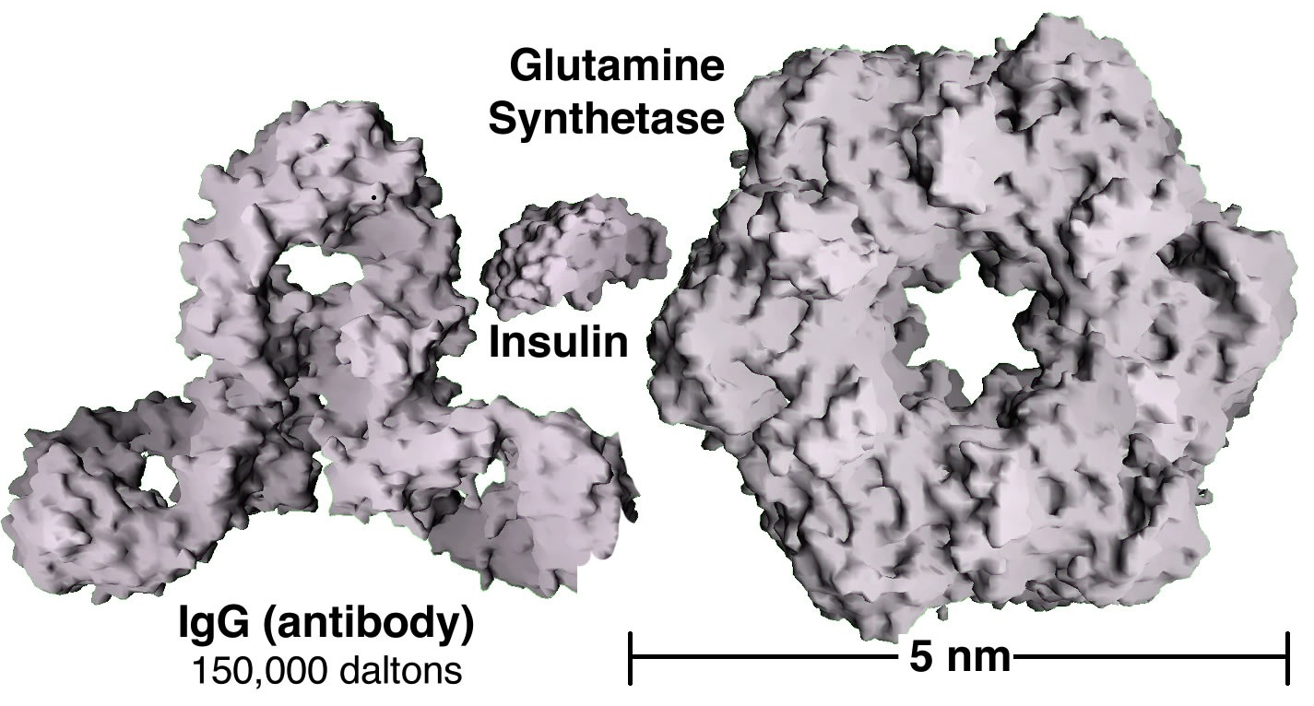

Assuming that they are pure, macroscopic materials have predictable properties and it doesn’t really matter the size of the sample. A macroscopic sample of pure gold behaves the same regardless of its size and if Archimedes (ca.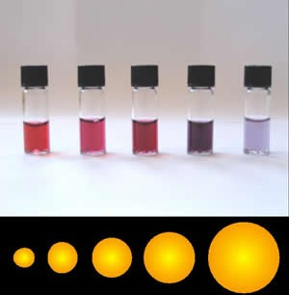 287–212 bce) were alive today, he could tell you whether it was pure or not based on its properties, for example, its density. But gold nanoparticles have different properties depending upon their exact size. For example, when suspended in water, they produce colors ranging from orange to purple, depending on their diameter (see Figure). Often the differences in the properties displayed are due to differences in the ratio of surface area to volume, which implies that intermolecular forces (forces between molecules) are more important for nanomaterials. As we cluster more and more particles together, the properties of the particles change. Biomolecules generally fall into the size range of nanomaterials, and as we will see their surface properties are very important in determining their behavior.

Unfortunately when we are talking about the properties of atoms and molecules versus substances and compounds, it can be difficult, even for experienced chemists, to keep the differences clear. In addition different representations are often used for different organizational levels; it is an important skill to be able to recognize and translate between levels. We will be using a range of representations to picture atoms and molecules; chemists (and we) typically use various shorthand rules, methods, and chemical equations to represent molecular composition, shape, and behaviors. But just knowing the equations, often the only thing learned in introductory chemistry courses, is not sufficient to understand chemistry and the behavior of atoms and molecules. Much of the information implied by even the simplest chemical equations can easily be missed—or misunderstood—if the reader does not also have a mental picture of what the diagram or equation represents, how a molecule is organized and its shape, and how it is reorganized during a particular reaction. We will be trying to help you get these broader pictures, which should you make sense of the diagrams and equations used here. That said, it is always important to try to explicitly identify what you are assuming when you approach a particular chemical system; that way you can go back and check whether your assumptions are correct.

### Where Do Atoms Come From?

*“We are stardust, we are golden, We are billion-year-old carbon.”   
 – Woodstock, Joni Mitchell*

*“Sometimes I’ve believed as many as six impossible things before breakfast.”*

*– Alice in Wonderland, Lewis Carroll*

Did you ever stop to ask yourself where the atoms in your body came from? Common answers might be that the atoms in our bodies come from food, water, or air. But these are not the ultimate answers, because we then need to ask, where did the atoms in food, water, and air come from? Where did the atoms in the Earth come from? There are really two general possibilities: either the atoms that make up the Earth and the rest of the universe are eternal or they were generated/created by some process. How do we decide which is true? What is the evidence favoring one model over the other? The answers come not from chemistry, but from astrophysics.

Given that we are thinking scientifically what kinds of evidence can we look for to decide whether atoms (or the universe) are eternal or recently created? Clearly we must be able to observe the evidence here and now and use it to formulate logical ideas that make clear and unambiguous predictions. As we will see we will be called upon once again to believe many apparently unbelievable things. The current organizing theory in astrophysics and cosmology, known as the Big Bang theory, holds that the universe is ~13,820,000,000 ± 120,000,000 years old or 13.82 ± 0.12 billion years - an unimaginable length of time. The Sun and Earth are ~5,000,000,000 years old, and the universe as a whole is ~156 billion light-years in diameter.[52]

The Big Bang theory was put forward in a response to the observation that galaxies in the universe appear to be moving away from one another. Because the galaxies that are further away from us are moving away more rapidly than those that are closer, it appears that space itself is expanding, another seriously weird idea.[53] Based on this observation, we can carry out what scientists call a thought experiment. What happens if we run time backwards, so that the universe is contracting rather than expanding? Taken to its logical conclusion, the universe would shrink until, at some point, all of the universe would be in a single place, at a single point, which would be unimaginably dense. Based on a range of astronomical measurements, this so-called singularity existed ~13.73 x 109 years ago, which means the universe is about 13.73 billion years old. The Big Bang theory tells us nothing about what happened before 13.73 x 109 years ago, and although there is no shortage of ideas, nothing scientific can be said about it, because it is theoretically unobservable, or at least that is what we have been led to believe by astrophysicists!

### Thinking About Atomic Origins

The current model of the universe begins with a period of very rapid expansion, from what was essentially a dimensionless point, a process known as inflation. As you might well imagine there is some debate over exactly what was going on during the first 10-43 seconds (known as the Planck time) after the universe’s origin. Surprisingly, there is a remarkable level of agreement on what has happened since then.[54] This is because there is lots of observable evidence that makes it relatively easy to compare hypotheses, accepting some and ruling out others. Initially remarkably hot (about 1023 K), over time the temperature (local energy levels) of the universe dropped to those that are reachable in modern particle accelerators, so we have actual experimental evidence of how matter behaves under these conditions. At 1 picosecond after the Big Bang, there were no atoms, protons, or neutrons, because the temperature was simply too high. There were only elementary particles such as photons, quarks, and leptons (electrons are leptons) - particles that appear to have no substructure. By the time the universe was ~0.000001 seconds old (a microsecond or 1 x 10–6 second), the temperature had dropped sufficiently to allow quarks and gluons to form stable structures, and protons and neutrons appeared. A few minutes later the temperature dropped to about 1,000,000,000 K (1 x 109 K), which is low enough for some protons and neutrons to stick together and stay together without flying apart again. That is, the kinetic energy of the particles colliding with them was less than the forces (the weak and strong nuclear forces) holding the protons, neutrons, and nuclei together. At this point the density of particles in the universe was about that of our air.

By the time the universe was a few minutes old it contained mostly hydrogen (1H1 = one proton, no neutrons) and deuterium (2H1 = one proton and one neutron) nuclei, with some helium (3He2 and 4He2 = two protons and either one or two neutrons, respectively), and a few lithium (7Li3 = three protons and four neutrons).[55] These nuclei are all formed by nuclear fusion reactions such as

1p+ + 1n0 → 2H+ + gamma radiation and 2H+ + 2H+  → 3He2+ + 1n0.

These fusion reactions take place in a temperature range where the nuclei have enough kinetic energy to overcome the electrostatic repulsion associated with the positively charged protons but less than that needed to disrupt the nuclei once formed. After a few minutes the temperature of the universe fell below ~10,000,000 (107) K. At these temperatures, the kinetic energy of protons and nuclei was no longer sufficient to overcome the electrostatic repulsion between their positive charges. The end result was that there was a short window of time following the Big Bang when a certain small set of nuclei (including 1H+, 2H+, 3He2+, 4He2+, and 7Li3+) could be formed. After ~400,000 years the temperature of the universe had dropped sufficiently for electrons to begin to associate in a stable manner with these nuclei and the first atoms (as opposed to bare nuclei) were formed. This early universe was made up of mostly (> 95%) hydrogen atoms with a small percentage each of deuterium, helium, and lithium, which is chemically not very interesting.

The primary evidence upon which these conclusions are based comes in the form of the cosmic microwave background radiation (CMBR), which is the faint glow of radiation that permeates the universe. The CMBR is almost perfectly uniform which means that no matter where you look in the sky the intensity of the CMBR is (essentially) the same. To explain the CMBR, scientists assume that the unimaginably hot and dense early universe consisted almost entirely of a plasma of hydrogen nuclei that produced vast amounts of electromagnetic radiation, meaning that the early universe glowed. The CMBR is what is left of this radiation, it is a relic of that early universe. As the universe expanded it cooled but those photons continued to whiz around. Now that they have to fill a much larger universe individual photons have less energy, although the total energy remains the same! The current background temperature of the universe is ~2.27 K, which corresponds to a radiation wavelength of ~1.9 mm (radiation in the microwave region); hence the name cosmic microwave background radiation.

After a billion years or so things began to heat up again literally (albeit locally). As in any randomly generated object the matter in the universe was not distributed in a perfectly uniform manner and as time passed this unevenness became more pronounced as the atoms began to be gravitationally attracted to each other. The more massive the initial aggregates the more matter was attracted to them. As the clumps of (primarily) hydrogen became denser the atoms banged into each other and these systems, protostars, began to heat up. At the same time the gravitational attraction resulting from the overall mass of the system caused the matter to condense into an even smaller volume and draw in more (mostly) hydrogen. As this matter condensed its temperature increased, as gravitational potential energy was converted into kinetic energy. At a temperature of ~10,000,000 (107) K the atoms (which had lost their electrons again because of the higher temperature) began to undergo nuclear fusion. At this point we would probably call such an aggregate of matter a star. This process of hydrogen fusion produced a range of new types of nuclei. Hydrogen fusion, or hydrogen burning as it is sometimes called, is exemplified by reactions such as the formation of helium nuclei:

4 1H+ → 4He2+ + 2e+ + energy.

When four protons are fused together they produce one helium-4 nucleus, containing two protons and two neutrons, plus two positrons (e+ - the antiparticle of the electron), and a great deal of energy. As the number of particles decreases (4 1H+ into 1 4He2+,), the volume decreases. Gravity produces an increase in the density of the star (fewer particles in a smaller volume). The star’s core, where fusion occurs, gets smaller and smaller. The core does not usually collapse totally into a black hole, because the particles have a huge amount of kinetic energy, which keeps them in motion and moving on average away from one another.[56]

As the star’s inner temperature reaches ~108 K there is enough kinetic energy available to drive other fusion reactions. For example three helium nuclei could fuse to form a carbon nuclei:

3 4He2+ → 12C6+ + lots of energy (note again, the result is fewer atoms).

If the star is massive enough, a further collapse of its core would increase temperatures so that carbon nuclei could fuse, leading to a wide range of new types of nuclei, including those of elements up to iron (56Fe26+) and nickel (58Ni28+), as well as many of the most common elements found in living systems, such as nitrogen (Ni7), oxygen (O8), sodium (Na11), magnesium (Mg12), phosphorus (P15), sulfur (S16), chlorine (Cl17), potassium (K19), calcium (Ca20), manganese (Mn25), cobalt (Co27), copper (Cu29), and zinc (Zn30).

In some instances these nuclear reactions cause a rapid and catastrophic contraction of the star’s core followed by a vast explosion called a supernova. Supernovae can be observed today, often by amateur astronomers, in part because seeing one is a matter of luck. They are characterized by a sudden burst of electromagnetic radiation, as the supernova expels most of its matter into interstellar dust clouds. The huge energies involved in such stellar explosions are required to produce the naturally occurring elements heavier than iron and nickel, up to and including Uranium (Ur82+). The material from a supernova is ejected out into the interstellar regions, only to reform into new stars and planets and so begin the process all over. So the song is correct, many of the atoms in our bodies were produced by nuclear fusion reactions in the cores of stars that, at one point or another, must have blown up; we are literally stardust, except for the hydrogen formed before there were stars!

### Looking at Stars

At this point you may still be unclear as to how we know all this. How can we know about processes and events that took place billions of years ago? Part of the answer lies in the fact that all the processes involved in the formation of new elements are still occurring today in the centers of stars. Our own Sun is an example of a fairly typical star; it is composed of ~74% (by mass) and ~92% (by volume) hydrogen, ~24% helium, and trace amounts of heavier elements. There are many other stars (billions) just like it. How do we know? Analysis of the emission spectra of the light emitted by the Sun or the light emitted from any other celestial object enables us to deduce which elements are present.[57] Similarly, we can deduce which elements and molecules are present in the clouds between stars by looking at which wavelengths of light are absorbed! Remember that emission/absorption spectra are a result of the interaction between the atoms of a particular element and electromagnetic radiation (light). They serve as a fingerprint of that element (or molecule). The spectrum of a star reveals which elements are present. No matter where an element is found in the universe it appears to have the same spectroscopic properties.

Astrophysicists have concluded that our Sun (Sol) is a third generation star, which means that the material in it has already been through two cycles of condensation and explosive redistribution. This conclusion is based on the fact that the Sun contains materials (heavy elements) that it could not have formed itself, and so must have been generated previously within larger and/or exploding stars. Various types of data indicate that the Sun and its planetary system were formed by the rapid collapse of a molecular (mostly hydrogen) cloud ~4.59 billion years ago. It is possible that this collapse was triggered by a shock wave from a nearby supernova. The gas condensed in response to gravitational attraction and the conservation of angular momentum; most of this gas (>98%) became the Sun, and the rest formed a flattened disc, known as a planetary nebulae. The planets were formed from this disc, with the small rocky/metallic planets closer to the Sun, gas giants further out, and remnants of the dust cloud distributed in the Oort cloud.[58] As we will see, living systems as we know them depend upon elements produced by second and third generation stars. This process of planet formation appears to be relatively common and more and more planetary systems are being discovered every year.[59]

Stars have a life cycle from birth to death; our Sun is currently about half way through this life cycle. There is not enough matter in the Sun for it to become a supernova, so when most of its hydrogen has undergone fusion, ~5 billion years from now, the Sun’s core will collapse and helium fusion will begin. This will lead to the formation of heavier elements. At this point, scientists predict that the Sun’s outer layer will expand and the Sun will be transformed into a red giant. Its radius will grow to be larger than the Earth’s current orbit. That will be it for life on Earth, although humans are likely to become extinct much sooner than that. Eventually the Sun will lose its outer layers of gas and they may become a part of other stars elsewhere in the galaxy. The remaining core will shrink, grow hotter and hotter, and eventually form a white dwarf star. Over (a very long) time, the Sun will cool down, stop emitting light, and fade away.

**Questions to Answer**

* How do the properties of isolated atoms or molecules give rise to the world we observe? Why are objects different colors, or have different melting points?
* Do isolated atoms/molecules exist in a state such as solid, liquid, or gas?
* Where do the atoms in your body come from? (Trace their origin back as far as you can.)
* How does the size of the universe influence the density of particles?
* How many protons, neutrons, and electrons does 4He have? How about 4He2+?
* Generate a graph that estimates the number of atoms in the universe as a function of time, beginning with the Big Bang and continuing up to the present day.
* Draw another graph to illustrate the number of elements in the universe as a function of time. Explain your reasoning behind both graphs.

**Questions to Ponder**

* Can an atom of one element change into an atom of another element?
* Is the number of atoms in the universe constant?
* How does the big bang theory constrain the time that life could have first arisen in the universe?

## 

## 3.2 Elements and Their Interactions

*“From the 115 elements you can build a near infinity of molecules, of any type you need, to get all the structural and functional diversity you can ask for. There are at least 100,000 different molecules in the human body. Some 900 volatile aroma components have been found in wine. Chemistry is molecules. We are molecules. Chemistry is a truly anthropic science.”*

*– Roald Hoffman (1937) quoted by Natalie Angier in The Canon*

By this point, you probably have some idea or mental image of the basic (low resolution) structure of atoms. We will therefore return to some questions left unanswered at the end of Chapter 1. Why is it that two hydrogen atoms form a strong stable (covalent) bond, a bond that requires temperatures above 5000 K to break, whereas two helium atoms and two hydrogen molecules have only a weak (London dispersion forces) attraction for each other that is broken at very low temperatures (4–20 K)? Because temperature is a measure of the kinetic energy present in the system we have to ask, what gives rise to this huge difference? Is there something fundamentally different going on in these situations? Other potentially troubling questions may also come to mind, in particular, how can pure samples of different elements be so different? Why is carbon either black (graphite) or transparent (diamond)? Why is gold shiny and yellow, while sulfur is dull and yellow? Why are most metals, but not gold or copper, shiny, solid, and colorless, while mercury is shiny, colorless, and liquid? Why are some elements more or less inert (such as gold, which does not tarnish) while others, such as iron (which rusts) and phosphorus (which bursts into flames) are highly reactive? To answer these questions will lead to an understanding of the basics of chemistry or how atoms interact with one another under various conditions. We will approach the answers in a step-by-step manner. In some cases where the answers are very complex (as is the case for why gold is yellow and mercury is a liquid), we will sketch out the answer but probably not provide a satisfying explanation. Luckily, most of the chemistry we need to address is not nearly so arcane!

Before we consider these and other questions, let us recap what we think we know about atoms and electrons. Most of an atom’s mass is localized in a very small region, the nucleus, surrounded by electrons that occupy most of the volume of the atom. Electrons have a number of strange properties because they are quantum mechanical particles. This means that under some conditions their behavior is best described by considering them as negatively charged particles, and under other conditions it is more helpful to consider them as waves; they are really both (and neither). Because of the uncertainty principle when we know the energy of each electron rather accurately we do not (and cannot) know where, exactly, a particular electron is at a particular moment in time. In fact, because all electrons are identical, if we had two electrons and turned away from them we could not tell which was which when we turned back. Within an atom each electron has a discrete energy and is characterized by its set of quantum numbers; no two electrons in an atom have the same set of quantum numbers. Perhaps you will be disappointed (or perhaps pleased) to know that a rigorous quantum mechanical (and relativistic) treatment of atoms and their interactions is beyond the scope of this book.[60] That said, we can give a reasonable overview of how the behavior of atoms can be explained in terms of atomic and molecular electron orbitals. We will also indicate where our description is an over-simplification.

It is worth remembering that there are very few (if any) instances when we come across isolated atoms. Although we often describe matter as being composed of atoms, that is a bit of an abstraction; most atoms are stuck to other atoms by bonds and interactions. As mentioned previously, this leads to emergent properties that are quite distinct from those of the isolated atoms of which they are composed. It is the interactions between atoms and molecules that makes surfaces solid.

If isolated atoms are rare, the obvious question is, why are they rare? What determines when and how atoms interact? The answer is simple really and based on a principle we have already encountered (and that we will return to time and again): systems will adopt the lowest energy state accessible to them. The reason is that at the lowest accessible energy state, the forces of attraction and repulsion are equilibrated. It would take more energy to move the components of the system (that is atoms in molecules, or electrons in atoms) because the forces acting on them would increase. Interactions and bond formation lead to lower potential energy. Whether the bonded system is stable will then depend upon the strength of the interaction/bond and the forces that impact the molecule. For example, surrounding molecules/atoms with a range of kinetic energies may collide with the molecule. If this kinetic energy of the impacting particle is larger than the interaction/bond energy, the collision can disrupt the interaction or break the bond(s) between them; if not, the interaction/bond will be stable. At the same time, there must be overarching principles governing which interactions occur and which do not; otherwise everything would clump together, which would be messy and not particularly interesting. These principles arise from the way electrons are organized in different types of atoms.



### Thinking about the nature of the chemical bond

There is no single explanation that captures all the properties observed when atoms interact to form a bond[61]. Instead we use a range of models of bonding. Now, what do we mean by model? Models are much more limited than theories, which have global application and can be proven wrong through observation and experimental data. Models are more like strategies that simplify working with and making predictions about complex systems. A model often applies to only very specific situations. For example the Bohr model of the atom applies only to hydrogen and then only under quite specific circumstances. We are going to consider a variety of bonding models, some of which you may already be familiar with, but it is important that you remember that different models are used depending upon which properties you want to predict and explain.   
 So back to our original dilemma, namely why is it that the interaction between two hydrogen atoms is so much stronger than that between two helium atoms? One useful model of bonding uses the idea that electrons can be described in terms of orbitals.[62] Each orbital can contain a maximum of two electrons (with opposite spins). Recall that in an isolated atom, the electrons are described by atomic orbitals; therefore when in molecules, they are described by molecular orbitals (MOs). When atoms approach each other, the atomic orbitals containing their outermost electrons, known as the valence electrons, begin to interact. Because of the wavelike nature of the electron, these interactions can be either constructive or destructive. If they interact in a constructive manner, the interaction is stabilizing, which means that potential energy decreases and (if that energy is released into the surrounding system) the two atoms adopt a more stable configuration; they form a bond that holds them together. If the interaction is destructive, there is no stabilizing interaction. In the case of hydrogen each atom has a single (1s) 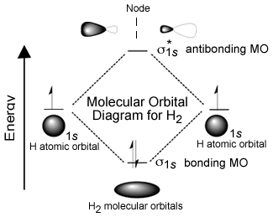orbital occupied by a single electron. As the atoms approach one another these 1s atomic orbitals interact to form two possible MOs: a lower energy, constructive or bonding MO, and a higher energy, destructive or anti-bonding MO. Notice that the bonding MO, a so-called σ1s (sigma) orbital, has electron density (that is a high probability that the electrons would be found there if we looked) between the two hydrogen nuclei. In the anti-bonding MO, known as σ*1s, the electrons are mostly not between the nuclei. One way to think about this is that in the bonding orbital the protons in the hydrogen nuclei are attracting both electrons (one from each atom) and it is this common attractive force between electrons and nuclei that holds the two hydrogen atoms together. In contrast in the anti-bonding orbital there is little electron density between the two nuclei and any electrons in that orbital are actually destabilizing the system by enhancing the repulsive interactions between the nuclei. (Can you provide a short reason why this would be the case?)

Just like an atomic orbital each MO, both bonding and anti-bonding, can hold two electrons. In the case of two approaching hydrogens there are only two electrons present in the system and the lowest energy state would have them both in the bonding orbital. Typically, both electrons in a H–H molecule are found in the lower energy (more stable) σ1s bonding orbital. This arrangement of electrons is referred to as a covalent bond; this is the arrangement that requires temperatures of ~5000 K to break, which means it requires a lot of energy to break a covalent bond.

Now let us take a look at what happens when two helium atoms approach. Each He atom has two electrons in its 1s orbital. As the orbitals approach they interact and again produce two MOs, the bonding σ1s orbital and the anti-bonding σ*1s orbital. The σ*1s MO has no electron density between the two He nuclei and has considerably higher energy than the atomic orbitals of the isolated atoms. Since there are 4 electrons present in the two He atoms and only two can occupy the σ1s bonding orbital; the other two have to go into the σ*1s anti-bonding orbital. The end result is that the decrease in potential energy (increased stability) associated with occupying the bonding orbital is more than off-set by the increased energy associated with occupying the σ*1s anti-bonding orbital. So, the end result is no overall stabilization and no decrease in energy associated with bond formation; no covalent bond is formed. The only interactions between helium atoms are the van der Waals interactions that occur between the two atoms that depend exclusively on London dispersion forces, as discussed in Chapter 1.

The interaction between two helium atoms is very similar to that between two H2 molecules. There is no possibility of stabilizing MOs forming and, as in the case of the helium atoms, hydrogen molecules (H–H or H2) interact exclusively through London dispersion forces (LDFs). The LDFs will be somewhat stronger between hydrogen molecules than between helium atoms, however, because there is a larger surface area over which they can interact.

The idea that—all other things being equal—a system will move to the lowest accessible energy state (losing the excess energy to their surroundings), where the forces of attraction and repulsion are equal, is applicable to a wide range of situations. The potential energy of the system falls as the distance between the atoms decreases until the system reaches a balance between the stabilizing interaction of bond formation and the destabilizing repulsion of the two nuclei. The energy difference between the separated atoms and the minimum energy is called the bond energy and this amount of energy must be supplied to the system to break the two atoms apart again. The distance between the nuclei when the bond energy is at its minimum is the bond length. When a bond is formed between two atoms energy is always released to the surroundings and the new material is always more stable than the two separate atoms. Because energy is conserved a bond cannot form unless this bond energy is transferred from the interacting atoms to the rest of the system (usually by colliding with other atoms and transferring energy). Making bonds is always exothermic (meaning that energy is released not absorbed). This implies that energy (from the surrounding system) is always needed to break a bond. To break a bond energy must be transferred from the surroundings. Bond breaking is endothermic meaning it requires energy from the external world, normally delivered through collisions with other molecules.

When we consider more complex chemical reactions we will find that these generally involve both bond breaking and bond formation; the overall reaction will be exothermic when more energy is released from bond formation than is used for bond breaking. Conversely a reaction is endothermic (that is, uses energy) if more energy is required to break bonds than is released in bond formation. The important point is that we have to consider the system as a whole, including all of the bonds formed and broken. We will come back to this topic (in much greater depth) in Chapters 5 and 7.

### Discrete Versus Continuous Molecules

Having considered the bonding situation with hydrogen and helium, the simplest two elements, we can now move on to consider other elements and the types of molecules that they form. In this discussion, we begin with molecules made up of a single type of atom. More complex molecules made of atoms of multiple elements will be considered in the next and subsequent chapters. As the number of protons in the nucleus of an element’s atoms increases, from 1 in hydrogen to 10 in neon, we find dramatic changes in physical properties that correlate with whether the elemental form is discrete or continuous. The discrete forms are either monoatomic—meaning that they exist as separate atoms (such as He and Ne) with no covalent bonds between them (although they do interact via van der Waals interactions)—or diatomic molecules (such as H2, N2, O2, and F2), meaning that they exist as molecules that have only two atoms. The elements that exist as small molecules have very low melting points (the temperatures at which they change from a solid to a liquid) and low boiling points (the temperatures at which they change from a liquid to a gas). But don’t confuse these phase transitions with the breaking of a diatomic molecule into separate atoms. Phase transitions, which we will discuss in greater detail later, involve disruption of interactions **between** molecules (intermolecular forces), such as London dispersion forces, rather than interactions **within** molecules, that is, covalent bonds.

**Table 3.1 The First 10 Elements in Their Naturally Occurring Elemental State**

| Elemental Form | H2 molecular | He  atomic | Li  continuous | Be  continuous | B  continuous | C  continuous | N2  molecular | O2  molecular | F2  molecular | Ne  atomic |
| --- | --- | --- | --- | --- | --- | --- | --- | --- | --- | --- |
| Melting Point | 13.81 K | 0.00 K | 453.65 K | 1560 K | 2348 K | 3823 K | 63.15 K | 54.36 K | 53.53 K | 24.56 K |
| Boiling Point | 20.28 K | 4.22 K | 1615 K | 2744 K | 4273 K | 4098 K | 77.36 K | 90.20 K | 85.03 K | 27.07 K |
| Bp-Mp (*) | 6.47 K | 3.27 K | 1161 K | 1184 K | 1925 K | 275 K | 14.21 K | 35.84 K | 31.5 K | 2.51 K |
| Name | hydrogen | helium | Lithium | beryllium | boron | carbon | nitrogen | oxygen | fluorine | neon |

* boiling point (Bp) minus melting point (Mp).

In contrast to the elements that form discrete molecules, the atoms of the other elements we are considering (that is Li, Be, B, C) interact with one another in a continuous manner. Rather than forming discrete molecules, these elements can form ensembles of atoms in which the number of atoms can range from the small (a few billion) to the astronomical (very, very large). Whether the materials are at the nano- or the macroscopic levels, the atoms in these ensembles are held together by bonds that are very difficult to break, like the bond in H–H. That is, a lot of energy must be put into the system to separate the component atoms. However, unlike hydrogen, the atoms that form these structures must form bonds with more than one other atom.  
 A consequence of this difference in organization is a dramatic increase in both the melting and boiling points compared to atomic (He, Ne) and molecular (H2, N2, O2, and F2) species (Table 3.1). The reason is that when a substance changes from solid to liquid (at the melting point) the component particles have to be able to move relative to one another. When the substance changes from a liquid to a gas (at the boiling point) the particles have to separate entirely. Consequently the magnitude of the melting and boiling points gives us a relative estimate of how strongly the particles are held together in the solid and liquid states. As we have already seen temperature is a measure of the average kinetic energy of the molecules in a system. For elements that exist as discrete atoms or molecules the only forces that are holding these **particles** together are London dispersion forces, which are relatively weak compared to covalent bonds. In contrast, the elements that exist as extensive networks of atoms joined by bonds require much more energy to break as the material goes from solid to liquid to gas.

**Questions to ponder**

* Are all bonds the same?
* What factors might influence bond strength?
* Why are the properties of atoms and molecules different?

**Questions to Answer**

* Where are the electrons in H2 when the temperature is greater than 5000 K?
* What would happen if you could form a He–He system with 3 electrons (instead of 4)?
* What would a molecular-level picture of H2 (g) look like?
* What would a molecular-level picture of H (g) look like?
* Where does the energy to break a bond come from?
* Where does the energy released upon bond formation go?
* The melting point of molecular hydrogen (H2) is ~14 K (-259 °C). Draw a molecular level picture of what molecular hydrogen looks like below this temperature (as a solid). Why are the molecules of hydrogen sticking together?
* The boiling point of molecular hydrogen (H2) is ~20 K (-253 °C). Draw a molecular level picture of what molecular hydrogen looks like above this temperature (as a gas).
* Molecular hydrogen dissociates at high temperatures (> 6000 K). Draw a picture of what you imagine this might look like. Why do you think it takes such a high temperature to bring about this change?

**3.3 Carbon: An Amazingly Allotropic Element**

To give you an idea of some of the different types of bonds that form between elements, we are going to consider several representative elements from different areas of the periodic table. For starters, let us take a look at carbon. Carbon (C) belongs to the family of elements known as non-metals. The bonding between C atoms (and to other types of atoms) is typically described as covalent bonding where each bond involves two electrons (one from each of the bonded atoms). Although this is the most common model we will see that it is not the only possible one; we will introduce other models as they are needed. Diamond is the name given to one of the naturally occurring forms (known as allotropes) of pure C; the other allotropes of carbon are graphite, graphene, and various fullerenes (↓), which we will return to later. **The important question is: How can these substances have such different properties, yet be composed of the same types of atoms?** For example: diamond is hard, colorless, sparkly and do not conduct electricity, but graphite is soft, grey, shiny, and does conduct electricity. The answer lies in the molecular level structure of these allotropes of carbon.

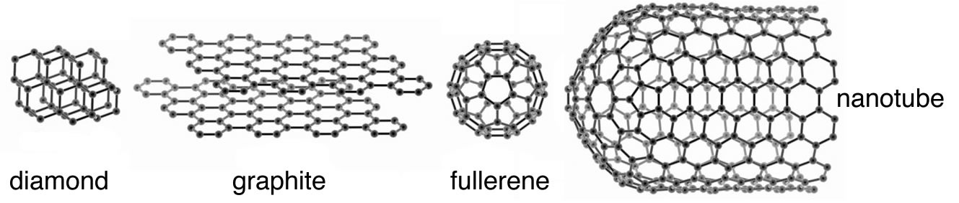

Diamonds form from carbon-rich materials subjected to very high pressure (45,000–60,000 atmospheres) but relatively low temperatures (900–1300 ºC).[63] Such conditions can be found about 100 miles under the Earth’s crust, the region known as the lithosphere. Diamonds have also been found in asteroids, which originate from outside of the Earth. Diamonds are so valued because they are rare, sparkly, hard, and almost completely inert. It is very hard to make diamonds do anything at all except sit there and sparkle; they don’t dissolve in water and they melt only at very high temperatures (mp = 3330 °C). Diamond has the highest melting point of any known substance, so high that these measurements are actually done under high pressure and then calculated to estimate what the value would be at atmospheric pressure. In addition, when diamond is melted it decomposes. When it is heated in an atmosphere of oxygen it reacts to produce carbon dioxide; when oxygen is absent it transforms into graphite. There is no such thing as molten diamond. Diamonds are extremely hard (the hardest naturally occurring substance) and do not conduct electricity at all (as we will see, to conduct electricity, electrons must be able to flow through the material). This suggests that the molecular-level structure of diamond is quite different from that found in metals (which we will see are malleable and conduct electricity). Any useful model of diamond’s structure must explain how these properties arise from atomic interactions.

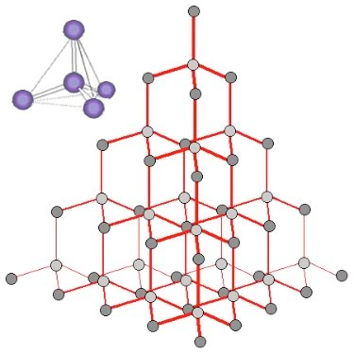

Let us step back and look at the properties of diamond and see if we can make sense of them. To be so stable (chemically inert) diamond must have very strong bonds that take a lot of energy to break. The fact that it does not conduct electricity indicates that the electrons must not be free to move around within a diamond. A polished diamond is sparkly because some light is reflected from the surface and some light passes through it, making it transparent. If the diamond were not cut with so many facets it would allow most light to pass through it.

When we look at an X-ray diffraction-based structure[64] of diamond we find that each carbon atom is surrounded by four other carbon atoms situated at equal distances and equal angles from each other. In this context, the most useful model of bonding involves thinking of each carbon atom as forming four covalent (electron-sharing) bonds, all arranged so that the electron pairs are as far apart as possible. This places the four bonded atoms at the corners of a tetrahedron, with a central carbon atom. Each of these corner atoms is itself at the center of a similar tetrahedron of carbons (see Figure). Experimental evidence indicates that all the bonds, bond lengths, and bond angles in diamond are identical; the C–C–C bond angles are ~109º. A diamond can be considered as one huge molecule connected by a network of carbon–carbon bonds.

How do we explain this arrangement in terms of what we know about the electronic structure of carbon atoms? The answer is that the electronic structure of the carbon atoms is reorganized to form bonding orbitals. In the case of carbon, each atom can form four bonding orbitals that are oriented as far apart as possible. There are several models to explain how this occurs, but it is important to remember that they are all models, designed to help us understand the properties of diamond.

### The Hybrid Orbital Model

In this model the orbitals involved in carbon–carbon bonding are considered to be hybrids or mixtures of atomic orbitals. If carbon forms four bonds (and it does) then four bonding orbitals are needed. Carbon has available orbitals in the second (n = 2) quantum shell: the 2s, 2px, 2py, and 2pz. In an isolated carbon atom there are two full (2s and one 2p) and two half-filled (the other two 2p) atomic orbitals. When the carbon atoms form a bond these orbitals are somehow mysteriously transformed into four new bonding orbitals, which are called sp3 hybrid orbitals because they are a mixture of an s and three p orbitals. These sp3 orbitals exist only in the context of bonded carbon; they are not present in isolated carbon atoms. They spring into existence when one carbon atom interacts with another atom to form a bond; they are generated through the interaction. In the case of carbon the four electron clouds (bonds) move as far apart as possible to minimize the repulsions between them, adopting a tetrahedral configuration (→).

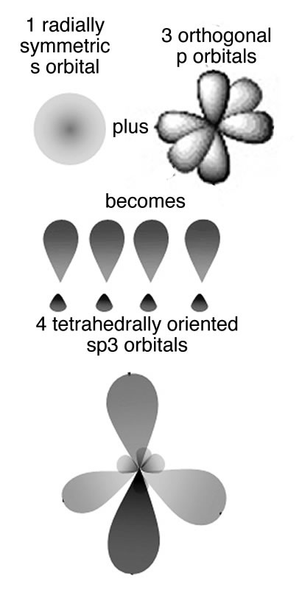

### The Molecular Orbital Model

Another way to consider how these bonds form is similar to the way we approached molecular hydrogen. That is, we consider that when carbon–carbon (C–C) bonds form, atomic orbitals are transformed into molecular orbitals (MOs). For each stabilizing bonding orbital, a destabilizing antibonding orbital is also formed. Using the molecular orbital approach we can model the bonding in diamond as carbon atoms forming a three-dimensional network held together by these molecular bonding orbitals. C–C bonds are very stable because there is a large energy gap between the bonding orbitals and the high-energy antibonding orbitals. The bonding molecular orbitals are occupied while the antibonding molecular orbitals are unoccupied. Because of this large gap between the filled bonding and empty antibonding orbitals it is hard to remove an electron from a C–C bonding MO. The electrons are not free to move between energy levels. Given that electrical conduction depends upon the relatively free movement of electrons it is not surprising that diamonds do not conduct electricity. But why, you might ask, is a diamond transparent, rather than opaque, like a block of graphite, which is also composed of only carbon atoms? For an object to be transparent most of the light that hits it must pass through it; the light can be neither reflected or absorbed. For a diamond to absorb light a photon would need to move an electron from a low-energy bonding MO to a high-energy antibonding orbital. However, visible light does not have enough energy to bridge the energy gap between the bonding and antibonding orbitals. Based on this thinking we conclude that there is something different between bonds holding C atoms together in diamond from the bonds holding C atoms together in graphite even though we do not know, at this point, what it could be.

An important point to consider here is that we have described the bonding in carbon using two different models: the hybrid orbital (valence bond) and molecular orbital models. Although this may be (a bit!) confusing, and may take some getting used to, it is quite common to describe chemical and physical phenomena using different models. Typically we use the simplest model that will allow us to explain and predict the phenomenon we are interested in. Usually the bonding in carbon is described using the hybrid orbital model, because it is highly predictive and easier to use in practice.

### Graphite

As we have already mentioned, different allotropes (different forms of the same element) can have quite different properties. The carbon allotrope graphite is soft, grey/black, opaque, conducts electricity, and slippery – it makes a good lubricant.[65] Diamond is hard, transparent, and does not conduct electricity. How can this be possible if both are pure carbon? The answer lies in how the carbon atoms are organized with respect to one another. Whereas the carbon atoms in diamond form a three-dimensional network, in graphite, the atoms are organized in two-dimensional sheets that stack one on top of the other. Within each two-dimensional sheet the carbon atoms are linked by covalent bonds in an extended array of six-membered rings. This means that the carbon sheets are very strongly bonded, but the interactions between sheets are much weaker. Although there are no covalent bonds between the sheets, the atoms of the sheets do interact through London dispersion forces, very much like the interactions that hold helium atoms together. Because the sheets interact over very much larger surface areas (→), however, these interactions are much stronger than those in helium. Yet another allotrope of carbon, graphene, consists of a single sheet of carbon atoms.[66] These sheets can be rolled into tubes to form nanotubes that are the subject of intense research interest because of their inherently high tensile strength. Carbon atoms can also form spherical molecules, known as buckminsterfullerenes or buckyballs.[67]

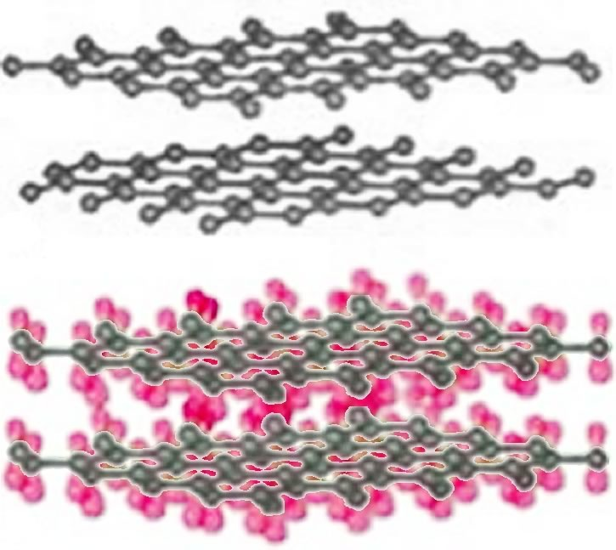

The obvious question is, why don’t covalent bonds form between graphite sheets? Why are the patterns of covalent bonding so different: three-dimensional (tetrahedral) in diamond, with each carbon bonded to four others, and two-dimensional (planar) in graphite and graphene, with each carbon atom bonded to only three others? One way to describe the molecular structure is to use the hybrid orbital bonding model. As we discussed previously, to form the four bonds attached to each carbon atom in diamond, we needed to hybridize four atomic orbitals to form four bonding orbitals. We might think we only need three bonds in graphite/graphene because each carbon is only connected to three others. This is not exactly true. In graphite and grapheme we use a model in which only three atomic orbitals are hybridized—an s and two 2p orbitals in order to form three sp2 bonding orbitals. These orbitals attach each carbon atom to three other atoms. Just like in diamond the three bonds associated with each carbon atom in graphite/graphene move as far apart as possible to minimize electron pair repulsion; they lie at the points of a triangle (rather than a tetrahedron). This geometry is called trigonal planar and the C–C–C bond angle is 120° (→).   
All well and good, but this does not really explain why the carbons in graphite/graphene are attached to three other carbon atoms, whereas in diamond each carbon is attached to four others. Perhaps surprisingly there is no good answer for why carbon takes up different forms—except that it can. But in fact carbon does form four bonds in graphite (carbon almost always forms four bonds—a central principle of organic chemistry). The trick is that the four bonds are not always equivalent; in graphite the fourth bond is not formed by the sp2 bonding orbitals but rather involves an unhybridized 2p atomic orbital. These p orbitals stick out at right angles to the sheet and can overlap with p orbitals from adjacent carbons in the same sheet (see Figure). Remember that p orbitals have two regions of electron density. To explain the fact that graphite conducts electricity, we use an idea from molecular orbital (MO) theory, namely that bonding and antibonding MOs are formed from the adjacent p orbitals that extend over the sheet surface. The energy different between these orbitals is not large and electrons can move from one to the other, allowing the movement of electrons throughout the whole sheet of graphite, which gives it many of the properties that we associate with metals. Note that we use both the hybridization model, which explains the planar framework of C–C bonds in graphite, and molecular orbital theory, which explains graphite’s electrical conductivity. So before we delve further into the properties associated with graphite, let us take a look at bonding in metals.

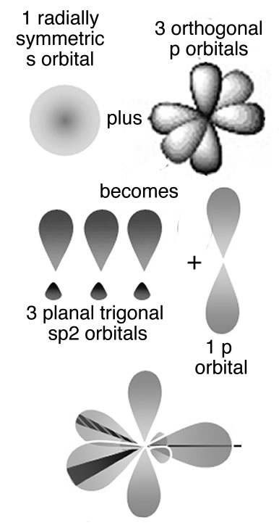

**Questions to Answer**

* Diamond and graphite appear to be quite different substances, yet both contain only carbon atoms. Why are the observable properties of diamond and graphite so different when they are made of the same substance?
* The electron configuration of C is 1s2 2s2 2p2. Using the idea that each atom provides one electron to a bond, if carbon used atomic orbitals to bond, how many bonds would it form? Would they all be the same? What would be the bond angles if this were to happen? (Draw a picture of what this might look like.)
* The electron configuration of C is 1s2 2s2 2p2 this means that carbon has 6 electrons. Why doesn't it form 6 bonds?
* We have seen that carbon can form materials in which it bonds to 4 other atoms (sp3 hybridization) or three other atoms (sp2 hybridization). What would be the hybridization for a carbon that was only bonded to two atoms? How would the other (unhybridized) p orbitals influence the behavior of such material (assuming that it could form)?

**Questions to Ponder**

* Could carbon form a three-dimensional structure by linking to two other carbon atoms?
* Do you think diamonds are transparent to all forms of light, such as X-rays?
* What does the color of graphite imply about the energies of the photons it absorbs?

## 3.4 Metals

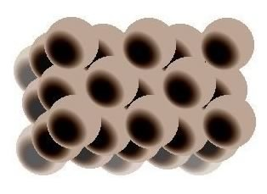

Metals have quite a wide range of properties at normal temperatures, from liquid (like mercury) to extremely hard (like tungsten). Most are shiny but not all are colorless. For example gold and copper have distinct colors. All metals conduct electricity but not all equally. How can we explain all these properties? Let us use aluminum (Al) as an example because most of us have something made of aluminum such as a pan or aluminum foil. With modern instrumentation it is quite easy to visualize atoms and a variety of techniques have been used to image where the aluminum atoms are in the solid structure. What emerges is a picture of aluminum nuclei and their core electrons, packed like spheres where one layer of spheres rests in the interstices of the underlying and overlying layers; where the positions of the electrons are within this structure not well defined.

In H–H or diamond the electrons involved in bonding are located (most probably) between the two nuclei. In contrast in aluminum and other metals the valence electrons are not closely associated with each nucleus. Instead they are dispersed over the whole macroscopic piece of metal. Imagine that instead of two or three or four atomic orbitals combining to form MOs, a mole (6 x 1023) of atomic orbitals were combined to produce a mole of MOs. As more and more MOs are formed the energies between them gets smaller and smaller. For a macroscopic piece of metal (one you can see) the energy gap between the individual bonding MOs will be negligible for all intents and purposes. These orbitals produce what is essentially a continuous band of (low-energy) bonding MOs and a continuous band of (higher-energy) anti-bonding MOs. The energy gap between the bonding and anti-bonding orbitals is called the band-gap and in a metal this band-gap is quite small (recall that the gap between the bonding and anti-bonding MOs in diamond is very large). Moreover in metals the bonding MOs (known as the valence band) are able to accommodate more electrons. This is because in metals there are typically fewer electrons than there are atomic orbitals. Consider aluminum: it has three valence electrons and in the ground (lowest energy) state has an electron configuration of 3s2 3p1. This suggests that it has two unoccupied 3p orbitals. We can consider the bonding MOs in aluminum to be formed from all the available atomic orbitals, which means that there are many bonding MOs that are not occupied by electrons. The physical consequences of this are that the valence electrons can move relatively easily from one MO to another because their energies are very close together. Whereas nuclei and core electrons remain more or less locked in position the valence electrons can spread out to form a kind of electron sea within the metal. When an electrical potential is applied across the metal, electrons from an external source can easily enter the valence band and electrons can just as easily leave the metal. Electrical conductivity is essentially a measure of how easily electrons can flow through a substance. Metals typically have high conductivity due to the ease with which electrons can move from one MO to another and the fact that each MO extends throughout the whole piece of metal. Because the numbers of electrons entering and leaving are the same, the piece of metal remains uncharged.

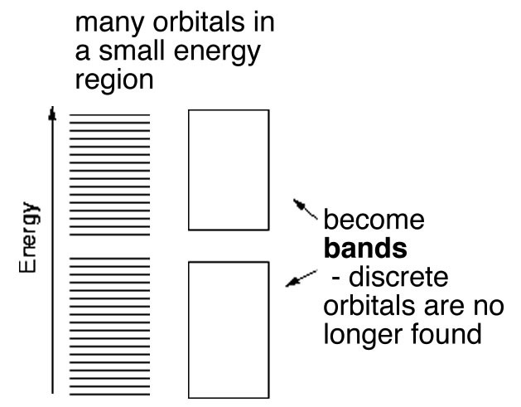

In this model the atomic cores are packed together and surrounded by a cloud of electrons that serve as the “glue” that binds them together. There are no discrete bonds in this type of structure. When a piece of metal is put under physical stress (for example it is stretched or deformed) the atoms can move relative to one another but the electrons remain spread throughout the structure. Metals can often be slowly deformed into different shapes without losing their structural integrity or electrical conductivity—they are malleable! They can be melted (increased atomic movement), become liquid, and then allowed to cool until they solidify; throughout this process they retain their integrity and their metallic properties and so continue to conduct electricity.[68] This is quite different from how other substances (such as diamond or water) behave. The hardness of a solid metal depends on how well its atoms packed together and how many electrons are contributed to the valence band of orbitals.

So why do some elements behave as metals and others do not? For example graphite conducts electricity but it is not malleable and can’t be heated and molded into other shapes. The answer lies in the behavior of the MOs and the resulting bonds they can produce. Graphite has a rigid backbone of carbon–carbon bonds that makes it strong and stable but overlaying those bonds is the set of delocalized MOs that spread out over the whole sheet. As a result graphite has some properties that are similar to diamond (stability and strength), some that are similar to metals (electrical conductivity), and some that are a consequence of its unique sheet structure (slipperiness).

### Why Are Metals Shiny?

We see things because photons hit the back of our retinas and are absorbed by specialized molecules (proteins and associated pigment molecules). This leads to changes in protein structure and initiates a cascade of neuron-based cellular events that alters brain activity. So where do these photons come from? First and foremost they can be emitted from a source (the Sun, a light bulb, etc.) that appears to shine and can be seen in the dark. Alternatively, photons can be reflected off a surface; in fact most of the things we see do not emit light, but rather reflect it. A red T-shirt appears red because it absorbs other colors and reflects red light. Photons can also be refracted when they pass through a substance. A cut diamond sparkles because light is refracted as it passes through the material and exits from the many facets. Refraction is caused when photons bump into electrons, are absorbed, and then (very shortly thereafter) are re-emitted as they travel through a material. These processes take time, so the apparent speed of light slows down. It can take a photon many thousands of years to move from the core to the surface of the Sun because of all the collisions that it makes during the journey.[69]

To explain why metals (and graphite) are shiny, we invoke a combination of reflection, refraction, and the energy levels of MOs. When a photon of light is absorbed and reemitted, the electron moves from one orbital to another. Let us consider a piece of metal at room temperature. When a photon arrives at the metal’s surface it encounters the almost continuous band of MOs. Most photons, regardless of their wavelength, can be absorbed because there is an energy gap between orbitals corresponding to the energy of the photon. This process promotes electrons up to a higher energy level. As the electrons drop back down to a lower energy level, the photons are re-emitted, resulting in the characteristic metallic luster. Metals actually emit light, although this does not mean metals glow in the dark (like a light bulb or the Sun). Instead, metals absorb and re-emit photons, even at room temperature.

The color of a particular metal depends upon the range of wavelengths that are re-emitted. For most metals the photons re-emitted have a wide range of wavelengths which makes the metallic surface silvery. A few metals, such as copper and gold, absorb light in the blue region and re-emit light with wavelengths that are biased toward the red end region of the spectrum (400–700 nm) and therefore they appear yellowish. This is due to relativistic effects way beyond the scope of this book, but something to look forward to in your future physical chemistry studies!

Now we can also understand why metals emit light when they are heated. The kinetic energy of the atoms increases with temperature which promotes electrons from low to higher energy orbitals. When these electrons lose that energy by returning to the ground state, it is emitted as light. The higher the temperature the shorter the wavelength of the emitted light. As a filament heats up, it first glows red and then increasing whiter as photons of more and more wavelengths are emitted.

**Questions to Answer**

* What properties indicate that a substance is metallic?
* Why are metals shiny?
* How can metallic properties be explained by the atomic-molecular structure of Al (for example)?
* Why can we see through diamond but not aluminum? How about graphite?
* Why does aluminum (and for that matter all metals) conduct electricity? What must be happening at the atomic-molecular scale for this to occur?
* What does the fact that diamond doesn’t conduct electricity tell you about the bonding in diamond?
* How do the bonding models for diamond and graphite explain the differences in properties between diamond, graphite, and a metal like aluminum?
* Why is it OK to use different models to describe bonding in different species?

This chapter has brought us to a point where we should have a fairly good idea of the kinds of interactions that can occur among atoms of the same element. We have seen that the properties of different elements can be explained by considering the structure of their atoms and in particular the way their electrons behave as the atoms interact to form molecules or large assemblies of atoms (like diamond.) What we have not considered yet is how atoms of different elements interact to form compounds (substances that have more than one element). In Chapter 4 we will take up this subject and much more.

# Chapter 4: Heterogeneous Compounds

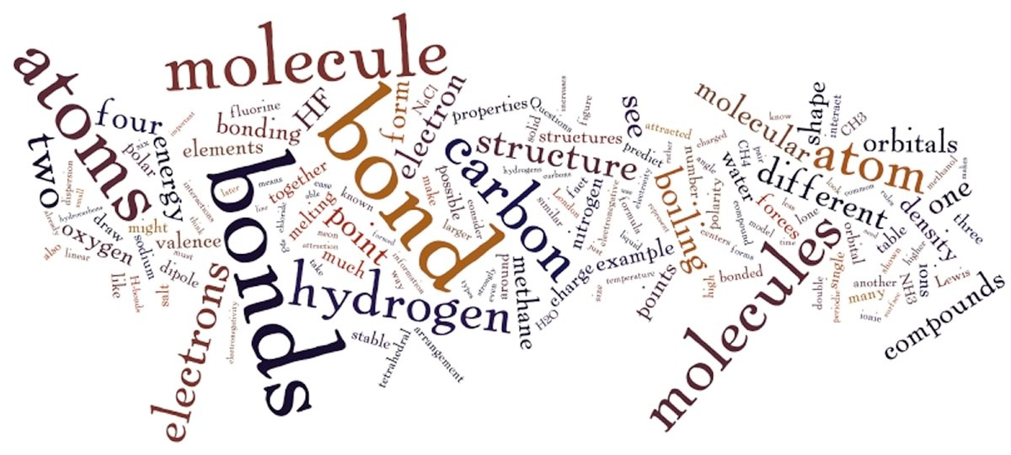

Up until this point we have considered only bonds between atoms of the same element. While this makes things simpler (although you might not agree after thinking about the many forms of carbon), it leaves out the vast majority of the compounds that exist in the world and their chemistries. Moreover, pure elements are rare in nature. Much of the efforts of alchemists, early chemists, and the modern refining industry involve determining how to (economically) separate specific types of atoms (elements) away from others. Modern chemistry is concerned (largely) with putting atoms together to form new and useful molecules. Both involve understanding the concepts underlying how atoms interact.

## 3D and 2D Representations

To extend our discussion to the wider world of what we might call heterogenous molecules, that is, molecules made up of atoms of more than one element, we will begin with carbon. Why carbon? Well, here are some reasons. Carbon is the fourth most abundant element in the universe (~3,032 atoms per million), after hydrogen (~705,700 atoms per million), helium (~275,200 atoms per million), and oxygen (~5,920 atoms per million). Carbon is distinguished from most other elements in its ability to form a vast array of diverse compounds by bonding with itself and other elements with bonds that are not too strong and not too weak. Under the conditions that persist on the surface of the Earth carbon compounds are stable enough to hang around but not stable enough to persist forever, so they are not dead ends. Carbon is a key building block of the major molecules of life: proteins, nucleic acids, lipids, and carbohydrates. We are carbon-based life forms! Carbon compounds are also used in a wide range of synthetic materials, such as pharmaceuticals, polymers, and high-tech materials; we also consume a lot of carbon compounds by burning them for fuel.

### Carbon: Always Tetravalent and Often Tetrahedral

Atoms combine in many different ways. We have already seen an example of how a covalent bond can form between two hydrogen atoms producing molecular (H2) as opposed to the atomic form of hydrogen. Similarly atoms of carbon can be linked together in various ways to form diamond, graphite, and graphene (see Chapter 3). Now we move on to molecules involving atoms of carbon and other elements. In keeping with our ongoing attempt to keep things simple (or better put, as simple as possible), let us start by examining the types of molecules that can be formed by combining carbon with hydrogen. There are many such molecules, and collectively they are known as hydrocarbons. The simplest such compound is methane CH4, a major component of natural gas. As in all its compounds and its elemental forms, carbon is tetravalent, which means that it always forms four bonds. We will now consider in greater detail why this is so, what forms the bonds can take, and what are the consequences of this fact. In this discussion, we will be building on the ideas introduced when we talked about diamond, graphite, and graphene.

To answer these questions we need to return to the ideas (introduced in Chapter 2) about the quantization of electron energy levels. Carbon has a total of six electrons, two of which are in a filled (1s) quantum shell, and four valence electrons; it is these valence electrons that can take part in bonding. Remember that the formation of a bond always lowers the energy of a system. It therefore makes sense that a carbon atom would form as many bonds as possible, resulting in the most stable possible molecular species.

What happens if we combine hydrogen with carbon? Do we get a compound with properties intermediate between the two? Absolutely not, as you might have expected when considering the differences between diamonds and graphite. As previously we use the hybridization model to explain the behaviors we observe. We begin with what we know: in methane the carbon atoms make four bonds, one to each of four hydrogen atoms. We also know, from experiment, that the shape of the methane molecule is tetrahedral; there is a carbon at the center and the four C–H bonds pointing towards the corners of a four-sided figure. Since each C-H bond is formed from bonding orbitals we can use the model for bonding where these four bonding orbitals arise from the “hybridization” of the pre-existing 2s and three 2p atomic orbitals. The electrons in the 1s orbital are not used because the amount of energy needed to use those electrons is greater than the energy that would be released upon bond formation (they are held tightly to the nucleus by the electromagnetic force). It turns out to be a general rule that electrons in the core of the atom—in filled shells—tend not to take part in bonding. This means we need only consider the valence electrons when thinking about bonding.

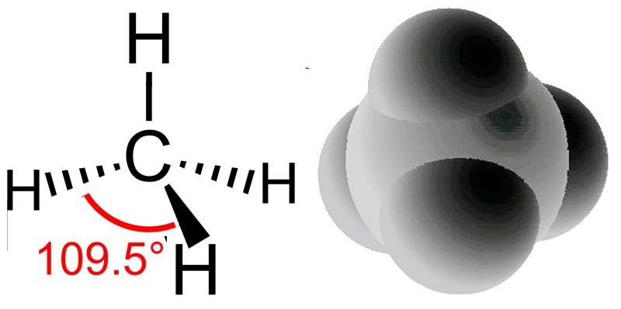

The hybridization of the 2s and the three 2p orbitals results in four sp3 molecular orbitals, each of which can interact with the H atom’s 1s orbital to form a bond. When a bonding orbital is formed it contains two electrons. Because carbon has four valence electrons and each of the four hydrogens has one electron the result is a total of eight electrons distributed in four bonding orbitals.

Recall that we say the hybridization of carbon is sp3 and the arrangement of the bonds is tetrahedral, which means the angle between orbitals (and the C–H bonds) is 109.5º. Another way to say this is that the H–C–H bond angle is 109.5º. We can predict that this will be the case based on theoretical calculations; these have been confirmed by experimental observations. But why should this be true? How many different arrangements are there for four hydrogens bonded to a single carbon? Why aren’t the hydrogens all arranged in a single plane (around a central C with 90º bond angles) rather than in the tetrahedral arrangement? The planar arrangement, which is known as a square planar geometry, is actually possible and is sometimes observed under some special conditions, usually in molecules involving transition metals as we will see later). The square planar arrangement is not as stable as the tetrahedral arrangement for carbon because each C–H bond can be considered as a region of high electron (negative charge) density. Given that like repels like, each bond repels the others and moves as far away from the other bonds as possible. The optimum bond angle turns out to be 109.5º away from each of their neighbors. At that point, if they moved away from one orbital they would move closer to another. You may want to convince yourself of this geometric fact by using a marshmallow, toothpicks, and gumdrops! This principle goes by the unwieldy name of valence shell electron pair repulsion (VSEPR) and can be used to predict (once you get the hang of it) the three-dimensional (3D) structure of simple molecules—assuming that you know how the atoms within a molecule are connected. For example, using VSEPR logic, you should be able to present a compelling argument for why the C–H bonds in methane do not adopt a square planar orientation, as well as the general shape of many other types of molecules. You can even go further, in methane all four atoms attached to the central carbon are the same but what if they are different? You should be able to make plausible predictions about how bond angles would change if one of the attached groups is larger than the others – how would that influence bond angles?

One problem for many people is that 3D visualization of molecular structures is not easy. It is particularly tricky when one is called upon to translate the more or less abstract two-dimensional (2D) representations (Lewis and dot stuctures ↓) that you find printed on the page of a book, into a 3D model you can manipulate with your hands or in your mind. In addition, chemists (and molecular biologists) have an annoying tendency of representing complex 3D structures using various 2D representations, which can be confusing if you don’t know what you are looking at (or for). You have probably already seen some of these different structures, and we will consider a number of them below. Each provides specific kinds of information about the molecule. Note that actual 3D physical models and web activities can be very helpful in solidifying your 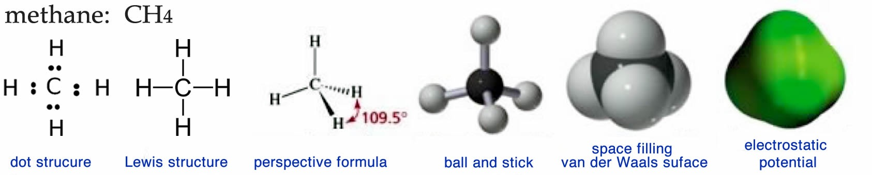ideas about structure.

If we were able to see a methane molecule, what we observe would probably be closest to the electrostatic potential map. This visualization provides a picture of the surface of the molecule, generally color coded to represent fluctuations in electron density. Notice that there are no color fluctuations on this model of methane indicating that there are no (permanent) electron cloud distortions in the molecule—the surface of the molecule is uniformly electrically neutral. What is not so easy to discern from this representation is the fact that the methane is tetrahedral or that the central carbon atom is bonded to four hydrogen atoms, a fact that is much easier to appreciate in the other representations. The electrostatic potential representation is very useful for large biological molecules for several reasons: it is much simpler than the other kinds of models because individual atoms are not represented; it shows the molecule’s shape; and it shows where charges and partial charges are located.

The space-filling or van der Waals model gives more structural information in that the individual atoms that make up the molecule are distinguished by color (black for carbon, white for hydrogen, red for oxygen, and blue for nitrogen.) The surface of the model represents the molecule’s van der Waals radius, which is the distance where attraction turns to repulsion when two molecules approach one another. As its name implies, such models represent the space occupied by each atom.

The ball-and-stick model of methane shows the central carbon (black ball) attached to four hydrogens (white balls) by sticks that represent the bonds between the atoms. Although this model is probably the easiest to visualize, it is misleading because it could give the impression that bonds are like sticks holding the atoms together. It also does not represent either the actual volume occupied by the molecule or its electrostatic surface features. Another problem with all three of the preceding types of models is that you need a computer and specialized software (or some artistic ability) to draw them, which may not always be convenient or possible.

One strategy to address this problem is through what is known as a perspective formula. In a perspective formula the atoms are represented by their atomic symbols (for example, C or H) and bonds are represented by various kinds of lines. A normal line is meant to indicate a bond that is in the plane of the paper, a wedged line  represents a bond that is coming out of the plane toward you (the reader), and a hatched line  represents a bond that is coming out of the plane, but away from you. This convention makes it easier to draw 3D perspective structures by hand without specialized software (or graphical talent.) We can, in fact, go one step further and draw methane without indicating its 3D structure at all. Structures that show all the bonds, atoms, and any valence electrons that are not in bonds, but do not attempt to accurately represent the 3D shape of a molecule are called Lewis structures. The Lewis structure for methane (see above) and the molecular formula CH4 represent a chemical shorthand that can provide a huge amount of information; we will see even more extreme examples as we go on. However, to be able to understand these representations, you must already know that the methane molecule is tetrahedral and the rules that apply to the geometry of carbon bonds, because neither is shown explicitly. If you didn’t know these things, you might even be tempted to assume that methane is organized with a square planar geometry or that the hydrogens are all located to one side of the carbon atom, neither of which is true!

Why, you might ask, would one want to draw structures with so much information missing? Perhaps, like medieval alchemists, modern chemists want to keep their secrets from the average person. Perhaps they just like secret codes and mystical symbols. Or perhaps it is because these shorthand representations of molecules are just much more compact and easy to draw, particularly when we get to large molecules with lots of atoms.[70] Drawing Lewis structures is an important and useful chemistry skill and we will return to it in more detail shortly. Once you have mastered it you will be able to look at a molecular formula such as CH4 (or C5H12) and (together with other information) be able to visualize the 3D structure of the molecule represented and predict many of the substance’s physical and chemical properties.

For example, models of the methane molecule predict that it is symmetrical. Again, this might not be entirely obvious just by looking at the structure, but if you make a model, or look at a rotatable interactive 3D model on the web you will see that it does not matter which way you look at the structure—all the C–H bonds are the same, and all the bond angles are the same. A little more information (which we will discuss later on) will let you deduce that there are no permanent electron density distortions in the molecule—just as is shown by the electrostatic potential map. Together these enable you to deduce that methane molecules are attracted to one another solely through London dispersion forces (like helium atoms or hydrogen molecules). Given how weak these interactions between molecules are we might be brave enough to predict that the melting and boiling points of methane are low (melting and boiling occur at relatively low temperatures) and we would be right! Methane melts at 91 K and boils at 112 K.[71]

**Question to Answer**

* Why (when present) are the four bonds formed by carbon usually arranged so that they point towards the corners of a tetrahedron?

**Questions to Ponder**

* If bond formation is stabilizing, why doesn’t carbon form six bonds, given that it has six electrons?
* Why doesn’t helium bond with carbon?
* What would be the consequences if carbon bonds with other atoms were very weak?
* What would be the consequences if carbon bonds with other atoms were very strong?

### Building Increasingly Complex Molecules

You will soon realize that it is possible to build a rather amazing number of compounds using just hydrogen and carbon. For example imagine that we remove one hydrogen from a methane molecule; this leaves us with what is known as a methyl (-CH3) group. We can combine two methyl groups by forming a C–C bond between them (you might want to convince yourself that each carbon atom is still making four bonds with neighboring atoms). The resulting molecule is known as ethane (→). The structure of ethane can be written in a number of ways, for example H3C–CH3, CH3–CH3 or C2H6. As the number of atoms increases so does the number of different ways a molecule can be represented. It is for this reason that chemists have developed a number of rules that are rather strictly adhered to; these rules make it possible to unambiguously communicate the structure of a molecule to others.[72] We will not spend much time on all of these various rules but there are web activities that you can do if you want to get an introduction and to practice them. These naming conventions are controlled by the International Union of Pure and Applied Chemistry, known as IUPAC and these rules can be found in the Compendium of Chemical Terminology.[73]

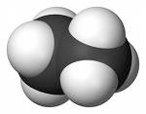

The process of removing hydrogens and adding methyl groups can continue, essentially without limit, to generate a family of hydrocarbons[74] known as the alkanes; the rules that govern these molecules are simple: each hydrogen makes one and only one bond; each carbon must make four discrete bonds; and these four bonds are tetrahedral in orientation. The number of carbons is in theory unlimited and how they are linked together determines the number of hydrogens. (Can you see how two hydrocarbons with the same number of carbon atoms could have different numbers of hydrogens?)

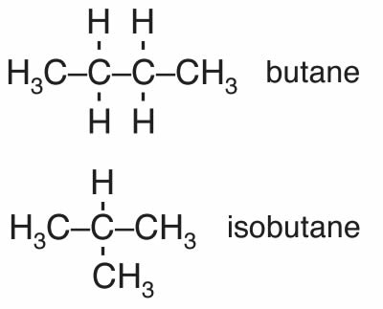

Depending on how the carbons are connected it is possible to generate a wide variety of molecules with dramatically different shapes. For example there are cage-like, spherical, and long, string-like alkanes. Consider the four-carbon alkanes. There are butane and isobutane that have the formula C4H10 as well as others with four carbons but different numbers of hydrogens, for example: cyclobutane, methylcyclopropane, and tetrahedrane. Butane has a boiling point of -0.5ºC, and isobutane has a boiling point of -11.7ºC. Why are the boiling points of butane and isobutane, which have the same atomic composition (C4H10), different? The answer lies in the fact that they have different shapes. The roughly linear carbon chain of butane has a larger surface area than isobutane, which gives it more surface area through which to interact with other molecules via London dispersion forces. This idea, that the shape of a molecule and its composition, determine the compound’s macroscopic properties is one that we will return to repeatedly.

**Question to Answer**

* Why are the melting and boiling points of methane higher than the melting and boiling points of H2?
* How many different compounds can you draw for the formula C5H12?
* What structures could you imagine for hydrocarbons containing five carbon atoms?
* Is there a generic formula for an alkane containing n carbon atoms? How does forming a ring of carbons change your formula?
* Which has the higher boiling point, a spherical or a linear alkane?
* How do boiling points and melting points change as molecular weight increases?

**Question to Ponder**

* Make a prediction as to the melting and boiling points of ethane, compared to methane. What assumptions are you making? How would you test whether those assumptions are valid?
* Why does the shape of a molecule influence its behavior and its macroscopic properties?

## 4.2 Single Bonds and Molecular Shape

C–C and C–H bonds are described by molecular orbitals; calculations indicate that most of the electron density associated with these orbitals lies between the two nuclei. The C–H bonds have a length of 109 x 10-12 m (109 pm) while the C–C bond is approximately 50% longer, 154 x 10-12 m (154 pm). This is because the C–C bonding orbital is made from sp3 hybrid orbitals, which are larger than the 1s orbital that hydrogen uses to form bonds. These so-called σ (sigma) bonds have an interesting property; the atoms that they link can spin relative to each other without breaking the bond between them. For a C–H bond, if the H spins it would be impossible to tell, since the H atom is radially symmetric around the C–H bond axis. But if the carbons in the C–C bond of ethane spin relative to each other, then it is possible to observe different arrangements by looking down the C–C bond axis. For example:

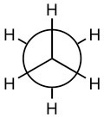 and 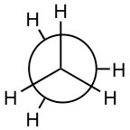are both representations of ethane (the C–C bond is not seen in this depiction because you are looking straight down the C–C bond). They appear different because the arrangement of the atoms is different in space, but in fact at room temperature these two arrangements can easily interconvert by rotating around the C–C bond.

This raises another point to consider, namely that starting (and stopping) bond rotations requires energy. Similarly, there can be vibrations along the length of a bond, which again involves the absorption or release of energy. We will consider this further later on.[75] In the case of the rotating bond it turns out that as the bulk of the groups attached to the carbons increases the energy required for the rotation around the C–C bond also increases. Big, bulky groups can bump into each other, occupying each other’s space causing electron-electron repulsions and raising the energy of any shape where the groups are too close. This tends to lock the molecule into specific orientations that can influence the compound’s physical properties. An example of how structure interferes with the formation of a molecule is a molecule containing 17 carbon atoms and 36 hydrogen atoms (→); although it is possible to draw this molecule it has never been synthesized because the atoms crowd each other, and intrude on each other’s space. It is possible, however, to synthesize molecules with the same number of carbon atoms but fewer hydrogen atoms.[76] Can you produce a plausible explanation for why?

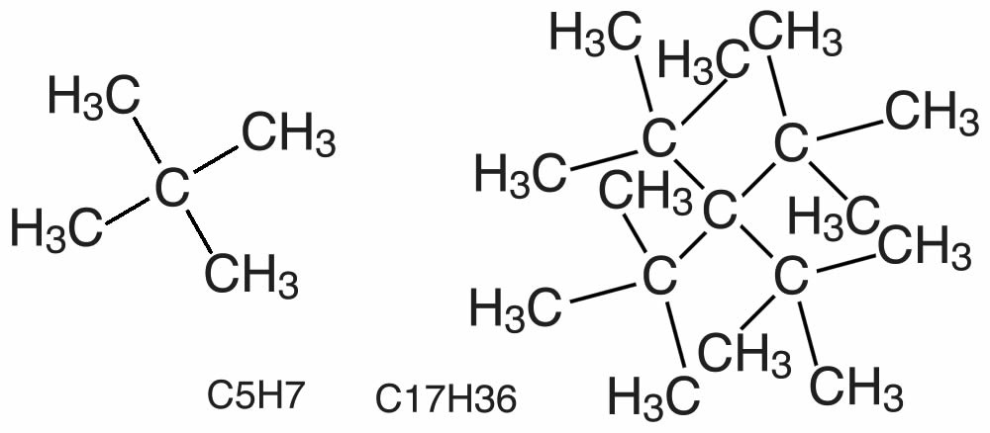

### Collapsing Real Structures Down to 2-Dimensional Representations

Now, an obvious problem with complex three-dimensional molecules, even those made up only of hydrogen and carbon, is how to convey their structure when they must be depicted in two dimensions, like when you are writing on paper. Research indicates that students (that is, most people) have a tough time with this task, which is why we will describe various approaches here.

Before we begin, we need to have some rules. Let us use the set of possible molecules that contain 5 carbon atoms and 12 hydrogen atoms; these are generically known as pentanes. You can begin with a piece of paper and a pencil; how many different molecules can you draw with the composition of C5H12? Clearly C5H12 does not uniquely define the structure of the molecule; it is better to use their distinct names: pentane, isopentane, and neopentane (→). Each of the different molecules you have drawn has the same molecular formula but a different shape and, it turns out, different properties. For example, pentane has a boiling point of 308 K, whereas the boiling points of isopentane and neopentane are 301 K and 283 K, respectively. Their shape, rather than their elemental composition, influences the strength of the attractions between the individual molecules, which in turn influences their boiling points. We call these kinds of related compounds structural isomers, which means they have the same composition (for example C5H12) but their constituent atoms are connected differently to give different structures and shapes.

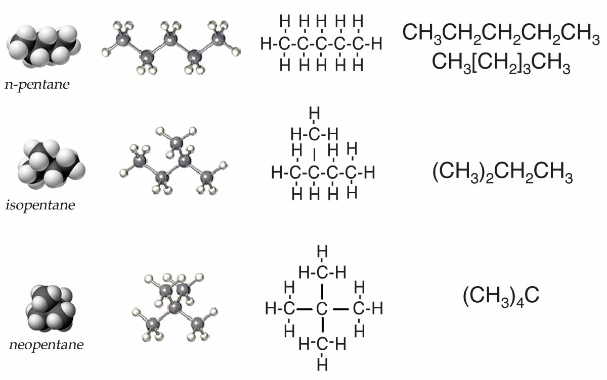

It is common to use a number of different types of representations to picture molecules. One way is through what are known as text formulas (or linear formulae). In this scheme, pentane is written CH3–CH2–CH2–CH2–CH3, which can also be written as CH3–[CH2]3–CH3. This captures some of the structural subtleties of pentane, but not all. For example, it does not illustrate the fact that the molecule is not strictly linear. Nevertheless, we can already anticipate complications. How would we write isopentane? The most obvious way would be (CH3)2CHCH2CH3. Neopentane is written as (CH3)4C. Does that make sense? Try deciphering them. We will return to this point later on in this chapter.

If we followed the logic of this approach we could draw a more complete representation of pentane, isopentane, and neopentane as Lewis structures, but again, we are missing the three-dimensionality. You might even be led to think that the molecules are actually flat when they are much more like balls. Although it is possible to make the representation a little more realistic by trying to indicate three-dimensionality using the wedge and dash symbols, these structures become very complicated very fast. It is not really practical to draw out full 3D structures for larger, complex molecules. One important skill you will need to master is the ways that short-hand structures (such as Lewis structures) can provide information about the 3D structure of a molecule that allows us to predict chemical and physical properties.

There is one more representation you will often see used that leaves out even more information. In the line structure the only things that are shown are the bonds between carbons! So for example for the pentanes (C5H12) we can draw structures such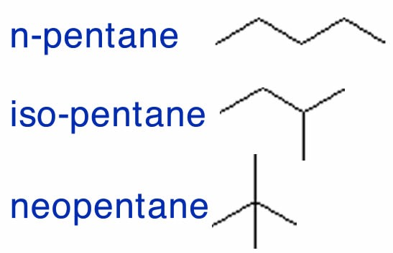 as those shown in the figure that omit all the symbols for atoms and all the C–H bonds. These structures should be used with caution because it is very easy to forget atoms or bonds when they are not in the representation. But what these line structures do show clearly is how the carbon atoms are connected, which can be very helpful at times.

**Questions to Answer**

* How many different compounds can you draw for C6H14? Draw out the full Lewis structure, the condensed formula, and the line formula.
* What are the advantages and disadvantages of each type of structure?

**Questions for Later:**

* When you think about rotating around a C–C bond (say in ethane), there are more and less stable orientations. Which orientation do you think is the most stable and why?
* Now imagine a butane molecule (C4H10) looking along the C2-3 bond. You would see one methyl group and two hydrogen atoms bonded to the two carbon atoms. How would that influence rotation around the C–C bond we have been considering?

## 4.3 Double and Triple Bonds

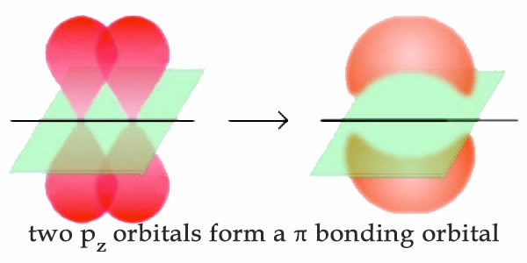

So far, we have considered what are known as single bonds; that is, all the C–C and C–H bonds in alkanes, and all the bonds in diamond. Each single bond involves two (and only two) electrons that are described by a bonding molecular orbital. In such a bonding orbital, most of the electron density is located between the two bonded atoms in a linear sigma (σ) bond. We have, however, already discussed albeit briefly bonds that involve more than one pair of electrons, namely those found in graphite. Recall that for graphite and graphene the bonds between carbon atoms in the sheet plane involve hybridized orbitals that are mixtures of the 2s2 and 2px and 2py (that is sp2 hybrid orbitals) leaving an unhybridized 2pz orbital. On bonding, these unhybridized 2pz orbitals reorganize to form what is known as a pi (π) bonding orbital. In π orbitals, the electron density lies above and below the axis connecting the bonded atoms. The combination of σ and π bonding orbitals produces a double bond. Double bonds are indicated by two lines, for example as in CH2=CH2 (ethene).

### Shapes of Molecules with Double (and Triple) Bonds

We can apply the same thinking about the arrangement of bonds around the carbon atoms in CH2=CH2 in much the same manner as we did for CH3–CH3. In ethene each carbon atom is surrounded by three centers of electron density, two Hs and one C. Note that the double bond counts as a single center of electron density (→). There are a number of important points to keep in mind when considering the effects of double bonds on a molecule and its properties. First, a C=C double bond is typically less stable (that is more reactive) than two separate single bonds. When we come to thinking about reactions we will find that replacing a double bond by two single bonds typically produces a more stable system. Second, although there is more or less free rotation around the axis of a single bond at room temperature, rotation is blocked by the presence of a double bond. For a rotation to occur, the π bond (in which there is electron density above and below the axis between the two carbon atoms) must be broken and then reformed. The presence of a double bond has distinct effects on molecular shape. The minimum energy arrangement for three centers is a two-dimensional arrangement in which the groups are oriented at about 120º to one another; an arrangement known as trigonal planar geometry.

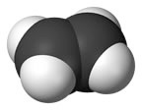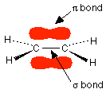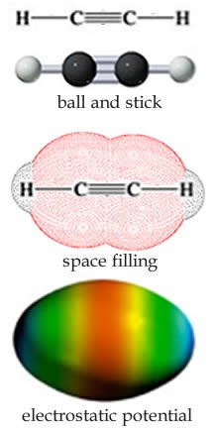

There is one more common type of bond that carbon can form, which is a triple bond. For example each carbon in C2H2 (ethyne) is surrounded by only two centers of electron density: a single sp hybrid orbital bonds between a carbon atom and a hydrogen atom and a triple bond, which can be thought of as a σ bond and two π bonds between the carbons, shown in the figure (→). The lowest energy arrangement around each carbon is a line in which the angle between the bonds is 180º. As before, a triple bond is less stable than three single bonds, and reactions can be expected!

We see that under most conditions, a carbon atom can participate in a maximum of four bonds; either four single bonds, two single bonds and a double bond, or one single bond and a triple bond.

**Questions to Answer**

* + Given a particular hydrocarbon, what factors would influence your prediction of its melting and boiling points? Can you generate some tentative rules?
  + How does the presence of a double bond influence the structure of a hydrocarbon?
  + How is the presence a triple bond different from that of a double bond?
  + Why do you think there is no tetrabonded from of carbon (that is C four bonds C).

**Questions to Ponder**

* + What limits the size and shape of a hydrocarbon?

## 4.4 Bonding in Nitrogen, Oxygen, and Fluorine

Even though the bonding of hydrogen and carbon atoms can generate a remarkable array of molecules, the hydrocarbons are really rather boring (chemically). They take part in a rather limited range of reactions and would not, on their own, be expected to produce anything like life. Of course there are many other elements, and their properties add chemical complexity to molecular behavior. From the perspective of living systems two of the most interesting elements are nitrogen and oxygen. Carbon has six electrons (two core and four valence) and can form four bonds with neighboring atoms. Nitrogen has seven electrons: two core and five valence: 1s2, 2s2, 2px1, 2py1, 2pz1. So if you are following the rules, you might well assume that nitrogen would be able to form five bonds (after all, it has five valence electrons). But when we look carefully, we never see a nitrogen atom making five bonds, and in all stable compounds it makes only three bonds. We can explain this observation in several ways. One factor is that nitrogen atoms are too small to support five centers of electron density around themselves because the bonds begin to overlap, which is destabilizing, just like we saw with bulky groups around a carbon. Another factor is that there are only four orbitals available in nitrogen in the second quantum shell. If nitrogen were to form five bonds it would have to use orbitals from the next quantum shell (3), but these orbitals are so high in energy that the energy required would not be offset by the energy released upon on bond formation. Together these factors mean that nitrogen, and in fact all elements in the second row of the periodic table, are limited to bonding arrangements with no more than four centers of electron density. As we will see later on, elements in the next row, such as phosphorus (P) and sulfur (S), are larger and have more available orbitals for bonding. These elements can form up to six centers of electron density.

The simplest compound of nitrogen is molecular nitrogen, N2. The two nitrogen atoms are bonded together by a triple bond, consisting of a σ and two π bonds. Molecular nitrogen, N2 is a stable (relatively nonreactive) molecular compound.[77] A common nitrogen-containing molecule is ammonia (NH3), which is analogous to methane (CH4). In ammonia the nitrogen atom is bonded to three hydrogen atoms. These three bonds involve three of nitrogen’s valence electrons; the remaining two valence electrons occupy a non-bonding orbital and are referred to as a lone pair. Given the molecular hybridization orbital model that we are using this implies that four sp3 orbitals are formed from the nitrogen atom’s 2s and 2p orbitals leading to four electron density centers around the nitrogen. The figure shows three representations of ammonia. The first indicates the N–H bonds but fails to show the lone pair orbital. The second uses the wedge and dash convention and dots to illustrate the geometry of both bonds and the lone pair. The actual shape of the molecule is determined by the arrangements of electron clouds and the bonded atoms. In NH3 all three bonds are equivalent (N–H) and so must be symmetrical, but the lone pair orbital is different because it takes up more space than bonding pairs, can you imagine why? This has a subtle effect on the shape of the molecule. The angles between the C–H bonds in CH4 are equal and 109º while the angles between the N–H bonds in NH3 are slightly smaller, 107.8º. The shape of the molecule itself (as outlined by the atoms) is a triangle-based pyramid rather than a tetrahedron. Finally the Lewis structure (the most abstract representation), indicates the bonds and lone pair electrons but gives an unrealistic depiction of the molecule’s geometry. It is up to the reader to supply the implicit information contained in the structure about bond angles and overall shape.

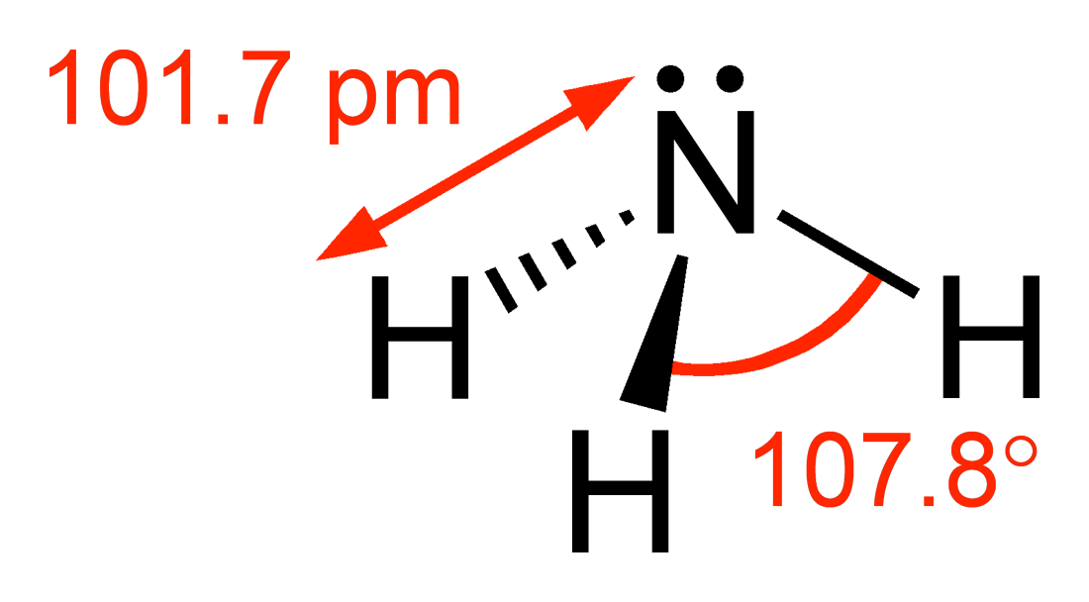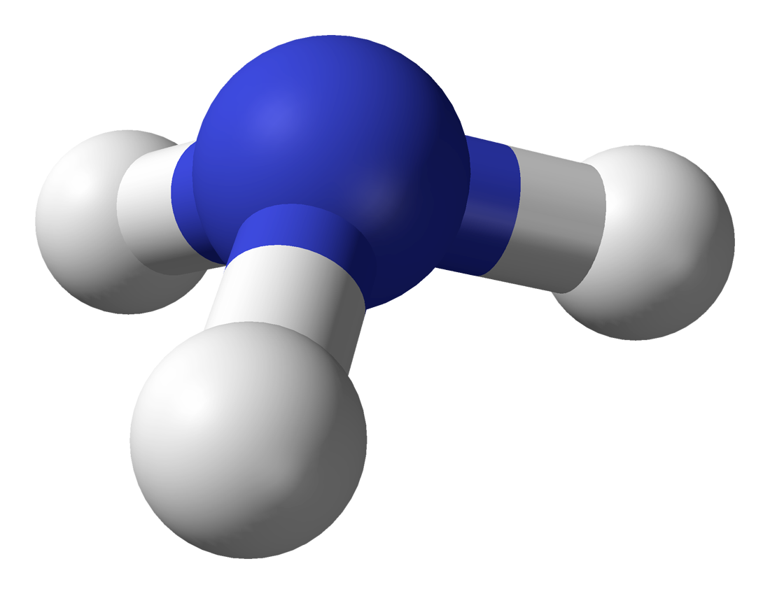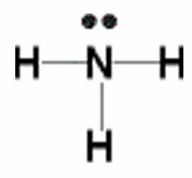

### Bonding of Oxygen and Fluorine

Let us now consider oxygen (O) which has eight electrons, two in the core and six valence (1s2, 2s2, 2px2, 2py1, 2pz1). As with nitrogen, oxygen does not use all its electrons to form six bonds because it is too small and the orbitals that would need to be used to make six bonds are too high in energy to be energetically accessible; that is, not enough energy would be released upon bond formation to “pay for” that energy.

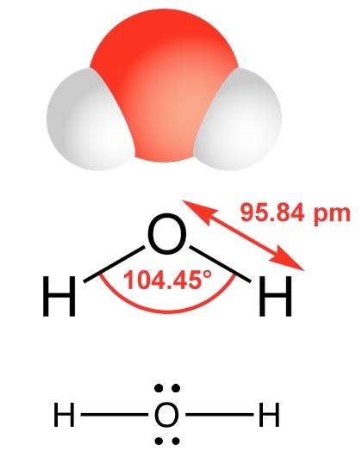

The simplest oxygen-containing molecule is molecular oxygen, O2. On our simple covalent bond model the two oxygen atoms are connected by a σ and a π bond, forming a double bond[78]. The next simplest, stable, most common, and by far the most important compound of oxygen at least from the perspective of living organisms, is water (H2O). In water there are two O–H bonds and two lone pair non-bonding orbitals. As in the case of nitrogen, the orbitals are sp3 hybrids and the oxygen atom is surrounded by four centers of electron density (see a pattern here?), two bonds, and two lone pairs. Again, the lone pair orbitals are larger than the O–H bonding orbitals, which distorts the tetrahedral symmetry of the molecule. Instead of equal angles of 109º between the orbitals, the angle between the O–H bonds is 104.5º. When we use a Lewis structure to represent the structure of H2O, it is critical to include all valence shell electrons.

Continuing on across the periodic table we see that fluorine is the next element after oxygen. It has nine electrons: two core and seven valence. Rather than forming seven bonds fluorine only forms a single bond for basically the same reasons that oxygen only forms two bonds. Hydrogen fluoride, HF, has one bond, but four centers of electron density around the fluorine. Because HF has only two atoms, they must by definition lie on a line and therefore we do not need to discuss its shape.

| Compound | Molar mass  (g/mole) | Boiling point | Bond type | Bond length (pm) | Atomic radius  (pm) |
| --- | --- | --- | --- | --- | --- |
| CH4 | 16 | –161 °C | C–H (in CH4) | 109 | C - 70 |
| NH3 | 17 | – 33 °C | N–H in (NH3) | 101 | N - 65 |
| H2O | 18 | 100 °C | O–H (in H2O) | 96 | O - 60 |
| HF | 20 | 19.5 °C | F–H in (HF) | 92 | F - 50 |
| Ne | 20 | –246.08°C | not applicable | not applicable | Ne - 38 |

As we will see, a valid Lewis structure makes it possible to extrapolate a significant amount of information about a molecule’s chemical and physical properties. A confusing point is 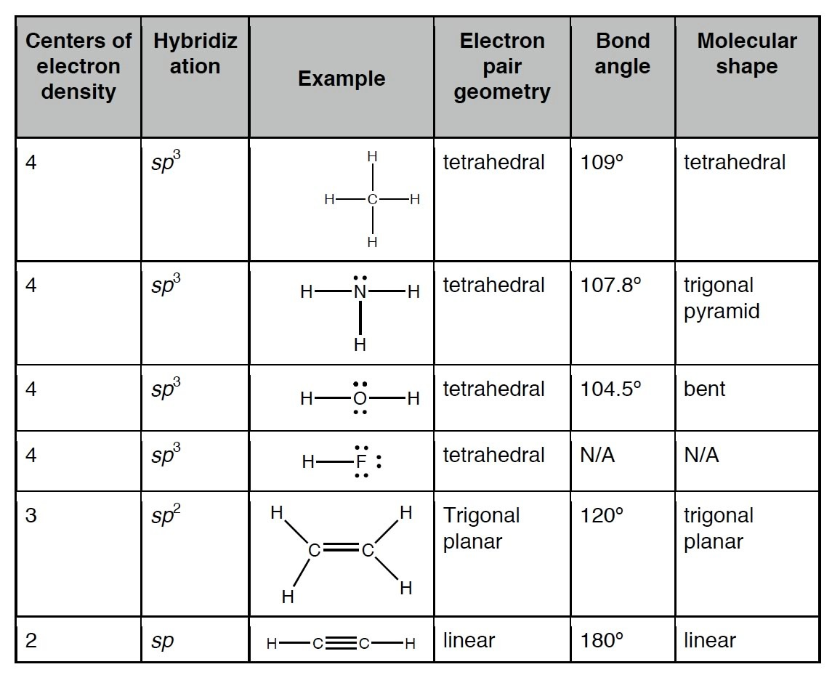that the Lewis structure can be written in a number of apparently different ways, which are actually equivalent. The key to remember is that the Lewis structure does not attempt to depict a molecule’s actual three-dimensional structure. It is a shorthand (a “cartoon” if you like) that assumes you already know the arrangement of orbitals. No matter how it is drawn, the actual structure of a H2O molecule is the same with a 104.5º bond angle between the O–H bonds.

| **CH4** | **NH3** | **H2O** | **HF** | **Ne** |
| --- | --- | --- | --- | --- |
| -258.7°F (-161.5°C) | -28.01°F (-33.34°C) | 212°F (100°C) | 67.1°F (19.5°C) | -410.9°F (-246.1°C) |

The tendency to form four centers (bonds or non-bonding pairs) has led to the rather misleading “octet rule”, which states that some elements tend to form molecules that have eight electrons around any atom (except for hydrogen). Unfortunately, the octet rule is far from being a rule because there are many exceptions, as we will see later. For example many of the elements past the second row of the periodic table are capable of bonding to more than four other atoms and some elements form stable compounds with less than eight electrons. It is important to remember that the octet rule is not the reason why atoms bond with each other, but it is a useful heuristic when constructing Lewis structures for the second row elements (C, N, O, F).

### Polarized Bonds and Electronegativity

Earlier we saw that the boiling points of hydrocarbons tend to increase as the number of carbons in the compound increases and that molecules with similar molecular weights have similar but not identical boiling points, with the shapes of the molecules having an effect, although a relatively small one. The attractions between hydrocarbons are due to London dispersion forces that depend on the size, surface area, and shape of the molecule. The larger these forces, the more strongly molecules will stick together and the more energy (higher temperature) will be needed to overcome these attractions.

Let us consider the boiling points of some common second row compounds involving bonds with hydrogen, that is, CH4, NH3, H2O and HF, and neon (Ne), which does not form bonds with hydrogen (the compounds of lithium, beryllium, and boron with hydrogen are much less common.) These compounds all have about the same molecular weight but different shapes. Based on our experiences with hydrocarbons, we would be well justified in predicting that they would have somewhat similar boiling points. Unfortunately, this prediction is not supported by experimental evidence (see Table). There is no clear trend, so something is going on that we have not yet considered. To explain this data we have to return to an idea that we discussed in Chapter 3, namely that the size of atoms decreases as you go across a row of the periodic table. Not only does the size (radius) of the atoms decrease (from 70 pm for carbon to 38 pm for neon) but so does the length of the bonds between the atoms and hydrogen (from 109 pm to 92 pm). This is both surprising and counterintuitive (which is why we are reminding you about it!)

Remember that the size of the atom is based on a balance between the attraction between the negatively charged electrons to the positively charged protons in the nucleus, the repulsions between the electrons as they get close to each other, and of course the arcane, but highly accurate rules of quantum mechanics. The reason that the atom’s size is decreasing as the number of protons increases is that each electron in the valence shell is attracted by an increasing number of protons in the nucleus. The more protons, the larger this attractive force. At the same time, the electrons in the same valence shell do not tend to repel each other as much as you might suspect because they are in different orbitals. Therefore the effective nuclear charge increases from left to right across the periodic table. This increase in effective nuclear charge doesn’t just affect the electrons in isolated atoms; it also affects the electrons in bonds. The ability to attract the electrons in bonds is called electronegativity, and because it derives from the same effect as that that determines effective nuclear charge and atomic radius, electronegativity also tends to increase from left to right across a row in the periodic table. It also decreases from top to bottom in a group of the periodic table. This makes sense because the further electrons are from the nucleus, the less they will be attracted to it. The exceptions to this rule are the noble gases (helium, neon, argon, etc.); because they do not form bonds with other elements (under normal circumstances) their electronegativities are usually not reported.

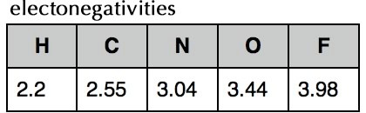

Electronegativities of selected elements

Fluorine is the most electronegative element and the Lewis structure of HF shows one H–F bond and three lone pairs. Fluorine attracts electrons very strongly—even the ones in the H–F bond so that the fluorine atom ends up with more than its fair share of electrons and the hydrogen atom ends up with less. One way to think about this is that the electron density in the H–F bond is shifted closer to the fluorine atom and away from the hydrogen atom (→). The result of this is that the fluorine atom has more negative charge than positive charge and the hydrogen atom has more positive than negative charge. We indicate this by writing a δ– charge on the fluorine atom and a δ+ charge on the hydrogen atom (δ is often used to denote a small increment, that is less than 1). That means that there is an unequal distribution of charge in the molecule. The HF molecule has a permanent dipole, that is, a separation of charge; the H–F bond is said to be polarized and the molecule is considered polar. Permanent dipoles are different from the transient dipoles associated with London dispersion forces. Because of their permanent dipoles molecules of HF interact with one another both attractively and repulsively, more strongly in some orientations than in others. HF molecules are attracted to each other much more strongly than neon atoms, for example, because of the presence of these permanent dipoles. This results in a much higher boiling point for HF than for neon (see above). That is, much more energy has to be supplied to the system to overcome the force of attraction and to separate HF molecules from each other than is needed to separate neon atoms. An important point to note is that HF only has one bond, and the polarity of the bond is the same as the polarity of the whole molecule. As we will see, this is not the case in molecules with more complex structures.

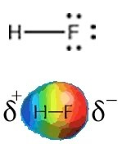

It is relatively easy to predict whether a particular bond is polar by looking at the electronegativity differences between the atoms in that bond. Typically, elements on the left-hand side of the periodic table (metals) have rather low electronegativities and elements over toward the right-hand side (non-metals) have higher electronegativities. There are several ways to calculate electronegativities but in general it is not very useful to memorize specific numbers. It is helpful, however, to understand the trends and to be able to predict bond polarities. Because fluorine is the most electronegative element it can be expected to make the most polarized bonds with hydrogen.[79] So let us take this logic a bit further. If HF has the most polar bonds then HF molecules should stick together with the strongest attractions and HF should have the highest boiling point. But oh no! Water’s boiling point is significantly higher (100 ºC compared to 19 ºC for HF). What is going on? Oxygen is not as electronegative as fluorine and so the O–H bond is not as polar as the H–F bond. Why then is the boiling point of H2O 81 °C higher than HF? To answer this question we need to consider another factor that affects the polarity of a molecule – and that is molecular shape.

**Questions to Answer**

* Why do you think that the trends in effective nuclear charge, ionization energy, and electronegativity are correlated?
* What does correlated mean?
* Can you draw a picture of (say) four H–F molecules sticking together?
* Is there any arrangement that they might take up or would they stick together in a totally random way?

**Questions to Ponder**

* + Why would you not expect polymeric oxygen, that is molecules similar to hydrocarbon chains (or perhaps you would)?

## 4.5 Molecular Shapes, Polarity, and Molecular Interactions

Now we really have to begin to use our 3D thinking and consider several additional factors: the shape of the molecules and how they interact. Much of this thinking is best done hands on with molecular models but we will outline the logic involved here. The HF molecule has a simple shape; it is linear with (partially) positively and (partially) negatively charged ends. In contrast, the H2O molecule has a more complex shape; it has two polar O–H bonds. To understand how this affects the polarity of the molecule we have to take into account the number of bonds, their polarization, and the overall shape of the molecule. Bond polarity is a vector quantity, which means it has both a magnitude and a direction. This is where an understanding of the 3D structure of the molecule becomes critical. Each O–H bond is polarized and the overall polarity of the molecule is determined by the vector sum of these bond polarities (that is you have to take into account both the magnitude and the direction of the bond dipoles). This may sound a bit complicated but in practice it is relatively easy to predict qualitatively what the overall polarity of the molecule is as long as you keep in mind its 3D structure. In water the two O–H bonds are at an angle of about 107° to each other (→). If we add the bond dipole moments up you can see that the overall direction of the dipole for the molecule bisects that angle, as shown in the figure. Now you might think that this exercise is a bit of a waste of time—surely it would make sense that if a molecule has polar bonds, then the molecule itself should be polar. However, as we will see shortly this is not always the case.

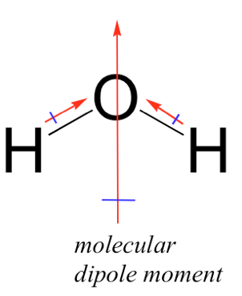

If we apply a similar analysis to ammonia (NH3) we see that the N–H bond is polar with a δ+s on the hydrogen atoms and a δ– on the nitrogen atom. Remembering that the actual shape of NH3 is a triangular based pyramid, with an H–N–H bond angle of ~105º, we can see that there is an overall dipole moment in ammonia. Therefore ammonia is a polar molecule.

If we contrast this with methane, however, we see two differences. The first is that carbon is not nearly as electronegative as nitrogen, oxygen, or fluorine, so the C–H bond is not as polar. That said, there is an electronegativity difference and so the electron density in the C–H bond is distorted towards the carbon atom (because it is a little more electronegative than the hydrogen atom.) At the same time, CH4 is symmetrical (tetrahedral.) If we add up all the bond dipoles they cancel each other out giving a molecular dipole moment of zero. Even if we were to replace the hydrogen atoms in methane with fluorine atoms to give CF4 (carbon tetrafluoride) the resulting molecule would still be non-polar, despite the fact that the electronegativity difference between carbon and fluorine is greater than that between hydrogen and oxygen! This is another example of something counterintuitive: something made up of polar parts that is not polar.

### The Famous Hydrogen “Bond”

Now that we have a better idea of how the shape and types of bonds in a molecule can affect its polarity, let us look a little more closely at how molecules interact with each other. The first thing to note is that globally non-polar molecules interact solely via London dispersion forces just like atoms of neon or helium. The boiling point of neon is –246 °C while the boiling point of CH4 is –161 °C. This means that methane molecules are more strongly attracted to each other than are neon atoms. We can explain this based on the fact that a methane molecule is larger than a neon atom. Because the electrons in methane molecules are dispersed over a larger area and their distribution (in space) is easier to distort, we say methane molecules are more polarizable. At the same time because methane molecules are non-polar, the boiling point of methane is much lower than that of substances made of polar molecules of similar size.[80]

Let us consider three such molecules: HF (bp 19.5 °C), H2O (bp 100 °C), and NH3 (bp -33 °C). All three are polar so they stick together but why are there such large differences in their boiling points? The answer lies in the fact that the molecules interact with one another in multiple ways. They all interact via London dispersion forces and dipole–dipole interactions. In addition, a new type of interaction, known as a hydrogen bond (or H-bond) is also possible. The term H-bond is somewhat misleading because these are much weaker than covalent bonds and do not involve shared electrons; the energy required to break a typical hydrogen bond is between 5 and 30 kJ/mole, whereas it requires over 400 kJ/mole to break a C–C bond.[81] In biological systems and in liquid water, H-bonds are continuously breaking and reforming. Hydrogen bonds are formed between two separate molecules.[82] In contrast to London dispersion forces, but like covalent bonds, H-bonds have a direction; they form when the hydrogen of one molecule, which is covalently bonded to an O, N or F, is attracted by the lone pair on an O, N of F of a neighboring molecule.

H-bonds are a special case of an electrostatic interaction involving a hydrogen atom that is bonded to a very electronegative atom (typically oxygen or fluorine) and an electronegative atom that has lone pairs of electrons. When a hydrogen is bonded in this way most of the electron density moves toward the electronegative atom, leaving a relatively large δ+ on the hydrogen. Water is a particularly important example of a molecule able to engage in hydrogen bonding, because each molecule of water has the possibility of forming four H-bonds (→). Each of the hydrogen atoms within a water molecule can bond to another water molecule, while each oxygen atom has two lone pairs that can interact with the electron-deficient hydrogen atoms of two different neighboring water molecules, shown in the figure. The ability to form large numbers and networks of hydrogen bonds is responsible for many of the unique properties of water including its relatively high melting point, boiling point, heat capacity, viscosity, and low vapor pressure. In contrast, HF and NH3 can form, on average, only two H-bonds per molecule. Can you figure out why this is so? Because there are fewer H-bonds to break, they have lower boiling points. HF has a higher boiling point than NH3 because the H-bonds in HF are stronger than those in NH3. (Can you figure out why?) In addition to their role in the bulk properties of substances like water, we will see that H-bonds play a critical role in the organization of biological systems, from the structure of DNA and proteins, to the organization of lipid membranes and catalytic mechanisms (but more about that later).

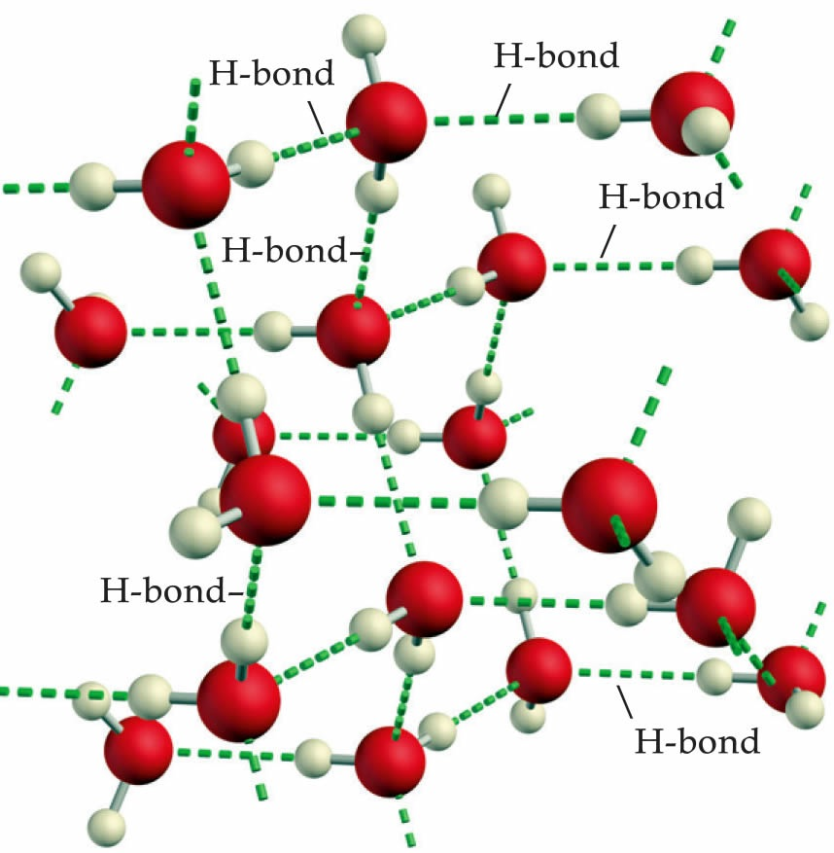

### Other Polar Bonds

We have seen that when hydrogen is covalently bonded to oxygen, nitrogen, or fluorine, the result is that the covalent bond is highly polarized and the majority of the electron density is located on the most electronegative atom. This means that the hydrogen atom has very little electron density remaining around it. Because hydrogen is such a small atom, the resulting positive charge density on the hydrogen atom is high. This leads to unusually strong attractions (H-bonds) with atoms that have lone pairs with which the positively charged hydrogen atom can interact. H-bonding is unique to molecules in which a hydrogen atom is covalently bonded to an oxygen, nitrogen, or fluorine atom. However, there are uneven charge distributions possible whenever two atoms with different electronegativities form a bond. Consider, for example, methanol (CH3OH). It has several different types of bonds with different distributions of charge in them. The familiar O–H bond in methanol is very much like the O–H bond found in water. That is, it is highly polarized and the hydrogen atom is a small, dense region of highly positive charge that can attract and will be attracted to regions of high electron density such as the lone pairs on oxygen. The methanol molecule also has a C–O bond and three C–H bonds. If we consider the differences in electronegativity we can predict the polarization of these bonds. Remember that carbon and hydrogen have quite similar electronegativities, and so the C–H bond is not very polarized. Carbon and oxygen, in contrast, are quite different in their electronegativities and the result is that the C–O bond is strongly polarized, with the δ+ located on the carbon atom and the negative end of the bond dipole on the oxygen atom. As we will see later this has implications for how methanol (and all C–O containing compounds) interact (and react) with other substances.

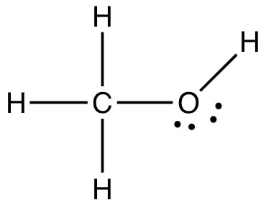

An inspection of the Lewis structure can reveal (to the trained mind!) a huge amount about the structure and polarity of a molecule and taking that one step further we can make predictions about the properties of the compound. For example if we compare the relative boiling points of methanol (CH3OH, bp 65 °C) and ethane (CH3CH3, bp -88.6 °C) we see (just as you already predicted no doubt) that methanol has a much higher boiling point because it takes more energy to separate molecules of methanol. The question arises: is this because methanol can form an H-bond with itself? Can you draw a picture of how this happens? Or is it because of the C–O dipole? We can look at this idea a little more closely by comparing the boiling points of three compounds that have similar molecular weights (so that they experience similar London dispersion forces), but different types of bonds in them.

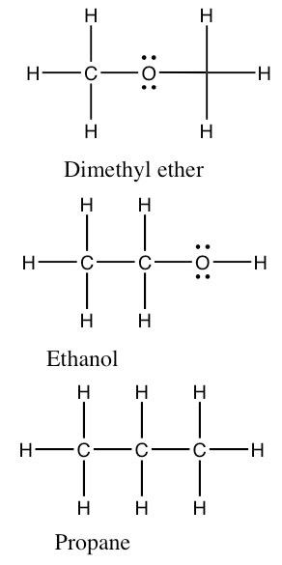

If we classify the kinds of bonds as before we see that dimethyl ether has non-polar C–H bonds and polar C–O bonds. The C–O–C bond angle is about 104°. Because each atom (except for H) is surrounded by four centers of electron density, the molecule is not linear as pictured. (Why not?) The molecule as whole is polar but cannot form hydrogen bonds with itself because none of the hydrogen atoms have a significant δ+ as they would if they were bonded to an oxygen atom. We call the type of forces between dimethyl ether molecules, dipole–dipole forces. On the other hand, an ethanol molecule—which has exactly the same molecular weight and formula—can form hydrogen bonds with itself because it has an O–H bond, and so has a small partially positively charged hydrogen atom. This minor difference has a huge effect on boiling point: ethanol boils at 78 °C whereas dimethyl ether boils at –23 °C. Both of them are considerably higher than propane at -44 °C (remembering that absolute zero is –273.15 °C). From comparing these three similar compounds we can see that a simple dipole–dipole attraction increases the boiling point by 21 °C, and on top of that the H-bonding attraction in ethanol is worth another 99 °C, bringing the boiling point of ethanol to 78 °C.

### Intermolecular Forces

Taken together, London dispersion forces, dipole-dipole interactions, and hydrogen bonds comprise a set of attractive forces that make separate molecules stick together. These are collectively named intermolecular forces, IMFs. These forces are caused by either permanent or temporary distortions of the electron cloud in a molecule – which leads to electrostatic attractions between separate molecules. For small molecules, the typical order for strengths of IMFs is:  
H-bonding (where available) > dipole–dipole interactions > London dispersion forces. At the same time, because London dispersion forces increase with molecular size and the extent of surface-surface interactions, they are often the predominant intermolecular force between large biological macromolecules.

### The Importance of Shape

While we are on the subject of carbon and oxygen containing compounds, let us take a look at one of the most common compounds of carbon and oxygen, carbon dioxide. You can draw the structure of CO2 with the carbon atom in the middle, double bonded to each of the oxygen atoms. That is, CO2 has two quite polar bonds in it, and so we might reasonably predict that its boiling point might lie somewhere between dimethyl ether and ethanol. But, as you probably already know, this is not the case. CO2 exists as a gas at room temperature. In fact CO2 does not have a liquid phase at standard atmospheric pressure; it changes directly from a solid to a gas, a process called sublimation, at -78 °C. How is such behavior to be understood, particularly given that CO2 has about the same molar mass as ethanol (CH3CH2OH), which is a liquid at room temperature? Once again we have to make sure we have considered all the factors that affect molecular polarity including bond polarity and shape. If you reflect back to the ideas about bond polarity and structure you will see that we have another case here of a molecule with polar bonds, but no overall polarity. CO2 has a linear structure so the bond polarities cancel each other out (they are at 180º from each other) (→). CO2 has no overall molecular polarity, even though it has polar bonds. Therefore the molecules do not stick together very well and it is a gas at room temperature.

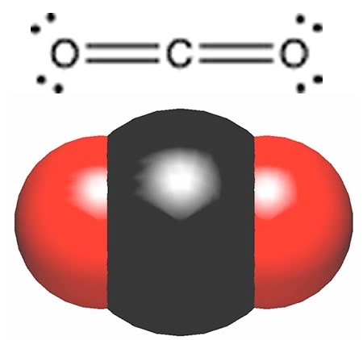

**Questions to Answer**

* What is the direction of the molecular dipole moment in ammonia? Draw out a picture showing how you came up with the answer. Does it matter which way you draw the molecule? What if you draw it upside down? Will that affect the direction of the dipole (in the real world)?
* Why are the interactions between H2O molecules stronger than those between HF molecules even though the polarity of the HF bond is larger than the polarity of the OH bond?
* Why don’t more than four water molecules interact with a central water molecule?
* What would you predict would be the relative boiling points of methanol (CH3OH) and ethane (CH3CH3), which have similar molecular weights?
* What would you predict would be the relative boiling points of methanol (CH3OH) and ethanol (CH3CH2OH)?
* What kind of compound (or what structural feature) would you expect might be attracted to the δ+ located on the carbon atom in methanol?

**Questions to Ponder**

* What would be the consequences (for life, the universe, and everything) if water molecules were linear?

## 4.6 Ionic Bonding

Our discussion up to now has centered on types of bonds that involve valence electrons being shared between (or more correctly being fought over – attracted to the opposite nuclei) different atoms. We have seen that we can consider electron density to be equally distributed between the bonding atoms, or that it may be distorted by being attracted to the more electronegative atom. What we have not looked at yet is the extreme case of this kind of distortion, in which the valence electrons are attracted so much by the electronegative atom that they are transferred completely. This kind of bonding is called ionic bonding (as you are almost certainly already aware).

Let us take a look at some common ionic compounds and see if we can make some sense of their properties from a consideration of their atomic-molecular structure. For the sake of simplicity we will confine ourselves (for the moment) to binary compounds (compounds with only two elements in them.) The most familiar of these compounds is sodium chloride (NaCl), common table salt. NaCl is a continuous compound that extends in three-dimensional array much like diamond (see Chapter 3.) NaCl is a solid at room temperature, with a very high melting point (801 °C), similar to the melting points of silver (961.78 °C) and gold (1064.18 °C), although much lower than the decomposition temperature of diamond (3550 °C). An interesting difference between diamond and sodium chloride occurs on heating. Remember diamond does not melt; it decomposes once enough energy is added to the system to break the C–C bonds. Under normal circumstances, the carbon atoms react with oxygen (O2) in the air to form carbon dioxide—a process that requires the addition of lots of energy to reverse (as we will see later). On the other hand NaCl melts (solid → liquid) and freezes (liquid → solid) at 801 °C, much like water, just at a higher temperature. Based on this difference, we might be tempted to conclude that covalent bonds are not broken when salt melts but that something stronger than the H-bonds that hold water molecules together are broken. What could that be?

A hint comes from studies first carried out by the English chemist Humphrey Davy.[83] Davy used a voltaic pile to study the effects of passing electricity through a range of substances.[84] Solid table salt did not conduct electricity, but liquid (molten) salt did. Not only did it conduct electricity, but when electricity (electrons) was passed through it, it decomposed to produce globules of a shiny, highly reactive metal (sodium, Na) and a pale green gas (chlorine, Cl2). Davy correctly (as it turned out) deduced that the elements in table salt (what we now know as sodium and chlorine) are held together by what he termed electrical forces. Just what caused those electrical forces was not discovered until the atomic nature of matter was elucidated over 100 years later.

It takes a great deal of energy to change table salt into its constituent elements. First the salt has to be heated to its melting point, and then electrical energy must be added to release the elements sodium and chlorine. The reverse reaction, combining the elements sodium and chlorine (don’t do this at home), produces sodium chloride and releases a great deal of energy (411 kJ/mol). Given the release of energy, we suspect that bonds are being formed during this reaction.

One of the important principles of chemistry is that structure on the atomic-molecular level is reflected in the behavior of materials in the real world. So, let us review some of the real-world properties of sodium chloride:

* It forms colorless crystals that are often cubical in shape and are hard and brittle.
* It has a high melting point and conducts electricity when melted, but not in the solid state.

Based on these properties, and what we know about interactions, bonds, and electricity, we can begin to make hypotheses about how atoms are organized in NaCl. For example, the fact that NaCl is a stable, crystalline solid at room temperature and that it melts at a high temperature implies that forces holding the atoms together are strong. The regular shape of salt crystals implies that bonds holding the atoms together extend in three dimensions with some regular pattern. If you take a large salt crystal and give it a sharp knock, it breaks cleanly along a flat surface. Diamond also behaves in this way. The ability of molten, but not solid, salt to conduct electricity suggests that melting leads to the appearance of moveable, electrically charged particles. The current interpretation of all these observations and experiments is that in the solid state salt (NaCl) is held together by the coulombic (electrical) attractions between sodium (Na+) and chloride (Cl–) ions. So when sodium metal (Na) reacts with chlorine (Cl2) gas, sodium and chloride ions are produced. In the solid state, these ions are strongly attracted to each other and cannot move, but they can move in the molten (liquid) state, and their movement is what conducts electricity (electrons).   
 One way to think of ionic bonding is that it is the extreme limit of a polar covalent bond. Typically, simple ionic compounds are formed from elements on the left-hand side of the periodic table (metals, such as sodium) and elements on the right-hand side (non-metals, such as chlorine). The non-metals tend to have a high electronegativity as a result of their high effective nuclear charge, whereas the metals have low electronegativity because their valence electrons are not very strongly attracted to their nuclei. When a metal atom meets a non-metal atom the non-metal attracts the valence electrons from the metal, so that for all intents and purposes electrons move from the metal atom (which then has a net positive charge) to the non-metal atom (which now has a net negative charge). This effect, however, applies only to the electrons in the unfilled valence shells. Electrons in a metal atom’s filled core orbitals require a lot more energy to remove. Why? Because they are closer to the positively charged nucleus (recall the jump in ionization energy when an electron is removed from the core). If there is a single outer-shell electron (as is the case with Na and other Group I metals) that electron is often lost, and the resulting atom (now called an ion) has a single positive charge (for example, Na+). If there are two outer-shell electrons, as in the case of the Group II metals, such as calcium and magnesium, both can be lost to produce doubly charged ions, such as Ca++ and Mg++ (usually written as Ca2+ and Mg2+). At the other side of the periodic table, the non-metals show exactly the opposite pattern, gaining electrons to become negatively charged ions.[85]

**Questions to Answer**

* The melting point of table salt is over 800 °C. Why is it so high?
* What properties do you associate with a solid?
* What happens on the atomic-molecular level when a solid melts?
* Why don’t metals tend to gain electrons? Why don’t non-metals lose electrons?
* What happens to the size of a sodium atom when it loses an electron to become Na+?
* What happens to the size of a chlorine atom when it gains an electron and becomes Cl–?

**Questions to Ponder**

* Why doesn’t solid table salt conduct electricity?
* Why does molten table salt conduct electricity?

### Back to Sodium Chloride

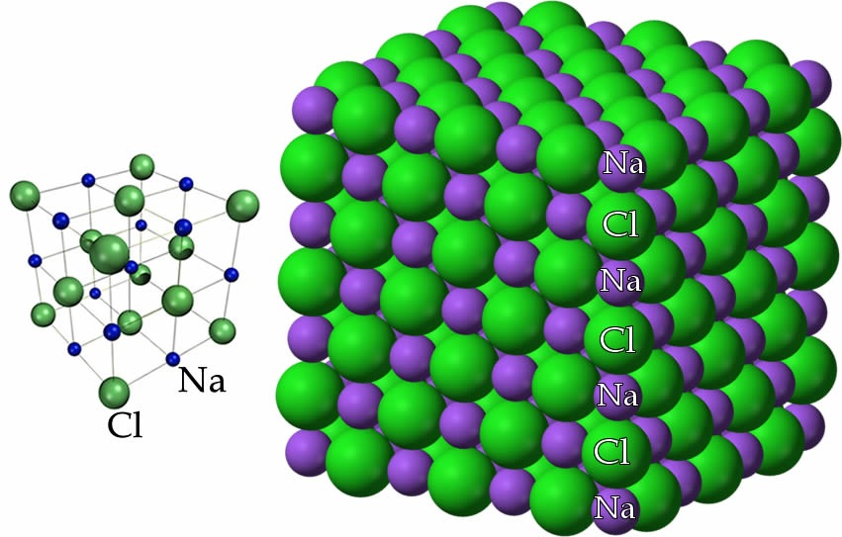

By this point, we have concluded that NaCl is composed of Na+ ions (cations) and Cl– ions (anions), but we have not yet discussed how these ions are arranged with respect to one another in space. As you may have come to expect, there is usually more than one way to represent a chemical structure. Different models emphasize different features of a substance but none of them are real in the sense that if we could look at the molecular-level structure, these models are not what we would see. At the same time, visible cubes of salt crystals provide a clue to atomic-molecular structure. If we follow the structure down from the macroscopic to the molecular, this cubic/rectangular structure is retained. A diagram of sodium chloride showing the relative positions of the ions, shown here, illustrates this cubic organization.

Another way to look at NaCl is to think of each Na+ ion as being surrounded by six Cl– ions, and each Cl– ion is surrounded by six Na+ ions. Such an arrangement is possible because of the relative sizes of the sodium and chloride ions; the smaller Na+ ions can sit in the holes between the larger Cl– ions (why are the chloride ions bigger than the sodium ions?). One consequence of this arrangement is that there is not an “ionic” bond that is analogous to a covalent bond. Our model of bonding here is best understood as this three-dimensional lattice of interacting ions. The alternating network of positive and negative ions makes for a very stable structure that is difficult to disrupt. The implication? Lots of energy is required to break these interactions and allow the ions to move with respect to one another. Many ionic compounds are organized in similar kinds of crystalline structures. A complexity (to which we will return in Chapter 6) is that many ionic compounds, including NaCl, are highly soluble in water, which means they interact strongly with water molecules. Often salts crystallize together with water molecules and form hydrated (with water) forms, as opposed to anhydrous (without water) forms.

### How Ionic Bonding Explains the Properties of Ionic Compounds

Let us return to the properties of ionic compounds and see how this molecular-level (microscopic) model of bonding explains their properties. First, their high melting points arise from the fact that enough energy must be supplied so that multiple (strong) coulombic interactions (recall each cation is surrounded by six anions and vice versa) between the ions must be overcome. In contrast for water, it is only the intermolecular forces between molecules that must be overcome to melt ice; IMFs are significantly weaker than full ionic interactions. Similarly it takes even more energy to vaporize   
 (liquid → gas) NaCl.

Now let us predict the melting points of different ionic compounds. Remember that the force between the ions is a Coulombic attraction: F α (q+ x q– ) / r2, where q+ and q– are the charges on the ions, and r is the distance between them. This equation tells us that as the charge on the ions increases, so does the force of attraction, but as the distance between them increases, the force of attraction decreases. That is, the coulombic attraction should be larger for small, highly charged ions, and this should be reflected in the melting points of ionic compounds. Even when we don't factor in the size of the ions, q1 x q2 = 4 which means that the attractive forces for CaO should be on the order of 4 times those for NaCl. Indeed, the melting point of calcium oxide (CaO) which has q1 = 2+ and q2 = 2– is 2,572°C.

**Questions to Answer**

* Draw a molecular level picture of liquid water, and a molecular level picture of liquid sodium chloride. Use this picture to explain why it takes more energy to melt solid salt than it does to melt solid water.
* Arrange these ionic compounds in order of increasing melting point: NaCl, KBr, CaO, Al2O3. Look up your answers and see if your predictions were correct.
* Arrange these materials in order of increasing melting point: CH4, MgBr2, HF, C(diamond). Look up your answers and see if your predictions were correct.
* What do you think happens to the size of the particle when a chlorine atom gains an electron to become a chloride ion? (hint recall that the size of an atom depends on the balance between the attractions between the electrons and the nucleus, and the repulsions between the electrons)
* What do you think happens to the size of the particle when a sodium atom loses an electron to become a sodium ion?

# Chapter 5: Systems Thinking

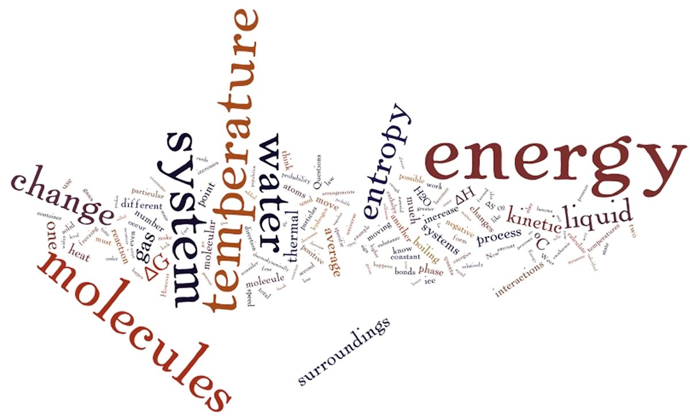

Let us recap where we are with atoms, at least from a chemistry perspective:

* Atoms interact electrostatically with each other in a variety of ways, from transient interactions that result in weak (easy to overcome) attractions to strong (bonding) interactions that are much more difficult to break.
* When atoms interact they form more stable systems, where the attractive and repulsive interactions are equal. The potential energy of the system decreases but the total energy of the system remains constant. The total energy of the interacting atoms (the system) can decrease if it is transferred to the surroundings, usually by collisions with other molecules or atoms but the emission of a photon is also possible.
* Whether weak or strong, all types of interactions require energy to overcome. Typically this energy is derived from collisions with surrounding molecules, although absorption of a photon can also overcome interactions.
* The ways that atoms interact depend upon the arrangements of the electrons within them. Different types of atoms have different “internal” arrangements of electrons.
* When atoms bond to form new materials (compounds), the properties of those compounds are emergent—that is, they are quite different from the properties of the isolated component atoms.
* The macroscopic properties of materials depend upon the types of bonds present and their spatial organization, which influences molecular shape, the distribution of charges within the molecule, and intermolecular interactions.
* Some materials are continuous (diamond, metals, ionic compounds), whereas others are composed of discrete molecular units (water, methane, lipids, proteins).
* If you know the temperature at which phase changes occur in a material (solid to liquid, liquid to gas, etc.), you can make predictions about how much energy is required to overcome the interactions between the particles that make up the material.

Now we are ready to draw all these ideas together and make connections between the macroscopic and molecular levels. Understanding these connections allows us to predict how and when chemical changes will occur, which is the heart of chemistry.

## 5.1 Temperature

Up to now the major types of change we have considered are phase changes (solid to liquid, liquid to gas, etc.) Now we will look at the elements of a phase change in greater detail starting with temperature. If you look up the definition of temperature you will probably find something like “the degree of heat of an object” and think to yourself, “Well, that’s not very illuminating, is it?” However, it is actually quite difficult to give a simple definition of temperature, (typically abbreviated as T). If you were already taught about temperature in physics courses, please bear with us (a chemist and a cell and molecular biologist) as we work our way through it, sometimes it it helpful to think about things you already know in new ways!

A useful macroscopic way of thinking about temperature is that it tells you in which direction thermal energy (often called heat) will move—energy always moves from a hotter (higher-temperature) object to a cooler (lower-temperature) one. This may seem like an obvious statement about how the physical world works but do you really know why it must be the case? Why doesn’t heat flow from cooler to warmer? Is there some principle that will allow us to to explain why? We will be coming back to these questions later on in this chapter.

Students often confuse temperature and thermal energy and before we go on we need to have a good grasp of the difference between them. The temperature of an object is independent of the size of the object, at least until we get down to the atomic/molecular level where temperature begins to lose its meaning as a concept.[86] The temperature of a drop of boiling water is the same as the temperature of a pan (or an ocean) of boiling water: 100 °C at sea level. At the same time the total amount of thermal energy in a drop of water is much less than that in a large pot of water at the same temperature. A drop of boiling water may sting for a moment if it lands on you, but a pan of boiling water will cause serious damage if it splashes over you. Why? Even though the two are at the same temperature, one has relatively little thermal energy and the other has a lot; the amount of energy is related to the size of the system. In addition, the amount of thermal energy depends on the type, that is, the composition of the material. Different amounts of different substances can have different amounts of thermal energy, even if they are at the same temperature (weird but true).

### Kinetic Energy and Temperature

Another way of thinking about temperature is that it is related to the energy of the particles in the sample: the faster the particles are moving, the higher the temperature. It may well take different amounts of energy to get particles moving at the same average kinetic energy. For a simple monoatomic gas, like helium or neon, the only motion that the atoms can do is to move from one place to another in a straight line until they bump into something else, such as another atom or molecule.[87] This kind of motion is called translational motion and is directly linked to the kinetic energy of the atom or molecule through the relationship KE = 1/2 m v(bar)2 = 3/2 kT where v(bar) is the average velocity of all of the molecules in the population[88], m is the mass, k is a constant, known as the Boltzmann constant, and T is the temperature. That is, the average kinetic energy of a gas is directly related to the temperature. In any given gaseous sample of moving atoms there are many collisions per unit time but these collisions do not alter the total energy of the system (it is conserved).[89] What these collision can, and often do, alter is the relative kinetic energies of the two (or more) colliding atoms: if one slows down, the other will speed up (remember, we are now talking only about monoatomic species; things get more complicated with more complex molecules).

Any single atom or molecule has kinetic energy, but not a temperature. This is an important distinction. Populations of molecules have a temperature related to their average velocity but the concept of temperature is not relevant to individual molecules, they have kinetic energy but not a temperature. This is a important idea, temperature as a characteristic of a system not its individual components. While a system has a unique temperature, the individual molecules that make up the system can have quite different kinetic energies. Because of collisions between molecules, an individual molecule’s kinetic energy can be changing rapidly, even though the temperature of the system is constant. When it comes to chemical reactions, it is individual kinetic energies that will be critical (we consider this point in greater detail in Chapter 7).

## 5.2 Thinking About Populations of Molecules

Within a population of atoms and molecules, the many collisions that occur per second lead to a range of speeds and directions (that is, velocities) of the atoms/molecules. When large numbers of particles are involved in a phenomenon, their individual actions are not important, for example when measuring temperature or pressure (although they are when individual molecules collide, that is, take part in chemical reactions). We treat large numbers of molecules as a population. A population is characterized by the distribution of the number or probability of molecules moving with various velocities.[90] This makes it possible to use statistical methods to characterize the behavior of the population. Although any particular molecule behaves differently from one moment to the next, depending upon whether it collides with other molecules or not, the behavior of the population is quite predictable.[91]

From this population perspective, it is the distribution of kinetic energies of atoms or molecules that depends upon the temperature of the system. We will not concern ourselves with deriving the equations that describe these relationships, but rather focus on a general description of the behavior of the motions of atoms and molecules in various states of matter.

Let us think about a population of molecules at a particular temperature in the gas phase. Because of their constant collisions with one another, the population of molecules has a distribution of speeds. We can calculate the probability of a particular molecule moving at a particular speed. This relationship is known as the Maxwell–Boltzmann distribution, shown in the graph. Its shape is a function of the temperature of the system; typically it rises fairly steeply from zero (all of the curves begin at zero – why is that do you think?) to a maximum, which then decreases and tails off at higher velocities (which correspond to higher kinetic energies). Because we are plotting probability versus kinetic energy (or rms velocity or speed) we can set the area under the curve to be equal to one (or any other constant). As the temperature changes, the area under the curve stays constant. Why? Because we are completely certain that each particle has some defined amount of kinetic energy (or velocity or speed), even if it is zero and even if we could not possibly know it (remember the uncertainty principle). As the temperature is increased, the relative number of particles that are moving at higher speeds and with more kinetic energy increases. The shape of the curve flattens out and becomes broader. There are still molecules moving very slowly, but there are relatively fewer of them. The most probable speed (the peak of the curve) and the average speed (which is a little higher since the curve is not symmetrical) increase as the temperature increases.

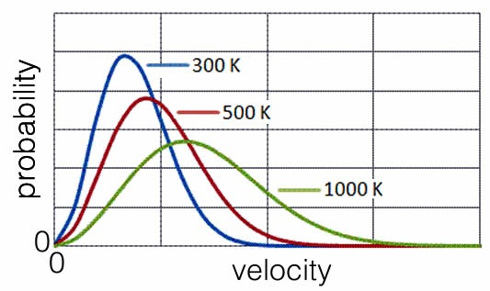

**Questions to Answer**

* What happens to the average speed of molecules as temperature increases?
* When molecules collide, why don’t they stick together?
* What do you think happens to the average speed as molecular weight increases (assuming the temperature stays the same)?
* Imagine a system composed of two different types of molecules, one much heavier than the other. At a particular temperature, how do their average kinetic energies compare? Which, on average, is moving faster?

**Questions to Ponder**

* How large does a system have to be to have a temperature, 10 molecules or 10,000,000?
* If one considers the uncertainty principle, what is the slowest velocity at which a molecule can move?
* If you place a thermometer into a solution, why does it take time for the reading on the thermometer to correspond to the temperature of the solution?

### Temperature, Kinetic Energy and Gases

Now here is an unexpected fact: the average kinetic energies of molecules of any gas at the same temperature are equal (since KE = 3/2kT, the identity of the gas does not matter). Let us think about how that could be true and what it implies about gases. Under most circumstances the molecules in a gas do not significantly interact with each other; all they do is collide with one another like billiard balls. So when two gases are at the same temperature, their molecules have the same average kinetic energy. However, an even more unexpected fact is that the mass of the molecules of one gas is different from the mass of the molecules of the other gas. Therefore, given that the average kinetic energies are the same, but the molecular masses are different, the average velocities of molecules in the two gases must be different. For example, let us compare molecular hydrogen (H2) gas (molecular weight = 2 g/mol) with molecular oxygen (O2) gas (molecular weight = 32 g/mol), at the same temperature. Since they are at the same temperature the average kinetic energy of H2 must be equal to the average kinetic energy of O2, then the H2 molecules must be moving, on average, faster than the O2 molecules.[92]

So the average speed at which an atom or molecule moves depends on its mass. Heavier particles move more slowly, on average, which makes perfect sense. Consider a plot of the behavior of the noble (monoatomic) gases, all at the same temperature. On average helium atoms move much faster than xenon atoms, which are over 30 times heavier. As a side note, gas molecules tend to move very fast. At 0 °C the average H2 molecule is moving at about 2000 m/s, which is more than a mile per second and the average O2 molecule is moving at approximately 500 m/s. This explains why smells travel relatively fast: if someone spills perfume on one side of a room, you can smell it almost instantaneously. It also explains why you can’t smell something unless it is a gas. We will return to this idea later.

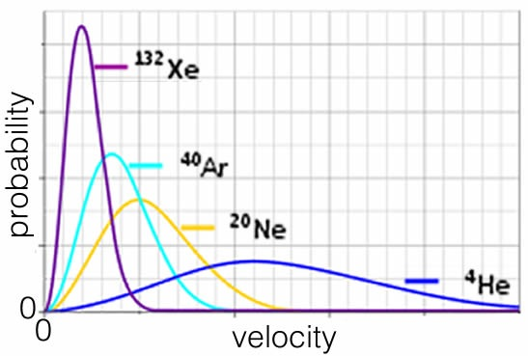

**Questions to Answer**

* Why don’t all gas particles move with the same speed at a given temperature?
* Where would krypton appear on the plot above? Why?
* Consider air, a gas composed primarily of N2, O2, and CO2. At a particular temperature, how do the average kinetic energies of these molecules compare to one another?
* What would a plot of kinetic energy versus probability look like for the same gas at different temperatures?
* What would a plot of kinetic energy (rather than speed) versus probability look like for different gases (e.g., the noble gases) at the same temperature?

**Questions to Ponder**

* If gas molecules are moving so fast (around 500 m/s), why do most smells travel at significantly less than that?
* Why does it not matter much if we use speed, velocity, or kinetic energy to present the distribution of motion of particles in a system (assuming the particles are all the same)?

## 5.3 Vibrating, Bending, and Rotating Molecules

As we have already seen the average kinetic energy of a gas sample can be directly related to temperature by the equation Ek(bar) = 1/2 mv(bar)2 = 3/2 kT where v(bar) is the average velocity and k is a constant, known as the Boltzmann constant. So, you might reasonably conclude that when the temperature is 0 K, all movement stops. However, if a molecule stops moving we should be able to tell exactly where it is, right? Oh no! That would violate the uncertainty principle, which means there will need be some uncertainty in its energy! At 0 K (a temperature that cannot be reached, even in theory) the system will have what is called zero point energy: the energy that remains when all the other energy is removed from a system (a quantum mechanical concept completely irrelevant to normal life).

For monoatomic gases, temperature is a measure of the average kinetic energy of molecules. But for systems made up of more complex molecules composed of multiple atoms, there are other ways to store energy besides translation (that is, moving through space). In these situations energy added to a system can not only speed up the movement of molecules but also make them vibrate, bend, and rotate (recall we discussed this briefly in Chapter 4)(FIG→). These vibrations, bends, and rotations are distinct for each type of molecule; they depend upon molecular shape and composition. Perhaps not surprisingly, they are quantized. This means that only certain packets of energy can be absorbed or released depending on which vibrations or rotations are involved.[93] Because of that, we can use these molecule-specific energy states to identify molecules and determine their structure at the atomic level. Just as we can identify atoms of elements by their electronic spectra (how their electrons absorb and emit photons as they move from one quantum level to another), we can identify molecules by the way they absorb or emit photons as the molecule moves from one vibrational or rotational state to another. Because it takes less energy to move between vibrational states, photons of infrared or microwave frequencies are typically involved in this analysis. This is the basis for infrared spectroscopy, a topic that we will return to in a separate work.

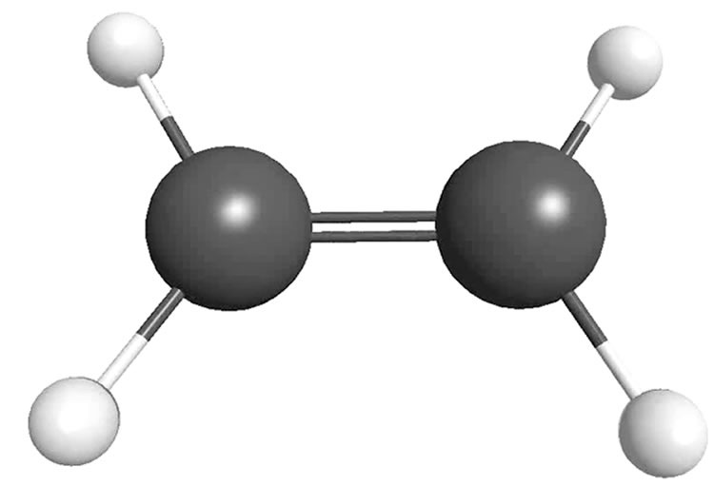

<https://www.youtube.com/watch?v=FnUGeYkFCCw>

As materials become more complex in structure, more energy is needed to increase their temperature because there are more ways for a complex molecule to vibrate, bend, and rotate; some of the added energy is used up in vibrations and rotations as well as translations. The amount of energy required to raise the temperature of a particular amount of substance is determined by the molecular-level structure of the material. We can do experiments to determine how adding energy to a substance affects its temperature. Although the word heat is sometimes used to describe thermal energy, in the world of physics it is specifically used to describe the transfer of thermal energy from one thing to another. So, we will stick with thermal energy here.

The units of thermal energy are joules (J).[94] Thermal energy is the sum of the kinetic and other potential energies of the particles in a system. There are two commonly used measures of how much energy it takes to change the temperature of a substance and, conversely, how much energy a substance can store at a given temperature: specific heat capacity (J/g ºC) and molar heat capacity (J/mol ºC). The specific heat of a substance tells you how much energy is required to raise the temperature of a mass (1 g) of material by 1 ºC; the molar heat capacity tells you how much energy is required to raise the temperature of a mole of particles by 1 ºC. The specific heats and molar heat capacity of a substance depend on both the molecular structure and intermolecular interactions (for solids and liquids, but not gases). Usually, more complex substances have a higher molar heat capacity because larger molecules have more possible ways to vibrate, bend, and rotate. Substances with strong IMFs tend to have higher heat capacities than those with weaker IMFs because energy must be used to overcome the interactions between molecules, rather than make the substance move faster - which increases the temperature.

### Heat Capacity and Molecular Structure

It takes 4.12 J to raise 1 gram of water 1 ºC (or 1 K.) If you add energy to a pan of water by heating it on a stove top energy is transferred to the molecules of water by collisions with the pan, which in turn has heated up from contact with the heating element[95]. The addition of energy to the system results in the faster movement of molecules, which includes moving from place to place, rotating, bending, and vibrating. Each type of movement adds to the overall thermal energy of the material. Although the molecules in a gas very rarely interact with one another, those in a solid and liquid interact constantly. The increase in temperature as a function of added energy is relatively simple to calculate for a gas; it is much more complicated for liquids and solids, where it depends upon molecular structure and intramolecular (within a molecule) as well as intermolecular (between molecules) interactions.

Consider the molar heat capacities and specific heats of water and the hydrocarbon alcohols (which contain an -OH group) methanol, ethanol, and propanol. As you can see in the table below, water has an unusually high specific heat, even though it is smaller than the other molecules. Their specific heats are pretty much constant, but their molar heat capacities increase with molar mass.

| Name | Formula | Molar Mass, g | Molar Heat Capacity  J/mol ºC | Specific Heat  J/g ºC |
| --- | --- | --- | --- | --- |
| Water | H2O | 18 | 75.4 | 4.18 |
| Methanol | CH3OH | 32 | 81.0 | 2.53 |
| Ethanol | CH3CH2OH | 48 | 112 | 2.44 |
| Propanol | CH3CH2CH2OH | 60 | 144 | 2.39 |

So an obvious question is, why is the specific heat of water so much higher than that of these alcohols? The reasons for this (apparent) anomaly are:

1. Water molecules are smaller so there are more molecules per gram than there are in the larger, more complex substances.
2. Each water molecule can form up to four hydrogen bonds, but the alcohols can only form a maximum of two hydrogen bonds each (why is this?). As thermal energy is added to the system some of that energy must be used to overcome the attractive forces between molecules (that is, hydrogen bonds) before it can be used to increase the average speed of the molecules. Because there are more hydrogen bonds forming attractions between water molecules, it takes more energy to overcome those interactions and raise the kinetic energy of the water molecules. The end result is a smaller increase in temperature for the same amount of energy added to water compared to methanol, ethanol, and propanol.

The relatively high specific heat of water has important ramifications for us. About 70% of the Earth’s surface is covered with water. Because of water’s high specific heat, changes in the amounts of solar energy falling on an area between day and night are “evened out” by the large amount of water in the oceans. During the day, the water absorbs much of the energy radiated from the sun, but without a drastic temperature increase. At night, as the temperature falls, the oceans release some of this stored energy, thus keeping the temperature fluctuations relatively small. This effect moderates what would otherwise be dramatic daily changes in surface temperature. In contrast, surface temperatures of waterless areas (like deserts), planets (like Mars), and the Moon fluctuate much more dramatically, because there is no water to absorb and release thermal energy.[96] This moderation of day–night temperature change is likely to be one of the factors that made it possible for life to originate, survive, and evolve on the early Earth. As we go on, we will see other aspects of water’s behavior that are critical to life.

### Removing Thermal Energy from a Gas

Now that we have been formally introduced to the concepts of heat, thermal energy, and temperature, we can examine what happens when energy is added or removed from matter. We begin with a gas because it is the simplest form of matter. We can observe a gas system by looking at a sealed container of water vapor. We can reduce the temperature by cooling the walls of the container; as gas molecules collide with the walls, some of their energy is transferred to the wall and then removed by the cooling system. Over time, the average kinetic energy of the molecules (temperature) decreases. We know that all molecules are attracted to one another by London dispersion forces. In the case of water molecules, there are also interactions mediated by the ability to make hydrogen bonds and dipole–dipole interactions. As temperature increases, these relatively weak interactions are not strong enough to keep molecules stuck together; they are broken during molecular collisions. As the temperature drops, and the average kinetic energy decreases, more and more of these interactions persist for longer and longer times. This enables groups of molecules to form increasingly larger and heavier aggregates. Assuming that our container is on the surface of the Earth, molecules fall out or condense out of the gaseous phase to form a liquid. Because the molecules in the liquid are interacting closely with one another, the volume occupied by these aggregates is much smaller than the volume occupied by the same number of molecules in a gas. The density (mass/volume) of the liquid is higher, and eventually these drops of liquid become large enough to feel the effect of gravity, and are attracted towards the Earth. As the drops of liquid fall to the bottom of the container they merge with one another and the liquid phase below separates from the gaseous phase above. The temperature where the liquid phase first appears is the boiling (or condensation) point of the material (for water it is 100 ºC under atmospheric pressure at sea level). If we continue to remove energy from the system at a fairly slow, steady rate, **the temperature will not change** until almost all the water vapor has condensed into liquid. Why do you think this is so? It may be easier to think about the reverse process: when water boils, the temperature of the water does not change until almost all the water in the liquid phase has vaporized, even though energy is being added to the system. What is that energy being used for?

Even at temperatures well below the boiling point there are still some molecules in the gaseous phase. Why? Because within the liquid, some molecules are moving fast enough (and are located close enough to the liquid–gas boundary) to break the interactions holding them in the liquid. When they leave the liquid phase, the average kinetic energy of the liquid drops (the molecules that leave have higher than average kinetic energy) and some of the kinetic energy of the escaping molecules is used to break free of the interactions holding them together in the liquid phase. The escaping molecules now have lower kinetic energy. This is the basis of the process known as evaporative cooling. The same process explains how the evaporation of sweat cools your body.

**Questions to Answer**

* Can you measure thermal energy directly? Why or why not?
* What can we measure changes in? How does that allow us to figure out changes in thermal energy of a system?
* Draw a graph of the change in temperature when equal amounts of thermal energy are added at the same rate to equal masses of water, ethanol, and propanol.
* Does each sample reach the same temperature? Why or why not?
* Plot the temperature change versus time as a sample of water vapor moves from a temperature of 110 ºC to 90 ºC.
* Draw a molecular-level picture of what the sample looks like at 110 ºC and 90 ºC. Explain what is happening in each different part of your graph.
* When energy is added to and the water boils, the temperature stays at 100 ºC until almost all the water is gone. What is the energy being used for?

**Questions to Ponder**

* What would life be like if we lived on a planet with no water, but instead the oceans were filled with methanol or ammonia (or filled with hydrocarbons as on Titan, a moon of Saturn)?
* After it’s just finished raining, why do pools of water disappear even when the temperature is below the boiling point of water?
* Clouds are made from small droplets of water, why don't they fall to Earth?

### Liquids to Solids and Back Again

Within a liquid, molecules move with respect to one another. That is why liquids flow. What does that mean at the molecular level? It means that the molecules are (on average) moving fast enough to break some, but not all, of the interactions linking them to their neighbors. But let us consider what happens as we remove more and more energy from the system through interactions of the molecules with the container’s walls. With less energy in the system, there is a decrease in the frequency with which molecules have sufficient energy to break the interactions between them, and as a result interactions become more stable. Once most interactions are stable the substance becomes a solid. The temperature at which the material goes from solid to liquid is termed the melting point. A liquid becomes a solid at the freezing point. For water at atmospheric pressure, this is 0 ºC (or 273.15 K). Just like the boiling/condensation point, the temperature does not change appreciably until all the liquid has solidified into ice, or all the ice has melted (→).

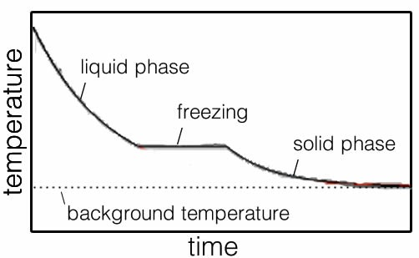

Molecular shape and the geometry of the interactions between molecules determine what happens when water (or any other liquid) is cooled and eventually freezes. In the case of frozen water (ice) there are more than 15 types of arrangements of the molecules, ranging from amorphous to various types of crystalline ice. In amorphous ice, the molecules occupy positions that are more or less random with respect to their neighbors; in contrast the molecules in crystalline ice have very specific orientations to one another. The form of ice we are most familiar with is known as Ice Ih, in which the water molecules are organized in a hexagonal, three-dimensional array. Each molecule is linked to four neighboring molecules through hydrogen bonds. This molecular-level structure is reflected at the macroscopic level, which is why snowflakes are hexagonal. Once frozen, the molecules can no longer move with respect to one another because of the bonds between them; the ice is solid and retains it shape, at both the visible and the invisible (molecular) level. However, because we are not at absolute zero (0 K or -273.15 ºC), the molecules are still vibrating in place.

Now, what would happen if we heated our container transferring energy from the surroundings into the system (the ice)? As energy is added to the ice the water molecules vibrate more and more vigorously and eventually the hydrogen bonding interactions holding the molecules in place are overcome and the molecules become free to move relative to one another other. The ice melts. At this temperature (0 ºC, 273.15 K) all the energy entering the system is used to overcome intermolecular attractions, rather than increase the speed of molecular motion. If the system is well mixed, the temperature stays at 0 ºC until all of the ice has melted. Then the temperature starts to rise again as the water molecules, now free to move relative to each other, increase in kinetic energy.

Because of the arrangement of water molecules in Ice Ih, the hexagonal “cages” of water molecules within the crystal have empty space within them. As the hydrogen bonds break, some of the water molecules can now move closer together to fill in these open spaces. The structure of the ice collapses in on itself. This open network of molecules, which is not present in liquid water, means that Ice Ih is less dense than liquid water, which is why it floats on liquid water. We don’t think much of this commonplace observation, but it is quite rare for a solid to be less dense than the corresponding liquid. More typically, materials (particularly gases, but also liquids and solids) expand when heated as a consequence of the increased kinetic energy, making the particles vibrate more vigorously and take up more space.

## 5.4 Open Versus Closed Systems

In our discussion, the container of water vapor (gas) is our system: the part of the universe we are observing. It is separated from the rest of the universe (its surroundings) by the walls of the container (its boundary[97].) When we remove energy from the system or add energy to it, that energy goes to or comes from the surroundings. Our system is not an isolated system. If it were, neither energy nor matter would move between the system and the surroundings. In practice it is difficult to construct a perfectly isolated system (although an insulated or styrofoam coffee cup with a lid on is not a bad approximation.) We can also distinguish between open and closed systems: in an open system both matter and energy can enter or leave (we can keep track of both) whereas in a closed system the amount of matter is constant and only energy can enter or leave. Whenever we look at a system our first task is to decide whether the system is isolated, open, or closed. All biological systems are open (both energy and matter are being exchanged with the surroundings.) In the absence of such an exchange, a biological system would eventually die.[98]

Let us consider a beaker of water without a lid as our open system. As the temperature rises, some of the water molecules have enough energy to escape from the body of the water. The liquid water evaporates (changes to a gas). Any gases that might be dissolved in the liquid water, such as oxygen (O2) or nitrogen (N2), also move from the liquid to the gaseous phase. At the boiling point, all the energy being supplied to the system is being used to overcome the intermolecular forces, as it was at the melting point. However, this time the molecules are completely separated from one another, although they still collide periodically. Thus energy is used to overcome attractive forces and the individual molecules fly off into the gas phase where the distances between them become so great that the attractive forces are insignificant.[99] As the liquid boils, its temperature does not rise until all of it has been transformed from liquid to vapor. As the gas molecules fly off, they carry with them some of the system’s energy.

**Questions to Answer**

* Begin with an ice cube in a beaker and end with water vapor. Draw a graph of the energy input versus the temperature of the system. Is your graph a straight line?
* What would happen to the mass of the beaker and water during this process?
* Can you reproduce the hexagonal symmetry of ice by using a model kit? What property of hydrogen bonds makes the structure so open?
* As the temperature rises in liquid water, what do you think happens to the density? Draw a plot of density versus temperature for a mass of water beginning at -10 ºC, up to 50 ºC.
* What happens when the temperature has risen such that the molecules have enough energy to overcome all the attractions between the separate molecules? Focus not on the covalent bonds but the attractions between separate molecules.

**Questions to Answer, continued**

* During evaporation and boiling do water molecules ever return to the liquid?
* Estimate the temperature at which the bonds within a water molecule break. How does that temperature compare to the boiling point of water? Why aren’t they the same temperature?
* How would an open and a closed system differ if you heated them from 30 to 110ºC?

Questions to Ponder

* Are boiling and evaporation fundamentally different processes?
* Under what conditions does evaporation not occur? What is happening at the molecular level?
* What is in the spaces in the middle of the hexagonal holes in Ice Ih?
* What would be the consequences for a closed or isolated biological system?

**Questions for Later**

* As you heat up a solution of water, predict whether water molecules or dissolved gas molecules will preferentially move from the liquid to the gaseous phase (or will they all move at the same rate?). What factors do you think are responsible for “holding” the gas molecules in the water?
* What do you think happens to the density of the gas (in a closed system) as you increase the temperature?
* What would happen if you captured the gas in a container?
* What would happen if you took that gas in the container and compressed it (made the volume of the container much smaller)?

## 5.5 Thermodynamics and Systems

The study of how energy in its various forms moves through a system is called thermodynamics. In chemistry specifically it is called thermochemistry. The first law of thermodynamics tells us that energy can be neither created nor destroyed but it can be transferred from a system to its surroundings and vice versa.[100] For any system, if we add up the kinetic and potential energies of all of the particles that make up the substance we get the total energy. This is called the system’s internal energy, abbreviated as E in chemistry.[101] It turns out that it is not really possible to measure the total internal energy of a system. But we **can** measure and calculate the **change** in internal energy represented as ΔE (we use the Greek letter Δ to stand for change). There are two ways that the internal energy of a system can change: we can change the total amount of thermal energy in the system (denoted as q), or the system can do work or have work done to it (denoted as w). The change in internal energy is therefore:

ΔE = q + w

At the molecular level, it should now be relatively easy to imagine the effects of adding or removing thermal energy from a system. However work (usually defined as force multiplied by distance) done on or by the system is a macroscopic phenomenon. If the system comes to occupy a larger or smaller volume, work must be done on the surroundings or on the system, respectively. With the exception of gases, most systems we study in chemistry do not expand or contract significantly. In these situations, ΔE = q, the change in thermal energy (heat). In addition, most of the systems we study in chemistry and biology are under constant pressure (usually atmospheric pressure). Heat change at constant pressure is what is known as a state function, it is called enthalpy (H). A state function is a property of a system that does not depend upon the path taken to get to a particular state. Typically we use upper case symbols (for example, H, T, P, E, G, S) to signify state functions, and lower case symbols for properties that depend on the path by which the change is made (for example, q and w). You may be wondering what the difference between a state and path function is. Imagine you are climbing Mount Everest. If you were able to fly in a balloon from the base camp to the top you would travel a certain distance and the height change would be 29,029 feet. Now in contrast if you traveled on foot, via any one of the recorded paths – which wind around the mountain you would travel very different distances – but the height change would still be 29,029 feet. That is the distance travelled is a path function and the height of Mt Everest is a state function. Similarly, both q and ΔH describe thermal energy changes but q depends on the path and ΔH does not. In a system at constant pressure with no volume change, it is the change in enthalpy (ΔH) that we will be primarily interested in (together with the change in entropy (ΔS), which we examine shortly in greater detail).

Because we cannot measure energy changes directly we have to use some observable (and measurable) change in the system. Typically we measure the temperature change and then relate it to the energy change. For changes that occur at constant pressure and volume this energy change is the enthalpy change, ΔH. If we know the temperature change (ΔT), the amount (mass) of material and its specific heat, we can calculate the enthalpy change:

ΔH (J) = mass (g) x specific heat (J/g ºC) x ΔT (ºC).[102]

When considering the enthalpy change for a process, the direction of energy transfer is important. By convention, if thermal energy goes out of the system to the surroundings (that is, the surroundings increase in temperature), the sign of ΔH is negative and we say the process is exothermic (literally, “heat out”). Combustion reactions, such as burning wood or gasoline in air, are probably the most common examples of exothermic processes. In contrast, if a process requires thermal energy from the surroundings to make it happen, the sign of ΔH is positive and we say the process is endothermic (energy is transferred from the surroundings to the system).

**Questions to Answer**

* You have systems (at 10 ºC) composed of water, methanol, ethanol, or propanol. Predict the final temperature of each system if equal amounts of thermal energy (q) are added to equal amounts of a substance (m). What do you need to know to do this calculation?
* Draw a simple sketch of a system and surroundings. Indicate by the use of arrows what we mean by an endothermic process and an exothermic process. What is the sign of ΔH for each process?
* Draw a similar diagram and show the direction and sign of work (w) when the system does work on the surroundings (expands), and when the surroundings do work on the system (contracts).
* Draw a diagram to show the molecular level mechanism by which thermal energy is transferred in or out of a system. For example how is thermal energy transferred as an ice cube melts in a glass of water?

**Questions to Ponder**

* What does the difference in behavior of water, methanol, ethanol, and propane tell us about their molecular behavior/organization/structure?

### The Second Law of Thermodynamics

Whereas the first law of thermodynamics states that you cannot get more energy out of a system than is already present in some form, the second law of thermodynamics tells us that we cannot even get back the energy that we use to bring about a change in a system. The idea in the second law is captured by the phrase “*for any change in a system, the total entropy of the universe must increase.*” As we will see, this means that some of the energy is changed into a form that is no longer useful (that is, it cannot do work).

There are lots of subtle and not so subtle implications captured by this statement and we will need to look at them carefully to identify them. You may already have some idea of what entropy means, but can you define it? As you might imagine it is not a simple idea. The word entropy is often used to designate randomness or disorder but this is not a very useful or accurate way to define entropy (although randomly disordered systems do have high entropy). A better way to think about entropy is in terms of probabilities: how to measure, calculate, and predict outcomes. Thermal energy transfers from hot to cold systems because the outcome is the most probable outcome. A drop of dye disperses in water because the resulting dispersed distribution of dye molecules is the most probable. Osmosis occurs when water passes through a membrane from a dilute to a more concentrated solution because the resulting system is more probable. In fact whenever a change occurs, the overall entropy of the universe always increases.[103] The second law has (as far as we know) never, ever been violated. In fact the direction of entropy change has been called “time’s arrow”; the forward direction of time is determined by the entropy change. At this point you should be shaking your head. All this cannot possibly be true! First of all, if entropy is always increasing, then was there a time in the past when entropy was 0?[104] Second, are there not situations where entropy decreases and things become more ordered, like when you clean up a room? Finally, given that common sense tells us that time flows in only one direction (to the future), how is it possible that at the atomic and molecular scale all events are reversible?

### Probability and Entropy

Before we look at entropy in detail, let us look at a few systems and think about what we already know about probability. For example if you take a deck of cards and shuffle it, which is more probable: that the cards will fall into the order ace, king, queen, jack, 10, 9, etc. for each suit, or that they will end up in some random, jumbled order? Of course the answer is obvious—the random order is much more probable because there are many sequences of cards that count as “random order” but only one that counts as “ordered.” This greater probability is true even though any pre-specified random sequence is just as unlikely as the perfectly ordered one. It is because we care about a particular order that we lump all other possible orders of the cards together as “random” and do not distinguish between them.

We can calculate, mathematically, the probability of the result we care about. To determine the probability of an event (for example, a particular order of cards), we divide the number of outcomes cared about by the total number of possible outcomes. For 52 cards there are 52! (52 factorial, or 52 x 51 x 50 x 49…) ways that the cards can be arranged.[105] This number is ~8.07 x 1067, a number on the same order of magnitude as the number of atoms in our galaxy. So the probability of shuffling cards to produce any one particular order is 1/52! – a very small number indeed. But because the probability is greater than zero, this is an event that can happen. In fact, it must happen eventually, because the probability that any given arrangement of cards will occur is 1. That is a mind bender, but true nevertheless. Highly improbable events occur all the time![106]

This idea of entropy, in terms of probabilities, can help us understand why different substances or systems have different entropies. We can actually calculate entropies for many systems from the formula S = k ln W, where S is the entropy, k is the Boltzmann constant, and W is the number of distinguishable arrangements (or states) that the system has.[107] So the greater the value of W (the number of arrangements), the greater the entropy.

In some cases it is relatively easy to figure out which system has more possible arrangements. For example, in a solid substance such as ice the molecules are fixed in place and can only vibrate. In a liquid, the molecules are free to roam around; it is possible for each molecule to be anywhere within the liquid mass and not confined to one position. In a gas, the molecules are not confined at all and can be found anywhere, or at least anywhere in the container. In general, gases have more entropy than liquids and solids. This so-called positional entropy can be extended to mixtures. In most mixtures (but not all, as we will see in the case of emulsions and colloids) the number of distinguishable arrangements is larger for the mixed compared to the unmixed components. The entropy of a mixture is usually larger.

So let us return to the idea that the direction of change in a system is determined by probabilities. We will consider the transfer of thermal energy (heat) and see if we can make sense of it. First, remember that energy is quantized. So, for any substance at a particular temperature there will be a certain number of energy quanta (recall that at the atomic-molecular level energy is quantized). To make things simpler, we will consider a four-atom solid that contains two quanta of energy. These quanta can be distributed so that a particular atom can have 0, 1, or 2 quanta of energy. You can either calculate or determine by trial and error the number of different possible arrangements of these quanta (there are 10). Remember that W is the number of distinguishable arrangements, so for this system W = 10 and S = k ln 10. Now, what happens if we consider two similar systems, one with 4 quanta and the other with 8 quanta? The system with 4 quanta will be at a lower temperature than the system with 8 quanta. We can also calculate the value of W for the 4-quanta (4-atom) system by considering the maximum number of possible ways to arrange the quanta over the 4 atoms. For the 4-atom, 4-quanta system, W = 35. If we do the same calculation for the 8-quanta, 4-atom system, W = 165. If taken together, the total number of arrangements of the two systems is 35 x 165 = 5775.[108]

But what about temperature? The 4-quanta system is at a lower temperature than the 8-quanta system because the 8-quanta system has more energy. What happens if we put the two systems in contact? Energy will transfer from the hotter (8-quanta) to the colder (4-quanta) system until the temperatures are equal. At this point, each will have 6 quanta (which corresponds to a W of 84). Because there are two systems (each with 6 quanta), the total W for the combined systems is W of 84 x 84 = 7056 states. You will note that 7056 is greater than 5775. There are **more distinguishable arrangements** of the quanta in the two systems **after** the energy transfer than before. The final system is more probable and therefore has a higher entropy.

Now you might well object, given that we are working with systems of only a few atoms each. It is easy to imagine that random fluctuations could lead to the movement of quanta from cold to hot, and that is true. That is why the behavior at the nanoscale is reversible. But when we are talking about macroscopic systems, such a possibility quickly becomes increasingly improbable as the number of atoms/molecules increases. Remember a very small drop of water with a weight of 0.05 grams contains approximately 1.8 x 1021 molecules (perhaps you can also calculate the volume of such a drop). Events that are reversible at the nanoscale are irreversible at the macroscopic scale – yet another wacky and counterintuitive fact. It is generally true that we are driven to seek a purpose for why things happen. In the grand scheme of things, the overarching idea that change in the universe is driven simply by the move to more probable states can be difficult to accept,but it is true – even when we consider living systems in the context of their surroundings.[109] The presence of a living system (which is itself highly organized) increases entropy of the Universe as a whole.

**Questions to Answer**

* Which has more entropy (in each case, explain your choice):
  + A new deck of cards or a shuffled deck?
  + Separated dye and water or a mixed-up solution?
  + H2O(s) or H2O(l)?
  + CaCO3(s) or CaO(s) + CO2(g)?
  + H2O(l) (at 25 °C) or H2O(l) (at 50 °C)?
* Do you think that the structure of a compound affects its entropy? Why?
* Predict the relative entropies of diamond and sodium chloride, carbon dioxide, oxygen, and HF. What factors influenced your prediction? Look up the entropies. Were you correct?

**Questions to Ponder**

* Can you think of any changes that occur that seem to produce more order?
* Why don’t living systems (organisms) violate the second law of thermodynamics?
* Does the second law rule out evolution?
* Does it argue for a supernatural soul running the brain?

## 

## 5.6 Back to Phase Changes

Let us now return to the situation with solids, liquids, and gases. How do we think about entropy in these systems? Doesn’t a substance become more ordered as we move it from gas to liquid to solid? Clearly the entropy of a solid is lower than that of a liquid, and the entropy of a liquid is lower than that of a gas. We can calculate (or simply look up) how entropies change for materials as they go from gas to liquid to solid. As we have predicted, they decrease. How can a change occur when the entropy of the system decreases (such as ice freezing)? Are we forced to conclude that things we know to happen are impossible according to the second law of thermodynamics? Of course not!

The second law of thermodynamics tells us that for every change that occurs, the entropy of the universe must increase. The problem with this is that we are all well aware of changes where the entropy apparently decreases. How can we resolve this seeming paradox? The answer lies in the fact that for any system the entropy may indeed decrease; water freezing is an example of this phenomenon. For the universe as a whole however (or more easily defined, the system and its surroundings) total entropy must increase. For example, when water freezes, the water molecules form stable interactions (hydrogen bonding interactions). As we have seen previously, the formation of stabilizing interactions means that the potential energy of the system has decreased. Because energy is conserved, this energy must be released to the surroundings as thermal (kinetic) energy. That is, the freezing of water is an exothermic process.

Now we can see the solution to our thermodynamic problem. The reason that the freezing of water does not violate the second law is that even though the system (ice) becomes more ordered and has lower entropy, the energy that is released to the surroundings makes those molecules move faster, which leads to an increase in the entropy of the surroundings. At the freezing point of ice the increase in entropy in the surroundings is greater than the decrease in entropy of the ice! When we consider both system and surroundings, the change in entropy (ΔS) is positive. The second law is preserved (yet again), but to understand why we must actively embrace systems thinking.

## 5.7 Gibbs (Free) Energy to the Rescue

We must consider changes in entropy for both the system and its surroundings when we predict which way a change will occur, or in which direction a process is thermodynamically favorable. Because it is almost always easier to look at the system than it is to look at the surroundings (after all, we define the system as that part of the universe we are studying), it would be much more convenient to use criteria for change that refer only to the system. Fortunately, there is a reasonably simple way to do this. Let us return to water freezing again and measure the enthalpy change for this process. The thermal energy change for the system, ΔHfreezing, is about –6 kJ/mol. That is, 6 kJ of thermal energy are released into the surroundings for every mole of water that freezes. We can relate this thermal energy release to the entropy change of the surroundings. Entropy is measured in units of J/K (energy/temperature). Because we know how much energy is added to the surroundings, we can calculate the entropy change that this released (enthalpic) energy produces.

Mathematically we can express this as ΔSsurroundings = –ΔHsurroundings/T. And because we know that ΔHsystem = –ΔHsurroundings, or that the energy lost by the system equals minus (–) the energy gained by the surroundings, we can express the entropy change of the surroundings in terms of measurable variables for the system. That is:   
 ΔSsurroundings = –ΔHsystem / T.

If you recall, we can express the total entropy change (the one relevant for the second law) as ΔStotal = ΔSsystem + ΔSsurroundings. Substituting for the ΔSsurroundings term, we get   
ΔStotal = ΔSsystem –ΔHsystem/T. Now we have an equation that involves only variables that relate to the system, which are much easier to measure and calculate. We can rearrange the equation by multiplying throughout by -T, which gives us:

–TΔStotal = ΔHsystem – TΔSsystem

The quantity –TΔStotal has units of energy, and is commonly known as the Gibbs energy change, ΔG (or sometimes as the free energy). The equation is normally written as:   
 ΔG = ΔH – TΔS.

The Gibbs energy change of a reaction is probably the most important thermodynamic term that you will need to learn about. In most biological and biochemical systems, it is ΔG that is commonly used to determine whether reactions are thermodynamically favorable. It is important to remember that ΔG is a proxy for the entropy change of the universe: if it is negative, universal entropy is increasing (and the reaction occurs); if it is positive, universal entropy would decrease if the reaction occurred (and so it does not). It is possible, however, for reactions with a positive ΔG to occur, but only if they are coupled with a reaction with an even greater negative ΔG (see Chapters 8 and 9).

There are numerous tables of thermodynamic data in most texts and on many websites. Because we often want to use thermodynamic data such as ΔH, ΔS, and ΔG, it is useful to have some reference state. This is known as the standard state and is defined as 298 K temperature, 1 atmosphere pressure, 1M concentrations. When thermodynamic data refer to the standard state they are given the superscript º (nought), so ΔHº, ΔSº, and ΔGº all refer to the standard state. However, we often apply these data at temperatures other than 298 K and although small errors might creep in, the results are usually accurate enough.

### What Is “Free” About Gibbs Free Energy?

We use ΔG or ΔGº to describe many systems (and especially biological ones) because both the magnitude and sign tell us a lot about how that system behaves. We use ΔG (the Gibbs free energy change) rather than ΔH (the enthalpy change) because ΔG tells us how much energy is actually available to bring about further change (or to do work). In any change some of the energy is lost to the environment as the entropy increases, this dissipated energy cannot be used to do any kind of work and is effectively lost. ΔG differentiates the energy produced from the change from the energy that is lost to the surroundings as increased entropy. As an example, when wood is burned, it is theoretically impossible to use all of the heat released to do work; some of the energy goes to increase the entropy of the system. For any change in the system, some of the energy is always lost in this way to the surroundings. This is why it is impossible to build a machine that is 100% efficient in converting energy from one kind to another (although many have tried–Google “perpetual motion machines” if you don't believe us). So the term “free energy” doesn’t mean that it is literally free, but rather that it is potentially available to use for further transformations.

When ΔG is negative, we know that the reaction will be thermodynamically favored.[110] The best-case scenario is when ΔH is negative (an exothermic change in which the system is losing energy to the surroundings and becoming more stable), and ΔS is positive (the system is increasing in entropy). Because T is always greater than 0 (in Kelvins), TΔS is also positive and when we subtract this value from ΔH, we get an even larger negative ΔG value. A good example of such a process is the reaction (combustion) of sugar (C6H12O6) with molecular oxygen (O2):

C6H12O6(s) + 6 O2(g) → 6 CO2(g) + 6 H2O(g).

This is an exothermic process and, as you can see from the reaction equation, it results in the production of more molecules than we started with (often a sign that entropy has increased, particularly if the molecules are of a gas).

A process such as this (-ΔH and +ΔS) is thermodynamically favored at all temperatures. On the other hand, an endothermic process (+ΔH) and a decrease in entropy (-ΔS) will never occur as an isolated reaction (but in the real world few reactions are actually isolated from the rest of the universe). For example, a reaction that combined CO2 and H2O to form sugar (the reverse reaction to the combustion reaction above) is never thermodynamically favored because ΔH is positive and ΔS is negative, making ΔG positive at all temperatures. Now you may again find yourself shaking your head. Everyone knows that the formation of sugars from carbon dioxide and water goes on all over the world right now (in plants)! The key here is that plants use energy from the sun, so the reaction is actually:

captured energy + 6 CO2(g) + 6 H2O(g) ⇆ C6H12O6(s) + 6 O2(g) + excess energy.

Just because a process is thermodynamically unfavorable doesn’t mean that it can never occur. What it does mean is that that process cannot occur in isolation; it must be “coupled” to other reactions or processes.

### Free Energy and Temperature

So we have two very clear-cut cases that allow us to predict whether a process will occur: where the enthalpy and entropy predict the same outcome. But there are two possible situations where the enthalpy change and the entropy term (TΔS) “point” in different directions. When ΔH is positive and ΔS is positive, and when ΔH is negative while ΔS is negative. When this happens, we need to use the fact that the free energy change is temperature-dependent in order to predict the outcome. Recall that the expression ΔG = ΔH – TΔS depends upon temperature. For a system where the entropy change is positive (+ΔS), an increase in temperature will lead to an increasingly negative contribution to ΔG. In other words, as the temperature rises, a process that involves an increase in entropy becomes more favorable. Conversely, if the system change involves a decrease in entropy, (ΔS is negative), ΔG becomes more positive (and less favorable) as the temperature increases.

| ΔH | ΔS | ΔG |
| --- | --- | --- |
| Negative (exothermic) | Positive (entropy increases) | Negative at all temperatures  (always thermodynamically favored) |
| Positive (endothermic) | Negative (entropy decreases) | Positive at all temperatures  (never thermodynamically favored) |
| Negative (exothermic) | Negative (entropy decreases) | Temperature dependent: as the temperature increases ΔG will become more positive and the reaction will become less favored (go backwards) |
| Positive (endothermic) | Positive (entropy increases) | Temperature dependent: as the temperature increases ΔG will become more negative and the reaction will become favored (go forwards) |

The idea that temperature affects the direction of some processes is perhaps a little disconcerting. It goes against common-sense that if you heat something up a reaction might actually stop and go backwards (rest assured we will come back to this point later). But in fact there are a number of common processes where we can apply this kind of reasoning and find that they make perfect sense.

Up to this point, we have been considering physical changes to a system—populations of molecules going from solid to liquid or liquid to gaseous states (and back). Not really what one commonly thinks of as chemistry, but the fact is that these transformations involve the making and breaking of interactions between molecules. We can therefore consider phase transitions as analogous to chemical reactions, and because they are somewhat simpler, develop a logic that applies to both processes. So let us begin by considering the phase change/reaction system

H2O (liquid) ⇌ H2O (gas).

We use a double arrow ⇌ to indicate that, depending upon the conditions the reaction could go either to the right (boiling) or to the left (condensing). So, let us assume for the moment that we do not already know that water boils (changes from liquid to gas) at 100 ºC. What factors would determine whether the reaction H2O (liquid) ⇌ H2O (gas) favors the liquid or the gaseous state at a particular temperature? As we have seen, the criterion for whether a process will “go” at a particular temperature is ΔG. We also know that the free energy change for a reaction going in one direction is the negative of the ΔG for the reaction going in the opposite direction. So that the ΔG for the reaction: H2O (liquid) ⇌ H2O (gas) is –ΔG for the reaction H2O (gas) ⇌ H2O (liquid).

When water boils, all the intermolecular attractions between the water molecules must be overcome, allowing the water molecules to fly off into the gaseous phase. Therefore, the process of water boiling is endothermic (ΔHvaporization = +40.65 kJ/mol); it requires an energy input from the surroundings (when you put a pot of water on the stove you have to turn on the burner for it to boil). When the water boils, the entropy change is quite large (ΔSvaporization = 109 J/mol K), as the molecules go from being relatively constrained in the liquid to gas molecules that can fly around. At temperatures lower than the boiling point, the enthalpy term predominates and ΔG is positive. As you increase the temperature in your pan of water, eventually it reaches a point where the contributions to ΔG of ΔH and TΔS are equal. That is, ΔG goes from being positive to negative and the process becomes favorable. At the temperature where this crossover occurs ΔG = 0 and ΔH = TΔS. At this temperature (373 K, 100 ºC) water boils (at 1 atmosphere). At temperatures above the boiling point, ΔG is always negative and water exists predominantly in the gas phase. If we let the temperature drop below the boiling point, the enthalpy term becomes predominant again and ΔG for boiling is positive. Water does not boil at temperatures below 100 ºC at one atmosphere.[111]

Let us now consider a different phase change, such as water freezing. When water freezes, the molecules in the liquid start to aggregate and form hydrogen bonding interactions with each other, and energy is released to the surroundings (remember it is this energy that is responsible for increasing the entropy of the surroundings). Therefore ΔH is negative: freezing is an exothermic process (ΔHfusion = – 6 kJ/mol).[112] Freezing is also a process that reduces the system’s entropy. When water molecules are constrained, as in ice, their positional entropy is reduced. So, water freezing is a process that is favored by the change in enthalpy and disfavored by the change in entropy. As the temperature falls, the entropy term contributes less to ΔG, and eventually (at the crossover point) ΔGfusion goes to zero and then becomes negative. The process becomes thermodynamically favored. Water freezes at temperatures below 0 ºC. At temperatures where phase changes take place (boiling point, melting point), ΔG = 0. Furthermore, if the temperature were kept constant, there would be no observable change in the system. We say that the system is at equilibrium; for any system at equilibrium, ΔG = 0.

**Questions to Answer**

* For each of these processes, give the change in entropy of the system, the direction of thermal energy transfer (the sign of ΔH), the change in entropy of the surroundings, and the change in entropy of the universe:
* Water freezing at -10 °C
* Water boiling at 110 °C
* For each of these processes predict the sign of change in entropy (ΔS) of the system, the direction of thermal energy transfer (the sign of ΔH), and the sign of the Gibbs free energy change, ΔG. What does the sign of ΔG tell you?
* Water freezing at -10 °C; Water boiling at 110 °C
  + Water boiling at -10 °C; Water freezing at 110 °C

**Questions to Ponder**

* Why do we denote excess energy as a product of this equation? captured energy + 6 CO2(g) + 6 H2O(g) ⇆ C6H12O6(s) + 6 O2(g) + excess energy.
* What other processes do you know that must be coupled to external energy sources to make them go?

# Chapter 6: Solutions

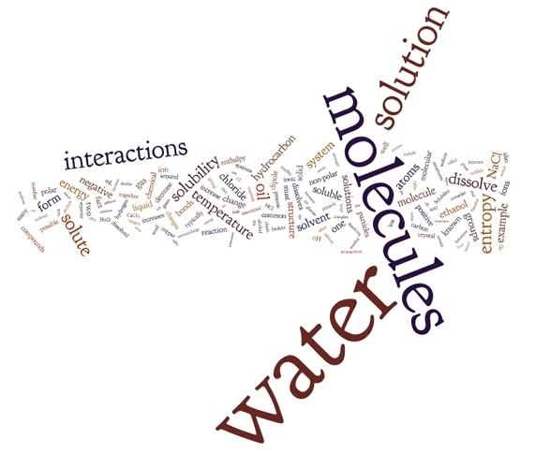

We have covered quite a number of topics up to this point: the structure of atoms, discrete molecules, complex network solids, and metals; how atoms and molecules interact, through London dispersion forces, dipole-dipole interactions, hydrogen bonds, and covalent and ionic bonds. We have discussed how changes in energy and entropy lead to solid, liquid, and gas state changes. So far, so good, but is this really chemistry? Where are the details about chemical reactions, acids and bases, gas laws, and so forth? Not to worry—we have approached the topics in this order so that you have a strong conceptual foundation before you proceed to the nuts and bolts of chemical reactions. Without this foundation, you would just memorize whatever equations we presented, without making the connections between seemingly disparate reactions. Many of these reactions are complex and overwhelming even for the most devoted student of chemistry. The topics we have covered so far will serve as a tool kit for understanding the behavior of increasingly complex chemical systems. We will continue to reinforce these basic ideas and their application as we move on to the types of reactions that are relevant to most chemical systems.

## 6.1 What Is a Solution?

The first type of complex system that we will consider is a solution. You almost certainly already have some thoughts about what a solution is and you might want to take a moment to think about what these are. This will help you recognize your implicit assumptions if they “get in the way” of understanding what a solution is scientifically. The major difference between a solution and the systems we have previously discussed is that solutions have more than one chemical substance in them. This raises the question: what exactly is a solution and what does it mean to dissolve? You are probably thinking of examples like sugar or salt dissolved in water or soda. What about milk? Is it a solution? Do solutions have to be liquid or can they also include gases and solids? What is the difference between a solution and a mixture?

It turns out that we can make solutions from a wide range of materials. Although it is common to think of solutions in terms of a solid dissolved into a liquid, this is not the only type of solution. Other examples of solutions include: gas in liquid (where molecular oxygen, or O2, dissolves in water – important for fish); solid in solid (the alloy brass is a solution of copper and zinc); gas in solid (hydrogen can be dissolved in the metal palladium); and liquid in liquid (beer is a solution of ethanol and water and a few other things).

Let us take a closer look at what we mean by a solution, starting with a two-component system. Typically, one of the components is present in a smaller amount than the other. We call the major component the solvent and the minor component(s) the solute(s). The most familiar solutions are aqueous solutions, in which water is the solvent. For example, in a solution of the sugar glucose in water, glucose molecules are the solute and water molecules are the solvent. In beer, which is typically 2–4% ethanol, ethanol is the primary solute and water is the solvent. Once they are thoroughly mixed, solutions have the same composition throughout—they are homogeneous at the macroscopic scale, even though at the molecular level we still find different types of molecules or ions. This is an important point: Once mixed, they remain mixed! If you take a sample from the top of a solution, it has the same composition as a sample from elsewhere in the solution. Solutions, when viewed at the molecular level, have the solute particles evenly (and randomly) dispersed in the solute. Also, because the solute and solvent are in contact with each other, there must be some kind of molecular interaction between the two types of molecules. This is not true for simple mixtures. For example, we tend to describe air as a mixture of gases (N2, O2, H2O, etc.), rather than a solution because the gas molecules do not interact aside from the occasional collision with each other.

### Molecular Formation of Solutions

Let us consider a solution of ethanol and water. Many common solutions contain these two components (usually with minor amounts of other substances as well). Ethanol and water are soluble in each other (what is known as “miscible”) in all proportions. For example, beer is typically about 3% alcohol (6% proof),[113] wine about 6% alcohol (12% proof), and liquors such as whiskey or brandy are about 50% alcohol (100% proof). How do they dissolve into each other at the molecular level, and why?

For a process to be thermodynamically favorable, the Gibbs (free) energy change (ΔG) associated with that process must be negative. However, we have learned that Gibbs energy change depends on both enthalpy (H) and entropy (S) changes in the system. It is possible to envision a wide range of situations - involving both positive and negative changes in H and S, and we have to consider the magnitudes of the enthalpy, the entropy and the temperature changes.

So what happens when we add a drop of ethanol to a volume of water? The ethanol molecules rapidly disperse and the solution becomes homogeneous. The entropy of the ethanol–water solution is higher than that of either substance on its own. In other words, there are more distinguishable arrangements of the molecules when they are mixed than when they are separate. Using simple entropic arguments we might, at least initially, extend the idea to include all solutions. Everything should be soluble in everything else, because this would to an entropy increase, right? Wrong. We know that this is not true. For example, oil is not soluble in water and neither are diamonds, although for very different reasons. So what are the factors influencing solution formation? We will see that some are entropic (involving ΔS) and some enthalpic (involving ΔH.)

**Questions to Answer**

* Make a list of some common solutions you might encounter in everyday life. How do you know they are solutions and not mixtures?
* Consider a solution formed from 100 g of water and 5 g sodium chloride:
  + - What would you expect the mass of the solution to be? Why?
    - What would you expect the volume of the solution to be? Why?
    - How would you test your hypotheses? What experiments would you do?
    - What evidence would you collect?

## 6.2 Solubility: why do some things form solutions and others not?

Let us say you have a 100-mL graduated cylinder and you take 50 mL of ethanol and add it to 50 mL of water. You might be surprised to find that the volume of the resulting solution is less than 100 mL. In fact, it is about 98 mL, assuming good technique (no spilling). How can we explain this? Well, we can first reassure ourselves that matter has not been destroyed. If we weigh the solution, it weighs the same as 50 mL of water plus 50 mL of ethanol. This means that the density of the water–ethanol solution must be greater than the density of either the water or ethanol alone. At the molecular level, we can immediately deduce that the molecules are closer together in the ethanol and water mixture than they were when pure (before mixing) –try drawing a molecular level picture of this to convince yourself that this is possible. Now, if you took 50 mL of oil and 50 mL of water, you would find that they do not mix—no matter how hard you tried. They will always separate away from one another into two layers. What factors determine whether or not substances form solutions?

First, we need to be aware that solubility is not an all-or-nothing property. Even in the case of oil and water, a very small number of oil molecules are present in the water (the aqueous phase), and a small number of water molecules are present in the oil. There are a number of ways to describe solubility. The most common way is to define the number of moles of solute per liter of solution. This is called the solution’s molarity (M, mol/L). Another common way is to define the number grams of solute per mass of solution. For example: 1 mg (10-3 g) of solute dissolved in 1 kg (103 g) of solution is 1 part per million (106) solute, or 1 ppm. As you might expect, given the temperature term in the free energy equation, solubility data are always reported at a particular temperature. If no more solute can dissolve at a given temperature, the solution is said to be saturated; if more solute can dissolve, it is unsaturated.

If we look at the structure of compounds that dissolve in water, we can begin to see some trends: hydrocarbons are not very soluble in water (remember from Chapter 4 that these are compounds composed only of carbon and hydrogen), whereas alcohols (hydrocarbons with an —O–H group attached) with up to 3 carbons are completely soluble. As the number of carbon atoms increases, the solubility of the compound in water decreases. For example, hexanol (CH3CH2CH2CH2CH2CH2OH), is only very slightly soluble in water (0.4 g/L). So perhaps the hydroxyl (—O–H) group is responsible for the molecule’s solubility in water. Evidence supporting this hypothesis can be found in the fact that diols (compounds with 2 —O–H groups) are more soluble than similar alcohols. For example, compared to hexanol, 1,6-hexanediol (HOCH2CH2CH2CH2CH2CH2CH2OH) is quite soluble in water. More familiar water-soluble compounds such as the sugars glucose, fructose, and sucrose (a dimer of glucose and fructose – shown in the figure) are, in fact, polyalcohols. Each of their six carbons is attached to a hydroxyl group.

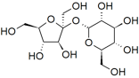

| **Compound** | **Molar Mass (g/mol)** | **Structure** | **Solubility (g/L) 20 ºC** |
| --- | --- | --- | --- |
| Propane | 44 | CH3CH2CH3 | 0.07g/L |
| Ethanol | 46 | CH3CH2OH | Completely miscible |
| Dimethyl ether | 46 | CH3OCH3 | 328 g/L |
| Pentane | 72 | CH3CH2CH2CH2CH3 | 0.4 g/L |
| Butanol | 74 | CH3CH2CH2CH2OH | 80 g/L |
| Diethyl ether | 74 | CH3CH2OCH2CH3 | 69 g/L |
| Hexanol | 102 | CH3CH2CH2CH2CH2CH2CH2OH | 0.4 g/L |
| 1,6 Hexanediol | 226 | HOCH2CH2CH2CH2CH2CH2CH2OH | 500 g/L |
| Glucose | 180 | C6H12O6 | 910g/L |

**Questions to Answer**

* Make a list of substances that you know dissolve in water.
* Which of these dissolve: metals, ionic compounds, molecular compounds (polar, non-polar), network solids (diamond graphite)?
* Can you make any generalizations about which things dissolve and which don't?
* What must happen in order for something to dissolve in water?
* How would you design an experiment to determine the solubility of a solute?
* How would you determine whether or not a solution was saturated?
* Draw a molecular level picture of a solution of ethanol and water showing why the solution is more dense than the separate liquids.
* Draw a molecular level picture of an oil and water mixture.
* Draw a molecular level picture of the process of solution
* When you try mixing oil and water, which layer ends up on top? Why?

**Question to Ponder**

* You have a saturated solution, with some solid solute present.
* Do you think the solute particles that are in solution are the same ones over time?
* How would you determine whether they were the same?

**Questions for Later**

* What would you predict for the sign of ΔS upon the formation of any solution? Why?
* What would you predict for the sign of ΔH upon the formation of any solution? Why?
* What would you predict for the sign of ΔG upon the formation of any solution? Why?

**6.3 Hydrogen Bonding Interactions and Solubility**

How does adding hydroxyl groups increase the solubility of a hydrocarbon in water? To understand this, we must return to the two components of the free energy equation: enthalpy and entropy. For a solute to dissolve in a liquid, the solute molecules must be dispersed in that liquid. Solubility depends on how many solute molecules can be present within a volume of solution before they begin to associate preferentially with themselves rather than the solvent molecules. When the solute molecules are dispersed, whatever bonds or attractions holding the particles together in the solute are replaced by interactions between solvent and solute molecules. You might deduce that one reason diamonds are not soluble in water is that the C—C bonds holding a carbon atom within a diamond are much stronger (take more energy to break) than the possible interactions between carbon atoms and water molecules. For a diamond to dissolve in water, a chemical reaction must take place in which multiple covalent bonds are broken. Based on this idea, we can conclude that the stronger the interactions between the solute particles, the less favorable it is for the solute to dissolve in water. At the same time, the stronger the interactions between solute and solvent molecules, the greater the likelihood that solubility will increase.

So do intermolecular interactions explain everything about solubility? Do they explain the differences between the solubility of hexane, hexanol, and hexanediol in water? Hexanediol (HO(CH2)6OH) is readily soluble, and if we consider its structure we can see that interactions between hexanediol molecules include hydrogen bonding (involving the two hydroxyl groups) and van der Waals interactions (LDFs and dipole-dipole). We can also approach this from a more abstract perspective. If we indicate the non-hydroxyl (—O–H) part of a molecule as R, then an alcohol molecule can be represented as R—O—H, and a diol can be represented as H–O—R—O–H. All alcohols have the ability to form hydrogen bonding interactions with each other as well as with water. So when an alcohol dissolves in water, the interactions between the alcohol molecules are replaced by interactions between alcohol and water molecules—an interaction similar to that between water molecules. Like water molecules, alcohols have a dipole (unequal charge distribution), with a small negative charge on the oxygen(s) and small positive charges on the hydrogen (bonded to the oxygen atoms). It makes sense that molecules with similar structures interact in similar ways. Thus, small molecular-weight alcohols can dissolve in water. But if you look again at the previous table, notice that hexanol (a 6-carbon chain with one —O–H group) is much less soluble than hexanediol (a 6-carbon chain with two —O–H groups—one at each end). As the non-polar carbon chain lengthens, the solubility typically decreases. However, if there are more —O–H groups present, there are more possible interactions with the water. This is also why common sugars, which are really polyalcohols with large numbers of —O–H groups (at least 4 or 5 per molecule), are very soluble in water. Their –O–H groups form hydrogen-bonds with water molecules to form stabilizing interactions. As the length of the hydrocarbon chain increases, the non-polar hydrocarbon part of the molecule starts to become more important and the solubility decreases. This phenomenon is responsible for the “like-dissolves-like” statements that are often found in introductory chemistry books (including this one, apparently). So, do intermolecular interactions explain everything about solubility? If only things were so simple!

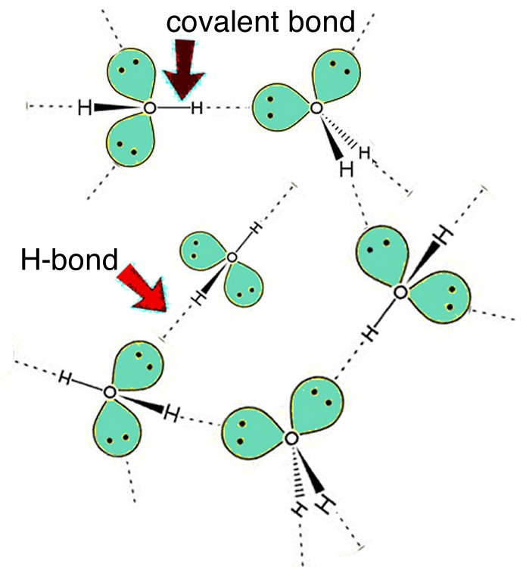

### Entropy and Solubility: Why Don’t Oil and Water Mix?[114]

The fact that oil and water do not mix is well known. It has even become a common metaphor for other things that do not mix (people, faiths, etc.) What is not quite so well known is, why? Oil is a generic name for a group of compounds, many of which are hydrocarbons or contain hydrocarbon-like regions. Oils are – well – oily, they are slippery and (at the risk of sounding tedious) unable to mix with water. The molecules in olive oil or corn oil typically have a long hydrocarbon chain of about 16–18 carbons. These molecules often have polar groups called esters (groups of atoms that contain C—O bonds) at one end.[115] Once you get more than six carbons in the chain, these groups do not greatly influence solubility in water, just as the single O—H groups in most alcohols do not greatly influence solubility. So, oily molecules are primarily non-polar and interact with one another as well as with other molecules (including water molecules), primarily through London dispersion forces (LDFs). When oil molecules are dispersed in water, their interactions with water molecules include both LDFs and interactions between the water dipole and an induced dipole on the oil molecules. Such dipole–induced dipole interactions are common and can be significant. If we were to estimate the enthalpy change associated with dispersing oily molecules in water, we would discover ΔH is approximately zero for many systems. This means that the energy required to separate the molecules in the solvent and solute is about equal to the energy released when the new solvent–solute interactions are formed.

Remember that the entropy change associated with simply mixing molecules is positive. So, if the enthalpy change associated with mixing oils and water is approximately zero, and the entropy of mixing is usually positive, why then do oil and water not mix? It appears that the only possibility left is that the change in entropy associated with dissolving oil molecules in water must be negative (thus making ΔG positive.) Moreover, if we disperse oil molecules throughout an aqueous solution, the mixed system spontaneously separates (unmixes). This seems to be a process that involves work. What force drives this work?

Rest assured, there is a non-mystical explanation but it requires thinking at both the molecular and the systems level. When hydrocarbon molecules are dispersed in water, the water molecules rearrange to maximize the number of H-bonds they make with one another. They form a cage-like structure around each hydrocarbon molecule. This cage of water molecules around each hydrocarbon molecule is a more ordered arrangement than that found in pure water, particularly when we count up and add together all of the individual cages! It is rather like the arrangement of water molecules in ice, although restricted to regions around the hydrocarbon molecule. This more ordered arrangement results in a decrease in entropy. The more oil molecules disperse in the water, the larger the decrease in entropy. On the other hand, when the oil molecules clump together, the area of “ordered water” is reduced; fewer water molecules are affected. Therefore, there is an increase in entropy associated with the clumping of oil molecules—a totally counterintuitive idea! This increase in entropy leads to a negative value for –TΔS, because of the negative sign. Therefore, in the absence of any other factor the system moves to minimize the interactions between oil and water molecules, which leads to the formation of separate oil and water phases. Depending on the relative densities of the substances, the oily phase can be either above or below the water phase. This entropy-driven separation of oil and water molecules is commonly referred to as the hydrophobic effect. Of course, oil molecules are not afraid (phobic) of water, and they do not repel water molecules. Recall that all molecules will attract each other via London dispersion forces (unless they have a permanent and similar electrical charge).

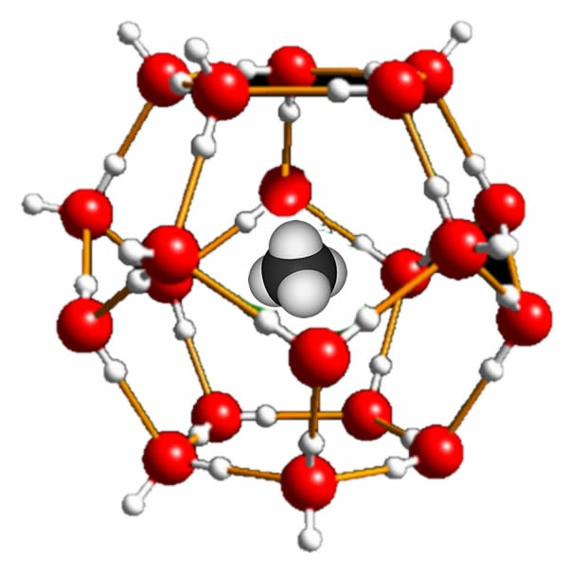

The insolubility of oil in water is controlled primarily by changes in entropy, so it is directly influenced by the temperature of the system. At low temperatures, it is possible to stabilize mixtures of water and hydrocarbons. In such mixtures, which are known as clathrates, the hydrocarbon molecules are surrounded by stable cages of water molecules (ice)(→). Recall that ice has relatively large open spaces within its crystal structure. The hydrocarbon molecules fit within these holes, making it possible to predict the maximum size of the hydrocarbon molecules that can form clathrates. For example, some oceanic bacteria generate CH4 (methane), which is then dissolved in the cold water to form methane clathrates. Scientists estimate that between two and ten times the current amount of conventional natural gas resources are present as methane clathrates.[116]

### Solubility of Ionic Compounds: Salts

Polar compounds tend to dissolve in water, and we can extend that generality to the most polar compounds of all—ionic compounds. Table salt, or sodium chloride (NaCl), the most common ionic compound, is soluble in water (360 g/L). Recall that NaCl is a salt crystal composed not of discrete NaCl molecules, but rather of an extended array of Na+ and Cl- ions bound together in three dimensions through electrostatic interactions. When NaCl dissolves in water, the electrostatic interactions within the crystal must be broken. By contrast, when molecular compounds dissolve in water, it is the intermolecular forces between separate molecules that are disrupted. One might imagine that the breaking of ionic interactions would require a very high-energy input (we have already seen that diamonds do not dissolve in water because actual covalent bonds have to be broken). That would be true if all we considered was the energy required to break the ionic interactions, as indicated by the fact that NaCl melts at 801 ºC and boils at 1413 ºC. But we know that substances like NaCl dissolve readily in water, so clearly there is something else going on. The trick is to consider the whole system when NaCl dissolves, just like we did for molecular species. We need to consider the interactions that are broken and those that are formed. These changes in interactions are reflected in the ΔH term (from ΔG = ΔH – TΔS).

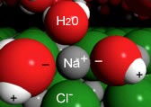

VisChem animation from depicting the hydration of a Na+ ion on a NaCl surface.

When a crystal of NaCl comes into contact with water, the water molecules interact with the Na+ and Cl- ions on the crystal’s surface, as shown in the figure. The positive ends of water molecules (the hydrogens) interact with the chloride ions, while the negative end of the water molecules (the oxygen) interacts with the sodium ions. So the ion on the surface of the solid interacts with water molecules from the solution; these water molecules form a dynamic cluster around the ion. Thermal motion (which reflects the kinetic energy of the molecules, that is the motion driven by collisions with other molecules in the system) then moves the ion and its water shell into solution.[117] The water shell is highly dynamic—molecules are entering and leaving it. The ion–dipole interaction between ions and water molecules can be very strongly stabilizing (-ΔH). The process by which solvent molecules interact with and stabilize solute molecules in solution is called solvation. When water is the solvent, the process is known as hydration.

**Questions to Answer**

* Draw a molecular-level picture of a solution of NaCl. Show all the kinds of particles and interactions present in the solution.
* When we calculate and measure thermodynamic quantities (such as ΔH, ΔS and ΔG), why is it important to specify the system and the surroundings?
* When a substance dissolves in water, what is the system and what are the surroundings? Why? What criteria would you use to specify the system and surroundings?
* For a solution made from NaCl and water, what interactions must be overcome as the NaCl goes into solution? What new interactions are formed in the solution?
* If the temperature goes up when the solution is formed, what can we conclude about the relative strengths of the interactions that are broken and those that are formed? What can we conclude if the temperature goes down?
* When you measure the temperature of a solution, are you measuring the system or the surroundings?

**Questions to Ponder**

* Why is the water shell around an ion not stable?
* What are the boundaries of a biological system?

## 6.4 Gibbs Energy and Solubility

Try adding NaCl to water, you can do this at the dinner table. You will see that the NaCl dissolves and the temperature of the solution goes down. Is this the case with all salts? No, it is not. If you dissolve calcium chloride (CaCl2) or magnesium chloride (MgCl2), the solution gets warmer, not colder. Dissolving CaCl2 or MgCl2 in water clearly involves some kind of energy release (recall that if the temperature increases, the average kinetic energy of the molecules in the solution also increases).

How do we explain why dissolving NaCl causes the temperature of the solution to decrease, whereas dissolving CaCl2 or MgCl2 makes the temperature increase? Because both processes (that is the dissolving of NaCl and CaCl2/MgCl2 into water) occur, they must be thermodynamically favorable. In fact, all of these compounds are highly soluble in water, the ΔG for the formation of all three solutions is negative, but the process results in different temperature changes. Let us look at the example of calcium chloride: as a crystal of CaCl2 dissolves in water, interactions between ions are broken and new interactions between water molecules and ions are formed. The table below lists the types of interactions forming in the crystal and the solvent.

Within the crystal, there are ion–ion interaction while in the solvent there are H-bonding, dipole–dipole, and LDF interactions. As the crystal dissolves, new ion–dipole interactions form between calcium ions and water molecules, as well as between chloride ions and molecules. At the same time, the majority of the interactions between water molecules are preserved.

| **Interactions Present Before Solution** | **Interactions Present After Solution** |
| --- | --- |
| **ion-ion**  (interactions between Ca2+ and Cl–) | **ion–dipole**  interactions between Ca2+ and H2O and Cl– and H2O) |
| **Interactions Between Water Molecules**  H-bonding, dipole–dipole, and LDFs | **Interactions Between Water Molecules**  H-bonding, dipole–dipole, and LDFs |

In order to connect our observation that the temperature increases with thermodynamic data, we have to be explicit about what we mean by the system and what we mean by the surroundings. In calcium chloride, the system is CaCl2 and the water molecules it interacts with. The surroundings are the rest of the water molecules (the solution). So when we measure the temperature change, we are actually measuring the temperature change of the surroundings (not the system). If the temperature rises, that means thermal energy is transferred from the CaCl2—H2O system to the water. Therefore, the interactions after the solution is formed are stronger and more stable than those for the solid CaCl2 and water separately. If we look up the enthalpy change for the solution of calcium chloride, it is around -80 kJ/mol: dissolving is exothermic and heat is transferred from the system to the surroundings.

So what is going on with NaCl? Solution temperatures decrease when NaCl is dissolved, so the solution (surroundings) loses energy to the ion–solvent interactions (system). Energy from the surroundings breaks up the NaCl lattice and allows ions to move into the solution. That would imply that ion–ion and H2O–H2O interactions are stronger than the ion–water interactions for the NaCl–H2O system. But why does NaCl dissolve at all? The answer is that enthalpy is not the critical factor determining whether solution happens. If we factor in the entropy change for the solution, which in this case is positive, then ΔG is negative. The dissolving of salt is an entropy-driven process!

To recap: for a solution to form, the Gibbs energy change must be negative. When calcium chloride dissolves in water, ΔH is negative and as it turns out ΔS is slightly negative (although this cannot be determined from observations). This results in a large negative ΔG and a very high solubility (595 g/L). By contrast, when sodium chloride dissolves, ΔH is positive, but ΔS is positive enough to overcome the effect of ΔH. This means that the Gibbs free energy change is also negative for this process. In fact, many solutes dissolve in water with a decrease in temperature. Ethanol—which is infinitely soluble in water—has an unfavorable enthalpy of solution. Thus, the entropy of mixing is the important factor.

**Questions to Answer**

* When ammonium chloride dissolves in water, the temperature of the solution drops. Predict the signs of ΔH, ΔS, and ΔG.and explain your reasoning by drawing molecular level pictures
* Calcium phosphate (Ca3(PO4)3) is insoluble in water. The ΔH for solution is about zero. Predict the signs of ΔS and ΔG and explain your reasoning by drawing molecular-level pictures.

## 6.5 Polarity

So far we have considered solutions that are made up of molecules that are either polar or non-polar or ionic species that have properties that are relatively easy to predict. Many substances, however, have more complex structures that incorporate polar, ionic, and non-polar groups. For example, many biomolecules cannot be classified as exclusively polar or non-polar, but are large enough to have distinct regions of differing polarity. They are termed amphipathic. Even though the structures of proteins such as RNA, DNA, and other biomolecules are complex, we can use the same principles involving entropic and enthalpic effects of interacting with water to understand the interactions between biomolecules, as well as within a given biomolecule. Biomolecules are very large compared to the molecules considered in most chemistry courses, and often one part of the molecule interacts with another part of the same molecule. The intramolecular[118] interactions of biological macromolecules, together with their interactions with water, are key factors in predicting their shapes.[119]

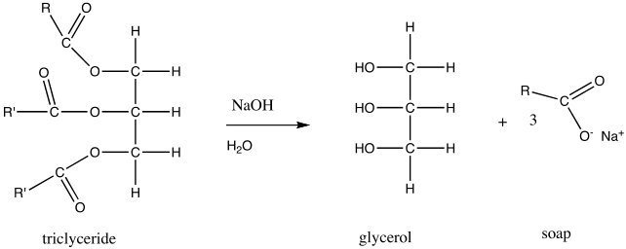

Let us begin with a relatively simple biomolecular structure. In the previous section we looked at the solubility of oils in water. Oils or fats are also known as a triglycerides. In the figure, R and R’ indicate hydrocarbon chains, which have the generic structure CH3CnH2n, shown in the figure. If you treat an oil or fat with sodium hydroxide (NaOH), the resulting chemical reaction leads to the formation of what is known as a fatty acid (in this example, oxygen atoms are maroon). A typical fatty acid has a long, non-polar hydrocarbon chain and one end that often contains both a polar and ionic group. The polar head of the molecule interacts with water with little or no increase in entropy, unlike a hydrocarbon, where the lack of H-bonding interactions with water forces a more ordered shell of water molecules around the hydrocarbon molecule, leading to a decrease in entropy. On the other hand, in water the non-polar region of the molecule creates a decrease in entropy as water molecules are organized into a type of cage around it—an unfavorable outcome in terms of ΔS, and therefore ΔG as well. So, which end of the molecule “wins”? That is do such molecules dissolve in water or not? The answer is: Both! These amphipathic molecules become arranged in such a manner that their polar groups are in contact with the water, while their non-polar regions are not. (See whether you can draw out such an arrangement, remembering to include the water molecules in your drawing.)

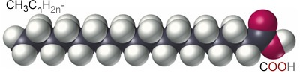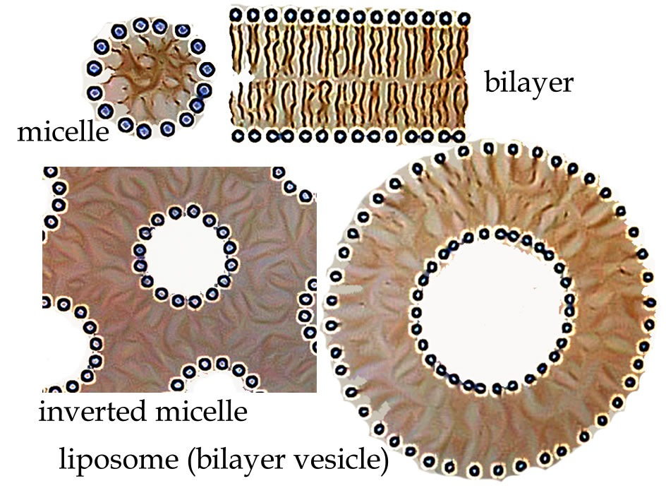

In fact, there are several ways to produce such an arrangement, depending in part on the amount of water in the system. A standard micelle is a spherical structure with the polar heads on the outside and the non-polar tails on the inside. It is the simplest structure that can accommodate both hydrophilic and hydrophobic groups in the same molecule. If water is limiting, it is possible to get an inverted micelle arrangement, in which polar head groups (and water) are inside and the non-polar tails point outward (as shown in the figure). Other highly organized structures can form spontaneously depending on the structure of the head group and the tail. For example, lipid molecules have multiple hydrocarbon tails and carbon ring structures called sterols. That structure creates a lipid bilayer—a polar membrane made up of two lipid molecule layers that form cellular and organellar boundaries in all organisms. It should be noted that these ordered structures are possible only because dispersing the lipid molecules in water results in a substantial decrease in the disorder of the system. In fact, many ordered structures associated with living systems, such as the structure of DNA and proteins, are the result of entropy-driven processes, yet another counterintuitive idea. This is one of the many reasons why biological systems do not violate the laws of thermodynamics and why it is scientifically plausible that life arose solely due to natural processes![120]

## Questions to Answer

* If you had a compound that you suspected might form micelles:
  + What structural features would you look for?
  + How might you design an experiment to determine whether the compound would form micelles in water?
  + What would be the experimental evidence?
* Why do you think some amphipathic molecules form spherical clusters (micelles or liposomes) whereas others form sheets (bilayers)? (Hint: consider the shape of the individual molecule itself.)
* Amphipathic molecules are often called surfactants. For example, the compounds used to disperse oil spills are surfactants. How do you think they work?

**Questions to Ponder**

* If membrane formation and protein folding are entropy-driven processes, does that make the origins of life seem more or less “natural” to you?

### Solutions, Colloids & Emulsions

So, do micelles dissolve in water? Well, micelles are not molecules but rather supramolecular assemblies composed of many distinct molecules. A glucose solution consists of isolated glucose molecules but micelles in solution consist of larger molecular aggregates. Solutions of macromolecular solutes are called colloids. These particles can be aggregates of molecules (like micelles), atoms (nanoparticles), or larger macromolecules (proteins, nucleic acids), among others. When these particles are on the order of the wavelength of visible light, they scatter the light; smaller objects do not. This is why a salt or sugar solution is translucent, whereas a colloidal dispersion of micelles or cells is cloudy.[121] This principle also explains why soap solutions are typically cloudy—they contain particles large enough to scatter the light. When the particles in a solution maintain the structure of a solid, the end result is known as a colloid. The colloid is stable because the thermal movements of these small, solid particles are suspended. As the particles get larger, the colloid becomes unstable; the influence of gravity overcomes the effects of thermal motion and the particles settle out. Before they settle out, such unstable systems are known as suspension

But if the suspended particles are liquid, the system is known as an emulsion. For example, if we looked at a salad dressing made of oil and water under a microscope, we would see drops of oil suspended in water. Emulsions are often unstable, and over time the two liquid phases separate. This is why you have to shake up salad dressing just before using it. There are many colloids and emulsions in the world around us. Milk, for example, is an emulsion of fat globules and a colloid of protein (casein) micelles.

**6.6 Temperature and Solubility**

Can you also predict the effect of temperature on solubility? If you raise the temperature, does solubility of a solute increase or decrease? It would be reasonable to assume that increasing temperature increases solubility. But remember that both ΔH and ΔS have a role, and an increase in temperature increases the effect of changes in entropy. Dissolving solute into solvent is likely to increase entropy (if ΔS is positive), but this is not always the case. Consider what happens when you heat up water on the stove. Bubbles of gas are released from the liquid long before the water reaches its boiling point. At low temperatures, these bubbles contain air (primarily N2, O2) that was dissolved in the water.[122] Why? Because the solubility of most gases in water decreases as temperature rises. We can trace the reason for this back to the entropy of solution. Most gases have very small intermolecular attractions – this is the reason why they are gases after all. Gas molecules do not stick together and form solids and liquids. Therefore, they do not have very high solubility in water. As an example, the solubility of O2 in water is 8.3 mg/L (at 25 ºC and 1 atmosphere).

Most gases have a slightly favorable (negative) enthalpy of solution and a slightly unfavorable (negative) entropy of solution. The effect on enthalpy can be traced to the dipole–induced dipole attractions formed when the gas dissolves in the solution. The decrease in entropy results from the fact that the gas molecules are no longer free to roam around – their positional entropy is more constrained within the liquid phase than it is in the gas phase. When the temperature is increased the gas molecules have more kinetic energy and therefore more of them can escape from the solution, increasing their entropy as they go back to the gas phase. Thus, the solubility of O2 and other gases decreases as temperature increases. This can produce environmental problems, because less oxygen is available for organisms that live in the water. A common source of thermal pollution occurs when power plants and manufacturing facilities expel warm water into the environment.

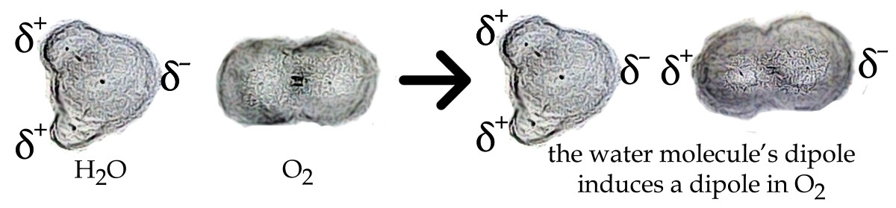

### Solutions of Solids in Solids: Alloys

Another type of solution occurs when two or more elements, typically metals, are melted and mixed together so that their atoms can intersperse, forming an alloy. Upon re-solidification, the atoms become fixed in space relative to each other and the resulting alloy has different properties than the two separate metals. Bronze was one of the first known alloys. Its major component is copper (~90%) and its minor component is tin (~10%), although other elements such as arsenic or phosphorus may also be included.

The Bronze Age was a significant leap forward in human history.[123] Before bronze, the only metals available were those that occurred naturally in their elemental form—typically silver, copper, and gold, which were not well suited to forming weapons and armor. Bronze is harder and more durable than copper because the tin atoms substitute for copper atoms in the solid lattice. Its structure has stronger metallic bonding interactions, making it harder and less deformable, with a higher melting point than copper itself. Artifacts (weapons, pots, statues, etc.) made from bronze are highly prized. Before bronze, the only metals available were those that occurred naturally in their elemental form– typically silver, copper, and gold.

Steel is another example of a solid–solid solution. It is an iron solvent with a carbon solute. The carbon atoms do not replace the iron atoms, but fit in the spaces between them; this is often called an interstitial alloy. Because there are more atoms per unit volume, steel is denser, harder, and less metallic than iron. The carbon atoms are not in the original lattice, so they affect the metallic properties more and make it harder for the atoms to move relative to each other. Steel is more rigid, less malleable, and conducts electricity and heat less effectively than iron.

### Is the Formation of a Solution a Reaction?

We have not yet considered what happens during a chemical reaction: a process where the atoms present in the starting material are rearranged to produce different chemical species. You may be thinking, “Isn’t the formation of a solution a chemical reaction?” If we dissolve ethanol in water, does the mixture contain chemically different species than the two components separately? The answer is no: there are still molecules of ethanol and molecules of water. What about when an ionic substance dissolves in water? For example, sodium chloride must separate into sodium and chloride ions in order to dissolve. Is that a reaction? Certainly interactions are broken (the interactions between Na+ Cl– ions) and new interactions are made (between Na+ ions and water and Cl– ions and water), but the dissolution of a salt has not traditionally been classified as a reaction, even though it seems to fit the criteria.[124] Rather than quibble about what constitutes a reaction, let us move along the spectrum of possible changes and look at what happens when you dissolve a molecular species in water and it forms ions.

When you dissolve hydrogen chloride, HCl (a white, choking gas), in water you get an entirely new chemical substance: hydrochloric acid (or muriatic acid as it is known in hardware stores), one of the common strong acids. This reaction can be written:

HCl (g) + H2O ➞ HCl (aq)   
This is a bit of shorthand because we actually begin with lots of water, but not much of it is used in the reaction. We indicate this fact by using the aq symbol for aqueous, which implies that the HCl molecules are dissolved in water (but as we will see they are now no longer molecules). It is important to recognize that hydrochloric acid, HCl (aq), has properties that are quite distinct from those of gaseous hydrogen chloride HCl (g). The processes that form hydrochloric acid are somewhat similar to those that form a solution of sodium chloride, except that in this case it is the covalent bond between H and Cl that is broken and a new covalent bond between H and O is formed at the same time.

HCl(g) + H2O ➞ H3O+ + Cl–

We call this reaction an acid–base reaction. In the next chapter, we will consider this and other reactions in (much) greater detail.

**Questions to Answer**

Can you convert the solubility of O2 in water into molarity (moles solute (O2) / liter solution)?

If solubility of gases depends on dipole–induced dipole interactions, what do you think the trend in solubility is for the noble gases (He, Ne, Ar, Kr, Xe)?

What else might increase the solubility of a gas (besides lowering the temperature)? (Hint: How are carbonated drinks bottled?)

Why do you think silver, copper, and gold often occur naturally as elements (rather than compounds)?

Draw an atomic-level picture of what you imagine bronze looks like and compare it to a similar picture of steel.

Use these pictures to explain the properties of bronze and steel, as compared to copper and iron.

**Questions to Ponder**

* Why do you think the Iron Age followed the Bronze Age? (Hint: Does iron normally occur in its elemental form? Why not?)
* How did the properties of bronze and steel influence human history?

# Chapter 7: A Field Guide to Chemical Reactions

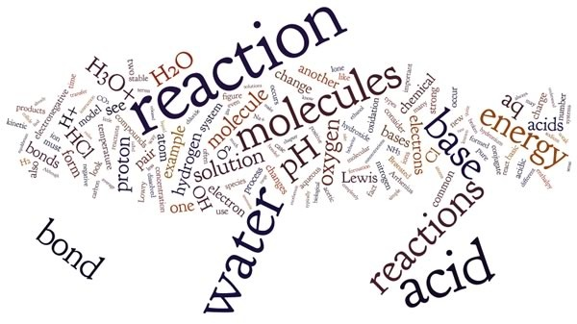

At last we have arrived at the place where many chemistry courses begin: chemical reactions. In this chapter we will examine what a chemical reaction is, which processes are not chemical reactions, how chemical reactions occur, and how they are characterized. We will also look at how molecules come to be reorganized during a chemical reaction. (In Chapter 8, we will look at reaction behaviors in greater detail.)

There are a bewildering array of possible reactions, but the truth is that most chemical reactions fall into a rather limited number of basic types. This is a good thing for the student of chemistry. Recognizing types simplifies our task greatly, and enables us to achieve a greater level of confidence with predicting and explaining the outcomes of chemical reactions. Although each particular reaction differs in its specific molecules and conditions (e.g., temperature, solvent, etc.), some common rules apply. Rather than bombard you with a lot of seemingly unrelated reactions, we will introduce you to the two most common reaction types: acid–base (which as we will see can also be classified as nucleophile/electrophile) and oxidation-reduction. Keep in mind that whatever the reaction type, reactions are systems composed of reactants, products, and the environment in which the reaction occurs. Reactants behave quite differently in the gas phase than in an aqueous or non-aqueous system. High or low temperatures also affect behavior. In the next chapter, we will consider how thermodynamics and kinetics come into play in particular reactions, under specific conditions. This will then lead us to consider equilibrium and non-equilibrium systems.

## 7.1 Collisions and Chemical Reactions

First we will state the obvious: chemical reactions are linked to change but not all change involves a chemical reaction. When liquid water boils or freezes, it undergoes a change of state (a phase change) but the water molecules are still discrete H2O molecules. In ice, they remain more or less anchored to one another through H-bonding interactions, whereas in liquid and water vapor they are constantly moving with respect to one another and the interactions that occur between the molecules are transient. We can write out this transition in symbolic form as:

H2O (solid) ⇄ H2O (liquid) ⇄ H2O (vapor)

The double arrows mean that the changes are reversible. In this case, reversibility is a function of temperature, which controls whether the interactions between molecules are stable (as in ice), transient (as in liquid water), or basically non-existent (as in water vapor). What you notice immediately is that there are water molecules present in each phase. This helps shed light on the common misconception that bubbles found in boiling water are composed of oxygen and hydrogen. Boiling does not break the bonds in a water molecule, so the bubbles are actually composed of water vapor. That said, within liquid water there is actually a chemical reaction going on: the disassociation of water into –OH and H+ (which we will discuss in more detail shortly). However a naked proton (that is, H+ as discrete entity) does not exist in water. Therefore, this reaction is more accurately written as:

H2O + H2O ⇄ H3O+ + –OH

Here we see the signature of a chemical reaction. The molecules on the two sides of the equation are different; covalent bonds are broken (an O—H bond in one water molecule) and formed (a H—O bond in the other.) All chemical reactions can be recognized in this way. The water dissociation reaction also illustrates how reactions can vary in terms of the extent to which they occur. In liquid water, which has a concentration of about ~55 M, very few molecules undergo this reaction. In fact, in pure water the concentration of H3O+ is only 10-7 M, which is eight orders of magnitude less than the concentration of water molecules. Another interesting feature of this reaction is that it is going in both directions, as indicated by the double arrows ⇄.

Water reacts with itself to form H3O+ + –OH, and at the same time H3O+ + –OH are reacting to generate water molecules. The reaction is at equilibrium, and in this case the position of the equilibrium indicates that the majority of the species in water are actually water molecules.

In contrast, other reactions essentially go to completion (proceed until essentially all the reactants are used up and the reaction is a equilibrium).[125] For example, pure ethanol (CH3CH2OH), is ~17.1 M and it will burn in air (which contains O2). We can write the reaction going to completion as:

CH3CH2OH + 3 O2 ⇄ 2 CO2 + 3 H2O

There is very little ethanol left if this reaction occurs in the presence of sufficient O2.[126] In the real world, the reaction is irreversible because the system is open and both CO2 and H2O escape and are therefore not able to collide with each other – which would be a prerequisite for the reverse reaction to occur. Another interesting feature of the ethanol burning reaction is that pure ethanol can be quite stable in contact with the atmosphere, which typically contains ~20% O2. It takes a spark or a little heat to initiate the reaction. For example, vodka, which is about 50% ethanol, will not burst into flames without a little help! Most reactions need a spark of energy to get them started, but once started, many of them release enough energy to keep them going. As we saw in our discussion of solutions, some reactions release energy (are exothermic) and some require energy (are endothermic). It is important to note that this overall energy change is not related to the spark or energy that is required to get some reactions started. We will return to these ideas in chapter 8.

Another feature of reactions is that some are faster than others. For example, if we add hydrogen chloride gas to water, a reaction occurs almost instantaneously:

HCl(g) + H2O(l) ⇄ H3O+(aq) + Cl–(aq)

Very little time elapses between dissolving the HCl and the reaction occurring. We say the rate of the reaction is fast or instantaneous (in Chapter 8, we will look more closely at reaction rate and what affects it.) In contrast, when iron nails are left out in the weather, they form rust, a complex mixture of iron oxides and hydroxides. This reaction is slow and can take many years, although in hot climates the reaction goes faster. Similarly, when we cook food, the reactions that take place occur at a faster rate than they would at room temperature.

As we have seen previously, bonded atoms are typically more stable than unbonded atoms. For a reaction to occur, some bonds have to break and new ones have to form. What leads to a bond breaking? Why are new bonds formed? What are the factors that affect whether reactions occur, how much energy is released or absorbed, where they come to equilibrium, and how fast they occur? All these questions and more will be addressed in Chapter 8.

But first things first, in order for a reaction to occur, the reacting molecules have to collide. They have to bump into each other to have a chance of reacting at all. An important point to remember is that molecules are not sitting still. They may be moving from one place to another (if they are in liquid or gaseous phase) and/or they are vibrating and rotating. Remember that the temperature of a system of molecules is a function of the average kinetic energy of those molecules. Normally, it is enough to define the kinetic energy of a molecule as 1/2 mv2, but if we are being completely rigorous this equation applies only to monatomic gases. Molecules are more complex because they can flex, bend, rotate around bonds, and vibrate. Many reactions occur in solution where molecules are constantly in contact with each other—bumping and transferring energy, which may appear as either kinetic or vibrational energy. Nevertheless, we can keep things simple for now as long as we remember what simplifications we are assuming. Recall that although temperature is proportional to the average kinetic energy of the molecules, this does not mean that all the molecules in the system are moving with the same velocity. There is typically a broad range of molecular velocities, even if all the molecules are of the same type. There is an even broader range in reaction mixtures, which have more than one type of molecule in them. Since the system has only a single temperature, all types of molecules must have the same average kinetic energy, which means that the more massive molecules are moving more slowly, on average, than the less massive molecules. At the same time, all the molecules are (of course) moving so they inevitably collide with one another and, if the system has a rigid boundary, with the boundary. We have previously described the distribution of velocities found in the system in terms of a distribution of velocity (or speed) and the percent or even absolute number of molecules with that speed, the Boltzmann distribution. At any particular temperature, there are molecules that move much faster (have higher kinetic energy) and other molecules that move much slower (have less kinetic energy) than the average kinetic energy of the population. This means that when any two molecules collide with one another, the energetics of that interaction can vary dramatically. Some collisions involve relatively little energy, whereas others involve a lot!

These collisions may or may not lead to a chemical reaction, so let’s consider what happens during a chemical reaction. To focus our attention, we will consider the specific reaction of hydrogen and oxygen gases to form water:

2H2 + O2 ⇄ 2H2O

This is, in fact, a very complex reaction, so let’s simplify it in a way that may seem cartoonish but which is, nevertheless, accurate. If we have a closed flask of pure oxygen, and we add some hydrogen (H2) to the flask, the two types of gas molecules quickly mix, because – as you will recall – the mixed system is more probable (that is the entropy of the mixed gases is higher than the unmixed.) Some of the molecules collide with each other, but the overwhelming majority of these collisions are unproductive. Neither the hydrogen molecule (H2) nor the oxygen molecule (O2) are altered, although there are changes in their respective kinetic energies. However, when we add kinetic energy (say, from a burning match, which is itself a chemical reaction), the average kinetic energy of the molecules in the heated region increases, thus increasing the energy that can be transferred upon collision, which increases the probability that a particular collision will lead to a bond breaking, which therefore increases the probability of the H2 + O2 reaction. In addition, because the stability of the bonds in H2O is greater than those of H2 and O2, the reaction releases energy to the surroundings. This energy can take the form of kinetic energy (which leads to a further increase in the temperature) and electromagnetic energy (which results in the emission of photons of light.) In this way, the system becomes self-sustaining. It no longer needs the burning match because the energy released as the reaction continues is enough to keep new molecules reacting. The reaction of H2 and O2 is explosive (it rapidly releases thermal energy and light), but only after that initial spark has been supplied.

We can plot out the behavior of the reaction, as a function of time, beginning with the addition of the burning match. It is worth keeping in mind that the reaction converts H2 and O2 into water. Therefore, the concentrations of H2 and O2 in the system decrease as the reaction proceeds while the concentration of H2O increases. As the reaction proceeds, the probability of productive collisions between H2 and O2 molecules decreases simply because there are fewer H2 and O2 molecules present. We can think of it this way: the rate at which the reaction occurs in the forward (to the right) direction is based on the probability of productive collisions between molecules of H2 and O2. This in turn depends upon their relative concentration (this is why hydrogen will not burn in the absence of O2). As the concentrations of the two molecules decrease, the reaction rate slows down. Normally, the water molecules produced by burning disperse and the concentration (molecules per unit volume) of H2O never grows very large. But if the molecules are in a container, then their concentrations increase, and eventually the backward reaction could begin to occur. The reaction will reach equilibrium, at which point the rate of forward and backward reactions would be equal. Because the forward reaction is so favorable, some (but very little) H2 and O2 would remain at equilibrium. The point is to recognize that reactions are dynamic and, depending on the conditions, the exact nature of the equilibrium state will be determined by concentrations, temperatures, and the nature of the reaction.

**Questions to Answer**

* + In your own words, define the term chemical reaction. How can you tell when a chemical reaction has occurred?
  + Give some examples of reactions that you already know about or have learned about in previous courses.
  + What do we mean by rate of reaction? How might you determine a reaction rate?
  + What conditions must exist in order for something to react?
  + How does the concentration of reactants and products influence the rate of a reaction?
  + Are chemical reactions possible in the solid phase?
  + What factors are required for a reaction to reach a stable (albeit dynamic) equilibrium?
  + Why is a burning building unlikely to reach equilibrium?
  + Assuming you have encountered them before, define the terms acidic and basic in your own words.

**Questions to Ponder**

* What reactions are going on around you right now?
* What is required in order for a reaction to go backwards?

## 7.2 Acid–Base Reactions: A Guide for Beginners

Let us begin with the hydrogen chloride and water reaction from the last chapter, a classic acid–base reaction. To understand how these types of reactions are related, we need to learn how to identify their essential and common components. Our first hurdle is the fact that the terms acid and acidity, and to a lesser extent, bases and basicity, have entered the language of everyday life. Most people have some notion of acids and acidity. Examples of common usage include: acid rain, stomach acid, acid reflux, acid tongue, etc. You might hear someone talk about wine that tastes acidic, by which they probably mean sour, and most people would nod their heads in comprehension. Old wine tastes like vinegar because it contains acetic acid. You have also probably heard of or even learned about measurements of acidity that involve pH, but what is pH exactly? What is an acid, and why would you want to neutralize it? Are acidic things bad? Do we need to avoid them at all costs and under all circumstances? Although the term base is less common, you may already be familiar with materials that are basic in the chemical sense. Bases are often called alkalis, as in alkaline batteries and alkali metals. They are slippery to the touch, bitter tasting.

Not surprisingly, many definitions of acid–base reactions have been developed over the years. Each new definition has been consistent, that is it produces similar conclusions when applied to a particular system, to the ones that have come before, but each new definition has also furthered the evolution of the idea of acids and bases. Later definitions encompass original ideas about acids and bases, but also broaden them and make them more widely applicable, covering a large array of reactions with similar characteristics. We will start with the simplest model of acids and bases—the Arrhenius model.[127] This is the most common introduction to acid–base chemistry; perhaps you have already been taught this model. Although the Arrhenius model is of limited usefulness, we will examine its simple structure as the foundation for more sophisticated and useful models. Our model-by-model consideration should help you appreciate how acid–base chemistry has become increasingly general, and powerful over time. As we progress, keep this simple rule in mind: All acid–base reactions begin and end with polarized molecules. As we go through the various models for acid–base reactions, see if you can identify the polar groups and how they interact with each other.

### Arrhenius Acids and Bases

In the Arrhenius model, an acid is defined as a compound that dissociates when dissolved in water to produce a proton (H+) and a negatively-charged ion (an anion). In fact, naked protons (H+) do not roam around in solution. They always associate with at least one, and more likely multiple, water molecules.[128] Generally, chemists use a shorthand for this situation, either referring to the H+ in aqueous solution as a hydronium ion (denoted as H3O+) or even more simply as H+, but do not forget, this is a short-hand. An example of an Arrhenius acid reaction is:

HCl(g) + H2O ⇄ H3O+ (aq) + Cl– (aq)

or, more simply (and truer to the original theory):

HCl(g) ⇄ H+ (aq) + Cl– (aq) or HCl(aq)

But this is really quite a weird way to present the actual situation, because the HCl molecule does not interact with a single water molecule, but rather interacts with water as a solvent. When hydrogen chloride (HCl) gas is dissolved in water, it dissociates into H+(aq) and Cl–(aq) almost completely. For all intents and purposes, there are no HCl molecules in the solution. An aqueous solution of HCl is known as hydrochloric acid, which distinguishes it from the gas, hydrogen chloride. This complete dissociation is a characteristic of strong acids, but not all acids are strong!

An Arrhenius base is defined as a compound that generates hydroxide (–OH) ions when dissolved in water. The most common examples of Arrhenius bases are the Group I (alkali metal) hydroxides, such as sodium hydroxide:

NaOH(s) + H2O ⇄ Na+(aq) + –OH(aq) or NaOH(aq)

Again, this is a reaction system that involves both NaOH and liquid water. The process of forming a solution of sodium hydroxide is just like the one involved in the interaction between sodium chloride (NaCl) and water: the ions (Na+ and –OH) separate and are solvated (surrounded) by the water molecules.

As we will see shortly, some acids (and bases) do not ionize completely; some of the acid molecules remain intact when they dissolve in water. When this occurs we use double-headed arrows ⇌ to indicate that the reaction is reversible, and both reactants and products are present in the same reaction mixture. We will have much more to say about the duration and direction of a reaction in the next chapter. For now, it is enough to understand that acid–base reactions (in fact, all reactions) are reversible at the molecular level. In the case of simple Arrhenius acids and bases, however, we can assume that the reaction proceeds almost exclusively to the right.

An Arrhenius acid–base reaction occurs when a dissolved (aqueous) acid and a dissolved (aqueous) base are mixed together. The product of such a reaction is usually said to be a salt plus water and the reaction is often called a neutralization reaction: the acid neutralizes the base, and vice versa. The equation can be written like this:

HCl(aq) + NaOH(aq) ⇄ H2O(l) + NaCl(aq)

When the reaction is written in this molecular form it is quite difficult to see what is actually happening. If we rewrite the equation to show all of the species involved, and assume that the number of HCl and NaOH molecules are equal, we get:

H+(aq) + Cl–(aq) + Na+(aq) + –OH(aq) ⇄ H2O(l) + Na+(aq) + Cl–(aq)

Na+(aq) and Cl–(aq) appear on both sides of the equation; they are unchanged and do not react (they are often called spectator ions because they do not participate in the reaction). The only actual reaction that occurs is the formation of water:

H+(aq) + –OH(aq) ⇄ H2O(l)

The formation of water (not the formation of a salt) is the signature of an Arrhenius acid–base reaction. A number of common strong acids, including hydrochloric acid (HCl), sulfuric acid (H2SO4), and nitric acid (HNO3), react with a strong base such as NaOH or KOH (which, like strong acids, dissociate completely in water) to produce water..

Such acid–base reactions are always exothermic and we can measure the temperature change and calculate the corresponding enthalpy change (ΔH) for the reaction. Regardless of which strong acid or strong base you choose, the enthalpy change is always the same (about 58 kJ/mol of H2O produced). This is because the only consistent net reaction that takes place in a solution of a strong acid and a strong base is:

H+ (aq) + –OH (aq) ⇄ H2O(l)

One other factor to note is that the overall reaction involves a new bond being formed between the proton (H+) and the oxygen of the hydroxide (–OH.) It makes sense that something with a positive charge would be attracted to (and bond with) a negatively-charged species (although you should recall why the Na+ and Cl– do not combine to form sodium chloride solid in aqueous solution.) Whether or not bonds form depends on the exact nature of the system, and the enthalpy and entropy changes that are associated with the change. We will return to this idea later in chapter 8.

**Questions to Answer**

* What would be the reaction if equal amounts of equimolar HNO3 and KOH were mixed?
* How about equal amounts of equimolar H2SO4 and KOH? What would the products be?
* How about equal amounts of equimolar H3PO4 and KOH?
* How many moles of NaOH would be needed to react fully with one mole of H3PO4?
* Draw a molecular level picture of Arrhenius acid base reaction.

**Brønsted–Lowry[129] Acids and Bases**

The Arrhenius acid–base model is fairly easy to understand but its application is limited to certain kinds of reactions. Rather than continue down this road, chemists found that they needed to expand their model of acids and bases and how they react. The first of these expansions was the Brønsted–Lowry model. In the Brønsted–Lowry model, an acid is characterized as a proton (H+) donor and a base as a proton acceptor. If we revisit the reactions we looked at earlier in the context of the Brønsted–Lowry acid-base model, we see that HCl is the proton donor; it gives away H+ and water is the proton acceptor. In this scheme, HCl is the acid and water is the base:

HCl(g) + H2O(l) ⇄ H3O+ (aq) + Cl–(aq)

acid base conjugate acid conjugate base

The resulting species are called the conjugate acid (so H3O+ is the conjugate acid of H2O) and the conjugate base (Cl– is the conjugate base of HCl). This is because H3O+ can and generally does donate its H+ to another molecule (most often another water molecule) and Cl– can accept an H+.

A major (and important difference) between the Brønsted–Lowry and Arrhenius acid–base models is that a Brønsted–Lowry acid must always have an accompanying base to react with—the two are inseparable. A proton donor must have something to donate the protons to (a base)—in this case, water. Remember that bond breaking requires energy, whereas bond formation releases energy. Some energy input is always required for a reaction in which the only thing that happens is the breaking of a bond (for example the Cl–H bond in HCl). Acid–base reactions are typically exothermic; they release energy to the surroundings and the released energy is associated with the interaction between the H+ and the base. In other words, the proton does not drop off the acid and then bond with the base. Instead, the acid–H bond starts to break as the base–H bond starts to form. One way that we can visualize this process is to draw out the Lewis structures of the molecules involved and see how the proton is transferred.  
 As shown in the figure, we use a dotted line to show the growing attraction between the partial positive charge on the H of the H—Cl molecule and the partial negative charge on the oxygen. This interaction results in the destabilization of the H—Cl bond. Because the Cl is more electronegative than the H, the electrons of the original H—Cl bond remain with the Cl (which becomes Cl-) and the H+ forms a new bond with a water molecule. Essentially, a Brønsted–Lowry acid–base reaction involves the transfer of a proton from an acid to a base, leaving behind the original bonding electrons.

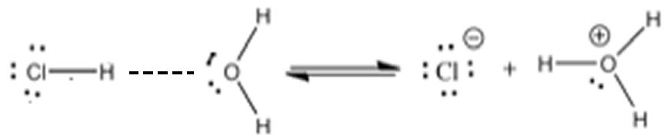

Another example of an acid–base reaction is the reaction of ammonia with water:

NH3(aq) + H2O(l) ⇄ NH4+(aq) + –OH(aq)  
 base acid conjugate acid + conjugate base

In this case, oxygen is more electronegative than nitrogen. The proton is transferred from the oxygen to the nitrogen. Again, the dotted line in the figure represents the developing bond between the hydrogen and the nitrogen. As the H—O bond breaks, a new H—N bond forms, making the resulting NH4+ molecule positively-charged. The electrons associated with the original H—O bond are retained by the O, making it negatively-charged. So, water is the acid and ammonia is the base! An important difference between this and the preceding HCl–H2O reaction is that H2O is a much weaker acid than is HCl. In aqueous solution, not all of the NH3 reacts with H2O to form NH4+. Moreover, the reaction between NH3 and water is reversible, as indicated by the ⇄ symbol. The next chapter will consider the extent to which a reaction proceeds to completion. You may be wondering why the water does not act as a base in the reaction with NH3, like it does with HCl. If you draw out the products resulting from a proton transfer from nitrogen to oxygen, you will see that this process results in a mixture of products where the more electronegative atom (O) now has a positive charge, and the less electronegative atom (N) has a negative charge. It does not make sense that the most electronegative atom would end up with a positive charge, and indeed this process does not happen (to any measurable extent).

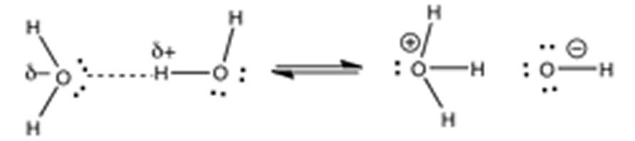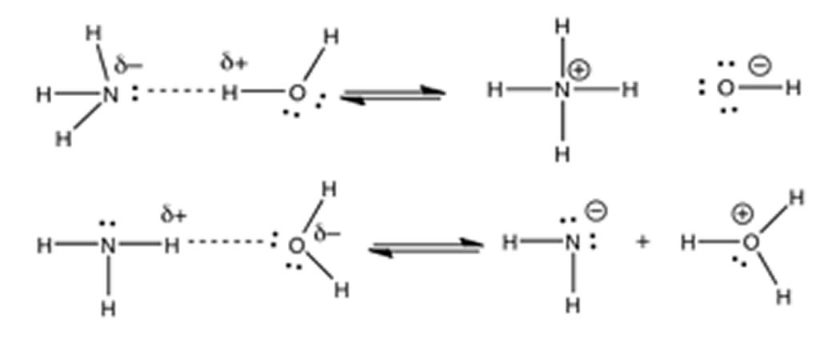

We will soon return to a discussion of what makes a compound acidic and/or basic. At the moment, we have two acid–base reactions: one in which water is the acid and the other in which water is the base. How can this be? How can one molecule of water be both an acid and a base, apparently at the same time? It is possible because of the water molecule’s unique structure. In fact, water reacts with itself, with one molecule acting as an acid and one as a base:

H2O(l) + H2O(l) ⇄ H3O+ (aq) + –OH(aq)   
 acid base conjugate acid + conjugate base

As shown in the figure, we can again visualize this process by drawing out the Lewis structures of the water molecules to see how the proton is able to move from one water molecule to another, so that it is never “alone” and always interacting with the lone pairs on the oxygens.

**Questions to Ponder**

* Between the Arrhenius model and the Brønsted–Lowry model of acids and base, which is more useful? Why?

**Questions to Answer**

* Which do you think is more likely to happen? The reaction H2O + H2O → H3O+ + –OH? Or the reverse process H3O+ + –OH → H2O + H2O? Could they both happen at once?
* What do you think the relative amounts of H2O, H3O+ + –OH might be in a pure sample of liquid water? How would you measure the relative amounts?
* Now that you know HCl is an acid and ammonia is a base, can you predict the reaction that occurs between them?
* Is water a necessary component of a Brønsted–Lowry acid–base reaction? How about for an Arrhenius acid–base reaction?

### How to Spot an Acid

Moving on from water, can we predict whether a compound will be an acid, a base, or neither? We have learned that we can predict many properties of materials by considering their molecular structure. When acids are written in their simplified form (for example HNO3 or H2SO4) it can be very difficult to see any similarities, but if we draw out the Lewis structures some commonalities emerge. Let us take a look at the Lewis structures for several strong acids, such as hydrochloric acid HCl(aq), nitric acid HNO3 (aq), and sulfuric acid H2SO4 (aq).[130] What structural feature do these substances have in common? Well, from their formulae it is clear that they all contain hydrogen, but there are many compounds that contain hydrogen that are not acidic. For example, methane (CH4) and other hydrocarbons are not acidic; they do not donate protons to other molecules.

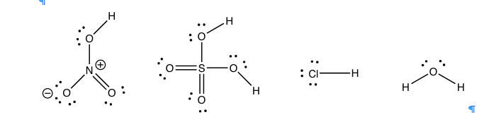

One common feature of acids is that the proton that gets donated (or picked off) is bonded to a highly electronegative atom. This atom is often either an oxygen or a halogen such as chlorine (Cl), bromine (Br), or iodine (I). Once you know what to look for, it is quite easy to spot the potentially acidic sites in a molecule. For example, in the previous figure, you could circle the “vulnerable” hydrogens. The ability to spot donatable hydrogens is a useful skill that allows you to predict properties of more complex molecules. But why is a hydrogen that is covalently bonded to an electronegative element potentially acidic and donatable?

First, let us consider the O—H bond. Based on our discussion of water molecules, we can predict that it is polarized, with a partial positive charge on the H and a partial negative on the O. In water, the H is (on average) also part of a hydrogen bonding interaction with the oxygen of another water molecule. It turns out that it does not take much energy to break the original O—H bond. Remember that H+ does not just “drop off” the acid, but at the same time forms a bond with the base molecule. In fact, strong acid–base reactions are typically exothermic, meaning that the new bond formed between the proton (H+) and the base is stronger than the bond that was broken to release the H+. The released energy raises the temperature of the surroundings. In an aqueous solution of a strong acid, hydrogen ions are moving rapidly and randomly from one oxygen to another. The energy for all this bond-breaking comes from the thermal motion of water molecules.

We must also consider what happens to the oxygen that gets left behind. When the acidic hydrogen is transferred, it leaves behind the electrons that were in the bond, giving that atom more electrons than it started with. The species left behind must be stable even with those extra electrons (the negative charge). In the example below, chloride ion Cl–(aq) is left behind when the proton gets transferred away. We know chloride is stable and common. It is not surprising that it is one of the products of the reaction.

HCl(g) + H2O(l) ⇄ H3O+ (aq) + Cl–(aq)

acid base conjugate acid + conjugate base

If you recall, electronegativity is a measure of the ability to attract (and retain) electrons[131]. Therefore, it makes sense that a negatively-charged, electronegative atom (like chlorine or oxygen) will be more stable than a negatively-charged, less electronegative atom (like carbon).

**Questions to Answer**

* What other atoms besides chlorine or oxygen are electronegative enough to stabilize those extra electrons?
* Draw the reactions of each of the strong acids with water: (HCl(aq)), nitric acid (HNO3 (aq)), sulfuric acid (H2SO4 (aq)), hydrogen bromide (HBr(aq)), and hydrogen iodide (HI(aq)). What are the commonalities? What are the differences?
* Draw the structures of methanol (CH3OH), acetic acid (CH3COOH), and methane (CH4) and write a potential reaction with water. Label the conjugate acid–base pairs.
* Which reactions do you think are likely to occur? Why?

**Questions for Later**

* What other methods (besides having a strongly electronegative atom) might be available to stabilize the electrons (recall that one model of bonding allows for molecular orbitals that extend over more than two atoms)? We will return to this idea later.

### Strong, Weak, Concentrated, and Dilute Acids and Bases

It can be very confusing when words have a different meaning in the scientific context than they do in everyday life. The words we use to describe solutions of acids and bases fall into this category of easily mixed-up definitions. We use the term strong to refer to acids that ionize completely in water, and weak for those acids that are only partially ionized (see Chapter 8 for more information on why). Strong and weak are used to describe an intrinsic property of the acid or base. The terms dilute and concentrated are used to describe the concentration of the acid in water. We could have a dilute solution (say 0.1 M) of the strong acid hydrochloric acid, or a concentrated solution (say 10 M) of the weak acid acetic acid. By contrast, when we refer to strong versus weak liquids in the everyday sense, we are referring to the concentration of the solution. For example, if you say, “This tea is very weak” or “I like my coffee strong” what you are really saying that you like a lot of tea or coffee dissolved in the solution you are drinking. It is important to remember this difference and understand that the scientific context can change the meaning of familiar words.

**Questions to Answer**

* Draw out molecular-level pictures of a dilute solution of a strong acid and a weak acid.
* Draw out molecular-level pictures of a concentrated solution of a strong acid and a weak acid.
* What are the similarities and differences between all the representations you have drawn?
* Consider what you have learned about the energy changes associated with the reaction of a strong acid with water. From a safety point of view, which of the following actions makes more sense when diluting a concentrated solution of a strong acid with water? Why?
* A. Add water slowly (dropwise) to the concentrated strong acid or
* B. Add the concentrated strong acid dropwise to water

### Factors That Affect Acid Strength

In Chapter 8, we will discuss the quantification of acid and base strength. First let us take a look at the factors that might affect the strength of an acid. As we have already seen, the ability of the conjugate base to hold on to (stabilize) the electron pair is crucial. There are several ways to accomplish this. The simplest is that the acidic H is attached to an electronegative atom such as O, N, or a halogen. There is a wide range of acidities for oxyacids. The differences in acidity are determined by the number of places available for the extra electron density to be stabilized. The figure illustrates a fairly simple example of this in the difference between ethanol (CH3CH2OH) and acetic acid (CH3COOH). Acetic acid is about 10 billion times more acidic than ethanol, because the conjugate base (acetate) is able to stabilize the negative charge on two oxygens instead of just one. This “spreading out” of the charge diminishes the electron-electron repulsions, and stabilizes the structure more than if the negative charge were localized on just one oxygen. If you draw out the Lewis structures of the common strong inorganic oxy-acids (e.g. HNO3 or H2SO4), you will see that it is possible to delocalize the negative charge of the corresponding anion on more than one oxygen.

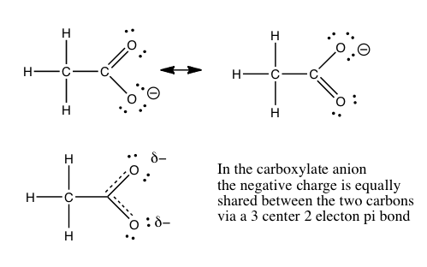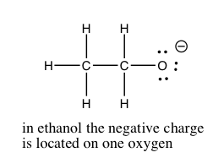

### How to Spot a Base

There is an equally simple method for figuring out which compounds are potential bases. Let us take a look at some common bases. The first bases that most people encounter are the metal hydroxides such as NaOH, KOH, and Mg(OH)2. The metal ions are generated when these compounds dissolve in water, but they typically do not play any role in acid–base reactions.[132] The base in these compounds is the hydroxide (–OH). Another common class of bases is molecules that contain nitrogen, like NH3. There many kinds of nitrogenous bases, some of which play a critical role in biological systems. For example, the bases in nucleic acids (DNA and RNA) are basic because they contain nitrogen. Let us not forget that water is also basic and can accept a proton.

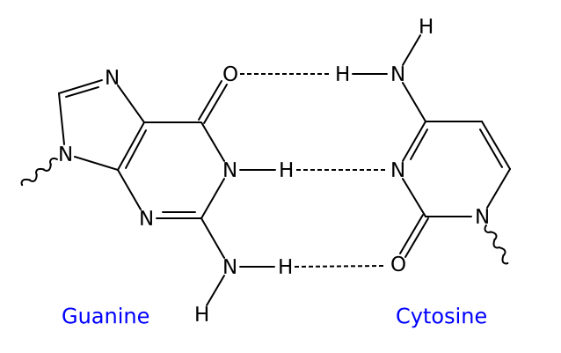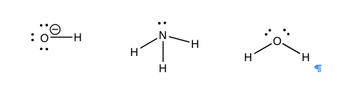

So what is the common structural feature in bases? Well, if an acid is the species with a proton to donate, then the base must be able to accept a proton. This means that the base must have somewhere for the proton to attach—it must contain a non-bonded (lone) pair of electrons for the proton to interact and bond with. If we look at our examples so far, we find that all the bases have the necessary non-bonded pair of electrons. Most common bases have either an oxygen or a nitrogen (with lone pairs of electrons) acting as the basic center. Once you learn how to spot the basic center, you can predict the outcome of a vast range of reactions rather than just memorizing them. It is often the case that if you can identify the acidic and basic sites in the starting materials, you can predict the product and ignore the rest of the molecule.

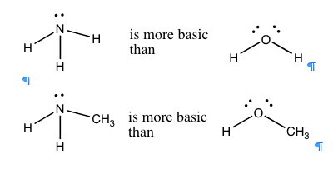

In general, nitrogen is a better proton acceptor than oxygen, because it is more basic. Ammonia (NH3) is more basic than water (H2O), and organic compounds with nitrogen in them are typically more basic than the corresponding compounds containing structurally-analogous oxygens (→). If we compare the trend in basicity for a range of simple compounds across the periodic table, we see that basicity decreases from NH3 > H2O > HF. This effect parallels the increase in electronegativity across the row. The ability to of an electron pair to bond with and accept a proton depends on how tightly that electron pair is held in by the donor atom. In fluorine, the most electronegative atom, the electrons are held so tightly and so close to the atom’s nucleus that they are not available to bond with a proton. Oxygen holds onto its electron pairs a little less tightly, and so is more likely than fluorine to donate a lone pair to a proton. Nitrogen, however, is even less electronegative and therefore has a more available lone pair, making most nitrogen compounds basic.[133]

**Questions to Answer**

* Why did we not include CH4 or neon in this analysis?
* Do you think compounds with ammonium (NH4+) are basic? Why or why not?
* Can you draw the structure of a basic compound that has not yet been mentioned in the text?
* Draw out the reactions of CH3NH2 and CH3OH with water. Label the conjugate acid and base pairs. Which reaction is most likely to occur? Why?
* How would you design an experiment to figure out whether a compound is an acid or a base (or both)? What experimental evidence would you accept to determine if you had an acid or a base or both?

## 7.3 Lewis Acid–Base Reactions

Although chemists use the Brønsted–Lowry model for any reaction in which a proton is transferred from one atom to another, there is an even broader model. The Lewis model incorporates reactions where there is no proton transfer. Instead of seeing the reaction as a proton transfer, we can look at it from the vantage point of the electron pair that eventually becomes part of the new bond. That is: we can consider an acid-base reaction as the donation of an electron pair (from a base) to form a bond between the donor atom and the proton (or the acid). So, instead of saying water transfers a proton to ammonia, the Lewis model would view the process as ammonia donating a lone electron pair to form a new bond with a proton from a water molecule. This process results in the transfer of a hydrogen from the water to the ammonia molecule (a bond formation event, as shown in the figure). The electrons that were originally bonded to the hydrogen do not disappear. Rather, they are left behind on the oxygen, leading to the generation of a hydroxide (–OH) ion. The Lewis acid–base model allows us to consider reactions in which there is no transferred hydrogen, but where there is a lone pair of electrons that can form a new bond.

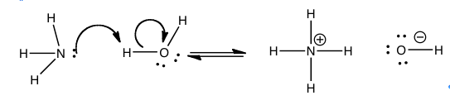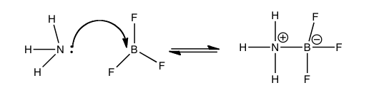

This figure shows an example of the Lewis acid–base model in the reaction between boron trifluoride (BF3) and ammonia (NH3). In this case, the base is the electron pair donor and the acid is the electron pair acceptor. The lone electron pair from NH3 is donated to boron, which has an empty bonding orbital that accepts the pair of electrons, forming a bond between the N and the B. Even though we use the term “donate”, the electron pair does not leave the NH3 molecule; it changes from a non-bonding pair to a bonding pair of electrons. BF3 is a Lewis acid, but note that it has no H to donate. It represents a new class of acids: Lewis acids. These include substances such as BF3 or AlCl3, compounds of periodic table Group III atoms, which have only six electrons in their bonding orbitals. This electron deficiency leaves empty, energetically-accessible orbitals open to accept an electron pair from the Lewis base, the electron pair donor. Other examples of Lewis acids are metal ions, like Fe2+, Fe3+, Mg2+, and Zn2+. All of these elements play a critical role in biological systems via their behavior as Lewis acids. An important example is the heme group of hemoglobin. In the center of this group is a positively-charged iron (Fe) atom. Such positively-charged ions (cations) have empty orbitals that can interact with the lone pair electrons from Lewis bases and form Lewis acid–base complexes. In the case of hemoglobin, the Lewis bases (O2, CO2, and CO) interact with Fe to move oxygen into the body from the lungs and move CO2 from the body to the lungs. It takes a little practice to gain confidence in recognizing Lewis acid–base reactions, but this skill can help us understand many biological and chemical systems.

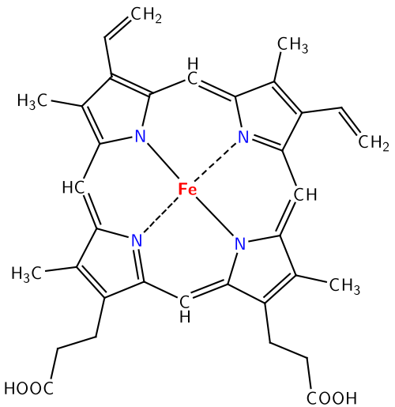

If we look back over the acid–base theories about acids, we see that the theories become increasingly complex as each subsequent theory subsumes the previous one and extends the range of reactions that can be explained. Neither the Arrhenius nor Brønsted–Lowry theories explain why iron in the heme complexes and oxygen to form the oxygen transport system in our bodies. The Lewis acid–base model, on the other hand, can help explain this as well as the simple reaction between HCl and NaOH (where –OH is the Lewis base and H+ is the Lewis acid).

**Questions to Answer**

* For the reaction: HCl(g) + H2O(l) --> H3O+(aq) + Cl–(aq), write out (in words and molecular level pictures) what is going on during the reaction in terms of:
  + Arrhenius acid–base theory
  + Bronsted–Lowry acid–base theory
  + Lewis acid–base theory
* Now do the same activity for the reaction of NH3 and HCl.
* Now do the same activity for the reaction of R2NH and AlCl3.
* Why do you think we use different models of acid–base reactions?
* Can you describe what would dictate the use of a particular model?

## 7.4 Nucleophiles and Electrophiles

The Lewis acid–base model is more inclusive than the Brønsted–Lowry model, but we often use the Brønsted–Lowry model because it is easier to follow the proton transfer from one molecule (the acid) to another (the base). In aqueous solutions, the Brønsted–Lowry theory also allows us to use the concept of pH to quantify acidity (as we will see shortly). Both the Lewis and Brønsted–Lowry models capture the overarching principle that most chemical reactions are initiated by an electrostatic interaction between a positively-charged portion of a molecule to a negatively-charged portion of the same, or another, molecule.[134] As we will see in the next chapter, molecules must collide with one another in order for reactions to occur between them—they do not react at a distance. When the reacting particles collide, there has to be some continuous pathway through which bonds rearrange and produce products. The first step in this pathway often involves Coulombic (electrostatic) interactions between specific regions of the molecules involved. Of course, whether or not such Coulombic interactions are stable depends upon the kinetic energies of the colliding molecules and exactly how they collide with one another. Catalysts often speed reactions by controlling how molecules collide with or interact with one another. This figure (→) shows the reaction of H2O and NH3, in which the positive end of one molecule interacts with the negative end of the other. If we consider this as a Lewis acid–base reaction, the same principle holds true. It turns out that we can profitably consider a wide range of reactions using the principle of Coulombic attraction. For example, ammonia (and other nitrogen compounds) can react with carbon-containing molecules if the appropriate conditions are met.

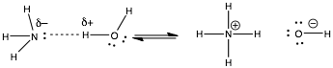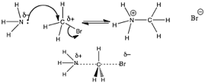

In the figure (→) the nitrogen is behaving as a Lewis base, donating its lone pair of electrons to the carbon. However, it is a little more difficult to see the analogy with a Lewis acid at the carbon site. What we can see is that there is an electronegative, polarizing group (in this case a bromine atom) bonded to the carbon. The presence of a bromine atom polarizes the C—Br bond, giving the carbon a slight positive charge. This makes the carbon susceptible to attack by the lone pair of the nitrogen. Since carbon does not have an empty orbital to accept the lone pair into, and carbon can never form more than four bonds, something has to give. What gives is the C—Br bond, which breaks, and the bromine carries away the electrons from the bond with it, producing a bromide ion, Br–.

This type of reaction, while is essentially a Lewis acid-base reactions, is usually described using yet another set of terms, probably because these reactions usually belong in the realm of organic chemistry, which was once considered a distinct chemical discipline. For organic chemists, the species with the lone pair (in this case the NH3) is called the nucleophile (literally, “nucleus-loving”) and is attracted to a positive center of charge. The species that accepts the lone pair of electrons, in this case the CH3Br molecule, is called the electrophile (literally, “electron-loving”). The species that is released from its bond with the carbon is called the leaving group. Leaving groups must be relatively electronegative (as in the case of Br) or stable when associated with an extra pair of electrons. So, good leaving groups are weak bases. Conjugate bases of strong acids are excellent leaving groups because they are stable.

If we analyze the reaction in the figure further, we see the nitrogen nucleophile approaching the carbon electrophile: as the bond forms between the C and N, the bond breaks between the C and the Br. The bond-breaking and bond-making occur simultaneously. Given what we know about water and aqueous solutions, we might even be so brave as to predict that the product (+NH3CH3 Br–) will rapidly lose a proton in aqueous solution to produce CH3—NH2 and H3O+. This kind of reaction is often referred to as a methylation (a –CH3 group is a methyl group). The product is an N-methylated derivative of ammonia.

As we have already seen, nitrogen compounds are common in biological systems. We now see how these compounds can also act as nucleophiles, and how methylation of nitrogen is a fairly common occurrence with a range of effects. For example, methylation and demethylation of the nitrogenous bases in DNA adenine and cytosine is used to influence gene expression and mark newly synthesized DNA strands from older, preexisting DNA strands. At the same time, various methylated sequences (such as CpG) are much less stable than the unmethylated form, and so more likely to to mutate.[135] Methylation reactions are quite common in other biological reactions as well. For example, epinephrine (also known as adrenaline, the fight-or-flight hormone) is synthesized in the body by methylation of the related molecule norepinephrine.

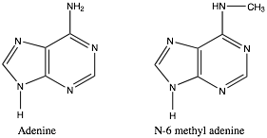

### Considering Acid–Base Reactions: pH

It is almost certain that you have heard the term pH, it is another of those scientific terms that have made it into everyday life, yet its scientific meaning is not entirely obvious. For example: why does an increase in pH correspond to a decrease in “acidity” and why does pH change with temperature?[136] How do we make sense of pH and use that information to better understand chemical systems?

The key idea underlying pH is that water undergoes an acid–base reaction with itself. Recall that this reaction involves the transfer of a proton from one water molecule to another. The proton is never free or “alone”; it is always bonded to an oxygen within another water molecule. Another important point about pH is that the reaction is readily reversible. Under normal conditions (room temperature), the reaction proceeds in both directions. If we look at the reaction, it makes intuitive sense that the reactants on the right (H3O+ and –OH) can react together to give two H2O molecules simply because of the interaction of the positive and negative charges, and we have already seen that the forward reaction does occur. This is one of the first examples we have seen of a reaction that goes both forward and backward in the same system. As we will see, all reactions are reversible at the nanoscale (we will consider the implications of this fact in detail in the next chapter). In any sample of pure water, there are three different molecular species: water molecules (H2O), hydronium ions (H3O+), and hydroxide ions (–OH), as shown in the figure (→). These three species are constantly interacting with each other through the formation of relatively weak H-bonding interactions, which are constantly forming and breaking. Remember, in liquid water, the water molecules are constantly in motion and colliding with one another. Some of these collisions have enough energy to break the covalent H—O bond in water or in the hydronium ion. The result is the transfer of H+ and the formation of a new bond with either another water molecule (to form hydronium ion) or with a hydroxide ion (to form a water molecule). To get a feeling for how dynamic this process is, it is estimated that the average lifetime of an individual hydronium ion is on the order of 1 to 2 picoseconds (1 x 10–12 ps), an unimaginably short period of time. In pure water, at 25 °C, the average concentration of hydronium ions is 1 x 10–7 mol/L. We use square brackets to indicate concentration, so we write this as:

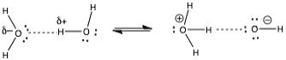

[H3O+] = 1 x 10–7 M

Note that this is a very, very, very small fraction of the total water molecules, given that the concentration of water molecules [H2O] in pure water is ~55.4 M.

In pure water, every time a hydronium ion is produced, a hydroxide ion must also be formed. Therefore, in pure water at 25 °C, the following equation must be true:

[H3O+] = [–OH] = 1 x 10–7 M

It must also be true that the product of the hydronium and hydroxide ion concentrations, [H3O+][–OH], is a constant at a particular temperature. This constant is a property of water. At 25 ºC, this constant is 1 x 10–14 and given the symbol Kw,25ºC. So why do we care? Because when we add an acid or a base to a solution of water at 25 ºC, the product of [H3O+][–OH] remains the same: 1 x 10–14. We can use this fact to better understand the behavior of acids, bases, and aqueous solutions.

For many people, dealing with negative exponents does not come naturally. Their implications and manipulations can be difficult. Believe it or not, the pH scale[137] was designed to make dealing with exponents easier, but it does require that you understand how to work with logarithms (perhaps an equally difficult task). pH is defined as: pH = – log [H3O+] [138]

In pure water (at 25 ºC), where the [H3O+] = 1 x 10–7 M, pH = 7 (pH has no units). A solution with a higher concentration of hydronium ions than pure water is acidic, and a solution with a higher concentration of hydroxyl ions is basic. This leads to the counter-intuitive fact that as acidity [H3O+] goes up, pH goes down. See for yourself: calculate the pH of a solution with a [H3O+] of 1 x 10–2 M (pH = 2), and of 1 x 10–9 M (pH = 9). Moreover, because it is logarithmic, a one unit change in pH corresponds to a change in [H3O+] of a factor of 10.

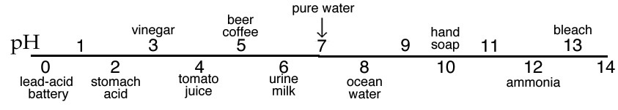

The pH scale is commonly thought of as spanning units 1–14, but in fact many of the strongest acid solutions have pH < 1. Representations of the pH scale often use colors to indicate the change in pH. This convention is used because there are many compounds that change color depending on the [H3O+] of the solution in which they are dissolved. For example, litmus[139] is red when dissolved in an acidic (pH < 7) solution, and blue when dissolved in a basic (pH > 7) solution. Perhaps you have noticed that when you add lemon juice (acidic) to tea, the color changes. Do not get confused: solutions of acids and bases do not intrinsically differ in terms of color. The color change depends on the nature of molecules dissolved in the solution. Think about how changes in pH might affect molecular structure and, by extension, the interactions between molecules and light (a topic that is more extensively treated in the spectroscopy supplement).   
 It is important to note that at 37 ºC the value of Kw is different: [H3O+][–OH] = 2.5 x 10–14 and therefore the pH = 6.8. Weirdly, this does not mean that the solution is acidic, since [H3O+] = [–OH]. The effect is small, but it is significant; it means that a pH of 7 does not always mean that a solution is neutral (it depends on the temperature). This is particularly important when the concept of pH is applied to physiological systems, since the body is usually not at room temperature.

Now let us consider what happens when we add a Brønsted–Lowry acid to water.

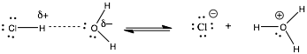

For example, if we prepare a solution of 0.10 M HCl (where we dissolve 0.10 mol HCl(g) in enough water to make 1 liter of solution), the reaction that results (see figure) contains more hydronium ion (H3O+). Now if we measure[140] the pH of the solution of 0.10 M HCl, we find that it is 1.0 pH units. If we convert back to concentration units from pH (if pH = – log [H3O+], then [H3O+] = 10–pH), we find that the concentration of H3O+ in 0.10 M HCl is 0.10 M. This makes sense, in light of our previous discussion about how HCl completely dissociates into Cl- and H+ (associated with water molecules).

|  |  |  |  |  |  |
| --- | --- | --- | --- | --- | --- |
|  | [HCl] M | [H2O] M | [H3O+] M | [OH] M | [Cl–] M |
| Before reaction | 0.10 | ~55.5 | 1.0 x 10–7 | 1.0 x 10–7 | 0 |
| After Reaction | ~0 | ~55.4 | ~1.0 x 10–1 | 1.0 x 10–13 | 1.0 x 10–1 |

This table gives the concentrations of all the species present both before and after the reaction. There are several things to notice about this table. Because the measured pH = 1 and we added 0.1 M (or 10-1 M) HCl, it is reasonable to assume that all the HCl dissociated and that the vast majority of the H3O+ came from the HCl. We can ignore the H3O+ present initially in the water. Why? Because it was six orders of magnitude (0.0000001)(10-7) smaller than the H+ derived from the HCl (10-1). It is rare to see pH measurements with more than three significant figures, so the H3O+ originally present in the water does not have a significant effect on the measured pH value. Although we are not generally concerned about the amount of hydroxide, it is worth noting that [H3O+][–OH] remains a constant (Kw),and therefore when [H3O+] increases the [–OH] decreases.

Although a number of substances dissolve in water, not all ionize, and not all substances that ionize alter the pH. For example, NaCl ionizes completely when dissolved in water, yet the pH of this solution is still 7. The Na+ and Cl– ions do not affect the pH at all. However, if we make a 1 M solution of ammonium chloride (NH4Cl), we find that its pH is around 5. Although it might not be completely obvious why the pH of this solution is 5 and the pH of a 1M NaCl solution is 7, once you know that it is (and given what you know about pH), you can determine the concentrations of H3O+, NH4+, NH3, –OH and Cl– present (see Chapter 8). The question is: Why are NH4Cl and HCl so different? (We consider this point in Chapter 9.)

### Making Sense of Vinegar and Other Acids

Now let us consider another common acid: acetic acid. If wine is left open to the air, it will often begin to taste sour because the ethanol in wine reacts with oxygen in the air and forms acetic acid. Acetic acid belongs to a family of organic compounds known as carboxylic acids. It has one acidic proton attached to the oxygen.

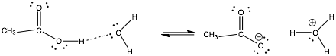

If we measure the pH of a 0.10-M solution of acetic acid, we find that it is about 2.8. The obvious question is why the pH of a 0.10-M solution of acetic acid is different from the pH of a 0.10-M solution of hydrochloric acid? The explanation lies in the fact that acetic acid (CH3COOH) does not dissociate completely into CH3CO2– and H3O+ when it is dissolved in water. A pH of 2.8 indicates that the [H3O+] = 10–2.8. This number can be converted into 1.6 x 10–3 M. About 1.6% of the added acetic acid is ionized (a form known as acetate ion, CH3COO–). The rest is in the protonated form (acetic acid, CH3COOH). The specific molecules that are ionized changes all the time; protons are constantly transferring from one oxygen to another. You can think of this process in another way: it is the system that has a pH, not individual molecules. If we look at a single molecule of acetic acid in the solution, we find that it is ionized 1.6% of the time. This may seem a weird way to think about the system, but remember, many biological systems (such as bacteria) are quite small, with a volume of only a few cubic microns or micrometers (a cubic micron is a cube 10–6 m on a side) and may contain a rather small number of any one type of molecule. Thus, rather than thinking about the bulk behavior of these molecules, which are relatively few, it can be more useful to think of the behavior of individual molecules averaged over time. Again, in an aqueous solution of acetic acid molecules, most of the molecules (~98.4%) are in the un-ionized form, so any particularly molecule is un-ionized ~98.4% percent of the time.

We can measure the pH of the solutions of many acids of known concentrations, and from these measurements make estimates of the strength of the acid. Strong acids, such as nitric, sulfuric, and hydrochloric are all totally ionized in solution. Weaker acids, such as organic acids, ionize to a much lesser extent. However, given the low naturally occurring concentrations of hydronium and hydroxide ions in pure water, even weak acids can significantly alter the pH of an aqueous solution. The same behavior applies to weak bases.

Conversely, if weak acids or bases are dissolved in solutions of different pH, the amount of ionization of the group may be significantly changed. For example, as we will see in chapters 8 and 9, if we added a weak acid to a solution that was basic (for example at pH 9), we would find that much more of the acid will ionize. Many biological molecules contain parts (called functional groups) that behave as weak acids or weak bases. Therefore, the pH of the solution in which these molecules find themselves influences the extent to which these functional groups are ionized. Whether a part of a large molecule is ionized or not can dramatically influence a biomolecule’s behavior, structure, and interactions with other molecules. Thus, changes in pH can have dramatic effects on a biological system. For example, if the pH of your blood changes by ± 0.3 pH units, you are likely to die. Biological systems spend much of the energy they use maintaining a constant pH (typically around 7.35-7.45).[141] In addition, the pH within your cells is tightly regulated and can influence cellular behavior.[142]

**Questions to Answer**

* How would you calculate the molarity of pure water?
* What percentage of water molecules are ionized at 25 °C?
* If the pH of a solution (at 25 ºC) is 2.0, what is the [H3O+]? What is the [–OH]?
* If the pH of a solution (at 37 ºC) is 2.0, what is the [H3O+]? What is the [–OH]?
* What would be the pH of a 0.01-M solution of HCl at 25 ºC?
* If the pH of a 0.1-M solution of NH4Cl is 5.1, what is the [H3O+]?
* Draw out a molecular level picture of what you imagine solutions of NaCl and NH4Cl look like.
* Why does acetic acid only have one acidic proton (after all, it does have a total of four protons)?
* Why is acetic acid more acidic than ethanol? What is it about the structure of acetic acid that makes it more acidic?

**Questions for Later**

* Why do you think we keep specifying the temperature in our discussions of reactions?

**Questions to Ponder**

* Carboxylic acid groups, –COOH, are common in large biomolecules. What would be the effect of raising or lowering the pH on carboxylate side chains?
* What effect do you think that might have on the properties of the biomolecule (solubility, interactions with other molecules, etc.)?
* Amino groups are also common. What would be the effect of raising or lowering the pH on an amino group?

## 7.5 Oxidation–Reduction Reactions

In contrast to acid–base reactions, oxidation–reduction (or redox) reactions obey a different pattern. In the simplest kinds of redox reactions, polar products are generated from non-polar reactants. You may have run into such reactions already (even if you did not know what they were called!) When iron is left in contact with oxygen (in air) and water, it rusts. The iron is transformed from a hard, non-polar metallic substance, Fe (solid), into a powdery substance, Fe2O3.nH2O(s). Rusting is mechanistically similar to the reactions that occur when copper turns green, when silver tarnishes and turns black, or (in perhaps the favorite reaction of chemists everywhere[143]) when sodium metal explodes in water.[144]

All of these reactions start with a metal in its elemental form. Pure metals have no charge or permanent unequal distribution of charge (which makes them different from salts like NaCl). In fact we can use the synthesis of sodium chloride (NaCl) from its elements sodium (Na) and chlorine (Cl2) to analyze what happens during a redox reaction. The reaction can be written as:

2Na(s) + Cl2(g) ⇄ 2NaCl(s)

We have already looked at the structure of ionic compounds in Chapter 4 and know that the best way to think about them is to consider NaCl as a three-dimensional lattice of alternating positive (Na+) and negative (Cl–) ions. That is as the reaction proceeds the metal atoms becomes cations, and the chlorine molecules become anions. We could write this as two separate reactions: The Na loses an electron – a process that we define as oxidation.

Na ⇄ Na+ +e– (an oxidation reaction)

The electrons must go somewhere (they cannot just disappear) and since chlorine is an electronegative element, it makes sense that the electrons should be attracted to the chlorine. We define the gain of electrons as a reduction.

Cl + e– ⇄ Cl – (a reduction reaction).

It turns out that all reactions in which elements react with each other to form compounds are redox reactions. For example, the reaction of molecular hydrogen and molecular oxygen is also a redox reaction:

2H2(g) + O2(g) ⇄ 2H2O(l)

The problem here is that there is no obvious transfer of electrons. Neither is there an obvious reason why these two elements should react in the first place, as neither of them has any charge polarity that might lead to an initial interaction. That being said, there is no doubt that H2 and O2 react. In fact, like sodium and water, they react explosively.[145] When we look a little more closely at the reaction, we can see that there is a shift in electron density on individual atoms as they move from being reactants to being products. The reactants contain only pure covalent (H—H and O—O) bonds, but in the product (H2O) the bonds are polarized: Hδ+ and Oδ– (recall that oxygen is a highly electronegative atom because of its highly effective nuclear charge.) There is a shift in overall electron density towards the oxygen. This is a bit subtler than the NaCl case. The oxygen has gained some extra electron density, and so been reduced, but only partially – it does not gain the whole negative charge. The hydrogen has also been oxidized by losing some electron density. We are really talking about where the electron spends most of its time. In order to keep this straight, chemists have developed a system of oxidation numbers to keep track of the losses and gains in electron density.

### Oxidation States and Numbers

Now, we may seem to be deploying more arcane terms designed to confuse the non-chemist, but in fact, oxidation numbers (or oxidation states) can be relatively easy to grasp as long as you remember a few basic principles:[146]

* For an ion, the charge is the oxidation number. The oxidation number of Na+ is +1, the oxidation number of the oxide ion (O2–) is –2.
* For elements that are covalently bonded to a different element, we imagine that all the electrons in the bond are moved to the most electronegative atom to make it charged. As an example, the oxygen in water is the more electronegative atom. Therefore, we imagine that the bonding electrons are on oxygen and that the hydrogen atoms have no electrons (rather, they have a +1 charge). The oxidation number of H (in water) is +1, whereas in oxygen it is -2, because of the -2 charge of the two imagined extra electrons that came from the bond.
* Elements always have an oxidation number of zero (because all of the atoms in a pure element are the same, so none of the bonds are polar).

Remember this is just a way to keep track of the electrons. Oxidation numbers are not real; they are simply a helpful device. It is also important to remember that the oxidation number (or state) of an atom is dependent upon its molecular context. The trick to spotting a redox reaction is to see if the oxidation number of an atom changes from reactants to products. In the reaction:

2H2(g) + O2(g) ⇄ 2H2O(l)

H changes from zero in the reactants (H2) to +1 in the products (H2O), and the oxygen goes from zero (O2) to –2 (H2O). When oxidation numbers change during a reaction, the reaction is a redox reaction.

Now lets look at the reaction sodium and water, which is a bit more complicated to see if we can spot what is oxidized and what is reduced.

2Na(s) + 2H2O(l) ⇄ 2Na+(aq) + 2–OH(aq) + H2(g)

It is relatively easy to see that the sodium gets oxidized, because it loses an electron, going from Na to Na+. But which species gets reduced? Is it the oxygen or the hydrogen? Or could it be both? If we check for changes in oxidation state, the oxygen in water starts at –2 and in hydroxide (–OH) it is still –2 (it has not been reduced or oxidized). If we check the hydrogens, we see two distinct fates. One of the hydrogen atoms stays bonded to the oxygen atom (in hydroxide); it starts at +1 and stays there. However, the other type ends up bonded to another hydrogen atom; it starts at +1 and ends at zero. It is these latter two hydrogen atoms that have been reduced!

Historically, the term oxidation has denoted a reaction with oxygen. For example, in simple combustion reactions:

CH4(g)+ O2(g) ⇄ CO2(g) + H2O(g)

Oxidation reactions like this provide major sources of energy, in the burning of fuel (natural gas, gasoline, coal, etc.) and also in biological systems. In the latter, carbons containing molecules such as sugars and lipids react with molecular oxygen to form compounds with very stable bonds (CO2 and H2O), releasing energy that can be used to break bonds and rearrange molecules. In a similar vein the original meaning of reduction was reaction with hydrogen, for example acetic acid can be reduced to ethanol by reacting with hydrogen:

CH3CO2H + H2(g) ⇄ CH3CH2OH

What is important to note is that, there cannot be an oxidation without a reduction – and vice-versa. Just like there can be no acid without a base.

**Questions to Answer**

* For the reaction CH4(g)+ O2(g) ⇄ CO2(g) + H2O(g), which atoms are oxidized and which are
* reduced?
* For the reaction CH3CO2H + H2(g) ⇄ CH3CH2OH which atoms are oxidized and which are   
   reduced?
* Write an explanation to a friend who has no chemistry background to explain the difference   
   between these two reactions that give the same product:   
   2H2(g) + O2(g) ⇄ 2H2O(l) and H+(aq) + –OH(aq) ⇄ H2O(l)

**Questions for Later**

* Is it possible to separate out the oxidation reaction (where electrons are lost) and the reduction reaction (where electrons are gained)? What would happen?
* What if you separate the two reactions but join them by an electrical connection? What do you think would happen?

## 7.6 Energy Changes and Chemical Reactions

All chemical reactions are accompanied by energy changes. Under most circumstances, particularly when the pressure and volume are kept constant, these changes can be ascribed to changes in enthalpy ΔH. For example, combustion reactions (redox reactions involving oxygen) are a major source of energy for most organisms. In warm-blooded organisms, the energy released through such reactions is used to maintain a set body temperature. Within organisms, combustion reactions occur in highly-controlled stages (which is why you do not burst into flames), through the process known as respiration (different from breathing, although breathing is necessary to bring molecular oxygen to your cells).

Not all biological forms of respiration use molecular oxygen.[147] There are other molecules that serve to accept electrons; this process is known as anaerobic (air-free) respiration. All known organisms use the molecule adenosine triphosphate (ATP) as a convenient place to store energy. ATP is synthesized from adenosine diphosphate (ADP) and inorganic phosphate. As two separate species, ADP and inorganic phosphate are more stable than ATP and the energy captured from the environment use to drive the synthesis of ATP can be released again via the formation of ADP and inorganic phosphate:

ADP + Pi + energy ⇄ ATP + H2O

If we looked closely at the molecular level mechanism of ATP synthesis, we would see that it is another example of an electrophile–nucleophile interaction. But regardless of the type of reactions, we can ask the same question: Where (ultimately) does the energy released in an exothermic reaction come from? When an exothermic reaction occurs and energy is transferred from the system to the surroundings, the result is a temperature increase in the surroundings and a negative enthalpy change –ΔH.) What is the source of that energy? Of course, you already know the answer—it has to be the energy released when a bond is formed!

The defining trait of a chemical reaction is a change in the chemical identity of the reactants: new types of molecules are produced. In order for this to occur, at least some of the bonds in the starting material must be broken and new bonds must be formed in the products, otherwise no reaction occurs. So to analyze energy changes in chemical reactions, we look at which bonds are broken and which are formed, and then compare their energies. As we will discuss later, the process is not quite so simple, given that the pathway for the reaction may include higher energy intermediates. As we will see it is the pathway of a reaction that determines its rate (how fast it occurs), whereas the difference between products and reactions determines the extent to which the reaction will occur. The following analysis will lead to some reasonable approximations for estimating energy changes during a reaction.

As we have already seen, bond formation releases energy and bond breaking requires energy. Tables of bond dissociation energies are found in most chemistry books and can be easily retrieved from the Internet.[148] One caveat: these measurements are typically taken in the gas phase and refer to a process where the bond is broken homolytically (each atom in the original bond ends up with one electron and the species formed are known as radicals).[149] The bond dissociation energy for hydrogen is the energy required to drive the process:   
 H–H(g) ⇄ 2H•

where the dot represents an unpaired electron. The enthalpy change for this process is   
ΔH = + 436 kJ/mol. Note that tables of bond energies record the energy required to break the bond. As we noted earlier, enthalpy is a state function – its value does not depend on the path taken for the change to occur, so we also know what the enthalpy change is for the reverse process. That is, when a hydrogen molecule forms from two hydrogen atoms the process is exothermic:

2H • ⇄ H–H(g) ΔH = – 436 kJ/mol.

We have tables of bond energy values for most common bond types, so one way to figure out energy changes (or at least the enthalpy changes) for a particular reaction is to analyze the reaction in terms of which bonds are broken and which bonds are formed. The broken bonds contribute a positive term to the total reaction energy change whereas bond formation contributes a negative term. For example, let us take a closer look at the combustion of methane:[150]

CH4(g)+ 2O2(g) ⇄ CO2(g) + 2H2O(g)

In the course of this reaction, four C—H bonds

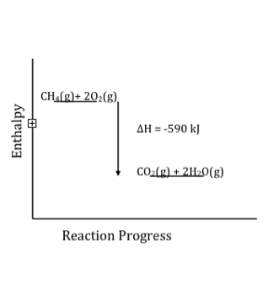

[4 x C—H (436kJ/mol)] and two O=O bonds (498 kJ/mol) are broken. The new bonds formed are 2 x C=O (803 kJ/mol) and 4 x O—H (460 kJ/mol). If you do the math, you will find that the sum of the bond energies broken is 2740 kJ, whereas the sum of the bond energies formed is –3330 kJ. In other words, the bonds in the products are 706 kJ more stable than the bonds in the reactants. This is easier to see if we plot the progress of enthalpy versus reaction; it becomes more obvious that the products are lower in energy (more stable).

There are several important aspects to note about this analysis:

1. This is only an estimation of the enthalpy change, because (as noted above) bond energies are averages and are measured in the gas phase. In the real world, most reactions do not occur in the gas phase. In solutions, there are all kinds of other interactions (intermolecular forces) that can affect the enthalpy change, but for an initial approximation this method often gives surprisingly good results.

2. Remember, every reaction must be considered as a part of the system. Both the reactants and products have to be included in any analysis, as well as the direction of energy transfer between the reaction system and the surroundings.

3. An exothermic reaction occurs when the bonds formed are stronger than the bonds that are broken. If we look closely at this calculation, we can see that combustion reactions are so exothermic because they produce carbon dioxide. The bond energy of the carbon—oxygen double bond is very high (although not two times the C—O single bond—can you think why?) The production of CO2 is very favorable from an energy standpoint: it sits in a deep energy well because it has such strong bonds. This point has important ramifications for the world we live in. Carbon dioxide is quite stable; although it can be made to react, such reactions require the input of energy. Large numbers of us expel CO2 into the atmosphere from burning fossil fuels and breathing, at a higher rate than is currently being removed through various types of sequestration processes, including chemical reactions and photosynthesis. You have certainly heard of the greenhouse effect, caused by the build-up of CO2. CO2 is difficult to get rid of because strong bonds give it stability. (Given the notoriety of CO2 in terms of climate change, we will come back to this topic later.)

**Questions to Answer**

* Many biology texts refer to energy being released when high-energy bonds in ATP are broken. In light of what you know, is this a reasonable statement? What do these texts really mean?
* Why do you think the enthalpy change for most Brønsted–Lowry acid–base reactions is independent of the nature of the acid or base? (Hint: What is the reaction that is actually occurring?)
* Using tables of bond dissociation energies, calculate the energy change for the reaction of CH2=CH2 + HCl ⇄ CH3CH2Cl. What steps do you have to take to complete this calculation? Make a list.
* If you look up the enthalpy change for this reaction (ΔH°) you will find it is not exactly what you calculated. Why do you think that is? (Hint: This reaction typically takes place in a solvent. What role might the solvent play in the reaction?)

# Chapter 8: How Far? How Fast?

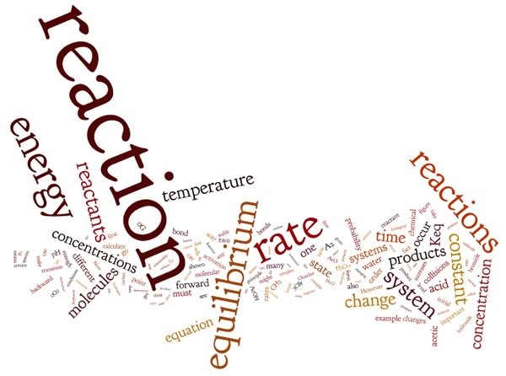

After our overview of common chemical reactions in Chapter 7, the next questions on your mind may well be what determines whether or not a reaction will happen, how fast it will go, how far it will go, or whether it will go in the forward or reverse direction? What causes gasoline to suddenly combust in a violent explosion whereas an iron nail slowly rusts over many years? Are these mysteries of the universe, or can we untangle them in some coherent way?

Once again, it turns out that the universe behaves in an orderly way, and by paying attention to various experimental observations, chemists over the last few centuries have come to understand the factors that control the rate, extent, and direction of reactions. The subject of rate and extent will lead us back to thermodynamics and Gibbs free energy, as we work out the molecular reorganizations that occur during the forward and reverse reactions. In this chapter, we introduce concepts that will allow us to consider how fast a reaction occurs and predict how far it will go.

## 8.1 What Factors Control Reactions?

The key to understanding the behavior of chemical reactions is to remember that: (a) chemical reactions are systems in which reactants and products interact with their environment and (b) at the molecular level, all reactions are reversible, even though some reactions may seem irreversible. For example, once a log starts burning, we cannot easily reassemble it from carbon dioxide (CO2), water (H2O), and energy. But in fact, we can reassemble the log in a fashion by allowing a tree to grow, and by using CO2 from the air, H2O from the ground, and energy from the sun (photosynthesis). However, this type of reverse (or backward) reaction is far more complex and involved than the simple forward reaction of burning.

There are, however, a number of factors that we can use to predict how fast and how far a particular reaction will go, including the concentration of the reactants, the temperature, the type of reaction, and the presence of a catalyst. The concentrations of molecules and the temperature of the system are important because all reactions involve collisions between molecules (except for reactions driven by the absorption of light—and you could view those as collisions of a sort). The concentration of reactants determines how often various types of collisions take place (i.e., the more molecules per unit volume, the more frequently collisions occur), whereas the temperature determines the energetics of the collisions: recall that there is a distribution of kinetic energies of molecules at a particular temperature, so not all collisions will lead to a reaction. Molecular structure also matters because it determines whether or not collisions are productive. The only collisions that work are those in which molecules hit each other in particular orientations and with particular energies.

As a reaction proceeds, and reactants are converted into products, the probability of product molecules colliding decreases (since there are fewer of them) while the probability of reactant molecules colliding increases. That is the rate of the forward reaction slows down and the rate of the reverse reaction speeds up This will continue until the rates of the forward reaction and the backward reaction are equal, and the system reaches equilibrium: the point at which no more macroscopic changes occur and the concentrations of reactants and products remain constant at the macroscopic scale.[151] However, as we will discuss further, the forward and back reactions have not stopped, and if we could see the molecules we would see both forward and back reactions still occurring, although there is no overall change in concentration.

As an example, Brønsted–Lowry acid–base reactions are very fast because the probability that the reaction occurs per unit of time is high. When an acid and a base are mixed together, they react immediately with no waiting and without the addition of heat. For example, if we dissolve enough hydrogen chloride gas (HCl) in water to make a 0.1 M solution of hydrochloric acid, the pH immediately drops from 7 (the pH of water) to 1.[152] This measurement tells us that all the HCl has ionized, to give: [H+] = 0.1 and [Cl–] = 0.1.

Now let us take the case of acetic acid (CH3COOH). If we dissolve enough acetic acid in water to make a 0.1-M solution, the pH of the solution immediately changes from pH 7 (pure water) to 2.9 (not 1). Even if you wait (as long as you want) the pH stays constant, around 3. You might well ask, “What is going on here?” The acid–base reaction of acetic acid and water is fast, but the pH is not as low as you might have predicted. We can calculate the [H+] from the pH, again using the relationship pH = – log [H+] and [H+] = 10-pH, giving us a value of [H+] = 1.3 x 10–3 M. Thus, the concentration of H+ is more than two orders of magnitude less than you might have expected! If you think about this, you will probably conclude that the amount of acetic acid (AcOH)[153] that actually reacted with the water must have been very small indeed. In fact we can calculate how much acetic acid reacted using the relationships from the equation:

AcOH + H2O ⇄ H3O+ + AcO–

If the concentration of acetic acid started at 0.10 M, and after the ionization reaction 1.3 x 10–3 M of H+ are present, then the final concentration of acetic acid must be (0.10 minus 1.3 x 10–3) M. If we use the appropriate number of significant figures, this means that the concentration of acetic acid is still 0.10 M (actually 0.0986 M).

There are two important conclusions here: first, the reaction of acetic acid is fast, and second, most of the acetic acid has not, in fact, reacted with the water. But wait—there is more! Even if the reaction appears to have stopped because the pH is not changing any further, at the molecular level things are still happening. That is, the reaction of acetic acid with water continues on, but the reverse reaction occurs at the same rate. So the bulk concentrations of all the species remain constant, even though individual molecules present in each population are constantly changing.[154] The questions of how far a reaction proceeds (towards products) and how fast it gets there are intertwined. We will demonstrate the many factors that affect these two reaction properties.

**Questions to Answer**

* Draw out a general Brønsted–Lowry acid–base reaction that might occur in water.
* Why do you think the reaction occurs so fast (as soon as the molecules bump into each other)?
* Do you think the water plays a role in the reaction? Draw out a molecular-level picture of your acid–base reaction, showing the solvent interactions.

**Question to Ponder**

* How do you think the reaction would be affected if it took place in the gas phase instead of an aqueous solution?

## 8.2 Reaction Rates

In science, when we talk about a rate we mean the change in a quantity over time. A few non-chemical examples include: certain investments with an interest rate, which is the increase in the principle over time (if the rate is negative, then it means that the amount of principle is decreasing over time—not a good investment!); your speed, which is the rate at which you travel down the road, given in miles per hour (or kilometers per hour); a child’s growth rate, which might be an inch or two per year (while the elderly might shrink at a different rate); and the growth rate of some plants, like kudzu, which can grow at a rate of 12 inches per day. The units of rate are an amount divided by a period of time. This might seem too obvious to dwell on, but it is worth noting that most real processes do not have a constant rate of change; rates themselves can and do change. This is one reason why calculus is useful in chemistry: it provides the mathematical tools needed to deal with changing rates, like those associated with planetary motions, falling bodies, and (it turns out) chemical reactions.

If we apply the idea of an amount divided by a period of time to the speed of a chemical reaction, what can we measure to determine a reaction’s rate? What units tell us the amount present, in the same way that miles and meters measure distance? We can’t use mass, because reactions occur between particles (atoms, molecules, ions), which have different masses. We must use the unit that tells us how many particles of a particular type there are—moles. Furthermore, because most reactions (particularly the ones involved in biological and environmental systems) occur in aqueous solutions or in the atmosphere, we usually use units of concentration—molarity (M, mol/L)—to describe the amount of a substance taking part in or produced by a reaction. Typically, the concentration of substance A2 is written [A2], and the rate of a reaction can be described as the change in concentration of a reactant or product over a unit of time. So, Δ[A2]/Δt or [A2]2 –[A2]1 / t2 –t1, where [A2]2 is the concentration at time t2, and [A2]1 is the concentration at time t2 (assuming that t2 occurs later in time than t1).

### Reaction Rates and Probabilities

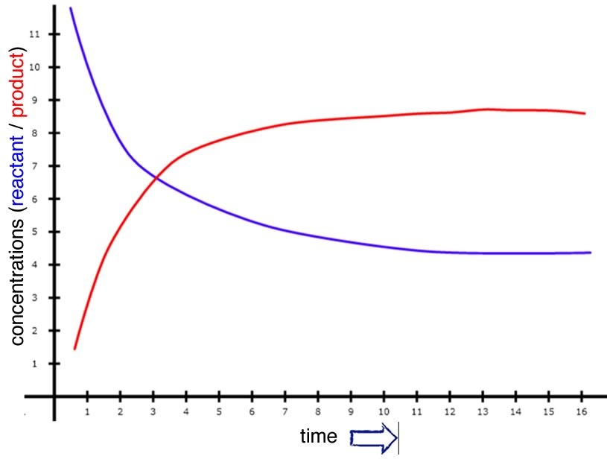

Let us now step back and think about what must happen in order for a reaction to occur. First, the reactants must be mixed together. The best way to make a homogeneous mixture is to form solutions, and it is true that many reactions take place in solution. When reactions do involve a solid, like the rusting of iron, the reactants interact with one another at a surface. To increase the probability of such a reaction, it is common to use a solid that is very finely divided, so that it has a large surface area and thus more places for the reactants to collide.[155]

We will begin with a more in-depth look at reaction rates with a simple hypothetical reaction that occurs slowly, but with a reasonable rate in solution. Our hypothetical reaction will be A2 + B2 ⇄ 2AB. Because the reaction is slow, the loss of reactants (A2 + B2) and the production of product (AB) will also be slow, but measurable. Over a reasonable period of time, the concentrations of A2, B2, and AB change significantly. If we were to watch the rate of the forward reaction (A2 + B2 ⇄ 2AB), we would find that it begins to slow down. One way to visualize this is to plot the concentration of a reactant versus time (as shown in the graph). We can see that the relationship between them is not linear, but falls off gradually as time increases. We can measure rates at any given time by taking the slope of the tangent to the line at that instant.[156] As you can see from the figure, these slopes decrease as time goes by; the tangent at time = 0 is much steeper than the tangent at a later time. On the other hand, immediately after mixing A2 + B2, we find that the rate of the backward reaction (that is: 2AB ⇄ A2 + B2) is zero, because there is no AB around to react, at least initially. As the forward reaction proceeds, however, the concentration of AB increases, and the backward reaction rate increases. As you can see from the figure, as the reaction proceeds, the concentrations of both the reactants and products reach a point where they do not change any further, and the slope of each concentration time curve is now 0 (it does not change and is “flat”).

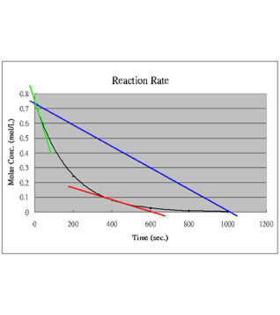

Let us now consider what is going on in molecular terms. For a reaction to occur, some of the bonds holding the reactant molecules together must break, and new bonds must form to create the products. We can also think of forward and backward reactions in terms of probabilities. The forward reaction rate is determined by the probability that a collision between an A2 and a B2 molecule will provide enough energy to break the A—A and B—B bonds, together with the probability of an AB molecule forming. The backward reaction rate is determined by the probability that collisions (with surrounding molecules) will provide sufficient energy to break the A—B bond, together with the probability that A–A and B–B bonds form. Remember, collisions are critical; there are no reactions at a distance. The exact steps in the forward and backward reactions are not specified, but we can make a prediction: if these steps are unlikely to occur (low probability), the reactions will be slow.

As the reaction proceeds, the forward reaction rate decreases because the concentrations of A2 and B2 decrease, while the backward reaction rate increases as the concentration of AB increases. At some point, the two reaction rates will be equal and opposite. This is the point of equilibrium. This point could occur at a high concentration of AB or a low one, depending upon the reaction. At the macroscopic level, we recognize the equilibrium state by the fact that there are no further changes in the concentrations of reactants and products. It is important to understand that at the molecular level, the reactions have not stopped. For this reason, we call the chemical equilibrium state a dynamic equilibrium. We should also point out that the word equilibrium is misleading because in common usage it often refers to a state of rest. In chemical systems, nothing could be further from the truth. Even though there are no macroscopic changes observable, molecules are still reacting.[157]

**Questions to Answer**

* What does linear mean (exactly) when referring to a graph?
* Imagine you are driving at a constant speed of 60 miles per hour. Draw a graph of distance versus time, over a time period of four hours.
* How would you determine your speed from the graph (assuming you did not already know the answer)?
* Now imagine you take your foot off the accelerator and the car coasts to a stop over the course of one hour. What is the average speed over the last hour? How would you figure that out?
* What is the speed exactly 30 minutes after you take your foot off the brake? How would you figure that out?
* Consider the reaction A2 + B2 ⇄ 2AB. If the rate of the forward reaction = – Δ[A2]/Δt (at a given time). How would you write the rate in terms of [B2] or in terms of [AB]?
* How does the rate of the forward reaction change over time? Does it increase, decrease or stay the same? Why?
* What does a probability of “0” mean?
* How do we know that, at equilibrium, the forward and reverse reactions are still occurring.
* Design an experiment that would allow you to investigate whether a reaction had stopped:at the macroscopic level and at the molecular level

**Questions to Ponder**

* Why can a macroscopic reaction be irreversible, even though at the molecular level reaction is reversible?
* Under what conditions (if any) would a reaction stop completely?
* Why are molecular level and macroscopic behaviors different?

**Questions for Later**

* Why do you think the amounts of products and reactants do not change after a certain time?
* What is the observable rate of reaction after the time when the concentrations of products and reactants change?

## 8.3 Kinetics and the Mechanisms of Reactions

The study of reaction rates, called chemical kinetics, encompasses a wide range of activities, measurements, and calculations. You might wonder why anyone would bother with this, but it turns out that we can use kinetic data to get more information about a reaction than just how fast it goes; we can find out about the pathway that the reaction takes from reactants to products, known as the mechanism of the reaction. If you think about a reaction in molecular terms, it seems clear that there must be a continuous pathway between reactants and products. The reactants do not suddenly disappear and then reappear as products, and in most reactions only one or two bonds are broken and formed as the reaction proceeds. This pathway, or mechanism, denotes the order in which bonds are broken and formed, and the intermediate species involved. However, because we cannot see directly what happens at the molecular level during a reaction, we have to rely on indirect methods to determine what is going on. Even using modern spectroscopic techniques, discussed in more detail in the spectroscopy section, some species in reaction pathways may only be present for femto (10–15) or atto (10–18) seconds. Events on these time scales are difficult to study, and in fact much of the current cutting edge research in chemistry and physics is directed at detecting and characterizing such ephemeral molecular-level events. As we will see, information about how the reaction rate varies with concentration and temperature can give us fascinating chemical insights into reaction pathways.

### Concentrations and Reaction Rates

As we have seen as the probability of collisions between reactant molecules increases, the rate of reaction increases. In order to get information about the reaction mechanism we need to know the exact relationship between concentrations and rates. This can be done using a number of different techniques and experimental set-ups. But before we do that, we need to go over a few more terms. Recall that the rate of the reaction is the change in concentration of reactant per unit time. If the time interval is measurable and real, the rate we get is called the average rate (over that time interval), as shown in the earlier graph. If we imagine that the time interval drops to 0, we get the instantaneous rate, which is the slope of the tangent to the concentration versus time curve at a given time (more calculus). The rate at the beginning of the reaction can be obtained by taking the tangent at the start of the reaction (t = 0). This initial rate is useful in many situations because as the reactants form products, these products can interfere with or inhibit the forward reaction. This is particularly true in biological systems, where a product may influence its own formation. For example, it can bind to a site on the enzyme that catalyzes the reaction. This type of interaction is common, and often inhibits the enzyme’s activity (a form of feedback regulation).

We can measure the initial rate for a reaction using different initial concentrations of reactants. Using an appropriate experimental design, we can figure out how the rate of the reaction varies with each reactant. For many common reactions, the relationship between the rate and the concentration is fairly straightforward. For example, in the reaction:

(CH3)3CBr + –OH + Na+  ⇄ (CH3)3COH + Br– + Na+,

the rate is dependent only on the concentration of t-butyl bromide [(CH3)3CBr], not on the concentration of the sodium ion [Na+] or the hydroxide ion [–OH]. “But why only the t-butyl bromide?” you might well ask. We will get to that point shortly, because it gives us some very interesting and important insights into the reaction mechanism. First, let us delve into a bit more background.

Because the rate is directly proportional to the [(CH3)3CBr], we can write the relationship between rate and concentration as: rate ∝ [(CH3)3CBr], or we can put in a constant (k) to make the equation:

rate = k[(CH3)3CBr]

We could also write

–Δ[(CH3)3CBr] /Δt = k[(CH3)3CBr],

or if we let the time interval drop to zero,

–d[(CH3)3CBr] /dt = k[(CH3)3CBr].

In all these forms, the equation is known as the rate equation for the reaction. The rate equation must be experimentally determined. It is worth noting that you cannot write down the rate equation just by considering the reaction equation. (Obviously, in this case, –OH or Na+ do not appear in the rate equation.) The constant (k) is known as the rate constant and is completely different from the equilibrium constant (Keq). The fact that they are both designated by k (one lower case and one upper case) is just one of those things we have to note and make sure not to confuse. A rate equation that only contains one concentration is called a first-order rate equation, and the units of the rate constant are 1/time.

Now, in contrast to the first-order reaction of methyl bromide and hydroxide, let us compare the reaction of methyl bromide with hydroxide:[158]

CH3Br + –OH + Na+ ⇄ CH3OH + Br– + Na+,

For all intents and purposes, this reaction appears to be exactly the same as the one discussed on the previous page. That is, the bromine that was bonded to a carbon has been replaced by the oxygen of hydroxide.[159] However, if we run the experiments, we find that the reaction rate depends on both the methyl bromide concentration [CH3Br] and on the hydroxide concentration [–OH]. The rate equation is equal to k [CH3Br] [–OH]. How can this be? Why the difference? Well, the first thing it tells us is that something different is going on at the molecular level; the mechanisms of these reactions are different.

Reactions that depend on the concentrations of two different reactants are called second-order reactions, and the units of k are different (you can figure out what they are by dimensional analysis). In general: rate = k [A] first order

rate = k [A][B] second order (first order in A and first order in B)

rate = k [A]2 second order (in A)

rate = k [A]2[B] third order (second order in A and first order in B).

There are a number of methods for determining the rate equation for a reaction. Here we will consider just two. One method is known as the method of initial rates. The initial rate of the reaction is determined for various different starting concentrations of reactants. Clearly, the experimental design is of paramount importance here. Let us say you are investigating our reaction A + B ⇄ 2AB. The rate may depend on [A] and/or [B]. Therefore, the initial concentrations of [A] and [B] must be carefully controlled. If [A] is changed in a reaction trial, then [B] must be held constant, and vice versa (you cannot change both concentrations at the same time because you would not know how each one affects the rate).

The method of initial rates requires running the experiment multiple times using different starting concentrations. By contrast, the graphical method involves determining the rate equation from only one run of the reaction. This method requires the collection of a set of concentration versus time data (the same data that you would collect to determine the rates). Ideally we would like to manipulate the data so that we can obtain a linear equation (y = mx + b). For example, if we have a set of [A] versus time data for a reaction, and we assume the reaction is first order in A, then we can write the rate equation as: -d[A]/dt =k[A].

Now, if we separate the variables [A] and t to get: -d[A]/[A] =kt. We can then integrate the equation over the time period t = 0 to t = t to arrive at:

ln [A]t = –kt + [A]0.[160]

You will notice that this equation has the form of a straight line; if we plot our data (ln [A] versus t) and if the reaction is first order in [A], then we should get a straight line, where the slope of the line is –k. We can do a similar analysis for a reaction that might be second order in [A]:

rate = k[A]2.

In this case, we can manipulate the rate equation and integrate to give the equation:

1/[A]t = kt + 1/[A]0.

Therefore, plotting 1/[A] versus t would give a straight line, with a slope of k, the rate constant. This method of analysis quickly becomes too complex for reactions with more than one reactant (in other words, reactions with rates that depend on both [A] and [B]), but you can look forward to that in your later studies!

| **Order** | **Rate Law** | **Integrated Rate Law** | **Graph for Straight Line** | **Slope of Line** |
| --- | --- | --- | --- | --- |
| 0 | Rate = k | [A]t =-kt + [A]0 | [A] vs. t | –k |
| 1 | Rate = k[A] | ln[A]t =-kt + ln[A]0 | ln [A] vs. t | –k |
| 2 | Rate = k[A]2 | 1/[A]t = kt + 1/[A]0 | 1/[A] vs. t | k |

The two approaches (multiple runs with different initial conditions and the graphical method finding the best line to fit the data) provide us with the rate law. The question is, what does the rate law tell us about the mechanism? We will return to this question at the end of this chapter.

**Questions to Answer**

* It turns out that most simple reactions are first or second order. Can you think why?
* Design an experiment to determine the rate equation for a reaction 2A + B ⇄ C. Using the method of initial rates and a first experimental run using 0.1-M concentrations of all the reactants, outline the other sets of conditions you would use to figure out what that rate equation is.
* What is the minimum number of runs of the reaction that you would have to do?
* How would you determine the rate for each of your sets of conditions?
* Now imagine you have determined that this reaction 2A + B ⇄ C does not depend on [B]. Outline a graphical method you could use to determine the rate equation. What data would you have to collect? What would you do with it?

**Questions for Later**

* Why do you think it is that we cannot just write the rate equation from the reaction equation?
* Why do you think that the most common rate equations are second order?

### Temperature and Reaction Rates

Temperature is another important factor when we consider reaction rates. This makes sense if you remember that the vast majority of reactions involve collisions and that the effects of collisions are influenced by how fast the colliding objects are moving. We know intuitively that heating things up tends to make things happen faster. For example, if you want something to cook faster you heat it to a higher temperature (and cooking, as we know, is just a series of chemical reactions). Why is this so? If we consider the reaction of hydrogen and oxygen, discussed in Chapter 7, which is a highly exothermic reaction—explosive, in fact. Yet a mixture of hydrogen and oxygen is quite stable unless energy is supplied, either by heating or a spark of electricity. The same is true of wood and molecular oxygen. The question is: What is the initial spark of energy being used for?

The answer lies within one of the principles that we have returned to over and over again: When atoms form bonds, the result is a more stable system, compared to the energy of non-bonded atoms. But not all bonds are equally stable; some are more stable than others. Nevertheless, energy is always required to disrupt a bond—any bond. If a reaction is to take place, then at least one of the bonds present in the reactants must be broken, and this requires energy.

Imagine two reactants approaching each other. As the reaction starts to occur, the first thing that happens is that at least one bond in a reactant molecule must start to break. It is the initial, partial-bond-breaking step that requires an input of energy from the molecule’s surroundings, and the amount of energy required and available will determine if the reaction occurs. If the amount of energy in the environment is not enough to begin the breaking of bonds in the reactants (for example, in the burning of wood, large amounts of energy are required for the initial bond breaking), then the reaction will not occur without an energy “push”. Wood does not just burst into flames (at least at standard temperatures)—and neither do humans.[161] The burning wood reaction, wood + O2 ⇄ H2O + CO2, does not occur under normal conditions, but if the temperature increases enough, the reaction starts. Once the reaction starts, however, the energy released from the formation of new bonds is sufficient to raise the local temperature and lead to the breaking of more bonds, the formation of new ones, and the release of more energy. As long as there is wood and oxygen available, the system behaves as a positive and self-sustaining feedback loop. The reaction will stop if one of the reactants becomes used up or the temperature is lowered.

It is the activation energy associated with reactions that is responsible for the stability of our world. For example, we live in an atmosphere of ~20% oxygen (O2). There are many molecules in our bodies and in our environment that can react with O2. If there were no energy barriers to combustion (i.e., reaction with O2), we would burst into flames. Sadly, as Salem witches and others would have attested (if they could have), raise the temperature and we do burn. And once we start burning, it is hard to stop the reaction. As we have said before, combustion reactions are exothermic. Once they have produced enough thermal energy, the reaction doesn’t need that spark any more. But that initial spark needs the addition of energy (such as the kind provided by a detonator) for explosions to occur.

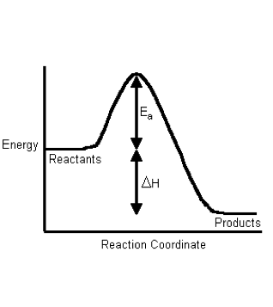

If we plot energy versus the progress of the reaction, we can get a picture of the energy changes that go on during the reaction. Remember that the reaction coordinate on the x-axis is not time; we have seen that reactions go backwards and forwards all the time. For a simple one-step reaction as shown in the figure, the highest point on the energy profile is called the transition state. It is not a stable entity and only exists on the timescale of molecular vibrations (femtoseconds). The energy change between the reactants and the transition state is called the activation energy. This is the energy that must be supplied to the reactants before the reaction can occur. This activation energy barrier is why, for example, we can mix hydrogen and oxygen and they will not explode until we supply a spark, and why we can pump gasoline in an atmosphere that contains oxygen, even though we know that gasoline and oxygen can also explode. The amount of energy that must be supplied to bring about a reaction is a function of the type of reaction, some reactions (acid base) have low activation energies and correspondingly high rates, and some (rusting) have high activation energies and low rates.

Now it should be easier to understand how increasing temperature increases the reaction rate—by increasing the average kinetic energy of the molecules in the environment. Recall that even though individual molecules have different kinetic energies, all of the different populations of molecules in a system have the same average kinetic energy. If we consider the effect of temperature on the Maxwell–Boltzmann distribution of kinetic energies, we see right away that at higher temperatures there are relatively more molecules with higher kinetic energy. Collisions between these high-energy molecules provide the energy needed to overcome the activation energy barrier, that is, the minimum energy required to start a chemical reaction. As the temperature rises, the probability of productive collisions between particles per unit time increases, thus increasing the reaction rate. At the same time, it is possible that raising the temperature will allow other reactions to occur (perhaps reactions we have not been considering). This is particularly likely if we are dealing with complex mixtures of different types of molecules.

The rate equation does not appear to contain a term for temperature, and typically we have to specify the temperature at which the rate is measured. However, because the rate changes with temperature, it must be the rate constant that changes. Sure enough, it has been determined experimentally that the rate constant is k can be described by the equation

k= Ae–Ea/RT,

where k is the rate constant, Ea is the activation energy, T is the temperature, and R and A are constants.[162] This is known as the Arrhenius equation. As you can see, k is directly proportional to the temperature, and indirectly proportional to the activation energy Ea. The constant A is sometimes called the frequency factor and has to do with the collision rate. A changes depending on the specific type of reaction (unlike R, the gas constant, which does not change from reaction to reaction). One way of thinking about the rate constant is to consider it as a representation of the probability that a collision will lead to products: the larger the rate constant, the more frequently productive collisions occur and the faster the reaction.

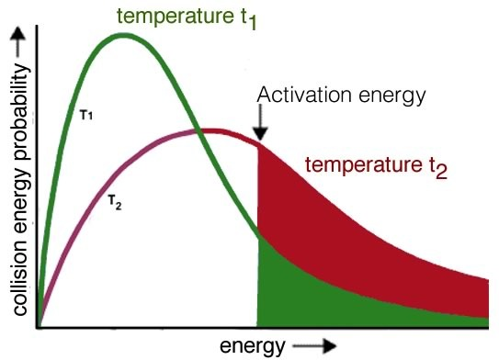

The activation energy for a reaction also depends upon the type of reaction that is occurring. For example, a Brønsted–Lowry acid–base reaction has a very low activation energy barrier. In these reactions the only thing that is happening is that a proton is being transferred from one electronegative element to another:

H—Cl + H—O—H ⇄ Cl– + H3O+   
(draw this out to better see what is happening).

The reaction is rapid because the Cl—H bond is highly polarized and weak. In a sense, it is already partially broken. Also, these reactions usually take place in water, which interacts with and stabilizes the growing charges. Low-energy collisions with water molecules are sufficient to finish breaking the Cl—H bond. We say that acid–base reactions like this are kinetically controlled because they occur upon mixing and do not require heating up or extra energy to proceed. Essentially all collisions involving the HCl molecule provide sufficient energy to break the H—Cl bond. This is also true for almost all proton-transfer reactions. However, for most other types of reactions, simply mixing the reactants is not enough. Energy must be supplied to the system to overcome this energy barrier, or we have to wait a long time for the reaction to occur. In fact, most organic reactions (those in which carbon is involved) are quite slow. Why the difference? The answer should be reasonably obvious. There is simply not enough energy in the vast majority of the collisions between molecules to break a C—H, C—C, C—N, or C—O bond. If you take organic chemistry lab, you will discover that large portions of time are spent waiting as solutions are heated to make reactions happen faster. As we mentioned before, this is quite fortunate. As we mentioned before, this is quite fortunate, since we are (basically) organized by chance and natural selection, from collections of organic reactions. If these reactions occurred spontaneously and rapidly, we would fall apart and approach equilibrium (and equilibrium for living things means death!). You may already see the potential problem in all of this: it is generally not advisable to heat up a biological system, but we certainly need biological systems to undergo reactions. Biological systems need different reactions to proceed in different places and at different rates, without being heated up. For this, biological systems (and many other types of systems) use a wide range of catalysts, the topic of our next section.

**Questions to Answer:**

* When a reaction releases energy, where does the energy come from?
* There is a rule of thumb that increasing the temperature by 10°C will double the rate for many reactions.
* What factor in the Arrhenius equation is always changing?
* Explain why the reaction rate increases when the temperature increases.

## 8.4 Catalysis

A catalyst provides an alternate pathway for a reaction to occur. More importantly, this pathway usually involves a lower activation energy than the uncatalyzed pathway, as shown in the graph. This means that the rate of the reaction can increase. It can do so because at a given temperature, collisions with enough energy to overcome the new lower activation energy barrier occur more frequently. But because the catalyst is neither a reactant nor a product of the reaction, it does not influence the reaction’s overall energy change. In biological systems, there are protein and RNA-based catalysts (enzymes and ribozymes); in non-living systems, minerals and metals often act as catalysts. Even simple species such as protons can be considered catalysts. Anything that is unchanged at the start and at the end of the reaction can be considered a catalyst. There are many different mechanisms through which catalysts can act. Biological catalysts are generally very selective in terms of the reactions they catalyze and very effective in speeding reactions up. It is not uncommon for the rate of a catalyzed reaction to be millions of times faster than the uncatalyzed reaction. In a complex reaction system, speeding up one reaction at the expense of others can have profound effects. However, there are also many examples where enzymes catalyze “off-target” reactions of the same or different types (although these reactions are generally accelerated to a much lesser extent). This ability to catalyze a range of reactions occurs because the surfaces of enzyme molecules are complex and often accommodate and bind a range of molecules. In other words, they are promiscuous.[163] The common analogy of an enzyme as a lock and the reactant molecules are viewed as the unique key, but this is far too simplistic. In reality, there are many molecules that can bind to a specific active site in an enzyme with greatly varying affinities. Although the mode of action of enzymes varies, in many cases the active site holds the two reactive molecules in close juxtaposition, which can speed their reaction. Can you imagine why?[164]

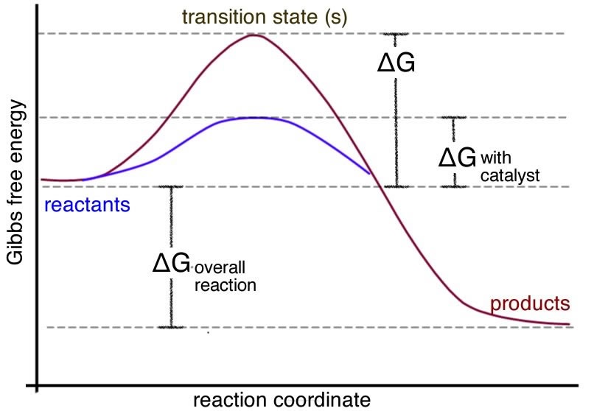

An organic chemical reaction that requires a catalyst is the addition of hydrogens across a C=C bond. Without the catalyst, this reaction would not occur on a human timescale. It is an important reaction in many pharmaceutical syntheses and in the production of fat (solid) from oil (liquids). For example, margarine is produced by adding hydrogen to the C=C bonds of oils extracted from plants, as shown in the figure. The removal of the C=C bond makes the molecules pack better together. This is because London dispersion forces can now act upon the whole length of the molecule, increasing the strength of the van der Waals interactions between the molecules. Thus, the hydrogenated oil is a solid at room temperature. The catalyst is usually a transition metal, palladium (Pd) or platinum (Pt), finely divided and adsorbed onto the surface of an inert substance like charcoal (carbon), as shown in the figure. The transition metal has empty d orbitals that interact with the C=C bond’s pi orbital, destabilizing the pi bond and making it more susceptible to reaction. H2 molecules also adsorb onto (interact with) the surface of the transition metal and insert themselves between the C and the catalyst, forming a fully-hydrogenated fat. Unfortunately, in many cases the hydrogen does not add across the double bond. Instead, the bond isomerizes from cis to trans, forming the unnatural trans isomer which has been implicated in the development of heart disease.[165]

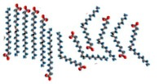

**Questions to Answer**

* Draw a representation of an enzyme active site. What kinds of interactions do you think hold the substrate molecule in the active site?
* Why do you think binding two reactants in close proximity will increase the reaction rate?

## 8.5 Equilibrium

Now that we have a good idea about the factors that affect how fast a reaction goes, let us return to a discussion of what factors affect how far a reaction goes. As previously discussed, a reaction reaches equilibrium when the rate of the forward reaction equals the rate of the reverse reaction, so the concentrations of reactants and products do not change over time. The equilibrium state of a particular reaction is characterized by what is known as the equilibrium constant, Keq.

We can generalize this relationship for a general reaction:

nA + mB ⇄ oC + pD.

Note that each concentration is raised to the power of its coefficient in the balanced reaction. By convention, the constant is always written with the products on the numerator, and the reactants in the denominator. So large values of Keq indicate that, at equilibrium, the reaction mixture has more products than reactants. Conversely, a small value of Keq (typically <1, depending on the form of Keq) indicates that there are fewer products than reactants in the mixture at equilibrium. The expression for Keq depends on how you write the direction of the reaction. You can work out for yourself that Keq(forward) = 1/Keq(reverse). One other thing to note is that if a pure liquid or solid participates in the reaction, it is omitted from the equilibrium expression for Keq. This makes sense because the concentration of a pure solid or liquid is constant (at constant temperature). The equilibrium constant for any reaction at a particular temperature is a constant. This means that you can add reactants or products and the constant does not change.[166] You cannot , however, change the temperature, because that will change the equilibrium constant as we will see shortly. The implications of this are quite profound. For example, if you add or take away products or reactants from a reaction, the amounts of reactants or products will change so that the reaction reaches equilibrium again—with the same value of Keq. And because we know (or can look up and calculate) what the equilibrium constant is, we are able to figure out exactly what the system will do to reassert the equilibrium condition.

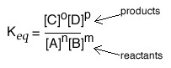

Let us return to the reaction of acetic acid and water:

AcOH + H2O ⇄ H3O+ + AcO–,

we can figure out that the equilibrium constant would be written as:

Keq = [H3O+][AcO–]/[AcOH].

The H2O term in the reactants can be omitted even though it participates in the reaction, because it is a pure liquid and its concentration does not change appreciably during the reaction. (Can you calculate the concentration of pure water?) We already know that a 0.10-M solution of AcOH has a pH of 2.9, so we can use this experimentally-determined data to calculate the equilibrium constant for a solution of acetic acid. A helpful way to think about this is to set up a table in which you note the concentrations of all species before and after equilibrium.

|  | **[AcOH] M** | **[H3O+]** | **[AcO–] M** |
| --- | --- | --- | --- |
| **Initial Concentration** | 0.10 | 1 x 10–7 (from water) | 0 |
| **Change in Concentration** (this is equal to the amount of AcOH that ionized - and can be calculated from the pH) | – 1.3 x 10–3 M  (because the AcOH must reduce by the same amount that the H+ increases) | 10–pH  = 1.3 x 10–3 M | 1.3 x 10–3 M (because the same amount of acetate must be produced as H+) |
| **Final**  (equilibrium concentration) | 0.10 – 1.3 x 10–3  ~ 0.10 | (1.3 x 10–3) + (1 x 10–7)  ~ 1.3 x 10–3 | 1.3 x 10–3 |

You can also include the change in concentration as the system moves to the equilibrium state: AcOH + H2O ⇄ H3O+ + AcO–. Using the data from this type of analysis, we can calculate the equilibrium constant: Keq = (1.3 x 10–3)2/0.1, which indicates that Keq for this reactions equals 1.8 x 10–5. Note that we do not use a large number of significant figures to calculate Keq because they are not particularly useful, since we are making approximations that make a more accurate calculation not justifiable. In addition, note that Keq itself does not have units associated with it.

### Free Energies and Equilibrium Constants

Now we can calculate the equilibrium constant Keq, assuming that we can measure or calculate the concentrations of reactants and products at equilibrium. All well and good, but is this simply an empirical measurement? It was certainly discovered empirically and has proven to be applicable to huge numbers of reactant systems. It just does not seem very satisfying to say this is the way things are without an explanation for why the equilibrium constant is constant. How does it relate to molecular structure? What determines the equilibrium constant? What is the driving force that moves a reaction towards equilibrium and then inhibits any further progress towards products?

You will remember (we hope) that it is the second law of thermodynamics that tells us about the probability of a process occurring. The criterion for a reaction proceeding is that the total entropy of the universe must increase. We also learned that we can substitute the Gibb’s free energy change (ΔG) for the entropy change of the universe, and that ΔG is much easier to relate to and calculate because it only pertains to the system. So it should not be a surprise to you that there is a relationship between the drive towards equilibrium and the Gibbs free energy change in a reaction. We have already seen that a large, negative Gibbs free energy change (from reactants to products) indicates that a process will occur (or be spontaneous, in thermodynamic terms[167]), whereas a large, positive equilibrium constant means that the reaction mixture will contain mostly products at equilibrium.

Think about it this way: the position of equilibrium is where the maximum entropy change of the universe is found. On either side of this position, the entropy change is negative and therefore the reaction is unlikely. If we plot the extent of the reaction versus the dispersion of energy (in the universe) or the free energy, as shown in the graph, we can better see what is meant by this. At equilibrium, the system sits at the bottom of an energy well (or at least a local energy minimum) where a move in either direction will lead to an increase in Gibbs energy (and a corresponding decrease in entropy). Remember that even though at the macroscopic level the system seems to be at rest, at the molecular level reactions are still occurring. At equilibrium, the difference in Gibbs free energy, ΔG, between the reactants and products is zero. It bears repeating: **the criterion for chemical equilibrium is that ΔG = 0** for the reactants ⇄ products reaction. This is also true for any phase change. For example, at 100 ºC and 1 atmosphere pressure, the difference in free energy for H2O(g) and H2O(l) is zero. Because any system will naturally tend to this equilibrium condition, a system away from equilibrium can be harnessed to do work to drive some other non-favorable reaction or system away from equilibrium. On the other hand, a system at equilibrium cannot do work, as we will examine in greater detail.

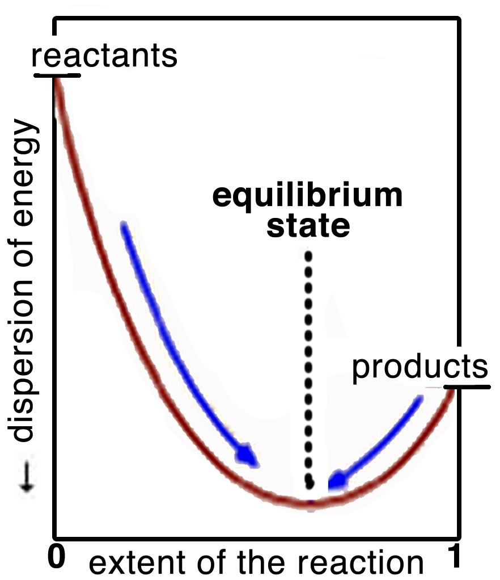

The relationship between the standard free energy change and the equilibrium constant is given by the equation:

ΔGº = – RT ln K

which can be converted into the equation

ln Keq = – ΔGº/RT or Keq = e –ΔGº/RT.

As we saw earlier, the superscript º refers to thermodynamic quantities that are measured and calculated at standard states. In this case ΔGº refers to 1 atmosphere pressure and 298 K and (critical for our present discussion) 1 M concentrations for both reactants and products. That is,: ΔGº tells you about the free energy change if all the substances in the reacting system were mixed with initial concentrations of 1.0 M. It allows us to calculate equilibrium constants from tables of free energy values (see Chapter 9). Of course, this is a rather artificial situation and you might be tempted to think that ΔGº is not very useful in the real world where initial concentrations of **both** reactants and products are rarely 1.0 M. But no, ΔGº does tell us something useful: it tells us which way a reaction will proceed under these starting conditions. If we have a specific set of conditions, we can use ΔGº to calculate the actual free energy change ΔG, where:   
 ΔG = ΔGº + RT ln Q

In this equation, the variable Q is called the reaction quotient. It has the same form as Keq ([products]/[reactants], except that the concentrations are not 1.0 M. Rather, they are the **actual** concentrations at the point in the reaction that we are interested in. The sign and magnitude of ΔG then will tell us which way the reaction will proceed and how far in that direction it will go.

The differences between Q and Keq, ΔG, and ΔGº are important to keep in mind. It is easy to get mixed up and apply them incorrectly. Q and ΔG relate to non-equilibrium systems whereas Keq and ΔGº tell us about the equilibrium state itself. At equilibrium, Q = Keq, and ΔG = 0, so that the equation ΔG = ΔGº +RT ln Q becomes ΔGº = – RT ln Keq. Note that Keq and ΔGº are constant for a given reaction at a given temperature, but Q and ΔG are not; their values vary according to the reaction conditions. In fact, by using Q and/or ΔG, we can predict how a system will behave under a specific condition as it moves towards the highest entropy state (to where ΔG=0).

### Equilibrium and Non-Equilibrium States

Let us look at a chemical system macroscopically. If we consider a reaction system that begins to change when the reactants are mixed up (that is, it occurs spontaneously), we will eventually see that the change slows down and then stops. It would not be unreasonable to think that the system is static and assume that the molecules in the system are stable and no longer reacting. However, as we discussed earlier, at the molecular level we see that the system is still changing and the molecules of reactants and products are still reacting in both the forwards and reverse reactions. In the case of our acetic acid example, there are still molecules of acetic acid, (AcOH), acetate (AcO-), and hydronium ion (H3O+) colliding with solvent water molecules and each other. Some of these reactions will have enough energy to be productive; molecules of acetate will transfer protons to water molecules and the reverse reaction will also occur. What has changed is that the rate of acetate (AcO-) and hydronium ion (H3O+) formation is equal and opposite to the rate of acetic acid deprotonation (transfer of the proton to water). Although there is no net change at the macroscopic level, things are happening at the molecular level. Bonds are breaking and forming. This is the dynamic equilibrium we discussed earlier.

Now what happens when we disturb the system. At equilibrium, the acetic acid–water system contains acetic acid (AcOH), protons (H3O+), and acetate ion (AcO–). We know that a 0.10-M solution of acetic acid has concentrations of [H3O+] = [AcO–] = 1.3 x 10–3 M. Now we add enough acetate[168] to make the acetate concentration 0.10 M? One way to think about this new situation is to consider the probabilities of the forward and backward reactions. If we add more product (acetate), the rate of the backward reaction must increase (because there are more acetate ions around to collide with). Note that to do this, the acetate must react with the hydronium ion, so we predict that the [H3O+] will decrease and the acetate will increase. But as we saw previously, as soon as more acetic acid is formed, the probability of the forward reaction increases and a new equilibrium position is established, where the rate of the forward reactions equal the rate of the backward reactions. Using this argument we might expect that at the new equilibrium position there will be more acetic acid, more acetate, and less hydronium ion than there was originally. We predict that the position of equilibrium will shift backwards towards acetic acid.

This probability argument gives us an idea of what will happen when an reaction at equilibrium is disturbed, but it doesn’t tell us exactly where it will restabilize. For that we have to look at Q and Keq. If we take the new initial reaction conditions (0.10 M AcOH, 0.10 M AcO–, and 1.3 x 10–3 M H3O+) and analyze them to determine the concentrations of all participating species, we can calculate Q and compare it to Keq:

Q = [H3O+][AcO–]/[AcOH] = (1.3 x 10–3)(0.1)/(0.1)

This generates a value for Q as 1.3 x 10–3. Now, if we compare Q and Keq, we see that Q is larger than Keq (1.3 x 10–3 > 1.8 x 10–5). To re-establish equilibrium, the system will have to shift so that Q becomes smaller or equal to Keq (at which point ΔG = 0). To do this, the numerator (products) must decrease, while the denominator (reactants) must increase.[169] In other words, the reaction must go backwards in order to reestablish an equilibrium state. This approach leads us to the same conclusion as our earlier probability argument.

If we recalculate the [H3O+] under the new equilibrium conditions (that is 0.10 M AcOH and 0.10 M acetate), we find that it has decreased considerably from its initial value of 1.3 x 10–3, down to the new value of 1.8 x 10–5 M.[170] Using this to calculate the pH, we discover that addition of sodium acetate causes the pH to rise from 2.9 to 4.5. This may not seem like much, but remember that each pH unit is a factor of 10, so this rise in pH actually indicates a drop in hydronium ion concentration of a bit less than a hundredfold. In order to regain the most stable situation, the system shifts to the left, thereby reducing the amount of product:

AcOH + H2O ⇄ H3O+ + AcO–   
There are a number of exercises that will allow you to better understand the calculations involved in defining the effects of perturbations (changes in conditions, concentrations, and temperature) on the equilibrium state of a system. (Many chemistry books are full of such buffer and pH problems.) What is really important to note is that a system will return to equilibrium upon perturbation. This is where the system is most stable. And once the system is at equilibrium, further perturbations will lead to a new equilibrium state.

### Le Chatelier’s Principle

You may recognize the preceding discussion as a rather well-known idea articulated by Henry Louis Le Chatelier: “If a chemical system at equilibrium experiences a change in [concentration](http://en.wikipedia.org/wiki/concentration), [temperature](http://en.wikipedia.org/wiki/temperature), [volume](http://en.wikipedia.org/wiki/volume), or partial [pressure](http://en.wikipedia.org/wiki/pressure), then the equilibrium shifts to counteract the imposed change and a new equilibrium is established.” Le Chatelier’s principle is one of the best-known and most widely applicable heuristics (a rule of thumb that helps you predict an outcome) in science. However, it is important to understand why this principle works. Le Chatelier’s principle is yet another reminder that the second law of thermodynamics is always in force.

Le Chatelier’s principle specifically mentions different kinds of changes that can affect the position of equilibrium, yet we have only discussed changes in concentrations. What about temperature, volume, and partial pressure? How do they affect equilibrium? We have also not specifically addressed equilibrium reactions that take place in the gas phase. As an example, important atmospheric reactions such as the formation and depletion of ozone take place in the gas phase. There is nothing particularly special or different about calculating the equilibrium constant for gas phase reactions. We can use either partial pressures of each gas or concentrations (mol/L), although the value of Keq differs depending on which units you choose. Also, you can’t mix and match; you must use either all pressures or all concentrations. The effect of increasing the volume is the same as decreasing the concentration, and increasing the pressure has the same effect as increasing the concentration. Note, however, that adding a gas that is not a participant in the reaction has no effect even though the total pressure is increased.

### Temperature, Equilibrium, and Reaction Rates

The effect of changing the temperature on the position of equilibrium is a little more complex. At first guess, you might predict that increasing the temperature will affect the rates of both the forward and backward reactions equally. However, if we look more closely, we see that this is not true. Cast your mind back to the discussions of temperature and thermal energy. If the temperature of the system is raised, it means that thermal energy has been added to the system from the surroundings. We can treat the addition of energy to the system as a perturbation and according to Le Chatelier’s principle, if something in the system is changed (concentration, volume, pressure, temperature), then the system shifts to a new equilibrium state. In order to predict the effect of adding energy to the system, we need to have more information about the energy changes associated with that system. As we saw earlier, the enthalpy change (ΔH) tells us about the thermal energy change for systems under constant pressure (most of the systems we are interested in). We can measure or calculate enthalpy changes for many reactions and therefore use them to predict the effect of increasing the temperature (adding thermal energy). For example, take the reaction of nitrogen and hydrogen to form ammonia.[171] This reaction is:

N2 (g) + 3 H2 (g) ⇄ 2 NH3 (g) (ΔH = -92.4 kJ/mol)

The reaction is exothermic because for each mole of ammonia (17g), 92.4 kJ of thermal energy is produced and transferred to the surroundings (as indicated by the negative sign of the enthalpy change). Now, if we heat this reaction up, what will happen to the position of equilibrium? Let us rewrite the equation to show that thermal energy is produced:

N2 (g) + 3 H2 (g) ⇄ 2 NH3 (g) + 184.8 kJ

(2 x 92.4 kJ since two moles of ammonia are produced). If thermal energy is a product of the reaction, Le Chatelier’s principle tells us that if we add more product, the reaction should shift towards the reactants. Sure enough, if we heat this reaction up, the position of equilibrium shifts towards ammonia and hydrogen—it starts to go backward! This is actually quite a problem, as this reaction requires a fairly high temperature to make it go in the first place. The production of ammonia is difficult if heating up the reaction makes it go in the opposite direction to the one you want.

It is important to remember that Le Chatelier’s principle is only a heuristic; it doesn’t tell us why the system shifts to the left. To answer this question, let us consider the energy profile for an exothermic reaction. We can see from the graph → that the activation energy for the reverse (or back) reaction (ΔG≠reverse) is larger than that for the forward reaction (ΔG≠forward). Stated in another way: more energy is required for molecules to react so that the reverse (back) reaction occurs than for the forward reaction. Therefore, it makes sense that if you supply more energy, the reverse reaction is affected more than the forward reaction.[172]

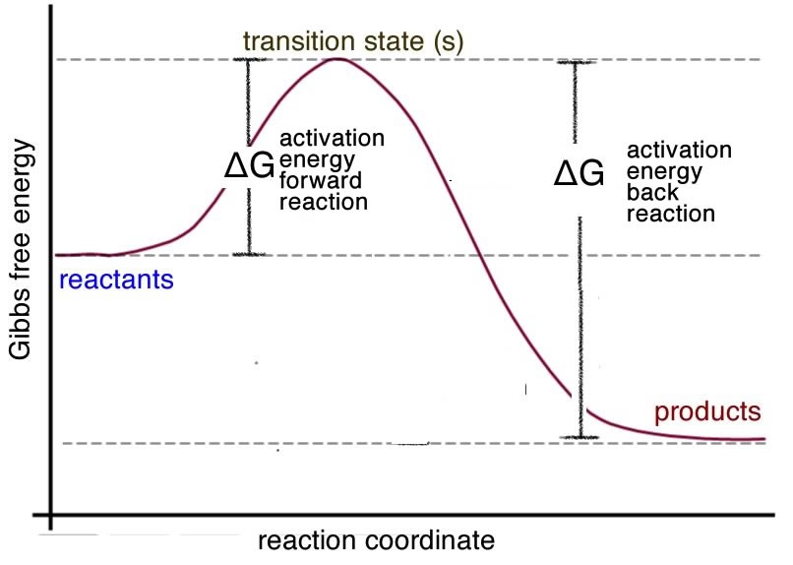

There is an important difference between disturbing a reaction at equilibrium by changing concentrations of reactants or products, and changing the temperature. When we change the concentrations, the concentrations of all the reactants and products change as the reaction moves towards equilibrium again, but the equilibrium constant stays constant and does not change. However, if we change the temperature, the equilibrium constant changes in value, in a direction that can be predicted by Le Chatelier’s principle.

### Equilibrium and Steady State

Now here is an interesting point: imagine a situation in which reactants and products are continually being added to and removed from a system. Such systems are described as open systems, meaning that matter and energy are able to enter or leave them. Open systems are never at equilibrium. Assuming that the changes to the system occur on a time scale that is faster than the rate at which the system returns to equilibrium following a perturbation, the system could well be stable. Such stable, non-equilibrium systems are referred as steady state systems. Think about a cup with a hole in it being filled from a tap. If the rate at which water flows into the cup is equal to the rate at which it flows out, the level of water in the cup would stay the same, even though water would constantly be added to and leave the system (the cup). Living organisms are examples of steady state systems; they are open systems, with energy and matter entering and leaving. However, most equilibrium systems studied in chemistry (at least those discussed in introductory texts) are closed, which means that neither energy nor matter can enter or leave the system.

In addition, biological systems are characterized by the fact that there are multiple reactions occurring simultaneously and that a number of these reactions share components—the products of one reaction are the reactants in other reactions. We call this a system of coupled reactions. Such systems can produce quite complex behaviors (as we’ll explore further in Chapter 9). An interesting coupled-reaction system (aside from life itself) is the Belousov–Zhabotinsky (BZ) reaction in which cesium catalyzes the oxidation and bromination of malonic acid.[173] If the system is not stirred, this reaction can produce quite complex and dynamic spatial patterns, as shown in the figure. The typical BZ reaction involves a closed system, so it will eventually reach a boring (macroscopically-static) equilibrium state. The open nature of biological systems means that complex behaviors do not have to stop; they continue over very long periods of time. The cell theory of life (the theory that all cells are derived from preexisting cells and that all organisms are built from cells or their products), along with the fossil record, indicates that the non-equilibrium system of coupled chemical reactions that has given rise to all organisms has persisted, uninterrupted, for at least ~3.5 billion years (a very complex foundation for something as fragile as life).

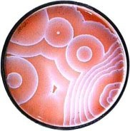

The steady state systems found in organisms display two extremely important properties: they are adaptive and homeostatic. This means that they can change in response to various stimuli (adaptation) and that they tend to return to their original state following a perturbation (homeostasis). Both are distinct from Le Chatelier’s principle in that they are not passive; they are active processes requiring energy. Adaptation and homeostasis may seem contradictory, but in fact they work together to keep organisms alive and able to adapt to changing conditions.[174] Even the simplest organisms are characterized by great complexity because of the interconnected and evolved nature of their adaptive and homeostatic systems.

**Questions to Answer**

* What does it mean when we say a reaction has reached equilibrium?
* What does the magnitude of the equilibrium constant imply about the extent to which acetic acid ionizes in water?
* Write out the equilibrium constant for the reaction H3O+ + AcO– ⇄ AcOH + H2O.
* What would be the value of this equilibrium constant? Does it make sense in terms of what you know about acid-base reactions?
* If the pH of a 0.15-M solution of an acid is 3.6, what is the equilibrium constant Ka for this acid? Is the acid a weak or strong acid? How do you know?
* Calcium carbonate (CaCO3) is not (very) soluble in water. Write out the equation for the dissolution of CaCO3. What would be the expression for its Keq? (Hint: recall pure solids and liquids do not appear in the expression.) If Keq for this process is 6.0×10-9, what is the solubility of CaCO3 in mol/L?
* What factors determine the equilibrium concentrations for a reaction?
* For the reaction N2 (g) + 3 H2 (g) ⇄ 2 NH3 (g) (ΔH = -92.4 kJ/mol), predict the effect on the position of equilibrium, and on the concentrations of all the species in the system, if you:
  + add nitrogen
  + remove hydrogen
  + add ammonia
  + heat the reaction up
  + cool it down
* Draw a reaction energy diagram in which the reverse reaction is much faster than the forward reaction (and vice versa).
* As a system moves towards equilibrium, what is the sign of ΔG? As it moves away from equilibrium, what is the sign of ΔG?
* Explain in your own words the difference between ΔGº and ΔG.
* Imagine you have a reaction system A ⇌ B for which Keq = 1. Draw a graph of how ΔG changes as the relative amounts of [A] and [B] change.
* What would this graph look like if Keq = 0.1? or Keq= 2?
* If ΔGº is large and positive, what does this mean for the value of Keq?
* What if ΔGº is large and negative, how does the influence Keq?

**Questions for Later**

* Why is Keq temperature-dependent?
* Explain mechanistically why random deviations from equilibrium are reversed.
* If the value of Q is > Keq, what does that tell you about the system? What if Q is < Keq?

**Questions to Ponder**

* The acid dissociation constant for ethanol (CH3CH2OH) is ~10–15. Why do you think acetic acid is 10 billion times more acidic than ethanol? (Hint: draw out the structures and think about the stability of the conjugate base.)
* If ΔG for a system is = 0, what does that mean?

## 8.6 Back to Reaction Mechanisms

Recall that one of the most important reasons for studying reaction kinetics is to get information about the reaction pathway, or mechanism. Now that we have all the concepts we need to understand these ideas, let us go back and see how to put it all together. The rate equation, along with the equilibrium constant, is the key to unraveling what happens during a reaction.

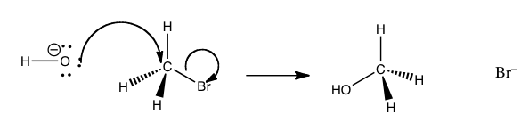

We have seen that, at a given temperature, the reaction rate depends on the magnitude of the rate constant and the concentrations of one or more of the reactants. However, for the two seemingly similar substitution reactions we discussed earlier, the rate equations are different. What is going on here? The answer lies in the fact that most reactions do not occur in one step. In many cases, there is not a smooth transition from reactants to products with a single transition state and activation energy, as we have simplistically portrayed it. Rather, there are a series of steps, each with their own transition state and activation energy. Here, we will only consider one-step and two-step reactions, but in reality there could be many distinct steps from reactant to product. Each step represents a kind of sub-reaction, each with its own activation energy and equilibrium state. The kinetics of a reaction is generally determined by the slowest of these sub-reactions, whereby a kind of bottleneck or rate-limiting step is formed. The rate equation gives us information about what reactants are present in the rate-determining step of the reaction. The reaction can only go as fast as the slowest step (the step with the highest activation energy barrier). As an analogy, imagine you are traveling at 70 mph on a five-lane highway. If the lanes suddenly narrow to allow only one lane of traffic, all the cars slow down. Although they are capable of traveling faster, no one can get past the slowest cars.

The reaction we discussed earlier between methyl bromide (CH3Br) and hydroxide (–OH):

CH3Br + –OH + Na+  ⇄ CH3OH + Br– + Na+

has been shown experimentally to have the rate equation: rate = k [CH3Br] [–OH]

What this tells us that the rate of this reaction depends on **both** reactants. This means that whatever the mechanism of the reaction, both reactants must be present in the transition state (the species at the highest energy on the energy profile) that determines the rate of reaction. From this information we might begin to think about what the pathway for the reaction might be. It turns out that the simplest possibility is actually the correct - which is that the reaction takes place in one step, as shown in the figure. that is the hydroxide (the nucleophile) is attracted to the carbon, and at the same time the carbon bromine bond is broken. that is the reaction take place in one step that involves both the hydroxide and the methyl bromide.

We can imagine what the structure of the transition state might look like (although we cannot detect it by any traditional methods because transition states only exist for one molecular vibration and are very difficult to detect). The nucleophile (–OH) is attracted to the δ+ on the methyl carbon. At the same time, the bromide ion starts to leave, so that at the “top” of the transition state (the most unstable point, requiring the most energy to form), we have a carbon that is coordinated to five other atoms by partial or full bonds. Given that carbon normally makes four bonds, it is no wonder that this pentavalent species sits at the reaction’s highest energy point.

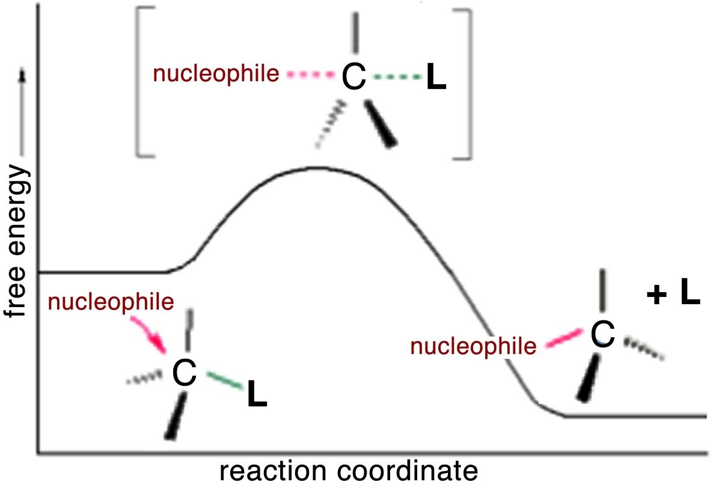

However, if we analyze what appears to be a very similar reaction:

(CH3)3CBr + –OH ⇄ (CH3)3COH + Br.

We must come to the conclusion that it has a different mechanism. Why? Because the rate equation for this reaction is first order: rate = k[(CH3)3CBr]. This tells us that only (CH3)3CBr is involved in the step that determines the rate. In other words, the transition state with the largest activation energy involves only the t-butyl bromide molecule. There is no nucleophile (the hydroxide) present during the step that determines how fast the reaction goes.

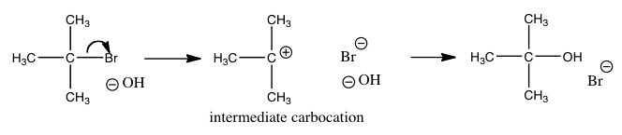

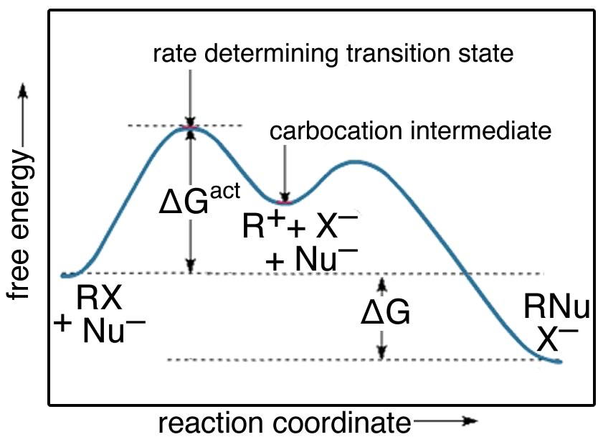

While there are a number of possible mechanism that we could postulate for this reaction, the mechanism for this reaction involves two discrete steps, as shown in the figure.

The first is the ionization of the t-butyl bromide, which involves breaking the C—Br bond. This results in a positively-charged carbon (the bromine takes all the electrons and becomes bromide ion)—a very unstable and distinct species known as a carbocation. The resulting carbocation is an intermediate: it sits in an energy well between two less stable states. This distinguishes it from the transition state, which precariously sits at the highest local energy state (surrounded by lower energy states). Intermediates lie in energy “valleys”, while transition states are at the summit of an energy “hill”, as shown in the figure. The carbocation can react with the hydroxide, to form the t-butyl alcohol, or it can react with the bromide to reform the original product (or a variety of other side reactions can occur). The important point here is that we can deduce how the reaction will proceed from the rate equation for each reaction.

**Questions to Answer**

* Draw a reaction energy diagram for a two-step reaction in which the second (or first) step is rate determining.
* What is the rate equation for a reaction which occurs in the following steps:
  + A + B → C (fast)?
  + A + C → D (slow)?
* Explain why it is not possible to write a rate equation from the reaction equation.

In this chapter we have explored how the fate of reactions is determined by a variety of factors, including the concentrations of reactants and products, the temperature, and the Gibbs energy change. We have learned that we can make a reaction go backward, forward, faster, or slower by examining the nature of the reaction and the conditions under which it is performed. You can now extend these principles to imagine how we might control reactions to do what we want, rather than let nature (or entropy) take its course. In the next chapter, we will take this one step further to see what happens when reactions are removed from isolation and allowed to interact with each other.

# Chapter 9: Reaction Systems

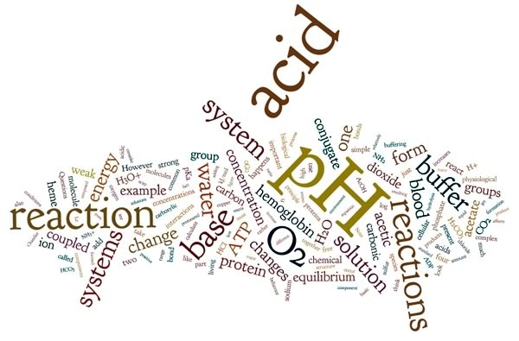

In the real world, simple chemical reaction systems are rare. Chemistry lab experiments typically involve mixing pure chemicals together in well-defined amounts under tightly-controlled conditions. In the wild, things are messier. There are usually a number of chemical species present, and this leads to competing reactions. Laboratory systems are effectively closed systems, and the results are analyzed only after the reaction has reached equilibrium. Real systems, on the other hand, are usually open and rarely reach equilibrium. This is particularly true for living systems, which tend to die if they reach equilibrium or become enclosed. In fact, most real systems are subject to frequent short- and long-term perturbations. We learned in the last chapter that perturbations (adding or taking away a product or a reactant) lead to compensatory changes and the system responds, as described by Le Chatelier’s principle. In the context of a more complex system, this simple behavior can produce quite dramatic results. Life is an example of such a system that has survived in its various forms uninterrupted for over 3.5 x 109 years.

In this chapter, we examine a range of complex systems and consider how living systems keep the concentration of important chemical species at a reasonable level (for example, by buffering the pH); how they use differences in concentrations of chemical species to drive cellular processes (like thought); and how reactions that release energy (by forming more stable compounds with stronger bonds) can be coupled to reactions that require energy in order to occur.

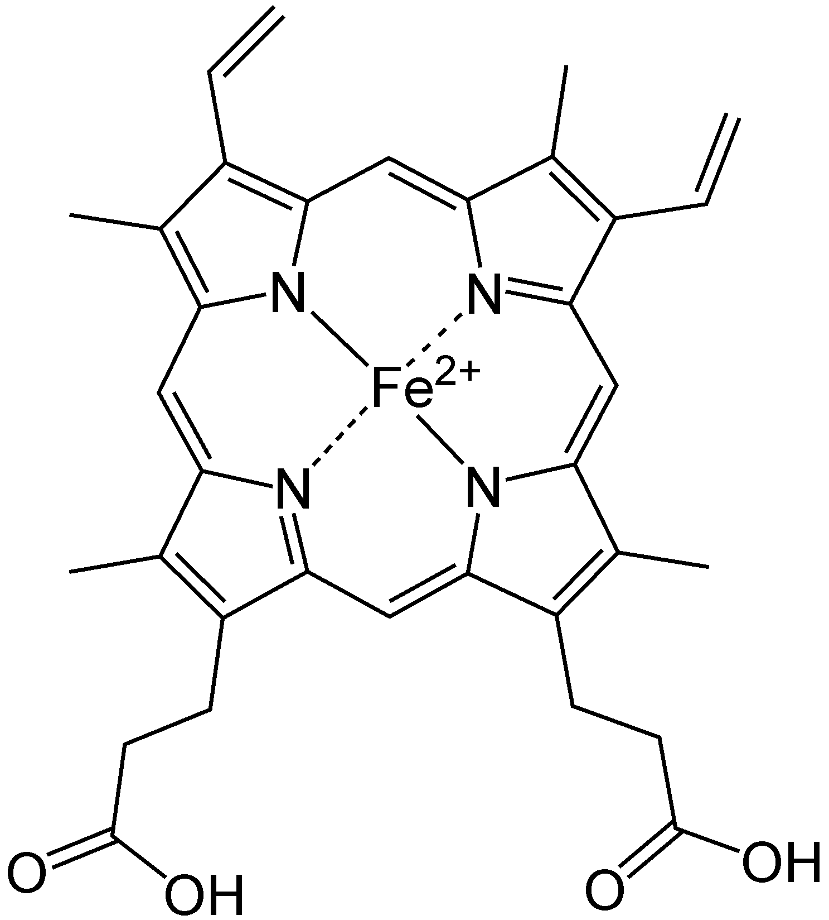

## 9.1 Systems Composed of One Reaction

We begin with a few important reactions that can either move backward or forward depending on conditions.[175] Molecular oxygen (O2) is a vital component in a number of reactions in our bodies, such as aerobic respiration, the evolutionarily ancient process by which we capture energy from food.[176] O2 must be transported to every cell so that it can participate in cellular reactions. O2 diffuses into the bloodstream in the lungs, but it is not very soluble in water (the main component of blood). If we relied on the solubility of oxygen in water to transport it around the body, we would be in trouble. Instead O2 reacts with (we usually say “binds to”, but this is definitely a chemical reaction) a protein called hemoglobin. The structure of hemoglobin is complex: it is composed of four polypeptide subunits and each polypeptide is associated with a heme group.[177] The heme group contains an iron ion (Fe2+) complexed to four nitrogenous bases linked into a ring (called a porphyrin) to form a more or less planar arrangement, as shown in the figure. Heme is also the central active portion of one of the major components of our immune system, myeloperoxidase[178]. When you blow your nose, that familiar green color is actually caused by the light absorbing properties of the heme group in this enzyme, rather than the bacterial infection. Because the 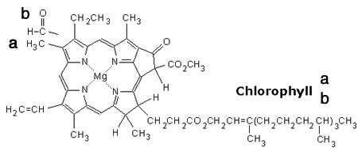heme group is in a different molecular environment, its color appears green rather than red. Chlorophyll, a similar molecule, differs most dramatically from heme in that the iron ion is replaced by a magnesium ion (as shown in the figure). Its function is not to bind O2 (or CO2), but rather to absorb visible light and release an energetic electron as part of the photosynthetic process.

Iron is a transition metal. Recall that these elements have d orbitals, some of which are empty and available for bonding. Iron II (Fe2+) has plenty of energetically-available orbitals, and therefore can form Lewis acid–base complexes with compounds that have available electrons (such as nitrogenous bases). Within the porphyrin ring, four nitrogens interact with the Fe2+ ion. Typically, transition metals form complexes that are geometrically octahedral. In the case of the heme group, four of these interactions involve nitrogens from the four rings; a fifth involves a nitrogen of histidine residue of one of the protein’s polypeptides that approaches from below the ring plane. This leaves one site open for the binding of an O2 molecule, which has available lone electron pairs.[179] When an O2 binds to one of these heme groups,

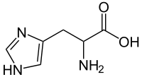

Hemoglobin + O2 ⇄ Hemoglobin - O2.

Note that this way of depicting the reaction is an oversimplification. As we said initially, each hemoglobin molecule contains four polypeptides, each of which is associated with a heme group (green in the figure), so there are four heme groups in a single hemoglobin molecule. Each heme group can bind one O2 molecule. When an O2 molecule binds to the heme iron, there are structural and electronic changes that take place within the protein as a whole. This leads to a process known as cooperativity, wherein the four heme groups do not act independently. Binding O2 to one of the four heme groups in hemoglobin causes structural changes to the protein, which increases the affinity for O2 in each of the remaining three heme groups. When a second O2 binds, affinity for O2 is once again increased in the remaining two heme groups.

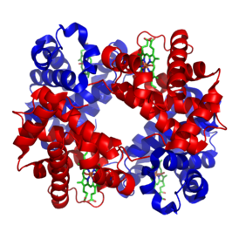

As you might suspect, this process is reversible. Imagine a hemoglobin protein with four bound oxygen molecules. When an O2 is released from the hemoglobin molecule, the affinity between the remaining O2s and the heme groups is reduced, making it more likely that more of the bound O2s will be released. This is an equilibrium reaction, and we can apply Le Chatelier’s principle to it. Where O2 is in abundance (in the lungs), the reaction shifts to the right (binding and increasing affinity for O2). Where O2 is present at low levels, the reaction shifts to the left (releasing and reducing affinity for O2). The resulting hemoglobin molecule has a high capacity for binding O2 where O2 is present at high concentrations and readily releases O2 where O2 is present at low concentrations. In the blood, [hemoglobin] ranges between 135–170 g/L, approximately 2 millimoles per liter (mM), and because there are four O2 binding sites per hemoglobin, this results in approximately ~ 250 mg/L or s8-mM concentration of O2.

By comparison, O2‘s solubility in water is ~ 8mg/L at 37 ºC, or 250 micromoles per liter (μM). The reaction can be written like this:

O2 in the air ⇄ O2 in the blood (liquid) + hemoglobin ⇄ hemoglobin-O2 + O2 in the blood ⇌ hemoglobin-2O2 + O2 in the blood ⇄ hemoglobin-3O2 + O2 in the blood ⇄ hemoglobin-4O2

When the hemoglobin reaches areas of the body where [O2] is low, the oxygen dissociates from the hemoglobin into the blood. The dissolved O2 is then removed from the blood by aerobic (oxygen-utilizing) respiration: C6H12O6 + 6O2 ⇄ 6CO2 + 6H2O.

The combination of Le Chatelier’s principle and the cooperativity of the O2 + hemoglobin reaction now leads to the complete dissociation of the hemoglobin—4O2 complex, releasing O2. The products of aerobic respiration (essentially a combustion reaction) are carbon dioxide and water. Clearly the water can be carried away in cellular fluid, but the carbon dioxide must be removed in a variety of ways: a small part is removed by reacting with the hemoglobin (but not at the Fe center), some is dissolved in the blood, and some takes part in the buffering system present in the blood, and most is released in the lungs, into the air that you breath out.

**Questions to Answer**

* What complicates reaction systems in the real world (outside the lab)?
* Why is O2 not very soluble in water?
* By what factor does binding with hemoglobin increase solubility of O2 in water?
* Draw Lewis structures for O2 and CO. Why do you think they bind in similar ways to hemoglobin?
* Why does CO2 react differently with hemoglobin from the way O2 interacts with hemoglobin?

**Questions to Ponder**

* Why does it make physiological sense that O2 binds to oxygen-free hemoglobin (deoxyhemoglobin) relatively weakly and cooperatively ?

## 9.2 Buffered Systems

When you think of the word buffer, you probably think of it as a safeguard or a barrier—something that provides a cushion or shield between you and something harmful. But in chemistry and biology, a buffer is a solution that resists changes in pH. As we will soon learn, this ability is critical to all living systems. Many reactions are affected by changes in pH. For example, strong acid and base solutions are harmful to living tissue because they cause rapid hydrolysis of the bonds that hold living organisms together. That is, acidic or basic solutions can speed up the reactions in which the bonds are broken (dead bodies are often disposed of in murder mysteries—and sometimes in real life—by dissolving them in strong acid or base). Proteins have many weak acid and base groups, and so even relatively small fluctuations in pH can cause changes in the charges of these groups. This can affect protein structure and function dramatically, in a way that is physiologically damaging to living systems.

Aqueous solution chemistry is terrifically complicated in living systems. However, we can begin to understand it by looking at simple chemical buffer systems. Let us first consider what happens if we take 0.10 moles of hydrogen chloride gas and dissolve it in enough water to make one liter of solution. The resulting 0.10-M solution of hydrochloric acid HCl (aq) has a pH of 1 (pH = – log (0.10), = – log (1.0 x 10–1). So the pH of the solution changes from 7 (for pure water) to 1, a change of 6 orders of magnitude in [H+]. Now, if we do the same experiment adding 0.10 mol HCl(g) to an appropriately buffered solution, we find the pH of the resulting solution does not change very much at all.

To understand how this happens, we have to review some acid–base chemistry. Specifically, we must reexamine what happens when acids and base react, what the products are, and how those products behave. We just calculated that the pH of a 0.10-M strong acid is 1.0. It does not matter which strong acid we choose, as long as it only has one proton to donate. So the pH of solutions HCl, HBr, and HClO4 are all the same because they are all almost completely ionized in aqueous solution. However, what happens if we use a weak acid like acetic acid (CH3COOH), hydrogen fluoride (HF), phosphoric acid (H3PO4), or carbonic acid (H2CO3)? The pH of each differs and none of them is as low as the strong acids because they do not ionize completely in solution. For example, the pH of 0.10-M acetic acid is ~2.9 because the concentration of H+ is lower than in 0.10-M HCl. Although that may not seem very different from a pH of 1, remember that [H+] is 10-1 (or 0.1 M) for a pH of 1 and 10-2.9 (or 0.0012 M) for a pH 2.9.

Now if we look at the conjugate bases of weak and strong acids we will see an analogous difference in their behavior to produce solutions with different pHs. The conjugate base of HCl is Cl– (the chloride ion.) However since we can’t just get a bottle of chloride (we need a counter ion for charge balance), we will use sodium chloride, NaCl, since we know that sodium ions are not reactive, they are usually “spectator” ions. If we measure the pH of a solution of NaCl, we will find that it is 7, just like water. Neither the sodium ion nor the chloride ion affects the pH. However, if we take the corresponding conjugate base from acetic acid, for example sodium acetate (CH3COONa), we find that a 0.1 M solution has a pH of about 9. This is quite surprising at first glance. Sodium acetate belongs to the class of compounds that we label generically as salts. In everyday life, salt refers to sodium chloride, but in chemistry the term salt refers to a compound that contains the conjugate base of an acid and a cation. Although it is tempting to think of all salts as innocuous and unreactive (like sodium chloride), it turns out that components of the salt (the conjugate base anion, and the cation) both affect the properties, even in a simple reaction like dissolving in water. In fact, the pH of any conjugate base of a weak acid tends to be basic.

Let us investigate a bit further. The previous observation implies that the acetate ion (CH3COO–) must be reacting with water to produce hydroxide (since we already know the Na+ does not react with water). This reaction is called a hydrolysis reaction. The name is derived from the Greek words for water (hydro-) and to break or separate (-lysis); it refers to reactions in which water is one of the reactants. We can write this hydrolysis reaction as:

CH3COO–(aq) + H2O(l) ⇄ CH3COOH(aq) + –OH(aq)

The production of hydroxide increases [–OH], in turn affects [H+] because the two are related by the equilibrium expression [H+] [–OH] = 1 x 10–14 = Kw. In other words, when the salt of a weak acid (that is, its conjugate base) is dissolved in water, a weak base is produced and that weak base has all the properties of any base: it can react with an acid.

It is possible to calculate the pH of weak base solutions, just as it is to calculate the pH of weak acids, if you know the acid equilibrium constant.[180] However, what is more interesting is what happens when a solution contains significant amounts of both a weak acid and its conjugate base. For example, if we take a solution that is 0.10 M in both acetic acid and sodium acetate, we can calculate the pH by setting up the equilibrium table:

AcOH + H2O ⇌ H3O+ + –OAc + Na+  
 Initial concentrations 0.10 M 1 x 10–7 0.10 M 0.10 M

Note that even though acetate is present in the initial mixture, we have put it on the product side. This is because when both acetic acid and acetate are present in the same solution, their concentrations are “linked”: they become part of an equilibrium system that can be described by the equilibrium constant for acetic acid.[181] If the concentration of one species is changed, the other must respond. Recall in Chapter 8 that we looked at what happens to the pH of a solution of acetic acid when an acetate ion is added: the presence of acetate affects the position of equilibrium for the acetic acid dissociation, and instead of a pH of 2.9 (for 0.10 M acetic acid), the pH of a solution that is 0.10 M in both acetic acid and sodium acetate is 4.7. The presence of the common ion acetate has suppressed the ionization of acetic acid. We can calculate the pH of any similar solution by adapting the expression for the acid dissociation equilibrium:

Ka = [H+][AcO–]/[AcOH].

As in our previous work with weak acids we are going to ignore any reaction with water from both the acetic acid and the acetate ion because they do not affect the pH significantly; both species are relatively weak as acids or bases. Even if we take these reactions into account, they do not change the answer we get. Substituting in the equation for Ka, we get:

Ka = 1.8 x 10–5 = [H+] (0.10)/(0.10).

Alternatively, we can use pKa, the negative log of Ka, giving us:

pKa = pH – log [AcO–]/[AcOH]   
or pH = pKa + log [AcO–]/[AcOH].

This equation is known as the Henderson–Hasselbalch equation. It is a convenient way to calculate the pH of solutions that contain weak acids and their conjugate bases (or weak bases and their conjugate acids).

Recall that a buffer can resist changes in pH. So the question is: how exactly does this happen? Let us take a closer look. Imagine we have a buffer solution that is 1.0 M in both acetic acid and acetate. The pH of this system is –log 1.8 x 10–5 = 4.74 (because [AcO–] = [AcOH]). Now let us add some acid to this buffer. To make calculations easy, we can add 0.01 mol HCl to 1.0 L of buffer solution[182]. What happens? The major species in the buffer solution are acetic acid, acetate, and water (hydronium ion and hydroxide ion are minor components). Which one will react with HCl(aq)? Just as in any acid–base reaction, it is more likely that the base will react with the acid that is, the acetate part of the buffer will react with the H+. The resulting reaction is:

H+ + –OAc ⇄ AcOH + H2O.

In this reaction, the acetate concentration decreases and the acetic acid increases. We can now calculate the initial (pre-reaction) and final (post-reaction) concentrations:

AcOH + H2O ⇄ H3O+ + –OAc

Initial [M] 1.00 (negligible) 1.00

add 0.01 M H++ +0.01 – 0.01

Equilibrium [M] 1.01 x 0.99

The pH of this system can be calculated from the Henderson–Hasselbalch equation:

pH = pKa + log (0.99/1.01) = 4.73.

The pH has hardly budged! (Recall that the pH of 0.01 M HCl is 2.0.) Even if we add more acid (say, 0.1 mol HCl) to our liter of buffer, the resulting pH does not change much (it is pH = 4.74 + log (0.90/1.10) = 4.65). Note that the addition of acid has moved the pH in the direction we would expect—slightly lower and more acidic but nowhere near what it would be if we had added the HCl directly to 1 L of water.

We can also look at what happens when we add a strong base to the buffer solution. If we add 0.01 mol sodium hydroxide to our liter of buffer, the “active” component of the buffer is now the acid, and the reaction is written: HOAc + –OH ⇄ AcO– + H2O.

The strong base reacts with the weak acid. The acid concentration falls and its conjugate base concentration rises, so:

AcOH + H2O ⇄ H3O+ + –OAc

Initial 1.00 (negligible) 1.00

add 0.01 M –OH –0.01 +0.01

Equilibrium 0.99 x 1.01

The new pH of the solution is pH = 4.74 + log (1.01/0.99) = 4.75—a slight increase but hardly detectable. (Note that the pH of a 0.01 M solution of NaOH is 12.)

So, buffers can keep the pH of a solution remarkably constant. - which, as we will see, this is very important for biological systems. But this raises another question, just how much acid could we add to the system before the pH did change appreciably, or rather, enough to influence the behavior of the system? In biological systems, the tolerance for pH change is fairly low. As we discussed previously, changes in pH can cause a cascade of reactions that may prove catastrophic for the organism.

The amount of acid or base that a buffer solution can absorb is called its buffering capacity. This capacity depends on the original concentrations of conjugate acid and base in the buffer and their ratio after reaction, or [conjugate acid]/[conjugate base]. If you start with a buffer that has equal amounts of acid and base, the ratio is equal to 1.0. As the ratio moves further away from 1.0, the pH is affected more and more, until it changes out of the desired range.

Another important property of buffers is the range of pH that they can act over. As we have seen from the Henderson–Hasselbalch equation, when the concentration of acid is equal to the concentration of base, the pH of the solution is equal to the pKa of the acid. Thus, the acetic acid/acetate buffer has a pH = 4.74. Generally, the effective buffering range is +1 or –1 pH unit around the pKa. So the acetic acid/acetate acts as an effective buffer in the range of pH 3.7-5.7, well within the acidic pH region. There are biological compartments (the stomach, lysosomes, and endosomes) that are acidic but the major biological fluids (cytoplasm and blood plasma) have pHs around 7.2–7.4. In these systems, buffers are phosphate or carbonate systems. For example, the phosphate buffer system is composed mainly of H2PO4– (the proton donor or acid), and HPO42– (the proton acceptor or base): H2PO4– + H2O ⇄ HPO42– + H3O+

What counts as an acid or a base depends entirely on the reaction system you are studying. This is an important point. Both H2PO4– and HPO42– can act as either an acid or a base depending on the pH. (Try writing out the reactions.) But at physiological pH (7.2-7.4), the predominant forms are H2PO4– and HPO42–. The pKa of the conjugate acid is 6.86 so it makes sense that this buffer system is active in cellular fluids.

**Questions to Answer**

* How much acid would you have to add to change the pH of a buffer that is 1.0 M in acid and conjugate base by one full pH unit?
* If the buffer is 0.1 M in acid and conjugate base, would you have to add the same amount of acid? Why or why not?
* What buffer systems would you use to buffer a pH of 4, 6, 8, and 10? What factors would you take into account?
* Carbonic acid (H2CO3) has two acidic protons. Draw out the structure of carbonic acid, and show how each proton can take part in an acid–base reaction with a strong base such as sodium hydroxide.
* What is the pH of a buffer system if the concentration of the acid component is equal to the concentration of its conjugate base?
* Can any buffer system buffer any pH? For example, could an acetic acid/acetate system effectively buffer a pH of 9?
* What criteria would you use to pick a buffer system for a particular pH?

**Questions to Ponder**

* What factors might make reactions sensitive to pH?
* Why are protein structure and activity sensitive to changes in pH?
* Which parts of proteins are affected by changes in pH? What kinds of chemical properties must they have? What groups of atoms do these bits of proteins contain?
* Would you expect nucleic acids to be more or less sensitive to pH changes than proteins?

**9.3 Amino Acids, Proteins, and pH**

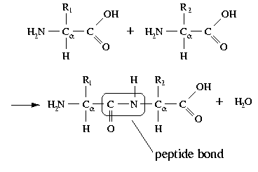

In addition to examining how adding a strong acid or base affects a buffer solution, we can also look at the effect of pH on a particular acid or base. This is particularly important in biological systems where there are many weak acid or base groups that can be affected by the pH. For example, proteins contain both weakly acidic –COOH and weakly basic –NH2 groups. A 1.0-M solution of a simple carboxylic acid like acetic acid has a pH of ~ 2.8; it turns out that most carboxylic acids behave in a similar way. If we manipulate the pH, for example, by adding a strong base, the acetic acid reacts with the base to form an acetate ion. Based on the Henderson–Hasselbalch equation, when [acetate] = [acetic acid], the pH equals the acid’s pKa, which is 4.74. As the pH increases, the concentration of acetate must also increase, until by pH ~7 (approximately normal physiological pH). At this point the concentration of acetic acid is very small indeed. The ratio of base to acid is about 200/1. That is, at physiological pHs groups such as carboxylic acids are deprotonated and exist in the carboxylate (negatively charged) form.

Conversely, if we look at the amino group (–NH2) of a protein, it is actually the base part of a conjugate acid-base pair in which the acid is the protonated form –NH3+. The pKa of an –NH3+ group is typically ~9. At a pH of 9 there are equal amounts of the protonated (– NH2) and unprotonated forms (–NH3+). So if we change the pH by adding an acid, the concentration of –NH3+ form increases as the base form –NH2 is protonated. At pH ~7 there is little of the –NH2 form remaining. Interestingly, this means that an amino acid (shown in the figure) never exists in a state where both the amino (–NH2) group and the carboxylic acid (–CO2H) exist at the same time. The “neutral” species is in fact the one in which –NH3+/–CO2– are present. This zwitterion (that is a neutral molecules with a positive and negative electrical charge at different locations, from the German zwitter, meaning “between”) is the predominant form at physiological pH.

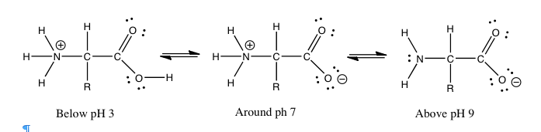

A protein is composed mainly (sometimes solely) of polymers of amino acids, known as polypeptides. In a polypeptide, the amino (–NH2) and carboxylic acid (–CO2H) groups of amino acids are bonded together to form a peptide bond (see figure). The resulting amide group (peptide bond) is neither acidic nor basic under physiological conditions[183]. That being said, many of the amino acids found in proteins have acidic (aspartic acid or glutamic acid) or basic (lysine, arginine, or histidine) side chains. The pH of the environment influences the conformations of the protein molecule and the interactions between these charged side chains (the spontaneous native conformations of the molecule are called protein folding). Changes from the “normal” environment can lead to changes in protein structure, and this in turn can change biological activity. In some cases, protein activity is regulated by environmental pH. In other cases, changes in pH can lead to protein misfolding (or denaturation, which in living organisms can cause disruption of cell activity or death). For example, if these groups are protonated or deprotonated, the electronic environment in that region of the protein can change drastically, which may mean that the protein will not only change how it interacts with other species but its shape may change so as to minimize repulsive interactions or produce new attractive interactions. Small changes in protein shape can have profound effects on how the protein interacts with other molecules and, if it is a catalyst, its efficiency and specificity. In fact, there are cases where environmental pH is used to regulate protein activity.

**Questions to answer:**

* What would be the ratio of –NH3+/–NH2 in a solution of a protein at pH 5, pH 7, and pH 9?
* What kinds of interactions would each form participate in?
* What is the predominant form of a carboxylic acid group at pH 5? pH 7, pH 9
* What kinds of interactions would each form participate in?
* What is the ratio of –NH3+/–NH2 in a solution of a protein at pH 5, pH 7, and pH 9? What kinds of interactions does each form participate in?
* What is the predominant form of a carboxylic acid group at pH 5? How about at pH 7 and pH 9? What kinds of interactions does each form participate in?

## 9.4 Coupled, Non-Equilibrium Reaction Systems

Another important buffer system is the carbonic acid (H2CO3) bicarbonate (HCO3–) buffer, which is a major buffering component of blood plasma. This system is more complex than the phosphate buffer, because carbonic acid is formed by the reversible reaction of carbon dioxide in water:

H2O + CO2 ⇄ H2CO3 and H2CO3 + H2O ⇄ HCO3– + H3O+

These are two reactions linked (or coupled) by a common intermediate. By examining these reactions more closely, we see how some systems exist under non-equilibrium conditions and how some reactions occur despite the fact that they have a positive free energy change and appear to contravene the second law of thermodynamics.

As we have seen previously, simple chemical reactions are characterized by how fast they occur (their rate) and how far they proceed toward equilibrium. While you will learn much more about reactions if you continue on in chemistry, that is not something we will pursue here - rather we will consider the behavior of systems of reactions and their behavior, particularly when they have not reached equilibrium. This is a situation common in open systems, systems in which energy and matter are flowing in and out. In Chapter 8, we considered single reactions and what happens when we perturb them, either by adding or taking away matter (reactants or products) or energy (heating or cooling the reaction.) Now it is time to look at what happens when reactions are coupled: when the products of one reaction are the starting materials for other reactions occurring in the same system.

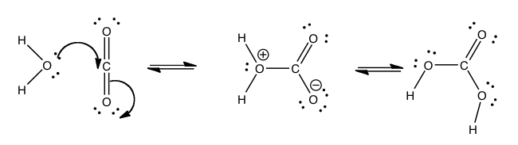

Take for example the coupled system introduced above - the pair of reactions that are linked by the formation and reaction of carbonic acid.

H2O + CO2 ⇄ H2CO3 and H2CO3 + H2O ⇄ HCO3– + H3O+

These coupled reactions are important for a number of reasons: they are responsible for the transport of excess carbon dioxide to the lungs and for buffering the pH of blood. Carbon dioxide enters the blood stream by dissolving in the plasma. However, it can also react with water in a reaction where the water acts as a nucleophile and the carbon dioxide acts an electrophile.

The formation of carbonic acid is thermodynamically unfavorable. The equilibrium constant for hydration of carbon dioxide is 1.7 x 10–3 and the standard free energy change ΔGº for the reaction [184] is 16.4 kJ. This means that the amount of carbonic acid in blood plasma is quite low; most carbon dioxide is just dissolved in the plasma (rather than reacted with the water). However, as soon as carbonic acid is formed, it can react with water:

H2CO3 + H2O ⇄ HCO3– + H3O+

to produce bicarbonate (HCO3–). Note that we now have the components of a buffer system (a weak acid, carbonic acid, and its conjugate base bicarbonate). The rate of this reaction is increased by the enzymatic catalyst carbonic anhydrase. In this buffer system the carbonic acid can react with any base that enters the bloodstream, and the bicarbonate with any acid. This buffering system is more complex than the isolated ones we considered earlier, because one of the components (carbonic acid) is also part of another equilibrium reaction. In essence, this means that the pH of the blood is dependent on the amount of carbon dioxide in the bloodstream:

H2O + CO2 ⇄ H2CO3 + H2O ⇄ HCO3– + H3O+

If we remove water from the equations (for the sake of clarity) we can see the connection better:

CO2 ⇄ H2CO3  ⇄ HCO3– + H3O+

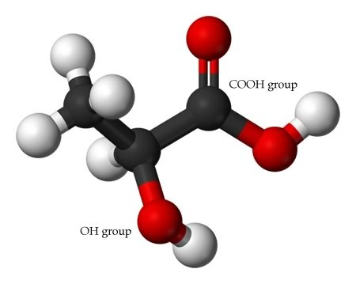

Lactic Acid

The pKa of carbonic acid is 6.37 and the pH of blood is typically 7.2–7.4, which does fall just within the buffering range. Under normal circumstances, this buffer system can handle most changes. However, for larger changes, other systems are called into play to help regulate the pH. For example, if you exert yourself, one of the products generated is lactic acid, (which we denote as LacOH).[185] When lactic acid finds its way into the bloodstream, it lowers the pH (increasing the amount of H3O+) through the reaction:

LacOH + H2O ⇄ H3O+ + LacO–

If we use Le Chatelier’s principle, you can see that increasing the H3O+ shifts the equilibrium toward the production of carbon dioxide in the buffer system. As the concentration of CO2 increases, a process known as chemoreception activates nervous systems, which in turn regulate (increase) heart and respiratory rates,which in turn lead to an increase in the rate of CO2 and oxygen exchange in the lungs.[186] As you breathe in O2, you breathe out CO2 (removing it from your blood). In essence, Le Chatelier’s principle explains why we pant when we exercise! [187] Conversely, when some people get excited, they breathe too fast (hyperventilate); too much CO2 is removed from the blood, which reduces the H3O+ concentration and increases the pH. This can lead to fainting (which slows down the breathing), a rather drastic way to return your blood to its correct pH. An alternative, non-fainting approach is to breathe into a closed container. By breathing expelled CO2 (and a lower level of O2), you increase your blood pH.

While we can use Le Chatelier’s principle to explain the effect of rapid or slow breathing, this response is one based on what are known as adaptive and homeostatic systems. Biological systems are characterized by many such interconnected regulatory mechanisms. They maintain a stable, internal chemical environment essential for life. Coupled regulatory systems lie at the heart of immune and nervous system function. Understanding the behavior of coupled regulatory systems is at the forefront of many research areas, such as: measuring the physiological response to levels of various chemicals (chemoreception); recognizing and responding to foreign molecules in the immune system; and measuring the response to both external stimuli (light, sound, smell, touch) and internal factors (such as the nervous system). Downstream of the sensory systems examined by such efforts are networks of genes, proteins, and other molecules whose interactions are determined by the thermodynamics of the chemical system. Although they were formed by evolutionary processes, and are often baroque in their details, they are understandable in terms of molecular interactions, chemical reactions, and their accompanying energy changes.

**Questions to Answer**

* If the pKa of carbonic acid is 6.35 and the pH of blood is over 7, what do you think the relative amounts of carbonic acid and bicarbonate are? Why?
* Draw out the series of reactions that occur when lactic acid is introduced into the blood stream and explain why this affects the concentration of carbon dioxide in the blood stream.
* If the amount of carbon dioxide in the atmosphere increases, what effect does it have on oceans and lakes?
* If carbon dioxide dissolves in water to give carbonic acid, what do you think nitrogen dioxide (NO2) gives when dissolved in water? How about sulfur dioxide? What effect does this have on the pH of the water it dissolves in?

## 9.5 Energetics and Coupling

We have seen that for systems of coupled reactions, changing the concentration of one of the components in the system affects all the other components, even if they are not directly reacting with the one that is changed. We can use the same principles to explain why it is possible to carry out reactions that are thermodynamically unfavorable. We will consider a fairly simple example and then move on to see how this works in biological systems.

Many metals are not found in their elemental form. For example, copper—an important metal used for a wide range of applications from wires to roofs—is often found as chalcocite, an ore containing copper as copper sulfide. We can imagine a simple chemical reaction to separate the copper from the sulfide:[188]

Cu2S(s) ⇄ 2Cu(s) + S(s) ΔGº = 86.2 kJ/mol

Note that this reaction is a redox reaction in which the Cu+ ion is reduced to Cu by the addition of an electron (from the sulfide S2–, which is oxidized to sulfur with an oxidation state of 0.) Unfortunately, because the free energy change for this reaction is positive, the system at equilibrium is composed mostly of Cu2S(s). How can we get copper out of copper sulfide? One possibility to exploit the reaction between sulfur and oxygen:

S(s) + O2(g) ⇄ SO2 (g), for which ΔGº = –300.1 kJ/mol.

This reaction is highly favorable and “goes” toward the production of SO2. It is basically the burning of sulfur (analogous to the burning of carbon) and is another redox reaction in which the sulfur is oxidized (from an oxidation state of 0 to +4). Note that one reason why this reaction is so favorable is the formation of the strong S-O bonds, which is a highly exothermic process.

If we take Cu2S(s) together with O2(g), we have a system composed of two reactions:

Cu2S(s) ⇄ 2Cu(s) + S(s) [reaction 1]

S(s) + O2(g) ⇄ SO2 (g) [reaction 2]

These two reactions share a common component (S(s)); therefore, they are coupled. Imagine what happens when reaction 1 proceeds, even a little. The S(s) produced can then react with the O2(g) present. As this reaction proceeds toward completion, S(s) is removed, leaving Cu (s) and SO2 (g). Based on Le Chatelier's principle, reaction 1 is now out of equilibrium, and thus generates more S(s) and Cu(s). Reaction 1 in isolation produces relatively little copper or sulfur, but it is dragged toward the products by reaction 2, a favorable reaction that removes sulfur from the system. If we assume that there are no other reactions occurring within the system, we can calculate the ΔGº for the coupled reactions 1 and 2. Under standard conditions, we simply add the reactions together:

| **Cu2S(*s*)** *⇆***2Cu(*s*) + S(*s*)** | **86.2 kJ/mol** |
| --- | --- |
| S(*s*) + O2(*g*) *⇆* SO2 (*g*) | –300.1 kJ/mol |
| **Cu2S(*s*) + O2(*g*)** *⇆* **2Cu(*s*) + SO2 (*g*)** | –213.9 kJ/mol |

So, the ΔGº for the coupled reaction is -213.9kJ/mol. This same basic logic applies to any coupled reaction system. Note that the common intermediate linking these two reactions is sulfur (S). However, it is not always so simple to identify the common intermediate. In this system, we are tacitly assuming that O2 and SO2 do not react with either Cu2S or SO2. If they did, those reactions would also need to be considered in our analysis. In fact, we need to consider all of the reactions that are possible with a system. This is normally not a big issue with simple chemical systems that contain relatively small numbers of different types of molecules (sometimes called species), but it is a significant concern when we consider biological or ecological systems that contain thousands of different types of molecules, which can interact and react in a number of ways.

For example, you may have learned in biology that the molecule adenosine triphosphate (ATP) is used to store and provide energy for cellular processes. What exactly does this mean? First, let us look at the structure of ATP: it is composed of a base called adenine, a sugar ribose, and three phosphate units. For our purposes, the adenine base and sugar (called adenosine when attached to each other) are irrelevant. They do not change during most of the reactions in which ATP takes part. They are organic “building blocks” with functional groups that allow them to interact with other components in the cell for other functions (for example, in RNA and DNA). To examine energy transfer, we can just use “A” (adenosine) to stand in for their structure. The important bit for our purposes are the phosphates hooked together by the P—O—P (phosphoanhydride) linkages. At physiological pH, most (if not all) of the oxygens of the phosphate esters are deprotonated. This means that there is a fairly high concentration of charge in this tri-ester side chain, which acts to destabilize it. The bonds holding it together are relatively weak, and the molecule reacts with any available entity to relieve some of this strain and form even more stable bonds. For example, ATP is unstable in water and reacts (hydrolyzes) to form adenosine diphosphate (ADP) and inorganic phosphate (HPO4), which is often written as Pi. This reaction is written as ATP + H2O ⇄ ADP + Pi.

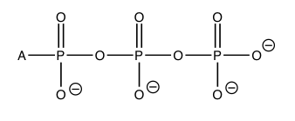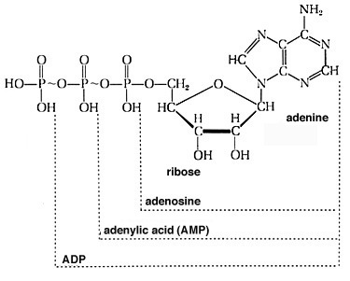

The standard free energy change for this reaction ΔGº = – 29 kJ/mol (at pH 7). This is a highly exergonic (heat or energy releasing) reaction; both the enthalpy and entropy changes for this reaction are favorable. ΔH is negative and ΔS is positive. It makes sense that the entropy change is positive. After all, we are producing two molecules from one. The enthalpy change also makes sense. We have already mentioned that ATP is unstable, and the loss of one of the phosphate groups relieves some of the strain caused by the charge repulsion between the three negatively charged phosphate groups in ATP. The bond energies in the product are stronger than the bond energies in the reactants and thus the reaction is exothermic. Like everything in living systems, this is all somewhat complicated by the presence of other substances in the cellular fluids, such as the metal ions Ca2+ and Mg2+, and changes in pH. However, the explanation is still valid. Make sure that you do not fall prey to the commonly held misconception that it is the breaking of the P—O bond that releases energy. On the contrary—it is the formation of more stable (stronger) bonds that releases energy.

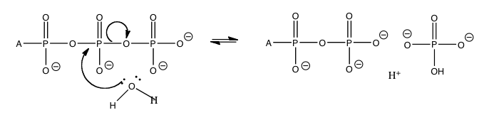

If we go one step further and look at the actual free energy change ΔG (as opposed to the standard change), using typical cellular concentrations of ATP, ADP and Pi, and ΔG = ΔGº + RTlnQ (where Q = [ADP][Pi]/[ATP]), we can calculate: ΔG = – 52 kJ/mol, assuming that the concentration of ATP is typically about ten times that of ADP, and that [Pi] is about 0.001 M. So in real conditions in the cell, the Gibbs free energy change is much higher than the standard Gibbs free energy change. This energy is not wasted; it is used to drive other reactions that would not otherwise occur. However, this energy cannot be used to drive just any random reaction. The reactions have to be coupled by common intermediates (just like the carbon dioxide carbonate system).

A typical reaction scenario is the transfer of the terminal phosphate group to another biomolecule as shown in the diagram. This transfer occurs with lipids and proteins, but typically the reacting group is an alcohol (ROH) or sometimes a carboxylic acid (RCOOH). The reaction that takes place is almost the same as the hydrolysis reaction except that the incoming nucleophile has much more “stuff” attached to the oxygen.

The formation of these phosphate esters makes the original functional group more reactive. For example, the formation of an amide bond (the major bond that holds proteins together) is normally exergonic (about + 2 to 4 kJ/mol). The formation of amide bonds is not spontaneous (you might want to think about what this means for the amide bonds in the proteins that make up a good portion of you). Therefore, protein synthesis is coupled with ATP hydrolysis, as is the production of many biomolecules, sugars, lipids, RNA, and DNA. The reactions are complex, but each of them is driven by a series of individual reactions linked by common intermediates.

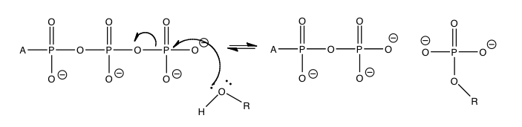

Now you might be asking: if ATP is so unstable, how does it get formed in the first place and how can it be found at such high concentrations? The short answer involves two ideas that we have encountered before: first, while ATP is unstable (like wood in the presence of O2), its hydrolysis does involve overcoming an activation energy and so under physiological conditions, an enzyme that can catalyze and coupled the hydrolysis of ATP to other reactions (an ATPase) is needed; second, ATP is formed through coupled reactions that link the oxidation of molecules such as glucose or through the direct absorption of energy in the form of light (photosynthesis). When glucose reacts with oxygen it forms carbon dioxide and water: C6H12O6 + 6O2 ⇄ 6CO2 + 6H2O

with an overall standard free energy change ΔGº = – 2870 kJ/mol. The reasons for this high negative free energy change are that ΔSº is positive (why do you think this is?), and there is a large negative ΔHº change. Remember that ΔHº can be approximated by looking at the changes in bond energy from reactants to products. A major reason for this high enthalpy change is that the bond energies in carbon dioxide and water are very high (a C=O bond takes 805 kJ/mol to break, and an O-H bond 463 kJ/mol), and therefore when C=O and O-H bonds are formed a large amount of energy is released. When one mole of glucose is completely oxidized to CO2 and H2O, the energy produced is harnessed to ultimately produce ~36 moles of ATP (from ADP and Pi).   
The mechanism(s) involved in this process are complex (involving intervening ion gradients and rotating enzymes), but the basic principle remains: the reactions are coupled by common and often complex intermediate processes. This reaction coupling leads to networks of reactions. The synthesis and reaction of ATP (and ADP) is governed by the same principles that govern much simpler reactions. Whether or not ATP or ADP is the dominant species in any cellular compartment depends upon the conditions and what substrates are present to form a reaction.

**Questions to Answer**

* Can you draw the protonated form of ATP?
* Can you draw the unprotonated form of ATP, showing how the negative charge is stabilized by the surrounding cellular fluids? (Hint: the fluid is mainly water.)
* The pKas of phosphoric acid (H3PO4) are 2.15, 7.2 and 12.35. Is the ATP protonated or deprotonated in the cellular environment?
* Write out a hypothetical sequence of two reactions that result in the production of a thermodynamically unfavorable product.
* How can you tell whether two reactions are coupled?
* Why do biological systems rely on coupled reactions?
* If ATP is unstable, how is it possible that ATP can exist at high concentrations within the cell?

**Questions to Ponder**

* If you are trying to determine if two reactions are coupled, what do you look for?
* Coupling allows unfavorable reactions to occur. Why doesn’t this violate the laws of thermodynamics?Assume that you have a set of five coupled reactions. What factors could complicate the behavior of the system?
* How could you insure that an unfavorable reaction continued to occur at a significant (useful)   
  rate?

# Appendix I: Spectroscopy

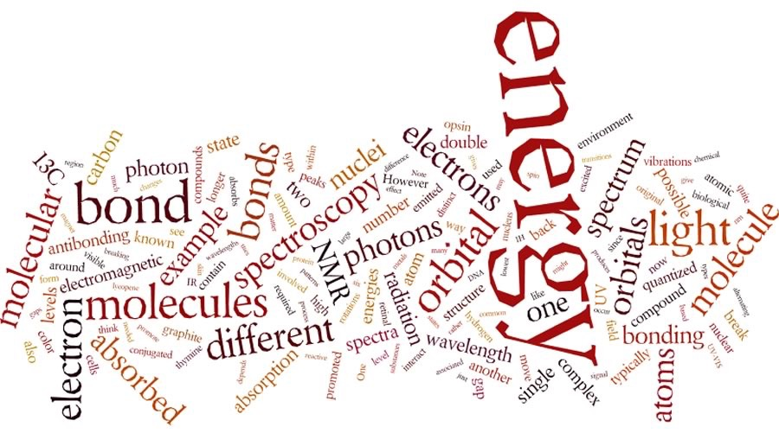

**How we know what we know about the structure of matter?** If you think back to our discussions of atomic structure, one of the most important pieces of evidence for the nature of atoms - particularly the arrangement of their electrons - was the way the atoms interact with electromagnetic radiation, that is, light. For example: the idea that both the energy of electromagnetic radiation and that of electrons is quantized came from Einstein’s analysis of the photoelectric effect. Electrons are ejected from metals only if they interact with photons of sufficient and discrete amounts of energy. More evidence for quantized electron energy states was provided from the study of atomic absorption and emission spectra, as photons of energy corresponding to the energy gaps between electron energy levels are either absorbed or emitted by electrons. Photons with the “wrong” amount of energy are not absorbed. Now that we have studied different assemblies of atoms (molecules, ions, networked structures), we can also look at how these larger entities interact with energy (in the form of electromagnetic radiation).

**Interactions of electromagnetic radiation and electrons in molecules:** As we have seen, just as electrons occupy atomic orbitals in atoms, the electrons in molecules occupy molecular orbitals. As with atomic orbitals, electrons in molecular orbitals can absorb or release photons of a specific energy as they move from one molecular orbital to another. However, there is a significant difference between the absorption/emission process in isolated atoms (or ions) and that of molecules. When an electron is promoted to a higher energy level in an atom, the product is an atom in an excited state – generally the excited atom (or ion) will decay back to the ground state by emitting a photon. A + hν→ A* (excited state) → A (ground state) + hν

However, when an electron within a molecule is excited it moves (or is “promoted”) from its original molecular orbital to another. Now there are a number of different consequences that may occur. For example, if the electron absorbs a photon and is promoted from a bonding molecular orbital to an anti-bonding orbital, the result will be that the bond will break, since there is now no overall stabilizing interaction. Consider H–H, which is the simplest possible molecule. The set of molecular orbitals for hydrogen includes a σ bonding and a σ* anti-bonding orbital. In the ground (or lowest energy) state, molecular hydrogen has a σ bonding orbital containing both of the molecule’s electrons. If one of the bonding electrons absorbs a photon that has just the right amount of energy (the energy difference between the bonding and anti-bonding orbital) it will be promoted and move into the destabilized anti-bonding orbital - causing the bond between the atoms to break. As you might imagine, if chemical bonds were susceptible to breaking merely by being exposed to low energy electromagnetic radiation, such as that of visible light, the world would be a different (and rather boring) place. For example, life would not be possible, since it depends upon the stability of molecules.

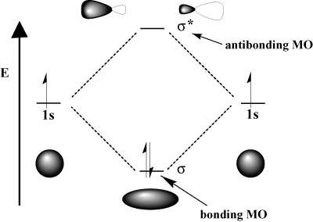

The energy of the photons required to bring about bond breaking is quite large. For example, the energy required to break an H-H bond (the bond energy) is 436 kJ/mol. If you calculate the wavelength of a photon that could deliver this amount of energy, the amount of energy required to break one H-H bond would be in the far UV section of the electrogmagnetic spectrum (~280nm). The typically strong covalent sigma (or single) bond requires quite high energy photons to break them.

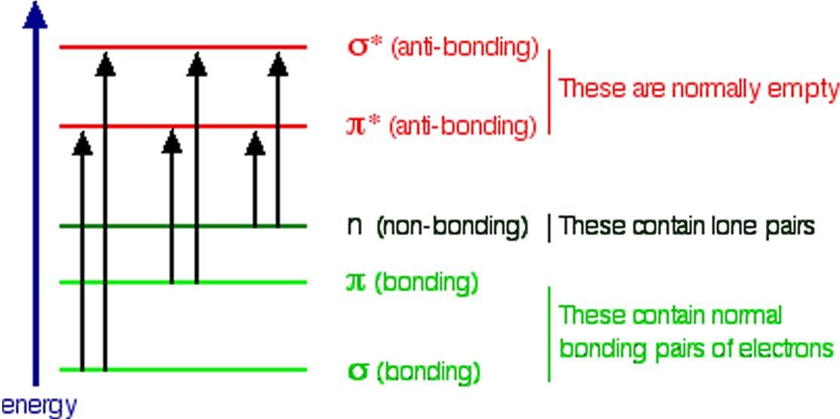So the question is, if the Earth’s atmosphere blocks out most (>98%) of high energy (ultraviolet) photons and most biologically important molecules cannot absorb visible light, why is there a need for sunscreen, which filters out the UV A (400- 315 nm) and UV B (315-280 nm) photons. The answer is that a most biological molecules contain more than simple σ bonds. For example, most complex biological molecules also contain π bonds and non-bonding electrons in addition to σ bonds; transitions between these orbitals may be observed as these orbitals require less energy to be effected. As you can see in the figure, the energy gaps between these orbitals are quite different and are smaller than the σ-σ* difference. Photons with enough energy to cause these electron transitions are present in sunlight. For example, a double bond has both a σ and a π bond. Absorption of a photon that would promote an electron from a pi bonding orbital to a π* anti-bonding orbital would have the effect of breaking the original π bond. One way to represent this is shown here →. One of electrons that was in the π bond is now in the high energy π* antibonding orbital and is far more reactive. Another way to think about it is that the electrons are now unpaired, and are much more likely to react to form a more stable entity[189]. An obvious way to regain stability is for the electron in the π antibonding orbital to drop back down to the bonding energy level and emit a photon of the same energy, and in most cases this is what happens - ultimately causing no damage. One caveat here is that since double bonds are rotationally constrained, it is possible that rotation can occur around the single (σ) bond before the π bond reforms; this leads to an isomer of the original alkene. On the other hand, if there is a nearby potentially reactive species, reactions between molecules (or in the case of biological macromolecules, between distinct regions of these molecules) can occur. For example, most of us are aware that exposure to the sun causes skin damage that can lead to skin cancer. A major mechanism for these effects involves DNA. Where two thymidine bases are adjacent to one another, a UV photon can be absorbed by a π bond in one thymine base. This broken π bond (and resulting unpaired electron) is very reactive. It can react with a π bond in an adjacent thymine-moeity leading to a new bond, a reaction that produces a four membered carbon ring, known as a thymine dimer. The DNA replication machinery cannot accurately replicate a sequence containing a thymine dimer, resulting in a change in DNA sequence - a mutation. Mutations of this type are a common early step in the generation of a cancerous skin cells.[190]

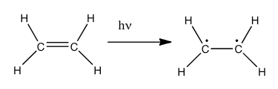

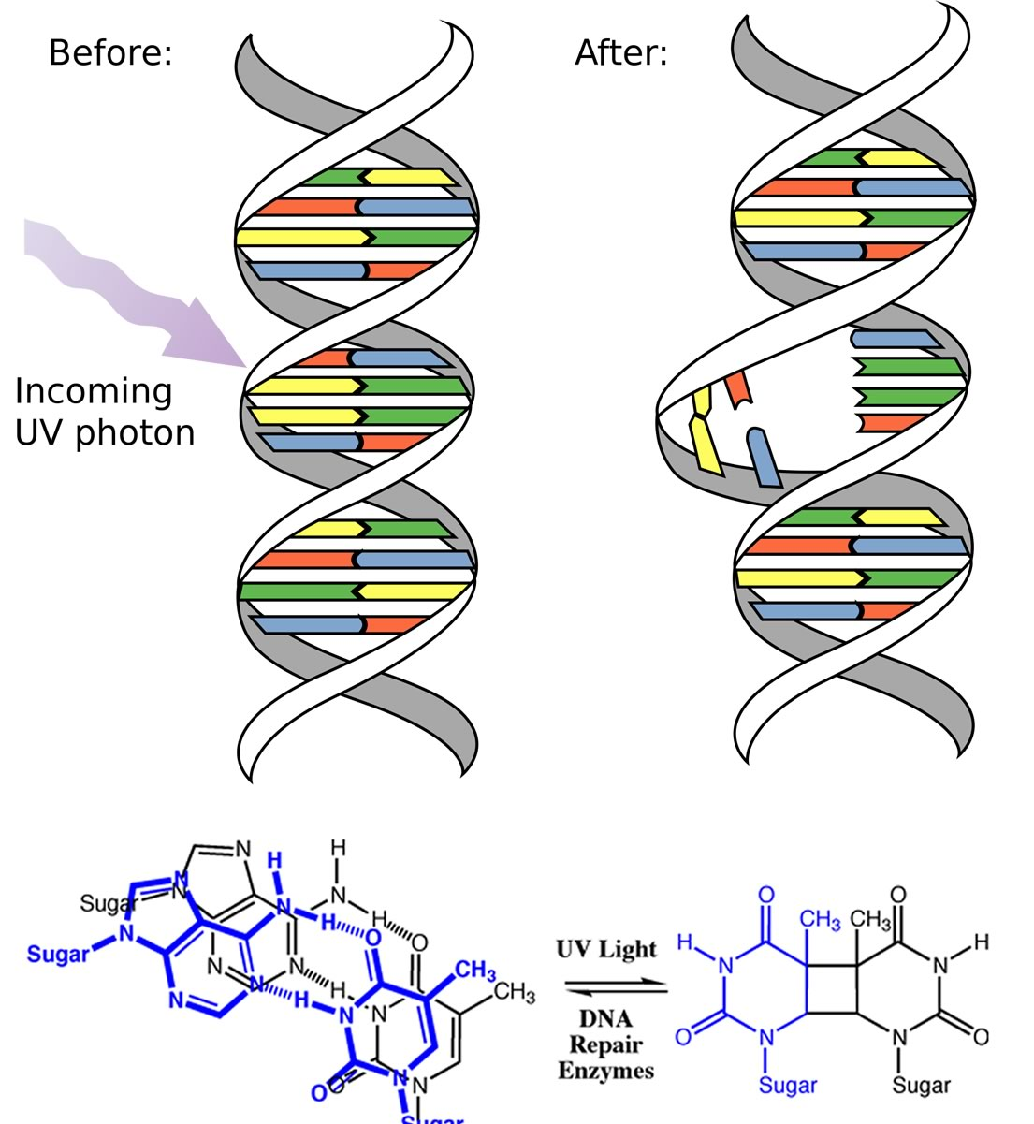

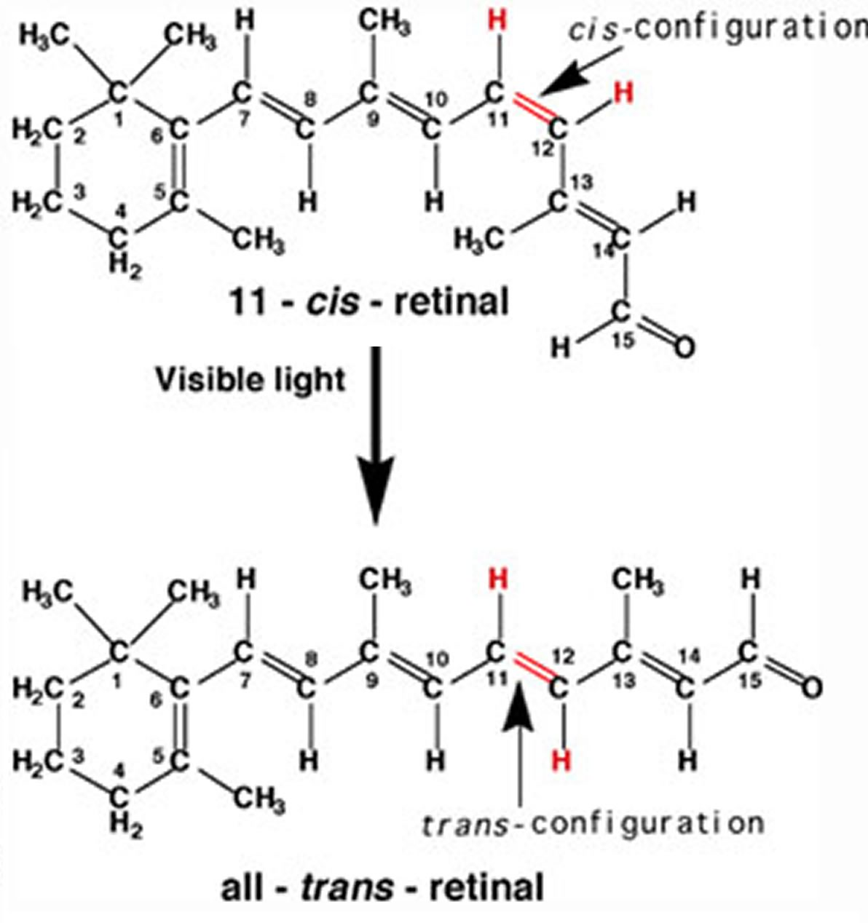A more benign example of photon absorption in biological systems underlies the mechanism by which we (and other organisms) detect light, that is how we can see things! While it was originally thought (at least by some) that vision involved rays emitted from eyes,[191] we now understand that to see we need to detect photons that are reflected or emitted by the objects around us. The process begins when the photons of light fall on cells known as photoreceptors. In our eyes, these cells are located within the retina, a sheet of cells than line the interior surface of the eye. Within a subset of retinal cells are a number of different types of molecules that contain π bonds. These molecules are proteins known generically as opsins. An opsin is composed of a polypeptide (or apoprotein) that is covalently bound to another molecule, 11-cis-retinal.[192] This molecule is derived from vitamin A (all trans retinol). The complex of apoprotein and retinal is the functional opsin protein. There are a number of different opsin components that influence the wavelength of the photons absorbed by the functional opsin protein. When a photon is absorbed, it promotes an electron from one of the retinal’s π bonds (between C11 and C12) to an antibonding orbital. Instead of reacting with another molecule, like thymine, there is a rotation around the remaining single (σ) bond, and then the re-formation of the π bond, which leads to the isomerization of the original 11-cis form into the trans isomer. This change in the shape of the retinal moiety in turn influences the shape of the opsin protein which initiates a cascade of electrochemical events that carry signals to the rest of the brain (the retina is considered an extension of the brain) that are eventually recognized as visual input.

**UV-Vis spectroscopy and chromophores - or why are carrots orange?** One common recommendation from doctors is that we eat plenty of highly colored fruits and vegetables. The compounds that give these foods their strong color have a number of commonalities. For example, the compound that gives carrots and sweet potatoes their distinctive orange color is beta-carotene. You might well notice its similarity to retinal. The compound that contributes to the red color of tomatoes is lycopene. Molecules of this type are known generically as pigments.

The wavelengths at which a compound absorbs light depends on the energy gap between the orbitals that are involved in the transition. This energy gap is determined by the structure of the molecule. A molecule with only single bonds absorbs light at shorter wavelengths (in the high energy UV), while more complex bonding patterns are associated with the absorption of visible light. For example, the presence of multiple π bonds and their interactions within the molecule can affect the energy gap between the molecular orbitals. Recall our discussion of graphite. Rather than thinking of graphite as sheets of fused six membered rings with alternating single and double bonds, we can think of each bond as a localized σ bond and a delocalized π bond. There are huge numbers of π molecular orbitals spread over the whole sheet of carbon atoms. The more π MO’s there are the more the energy gap between these orbital decreases, that is, the less energy (longer wavelength light) is needed to move an electron from a π to π* orbital. In the case of network substances like graphite and metals, the energy gap between the orbitals becomes negligible, and we think of the bonding model as a band of molecular orbitals. In these cases, many wavelengths of light can be absorbed and then re-emitted which gives graphite and metals their characteristic shininess. In substances like lycopene or β-carotene we also find this pattern of alternating single and double bonds. We say that compounds with this pattern of alternating single and double bonds (e.g. –C=C–C=C–) are conjugated, and we can model the bonding in the same way as graphite. There are π MO’s that can extend over the region of the molecule, and the more orbitals there are, the closer together in energy they get.

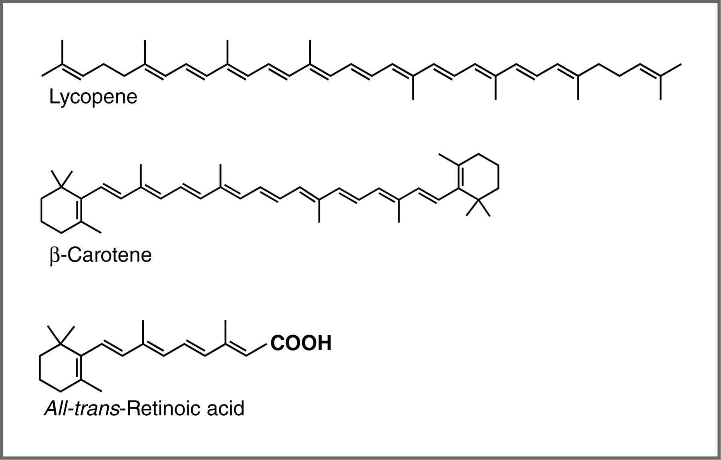

For an isolated C=C double bond, the energy required to promote an electron from the π to the π* orbital corresponds to the light in the UV region (around 170 nm), but as the number of double bonds that are conjugated (separated by single bonds) increases, the energy gap between the highest occupied molecular orbital (HOMO) and the lowest unoccupied molecular orbital (LUMO) decreases. Eventually, the wavelength of light needed to promote an electron from the HOMO to the LUMO moves into the visible region, and the substance becomes colored. (Note that it does not become the color of the light that is absorbed – but rather the remaining light that is transmitted or reflected). These conjugated regions of molecules are called chromophores.[193] The longer the conjugated section of the molecule, the longer the wavelength that is absorbed. You will notice that both lycopene and B-carotene contain large chromophore regions.

Samples of UV-VIS absorption spectra are shown here. Note that in contrast to the atomic absorption spectra we saw earlier which consisted of sharp lines corresponding to the wavelength of light absorbed by atoms, these spectra are broad and ill defined. In addition, you can see that the longer (larger) the chromophore the longer the wavelength that is absorbed, and each of these compounds appears to be a different color.

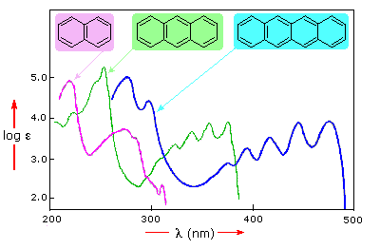

The fact that the peaks in these spectra are not sharp means that UV-VIS spectroscopy is typically not used for identification of compounds (see below for IR and NMR spectroscopy which can be used for this purpose). However the amount of light absorbed is proportional to the concentration of the substance and therefore UV-VIS spectroscopy can be used to determine the concentration of samples. There are other optical behaviors associated with complex molecules in organisms, including molecular systems that that emit light, a process known as bioluminescence that we will not discuss here.[194]

**InfraRed spectroscopy – looking at molecular vibrations:** Up to now we have concentrated on the absorption (and emission) of energy caused by transitions of electrons between quantized energy levels. However, as we discussed earlier, electron energies are not the only quantized energies at the atomic-molecular level. In molecules, the energies of both molecular vibrations and rotations are also quantized, but the energies involved are much lower than those needed to break bonds. When two atoms are bonded, the atoms can move back and forth relative to each other: as they move, the potential energy of the two atom system changes (why is that?). There are also motions associated with rotations around bonds. But (weirdly, and quantum mechanically) rather than being able to assume any value, the energies of these vibrations (and rotations) are also quantized. The energy gaps between the vibrational energy levels tend to be in the range of infrared radiation. When we look at the light absorbed or emitted by vibrational energy changes we are doing what is known as infrared spectroscopy. Transitions from one rotational energy level to anther can be promoted by microwave radiation, leading to microwave spectroscopy. **The table below** provides examples of different types of spectroscopy, the wavelength of electromagnetic radiation typically involved, and the uses of each kind of spectroscopy.

**Table I**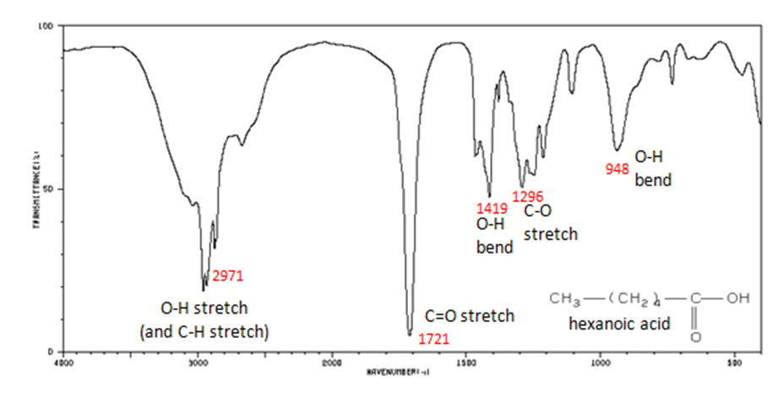

|  |  |  |  |
| --- | --- | --- | --- |
| **Type of Spectroscopy** | **Radiation wavelength** | **Interaction with matter** | **Purpose** |
| UV-VIS | 350-700 nm | Electronic transitions in molecules | Often used to determine concentrations |
| IR | 2,500 to 16,000 nm | Molecular vibrations | To determine presence of particular groups of atoms (functional groups |
| NMR | 10-100 m | Nuclear transitions | Identify types of C and H in molecules |
| MRI | 10-100 m | Nuclear transitions | Imaging (typically human body parts) |

Why, you might ask, are we interested in the vibrations and rotations of molecules? It turns out that many molecules and fragments of molecules have very distinctive IR absorption patterns that can be used to identify them. The figure shows an IR spectrum of a carboxylic acid and how the various peaks can be ascribed to vibrations of different bonds or groups within the molecule. Infrared spectroscopy allows us to identify substances from these patterns, both in the lab and for example in interstellar dust clouds. The presence of quite complex molecules in space (hundreds of millions of light years away from earth) has been detected by the use of IR spectroscopy.

**Nuclear Magnetic Resonance Spectroscopy (NMR):** NMR is a form of spectroscopy which uses the fact that certain nuclei can, depending on their structure, behave like tiny spinning magnets. Two of the most common nuclei used for NMR spectroscopy are 1H and 13C. When materials that contain carbon or hydrogen atoms in them are placed in a magnetic field, there are two possible orientations of these nuclei can exist in with respect to the field: a low energy orientation in which the nuclear magnet is aligned with the field, and a high energy orientation in which the nuclear magnet is aligned against the field. The effect of this is to split the energy levels of the nuclei. This makes it possible to cause a transition between the two energy levels by the absorption of electromagnetic radiation of appropriate energy- which in this instance, is in the radio wave range.

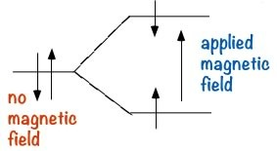

The exact energy of these changes depends upon the environment of the nuclei, if the C or H is in an electron deficient environment it will appear at a different frequency in the spectrum than a C or H that is surrounded by more electron density (the nucleus is said to be shielded by the electrons.) From a study of the different energies absorbed as the nucleus flips from one spin state to another, it is possible derive information about the structure of the compound.

The information that can be obtained from simple NMR spectra has to do with the number and type of nuclei that are in a certain compound. The simplest type of NMR spectrum is based on 13C. 13C is a minor isotope of carbon (about 1% of natural abundance) and is present in all naturally occurring samples of carbon compounds. In a 13C spectrum, each carbon atom in the molecule will give rise to a signal or peak in the spectrum based on its chemical environment. For example, ethanol (CH3CH2OH) has two peaks in its 13C spectrum because there are two, and only two distinct chemical environments that a carbon atom can “inhabit”. In contrast, cyclohexenone produces a spectrum that has six distinct peaks, because each of the six carbon atoms in the molecule inhabits a distinctly different environment. Benzene (C6H6) on the other hand has only one signal in its 13C NMR spectrum since there is only one type of carbon in this molecule, all the positions in the ring are equivalent. (Draw out the Lewis structure to convince yourself that this is true)

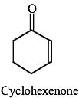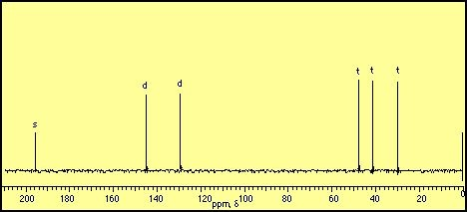

Spectrum of cyclohexenone

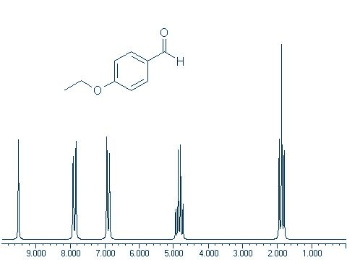

Proton or 1H NMR spectra appear more complicated because each hydrogen atom tends to give a signal that is split into several different peaks. This is because each H nucleus can be affected by the neighboring nuclei. This produces multiple energy levels for each H, which results in more complex spectra. 13C appears simpler because there are typically only one (or zero) 13C nucleus in any molecule, therefore there are no interactions by nearby carbons (12C does not have different nuclear energy levels in a magnetic field). Note that this 1H NMR spectrum is much more complex than the 13C NMR. However, there are five distinct clusters of signals and there are five kinds of protons in the compound that gives rise to this spectrum

A variant of NMR is Magnetic Resonance Imaging (MRI), which is based on the same underlying nuclear behaviors, but uses a somewhat different approach. In MRI the material (usually a person) from which you want to record the spectrum is placed in a large magnet which separates the nuclear spin states as described above. The target is irradiated with a pulse of radiowaves that promotes all the nuclei up to their highest accessible energy state. As the nuclei decay back to the lower spin state they emit photons. Instead of detecting the energies of these photons, the system records the times it takes for photons to be emitted as the nuclei drop back to their lowest energy states. These times are dependent on the environment of the nuclei making it possible, through data manipulation, to develop internal visualizations of the body in the scanner.

These are just a few types of examples of spectroscopy. There are many more that you may encounter, but typically these methods all depend on recording how matter and energy interact and using that data to determine the arrangement of the atoms in the matter that is under investigation.

1. Take a look at Pauling’s General Chemistry and tell us we are wrong.
2. <http://www.the-scientist.com/?articles.view/articleNo/36919/title/Cancer-Causing-Herbal-Remedies/>
3. Scale of the universe: <http://htwins.net/scale2/>
4. <http://www.iep.utm.edu/t/thales.htm>
5. Of course if you know your movies, you know that the “Fifth Element” is love.
6. <http://plato.stanford.edu/entries/democritus/>
7. First description of Brownian motion - Epicurus
8. *A History of Greek Philosophy by William Keith Chambers Guthrie. p. 212.*
9. http://www.chm.bris.ac.uk/webprojects2002/crabb/history.html and <http://en.wikipedia.org/wiki/Chemistry_(etymology)>
10. An important event was the rediscovery by Poggio of Lucretius’s “On the Nature of Things,” a poem centered on the atomic nature of the universe (see The Swerve by Stephen Greenblatt). One reason Giordano Bruno was burnt at the stake was the fact that he took these ideas seriously.
11. <http://elements.vanderkrogt.net/elem/p.html>
12. The Philosopher’s stone was thought to be able to turn base (common) metals into gold, and perhaps even be the key to everlasting life. It was the ultimate goal of the alchemists. Interestingly the first Harry Potter book was titled Harry Potter and the Philosopher’s Stone in England but was re-titled in America, because the publishers thought that American children would not be interested in a book with this title, perhaps due a failure to appreciate the importance of philosophy.
13. Religious dissenters, that is, non-Anglicans, were not allowed access to English universities at that time.
14. An extraordinary number of discoveries related to the structure of the atom were made by scientists in or from Manchester. There must be something in the air there. It is, of course, completely fortuitous that one of the authors was also born and bred in Manchester!
15. <http://www.youtube.com/watch?v=eQOTy6JUjEg>  
    <http://groups.molbiosci.northwestern.edu/holmgren/Glossary/Definitions/Def-L/law_multiple_proportions.html>
16. That is, a person from Manchester, England.
17. This works because the electrons are spinning.
18. <http://www.aip.org/history/electron/jjsound.htm>
19. A term made popular (although often misunderstood) by T. S. Kuhn, The Structure of Scientific Revolutions, 1st. ed., Chicago: Univ. of Chicago Pr., 1962
20. This can be a little confusing to those not familiar with plum pudding – a “delicious” English delicacy composed of dried fruit (raisins) in a spongy base, usually prepared by boiling for several days and often served with rum sauce.
21. Yes we did tell you to think of electrons as a cloud - because this is a helpful model - but electrons are both particles and “clouds” as we will discuss later, in fact in some instances they appear to be quite close to perfect spheres in shape, In fact “The experiment, which spanned more than a decade, suggests that the electron differs from being perfectly round by less than 0.000000000000000000000000001 cm. This means that if the electron was magnified to the size of the solar system, it would still appear spherical to within the width of a human hair. (Hudson et al "[Improved measurement of the shape of the electron](http://www.nature.com/nature/journal/v473/n7348/full/nature10104.html)" DOI: 10.1038/nature10104).
22. See <http://www.youtube.com/watch?v=p_o4aY7xkXg> for an excellent explanation of this phenomenon.
23. That said, we recommend the discription given in Einstein and Infeld’s Evolution of Physics: <https://archive.org/details/evolutionofphysi033254mbp>
24. [The trouble with chemical energy: why understanding bond energies requires an interdisciplinary systems approach](http://www.ncbi.nlm.nih.gov/pubmed/23737636). CBE Life Sci. Education,**12**:306-12.
25. Magnetic, like electrical force can also be attractive or repulsive. Most of us have played with magnets and felt the force of attraction between a north and south pole of a set of magnets, which gets stronger as the magnets get closer together, and the repulsion between two north poles which also gets stronger as the magnets get closer together.
26. A point we have not considered is why the atoms or molecules stop moving toward each other, which will return to shortly.
27. Remember speed is a directionless value, while velocity involves both speed and direction.
28. Imagine, as an analogy that the two atoms are balls rolling down opposite sides of a hill towards a valley, their potential energy falls as they move down - but their kinetic energy rises and they speed up.
29. To continue our analogy as the balls get to the bottom of the hill, they collide and bounce back - rolling back up the hill, until once again the force of gravity takes over and they start to roll back down. In an ideal (unreal) situation with no friction, this situation would simply continue, until some other factor is introduced.
30. It is these factors that made the report of cold fusion so strange and so exciting to physicists. The temperatures and pressures required for fusion are so high that they are extremely difficult to achieve under controlled conditions. The failure to reproduce the original cold fusion report reinforces our understanding of how atoms interact. That scientists around the world attempted to reproduce the original observation (and failed), illustrates the open-mindedness of the scientific community. The fact that badly controlled and irreproducible observations were published, illustrates how scientific effort and resources (that is, research funds) can be wasted by inadequate pre-publication review. But science, like all human activities, is imperfect. The price for open-mindedness may be be wasted time and effort, yet it remains critical to scientific process and progress. At the same time, once the replication efforts failed, it became a waste of time (or a delusional obsession) to pursue cold fusion.
31. According to Robert Parson, “At 1 atmosphere pressure, Helium does not melt at ANY temperature - it stays liquid down to absolute zero. (If you want to be picky,  it is a liquid down to the lowest temperatures that anyone has ever achieved, which are orders of magnitude less than 1 K (<http://en.wikipedia.org/wiki/Dilution_refrigerator>), and our best theories predict that it will remain a liquid no matter how low the temperature.) To get solid helium you have to increase the pressure to 25 atmospheres or above. This is one of the most dramatic consequences of zero-point energy: the intermolecular forces in He are so weak that it melts under its own zero point energy. (This leads to the peculiar consequence that Helium at zero Kelvin is a liquid with zero entropy.)
32. In fact this is known as the bond energy – the energy required to break the bond – which in the case of H2 is 432 kJ/mol.
33. This may (or may not) be helpful: http://www.cv.nrao.edu/course/astr534/PDFnewfiles/LarmorRad.pdf
34. <http://phet.colorado.edu/en/simulation/wave-interference>
35. Link to “Dr. Quantum” double slit experiment: <http://www.youtube.com/watch?v=DfPeprQ7oGc>
36. In fact, there is lots of light within your eyeball, even in the dark, due to black body radiation. You do not see it because it is not energetic enough to activate your photosensing cells. See: <http://blogs.discovermagazine.com/cosmicvariance/2012/05/25/quantum-mechanics-when-you-close-your-eyes/>
37. <http://www.physorg.com/news76249412.html>
38. h= 6.626068 × 10-34 m2kg/s (or joule-seconds, where a joule is the kinetic energy of a 2 kg mass moving at a velocity of 1 m/s)
39. This is known as the Rayleigh-Jeans law.
40. <http://phet.colorado.edu/simulations/sims.php?sim=Photoelectric_Effect>
41. One type of semi-exception is illustrated by what are known as two- and multi-photon microscopes, in which two lower energy photons hit a molecule at almost the same moment, allowing their energies to be combined; see http://en.wikipedia.org/wiki/Two-photon_excitation_microscopy.
42. For a more complex explanation, see: <http://www.coffeeshopphysics.com/articles/2011-10/30_the_discovery_of_rainbows/>
43. Bohr model applet particle and wave views: <http://www.walter-fendt.de/ph11e/bohrh.htm>
44. Although the resting mass of a photon is zero, a moving photon does has an effective mass because it has energy.
45. Good reference: <http://ww2010.atmos.uiuc.edu/(Gl)/guides/rs/rad/basics/wvl.rxml>
46. see <https://www.youtube.com/watch?v=6SxzfZ8bRO4> and <https://www.youtube.com/watch?v=1920gi3swe4>
47. These experiments are carried out using atoms in the gas phase in order to simplify the measurement.
48. There are a number different ways of defining the size of an atom, and in fact the size depends on the atom’s chemical environment (for example, whether it is bonded to another atom or not). In fact, we can only measure the positions of atomic nuclei, and it is impossible to see where the electron cloud actually ends; remember that orbitals are defined as the surface within which there is a 90% probability of finding an electron. Therefore, we often use the van der Waals radius, which is half the distance between the nuclei of two adjacent unbonded atoms.
49. For more information see: <http://winter.group.shef.ac.uk/orbitron/AOs/1s/index.html>

    <http://www.uark.edu/misc/julio/orbitals/index.html>
50. This is called the Pauli exclusion principle, which states that no two electrons may occupy the same quantum state; that is, no two electrons can have the same value for all four quantum numbers.
51. This is often called Hund’s rule. Just as passengers on a bus do not sit together until they have to, neither do electrons.
52. <http://www.space.com/scienceastronomy/mystery_monday_040524.html>
53. <http://www.youtube.com/watch?v=th_9ZR2I0_w&feature=c4-overview&list=UUUHW94eEFW7hkUMVaZz4eDg>
54. <http://www.astro.ucla.edu/~wright/BBhistory.html>
55. In this nomenclature (described more on the web), the first superscript number is the number of proton and neutrons, while the second superscript number is the number of protons; both numbers are always integers. The letter is the symbol of the element, e.g. He for helium or Li for lithium.
56. Nuclear fusion releases huge amounts of energy (some of the mass is transformed into energy). On Earth, controllable nuclear fusion has long been a potential target in the search for new energy sources, but so far the energy required to bring about the initial fusion has not been replaced when the fusion occurs – i.e., nuclear fusion reactors have yet to break even. Uncontrolled nuclear fusion takes place in hydrogen bombs – clearly not a viable option for a useful energy source at the moment. Nuclear fusion does however take place in stars, and is self-sustaining. The reason you can see and feel the energy from the Sun is that is it undergoing nuclear fusion reactions, which supply us with almost all the energy that is used on Earth today.
57. It has been estimated that it takes between 10,000 to 170,000 years for a photon released during a fusion reaction at the Sun’s core to reach its surface. <http://sunearthday.nasa.gov/2007/locations/ttt_sunlight.php>
58. More physics that we will conveniently pass over, but it is worth noting that this is why the planets all move around the Sun in the same direction.
59. You may want to search the web for “extrasolar planets.”
60. For those who want more, rest assured that you will find out if you take more advanced classes either in physics or physical chemistry.
61. This study shows images of bonds forming <http://www.sciencemag.org/content/340/6139/1434.abstract>
62. Although perhaps the word orbital is confusing because it implies a circular or elliptical motion, what we mean is the volume in which there is a 90% probability of finding an electron. That said, orbitals are the way chemists (and the occasional physicist) talk, so we have to use it.
63. How much pressure is that exactly in real world terms?
64. <http://en.wikipedia.org/wiki/X-ray_crystallography>
65. In fact the sheets in graphite do not slip relative to each other very readily. On Earth graphite is a lubricant, but in space in the absence of small molecules like O2, N2 and H2O, graphite does not lubricate. It is thought that the sheets slip relative to each other as if they were rolling on ball bearings (the small molecules). As you might imagine, this discovery caused some consternation in high-flying airplanes where the engines began to fail because of lack of lubrication.
66. The Nobel Prize in Physics was awarded in 2010 for the discovery of graphene. <http://nobelprize.org/nobel_prizes/physics/laureates/2010/>
67. In 1996 Smalley, Kroto, and Curl were awarded the Nobel Prize in Chemistry for the discovery of fullerenes. <http://nobelprize.org/nobel_prizes/chemistry/laureates/1996/>
68. We need to mentions (at least) what electricity is, i.e. the flow of electrons.
69. Robert Naeye (1998). Through the Eyes of Hubble: Birth, Life and Violent Death of Stars. CRC Press. ISBN 0750304847. Of course this raises the question, is it the same photon?
70. We do not believe that their intent is to torment students, and perhaps they have just forgotten that not every student knows or remembers all of the rules.
71. Unless otherwise noted, we always consider melting and boiling points at atmospheric pressure.
72. Chemists are not being unnecessarily difficult; anatomists also have a very strict set of names for the various bones and nerves in the body, in part to avoid confusion during medical procedures.
73. <http://www.iupac.org/> and <http://goldbook.iupac.org/index.html>
74. Hydrocarbons contain only hydrogen and carbon. Be careful not to confuse them with carbohydrates, which contain carbon, hydrogen, and oxygen and include sugars. We will consider carbohydrates in more detail later on.
75. In fact, we will see that these rotations and vibrations are quantized!
76. <http://pubs.acs.org/doi/full/10.1021/ci0497657>
77. However, a nitrogen compound with some structural similarities to diamond has been identified. It was synthesized from N2 at high pressure and temperatures. In this polymeric nitrogen, each nitrogen is connected to three neighbors via single bonds, in a similar way that diamond has carbons connected to four neighbors. However this polymeric nitrogen is highly unstable and reactive – unlike diamond. <http://www.nature.com/nmat/journal/v3/n8/abs/nmat1146.html>
78. Interestingly O2 cannot be well described by a simple valence bond model, because it can be shown that molecular oxygen has two unpaired electrons (it is a di-radical). The bonding is best explained by using molecular orbital theory.
79. Another way to talk about polarity is to say the bond (or molecule) has a dipole moment (unit Debye)- that is the magnitude of the charges x distance separating them.
80. It is worth keeping in mind the distinction between the molecules a substance is composed of, and the substance itself. Molecules do not have a boiling point, substances do.
81. Remember what a mole is, and that a kilojoule (kJ) is a unit of energy.
82. In larger molecules, such as proteins and nucleic acids, H-bonds can also form between distinct regions of a single molecule.
83. While Davy is well known now for his experiments on the nature of salts, he began his chemical career in his early twenties researching medical uses of gases. He apparently became very fond of nitrous oxide (N2O, laughing gas), which he reported was an enjoyable recreational drug and a cure for hangovers (ref SALT).
84. In 1800 the first electric battery, the Voltaic Pile, was developed. It was promptly put to use by a growing number of scientists. For example, molecular hydrogen and oxygen could be produced by passing electricity through water.
85. Positively charged ions are known as cations and negatively charged ions are known as anions.
86. Instead of talking about the temperature of an isolated atom or molecule, we talk about its kinetic energy.
87. We can ignore gravitational effects because at the molecular level they are many orders of magnitude weaker than the forces between atoms and molecules.
88. actually v(bar) is the root mean squared velocity of the gas particles,a measure that is similar to the mean, but makes the direction of the particles irrelevant.
89. We can also, for all practical purposes, ignore the fact that E = mc2; the conversions between energy and matter are insignificant for chemical processes.
90. Although this distribution of speeds of atoms was first derived mathematically, it is possible to observe experimentally that atoms in a gas are moving at different speeds.
91. Interestingly, this is like our approach to the decay of unstable atoms. We cannot predict when a particular atom will decay, but in a large enough population, we can very accurately predict the number of atoms per second that will decay.
92. We use average speed and velocity to describe the motion of the particles in a gas, but it is more accurate to use the root mean square (rms) of the velocity, that is, the square root of the average velocity. However, for our purposes average speed (or velocity) is good enough.
93. Translational energies are also quantized but the quanta are so small that in practice we do not need to worry about that.
94. There are a number of different energy units, including calories, but they are all measures of the same thing, so we will stick to joules here.
95. Alternatively in microwave ovens, the water molecules gain energy by absorbing microwave radiation which makes them rotate. When they collide with other molecules this energy can also be transformed into vibrations and translations, and the temperature of the water heats up.
96. The situation on planets like Venus and Jupiter is rather more complex.
97. The boundary between a system and surroundings depends on how you define the system. It can be real (as in the beaker) or imaginary (as in some ecosystems). In biological systems, the boundary may be the cell wall, or the boundary between the organism and its surroundings (e.g., skin).
98. The only exception would be cryptobiotic systems, like the tardigrads mentioned earlier.
99. Remember that London dispersion forces fall off as 1/r6, where r is the distance between the molecules.
100. In fact, we should say mass-energy here, but because most chemical and biological systems do not operate under the high-energy situations required for mass to be converted to energy we don’t need to worry about that (for now).
101. Or U if you are a physicist. This is an example of how different areas sometimes seem to conspire to make things difficult by using different symbols and sign conventions for the same thing. We will try to point out these instances when we can.
102. One important point to note is that this relationship only works when the thermal energy is used to increase the kinetic energy of the molecules—that is, to raise the temperature. At the boiling point or freezing point of a liquid the energy is used to break the attractions between particles and the temperature does not rise.
103. This is another example of the different ways that the same process is described. In chemistry we usually describe osmosis as movement from a solution of low concentration to high (where we are referring to the concentration of the solute). In biology osmosis is often described as movement from high concentration (of water) to low. These two statements mean exactly the same thing even though they appear to be saying the opposite of each other.
104. One of many speculations about the relationship between the big bang and entropy; <http://chronicle.uchicago.edu/041118/entropy.shtml>
105. <http://www.schuhmacher.at/weblog/52cards.html>
106. A realistic understanding of the probability of something happening is a great asset (but would put the gambling and lottery industries, and perhaps part of the investment community, out of business). Listen to: <http://www.wnyc.org/shows/radiolab/episodes/2009/09/11>
107. or Ω in some texts.
108. We multiply, rather than add W when we combine systems.
109. A great lecture by Richard Feynmann on this topic: <http://research.microsoft.com/apps/tools/tuva/#data=5%7C0%7C%7Cd88d1dbd-a736-4c3f-b832-2b0df62e4eca%7C%7C>
110. Many people use the term spontaneous, but this is misleading because it could make people think that the reaction happens right away. In fact, ΔG tells us nothing about **when** the process will happen, only that it is thermodynamically favored. As we will see later, the rate at which a process occurs is governed by other factors.
111. So why, you might ask, does water evaporate at temperatures lower than 100 ºC? We will come to that soon.
112. This is another rather counterintuitive idea, but remember that to freeze something you have to take heat away (for example, in a refrigerator).
113. Percent proofing of alcoholic beverages can be traced back to the 18th century, when British sailors were partially paid in rum. To prevent it from being watered down, the rum was “proofed” by seeing if it would support the combustion of gunpowder.
114. Silverstein, Todd P. J. Chem. Educ. 1998 75 116
115. See additional materials for structures and names of functional groups.
116. <http://en.wikipedia.org/wiki/Methane_clathrate>
117. ACS GenChem materials
118. Intramolecular means within the same molecule. Intermolecular means between or among separate molecules.
119. For examples, see the internet game “foldit”, which uses intramolecular interactions to predict how proteins will fold into the lowest energy shape.
120. Why do you use soap and shampoo? Why not use just water? The answer is, of course, that water doesn’t do a very good job of getting dirt and oil of your skin and hair because grime is just not soluble in water. Soaps and detergents are excellent examples of amphipathic molecules. They both have a polar head and a long non-polar tail, which leads to the formation of micelles. Oily molecules can then be sequestered within these micelles and washed away.
121. It is often possible to track the passage of a beam of light through such a solution, known as the Tyndall effect.
122. At the boiling point, the bubbles contain only water molecules because all the air has been expelled long before this temperature is reached.
123. <http://en.wikipedia.org/wiki/Bronze_Age>
124. It has been noted that one reason why chemistry is so difficult is that even experienced chemists cannot agree on the terminology and this is one such example.
125. That said, one might argue that 10-7 M is complete
126. Although slight traces of ethanol are still detectable; forensic scientists can detect the presence of substances such as hydrocarbons at the scene of a fire, even though the amounts are extremely small.
127. Arrhenius proposed these ideas in 1888 and won a Nobel Prize for his discovery of ionization reactions in solution in 1903.
128. <http://www.nature.com/nature/journal/v397/n6720/abs/397601a0.html>
129. This theory was postulated simultaneously by both Brønsted and Lowry in 1923.
130. In strong acids, the proton is completely donated to water in aqueous solution (i.e., there is no detectable amount of un-ionized acid in the water).
131. Recall also that electronegativity stems directly from the effective nuclear charge on a particular atom. If you don’t remember why, go back to chapter 2 and review this important idea.
132. Although some highly-charged metal ions react with water, we will not consider these reactions at the moment. Group I and II cations are stable in water.
133. There are some nitrogenous compounds that are not basic because the lone pair is already being used for some other purpose. If you continue to study organic chemistry, you will learn about these ideas in more detail.
134. Note reactions between molecules are intermolecular reactions; those that involve a single molecule are intramolecular.
135. <http://www.springerlink.com/content/n274g10812m30107/>
136. In fact Kw increases with temperature due to Le Chatelier’s principle, about which we will have more to say shortly.
137. The pH scale was first developed in 1909 by Danish biochemist Soren Sorensen.
138. In fact, pH is better defined as pH = {H3O+}, where the { } refer to the activity of the species rather than the concentration. This is a topic better left to subsequent courses, although it is important to remember that any resulting calculations on pH using concentrations provide only approximations.
139. Litmus is a [water](http://en.wikipedia.org/wiki/water)-[soluble](http://en.wikipedia.org/wiki/soluble) mixture of different [dyes](http://en.wikipedia.org/wiki/dye) [extracted](http://en.wikipedia.org/wiki/extract) from [lichens](http://en.wikipedia.org/wiki/lichens), especially [Roccella tinctoria](http://en.wikipedia.org/wiki/roccella_tinctoria)— Wikipedia!
140. pH is typically measured by using a pH meter that measures the differences between the electrical potential of the solution relative to some reference. As the concentration of hydronium ion increases, the voltage (potential between the solution and the reference) changes and can be calibrated and reported as pH.
141. <http://www.bbc.co.uk/dna/h2g2/A8819652>
142. <http://www.ncbi.nlm.nih.gov/pmc/articles/PMC1148806/pdf/biochemj00237-0011.pdf>
143. This is based on the personal memories of one (and only one) of the authors.
144. Visit [http://www.youtube.com/watch?v=eCk0lYB_8c0](http://www.youtube.com/watch?v=eck0lyb_8c0) for an entertaining video of what happens when sodium and other alkali metals are added to water (yes, they probably faked the cesium).
145. Hydrogen and oxygen can be used as rocket fuel, and the so-called “hydrogen economy” is based on the energy released when hydrogen reacts with the oxygen from the air.
146. <http://www.youtube.com/watch?v=oXHtOjXxvRo>
147. When O2 is used, the process is known as aerobic respiration.
148. Although bond dissociation energy and bond energy are often used interchangeably, they are slightly different. Bond dissociation energy is the energy required to break a particular bond in a molecule; bond energy is the average energy required to break a bond of that type. For our purposes, the difference is not important. Tables of bond energies usually refer to average bond energies.
149. Species with unpaired electrons
150. To begin this calculation, you must be able to figure out what bonds are present in the molecule; you must be able to draw the Lewis structure.
151. The rate of reaction is discussed in the next section.
152. Recall that the pH = – log [H+], so [H+] = 10-pH , if the pH is = 1 then the concentration of H+ = 10–1, or 0.1 M.
153. We write acetic acid in this condensed formula for clarity, remembering that the actual structure of acetic acid is CH3C=O(O-H), and it is the H on the terminal O that is donated to a base (water).
154. This is true provided that we are talking about reasonably large numbers of molecules - the smaller the number of molecules, the “noisier” the process. You can think about the molecular movements of a single molecule compared to the movement of many molecules, as an example.
155. One very unfortunate consequence of this is that flour stored in grain silos can explode without warning, if exposed to a spark or other energy source. <http://en.wikipedia.org/wiki/Grain_elevator#Elevator_explosions>
156. The slope of the tangent is the change in concentration/change in time or the rate of the reaction. The slope of the tangent is the derivative of the curve at that point (calculus!).
157. You might ask yourself: How do we know the molecules are still reacting if we can only observe the macroscopic level? There are a number of ways of tracking what happens at the molecular level. For example, there are spectroscopic techniques such as NMR that can be used, but they are beyond the scope of this book.
158. In fact, this reaction has a number of different products. For now we will concentrate on this one.
159. We call these kinds of reactions substitution reactions because one group has been substituted for another. In fact, they are also nucleophilic substitution reactions, because the hydroxide is acting as a nucleophile here.
160. It is not necessary to be able to follow this mathematical reasoning; it is included to show where the equation comes from.
161. [http://en.wikipedia.org/wiki/Spontaneous_human_combustion](http://en.wikipedia.org/wiki/spontaneous_human_combustion)
162. R is known as the gas constant; it turns up in many different equations. For example, the ideal gas law PV=nRT (the units depend on the equation where it is used). R is also related to the Boltzmann constant kB, (or k, yet another confusing use of symbols, since the Boltzmann constant is in no way related to the rate constant (k), or the equilibrium constant (K)).
163. <http://www.ncbi.nlm.nih.gov/pubmed/21332126>
164. Here is an example: <http://www.febsletters.org/article/S0014-5793(07)00971-4/abstract>
165. <http://www.webmd.com/diet/features/trans-fats-science-and-risks>
166. Strictly speaking, it is not concentrations that appear in the expression for K. Rather, it is another property called the activity (a)—often called the effective concentration. The activity takes into account the interactions between molecules and ions and solvents, but for our purposes it is acceptable to use concentrations in the expressions for Keq. One outcome of this is that activity is a dimensionless quantity, so equilibrium constants are one of the few places where we don’t have to worry about getting the right units!
167. Once more it is important to note that in thermodynamic terms, reactions referred to as spontaneous (inappropriately, in our view) do not indicate the rate at which a reaction will happen, but rather whether it will ever happen. In fact some “Spontaneous” reactions either do not occur at all (wood in an atmosphere containing oxygen does not burn spontaneously) or occur quite slowly (iron rusting).
168. Of course, there is no such thing as acetate (CH3COO–) alone. There must also be a counter-ion present. Typically, we use ions such as Na+ or K+, stable monovalent cations that will not participate in any further reaction. So when we say we add acetate to the solution, we really mean we add sodium acetate—the sodium salt of acetic acid (just like sodium chloride is the sodium salt of hydrochloric acid).
169. If you think about it for a moment you will see that if the concentration of any species changes in a closed system, then the concentrations of all the other species must also change.
170. You might be wondering if there is some trick here. There is—we are ignoring several side reactions that in fact tend to cancel each other out. If you are interested, there are a number of helpful sites that can assist you with the more complex calculations required.
171. The production of ammonia is a commercially-important process because nitrogen is an important element necessary for plant growth (it is commonly added to fertilizers). However, the major source of nitrogen is “locked up” in the air as molecular nitrogen, - a substance that is quite unreactive and inaccessible to most plants.
172. By analogy, consider the NCAA basketball tournament: if the field is widened to allow more participants, it helps the weaker teams because the stronger teams would have made it into the tournament anyway.
173. [http://www.youtube.com/watch?v=IBa4kgXI4Cg](http://www.youtube.com/watch?v=iba4kgxi4cg)
174. This type of adaptation is physiological and occurs within individual organisms; it is distinct from, but based on, evolutionary processes that act on populations of organisms.
175. Of course this designation is entirely arbitrary, as backward and forward depend on how the initial reaction is written.
176. We recognize such evolutionarily conserved processes because they used essentially (but not quite) the same reaction components and strategies. For example, aerobic respiration (whether in bacteria, potatoes, or humans) uses a structurally similar membrane system to transfer electrons from molecule to molecule (redox reaction). This generates an H+ gradient then used by a rotatory protein “generator” to synthesize ATP.
177. Amino acid chains are referred to as polypeptides; a protein is a functional unit, which can be composed of multiple polypeptides and non-polypeptide components such as heme groups.
178. <http://benbleasdaleblogs.wordpress.com/2013/10/23/want-to-see-an-enzyme-check-inside-your-nose/>
179. This binding site can also be occupied by other types of molecules, in particular carbon monoxide (CO). Because the binding of O2 to hemoglobin is much weaker and less stable than the CO–hemoglobin interaction, exposure to CO blocks O2 transport through the body, leading to suffocation.
180. An explanation of how to do this is provided in the supplementary materials.
181. It is always important to keep in mind that even though we write reaction equations with “sides” – product and reactant – in fact all these species are present in the same reaction vessel.
182. By adding a small amount of solute (rather than a volume of solution) we will not significantly affect the volume of te solution - which will make determining the concentration easier
183. You might wonder why the amide nitrogen is not basic - even though it appears to have a lone pair of electrons. However these electrons are not available for donation because they are conjugated (interacting) with the C=O group. You will have to wait until organic chemistry to hear more on this fascinating topic
184. calculated from ΔGº = –RTlnK at physiologycal temperature 37 ℃,
185. This occurs primarily because O2 is in short supply and the aerobic respiration reaction cannot proceed to completion.
186. Guyenet et al, 2010. Central CO2 chemoreception and the integrated neural mechanisms of cardiovascular and respiratory control. J. Appl. Physiol. [online] 2010. 108, 995. <http://www.ncbi.nlm.nih.gov/pubmed/20075262>.
187. Although it does not explain why we would want to exercise in the first place.
188. Adapted from Physical Chemistry for the Chemical and Biological Sciences by Raymond Chang [complete citation]
189. Species with unpaired electrons are called radicals or free radicals - they are typically highly reactive and are thought to be implicated in many processes involving cellular damage and aging.
190. Fortunately there cellular mechanisms that can detect and repair these kinds of radiation induced mutations (more here?)
191. <http://nivea.psycho.univ-paris5.fr/FeelingSupplements/AncientVisions.htm>
192. Other related molecules are found throughout the biological world, for more examples see   
     <http://www.ncbi.nlm.nih.gov/pubmed/3416013>
193. http://phototroph.blogspot.com/2006/11/pigments-and-absorption-spectra.html
194. http://en.wikipedia.org/wiki/Bioluminescence) and <http://www.microscopyu.com/articles/livecellimaging/fpintro.html>